**Name: Nimya Satheesh**

**Roll No: 26**

**Batch: B**

**Date:23-05-2022**

**NETWORKING&SYSTEM ADMINISTRATION LAB**

**Experiment No.: 24**

**Aim**

The Docker, installation and deployment.

**Procedure**

**Step 1:** Open the terminal on Ubuntu.

**Step 2:** Remove any [Docker files](https://www.simplilearn.com/tutorials/docker-tutorial/what-is-dockerfile) that are running in the system

**Syntax:-** **$ sudo apt-get remove docker docker-engine docker.io**

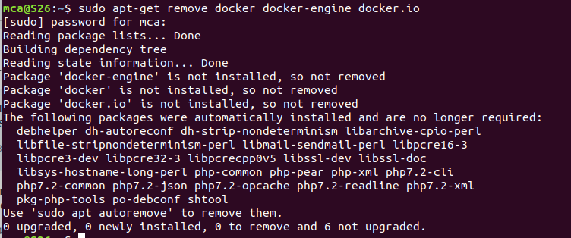

**Step 3:**  Check if the system is up-to-date

**Syntax:- $ sudo apt-get update**

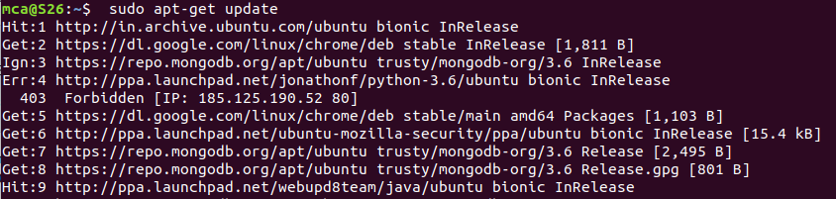

**Step 4:**  Install Docker

**Syntax:- $ sudo apt install docker.io**

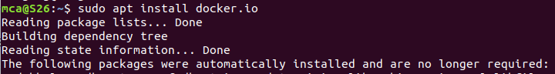

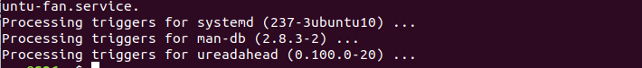

**Step 5:** Install all the dependency packages

**Syntax:- $ sudo snap install docker**



**Step 6:** check the version installed

**Syntax:- $ docker –version**



**Step 7:** Pull an image from the Docker hub

**Syntax:- $ sudo docker run hello-world**

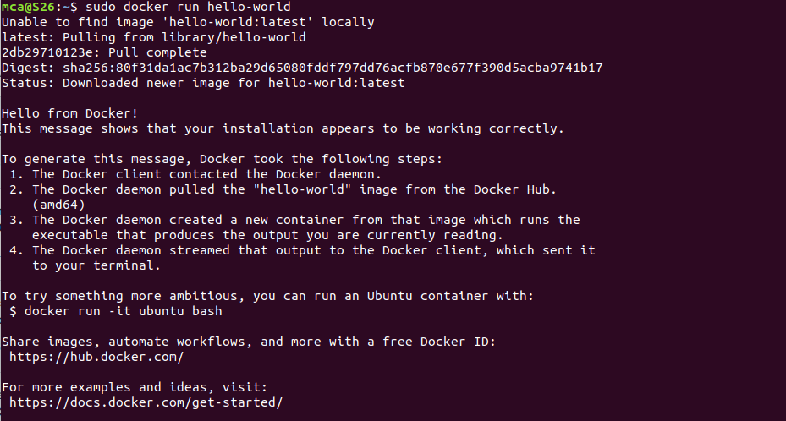

**Step 8:** Check if the docker image has been pulled and is present in your system.

**Syntax:- $ sudo docker images**



**Step 9:** To display all the containers pulled

**Syntax:- $ sudo docker ps -a**



**Step 10:** To check for containers in a running state

**Syntax:- $ sudo docker ps**

