**NETWORKING&SYSTEM ADMINISTRATION LAB**

**Name: Nimya Satheesh**

**Roll No:26**

**Batch:B**

**Date:21-02-2022**

**Experiment No.: 3**

**Aim**

Familiarization of Linux Commands

**Procedure**

**1. pwd**

The pwd command is used to display the location of the current working directory.

**Syntax :**



**2. mkdir**

The **mkdir command is used to create a new directory under any directory**

**Syntax :**



**3. ls**

The ls command is used to display a list of content of a directory

**Syntax :**

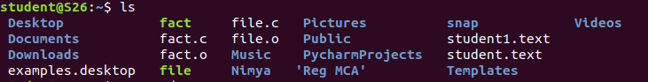

**4. ls -l**

**Syntax :**

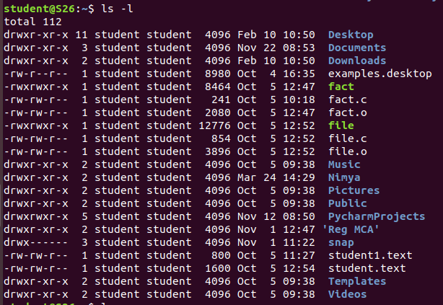

**5. ls -R**

**Syntax :**

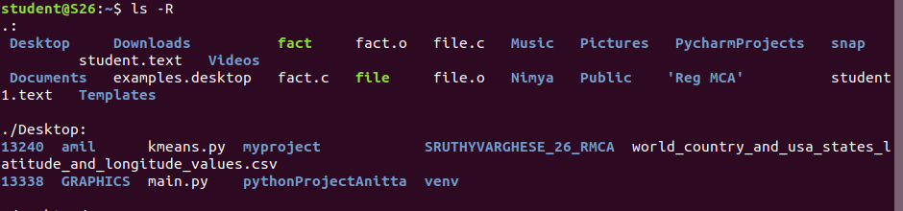

**6. ls -a**

**Syntax :**

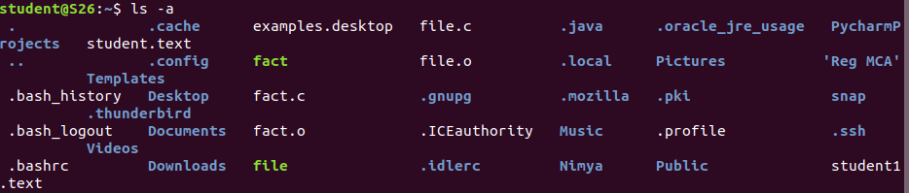

**7. ls -al**

**Syntax :**

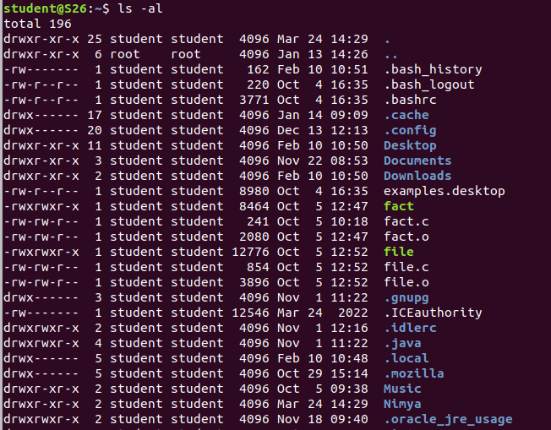

**8. ls -t**

**Syntax :**

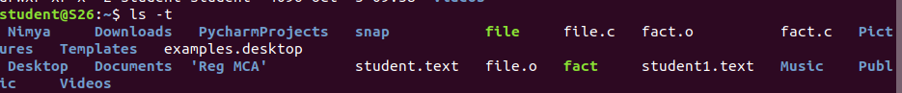

**9. cd**

The cd command is used to change the current directory

**Syntax :**



**10. cd -**

**Syntax :**



**11. cat > a.txt**

The cat command is a multi-purpose utility in the Linux system. It can be used to create a file, display content of the file, copy the content of one file to another file, and more.

**Syntax :**

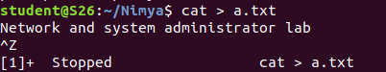

**12. cat >> a.txt**

**Syntax :**

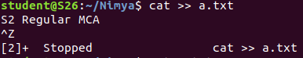

**13. cat a.txt**

**Syntax :**



**14. cat a.txt > b.txt**

**Syntax :**



**15. cat b.txt**

**Syntax :**



**16. man**

**Syntax :**



