**Name: Nimya Satheesh**

**Roll No: 26**

**Batch: B**

**Date: 05-05-2022**

**NETWORKING&SYSTEM ADMINISTRATION LAB**

**Experiment No.: 9**

**Aim**

1. Write a shell script program to enter basic details

2. Write a shell script program to find largest of two numbers.

3. Write a shell script program sum of two numbers.

4. Write a shell script program to check whether even or odd.

5. Write a shell script program to find largest of three numbers.

**Procedure**

1. **Syntax:-** $vi sample.sh

#!/bin/bash

# This is my first shell pgm

echo "Hello world!!"

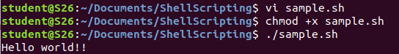

**Syntax:-** $ gedit first.sh

#!/bin/bash

a=10

echo $a

echo "Enter the value"

read value

echo "The entered value is : "

echo $value

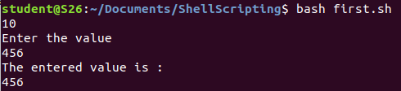

2. **Syntax:-** $ gedit largestoftwonum.sh

echo "Enter the first number "

read num1

echo "Enter the second number "

read num2

if [ $num1 -gt $num2 ]

then

echo $num1" is greatest number."

else

echo $num2" is greatest number."

fi

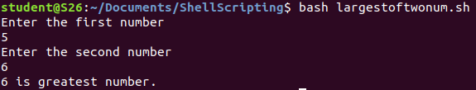

3.**Syntax:-**  $ gedit addtwonumbers.sh

#!/bin/bash

echo "Enter the first number "

read num1

echo "Enter the second number "

read num2

sum=$(($num1+$num2))

echo "The sum of" $num1 "and" $num2 "is : "$sum

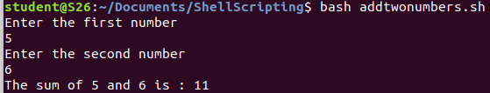

4. **Syntax:-** $ gedit evenandodd.sh

echo "Enter a number : "

read num

if [ $((num % 2)) -eq 0 ]

then

echo $num" is even"

else

echo $num" is odd"

fi

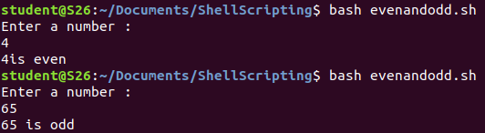

5. **Syntax:-** $ gedit largestoftwonum.sh

echo "Enter the first number "

read num1

echo "Enter the second number "

read num2

echo "Enter the third number "

read num3

if [ $num1 -gt $num2 -a $num1 -gt $num3 ]

then

echo $num1" is greatest number"

elif [ $num2 -gt $num1 -a $num2 -gt $num3 ]

then

echo $num2" is greatest number"

else

echo $num3" is greatest number"

fi

