Final Year Project Report
Full Unit – Final Report

AI MAZE GAME USING IMAGE PROCESSING WITH A* PATHFINDING AND DFS ALGORITHM FOR MAZE GENERATION
Jessada Khaoseengam

A report submitted in part fulfilment of the degree of
BSc (Hons) in Computer Science
Supervisor: Matteo Sammartino

Department of Computer Science
Royal Holloway, University of London

Declaration
This report has been prepared on the basis of my own work. Where other published and unpublished source materials have been used, these have been acknowledged.

Word Count:

Student Name: Jessada Khaoseengam

Date of Submission:

Signature:
Table of Contents
Abstract 4
Chapter 1: Introduction 5
1.1 Aims and Objectives of the Project 5
1.2 Planning and Timescale 5
Chapter 2: Survey of Related Information 7
2.1 Methods of Maze Generations 7
2.2 Methods of Maze Solving 7
2.3 Choice of Programming Language 7
2.4 Time Complexity 7
2.5 User Interface 7
Chapter 3: Software Engineering 8
3.1 Testing 8
3.2 Code Technical Explanation 8
Chapter 4: Appendix 9
4.1 Acronyms 9
4.2 Glossary 9
4.3 Diary 9
Chapter 5: Bibliography 11

Abstract
In the era of rapid technological advancements, the fusion of image processing (IP) and artificial intelligence (AI) has opened new horizons for interactive gaming experiences. This project presents the development of a maze game that utilizes AI algorithms – the A* algorithm for real-time pathfinding and Depth First Search (DFS) algorithm for random maze generation. For current two-dimensional maze games, pre-generated stages are used as the main driver for gameplay which provides a limited content experience for the player and inhibits replayability. The player would then find themselves repeating the same stages, eventually finding the game mundane. A way to resolve this issue is to generate a series of random stages as they progress ensuring that no new level is the same [3] . To provide endless gameplay potential, a choice of three maze generation algorithms: Depth-first search, recursive division algorithm (RDA) and Prim’s can be considered to fulfill this objective. As the game is ran on a two-dimensional grid of limited size, DFS is the most suitable algorithm to pair with the A* pathfinding algorithm as it can produce the maximal path lengths compared to the other algorithms [1] it also works seamlessly with two-dimensional grid applications which is helpful when developing on an Python platform. With the use of DFS, procedurally generated mazes are truly random and can offer unique mazes for the player to solve.
The main objective of this project is to produce an engaging and easy to play experience where players can navigate through a series of randomly generated mazes whilst racing against the clock with the limited option for AI assistance when stuck on a stage. To achieve this, the application of the A* algorithm is used to calculate the shortest path from start to finish upon command, in real time. Since the game will be operating on a finite graph, the A* algorithm executes by managing two scoring mechanisms where one represents the score for reaching a node on a current route and another heuristic score for selecting the next node to visit [2]. This mode of operation ensures efficiency as with each iteration a path to the final node is established. This aspect is an essential driver for gameplay features. The player is tasked to complete as many stages as they can before the timer runs out. With each completed stage the timer is renewed, and the cycle of gameplay is repeated until the timer runs out. To allow greater playability and intrigue, a score of how many stages the player passed will be recorded where they aim to beat their highest score on their future plays encouraging further attempts to beat their high score[5]. The game also offers another feature allowing the player to create their own mazes on paper where the image processing feature of the game will map the maze, allowing the pathfinding algorithm to solve it.
The fundamental element in developing the image processing feature of the game is the use of OpenCV in conjunction with VS Code IDE using Python for core game elements. IP is used to map the custom maze the player creates where image and edge detection will plot the walls of the maze and place start/finish nodes allowing the pathfinding algorithm to process. Since capturing an image may not always be perfect, IP techniques can manipulate the image to reduce noise such as Gaussian blur [4] and Image histograms for wall detection to ensure the maze is suitable for mapping and applying the pathfinding algorithm. This aspect of the game will be the next focus after developing the base game.

Introduction

Aims and Objectives of the Project
The Project’s main purpose is to create an interactive maze puzzle game applying various techniques of artificial intelligence to enable assistive capability while producing an efficient maze generator to maximise user engagement.
The first step to accomplishing this goal is to establish a user interface (UI) where the user can interact with the game providing visual feedback. It will consist of a start, solve, and quit buttons contained within a small window where the game will run. When selecting play the user will initiate the main game where they must reach the end waypoint objective whilst navigating through the maze. Upon completion they will progress onto the next stage with a slightly more complex maze structure. For every completion the maze generator will produce larger and more complex mazes. The user must locate the objective before time runs out which replenishes with each completed stage. If the timer runs out the score of every completed stage is recorded and the game will prompt the user to play again or return to the main menu.
The solve button launches the IP aspects of the program where they are prompted to present a premade maze to their webcam/camera in which the pathfinding algorithm will display a path highlighting the solution from start to finish.

Planning and Timescale
During term one I will primarily concentrate on establishing the foundations of the game and implementing the various AI algorithms. In term two I can then focus on adding the image processing feature and further cleanup code. Shown below is a Unified Modeling Language (UML) diagram which blueprints the basic overview of the structure of the code that is developed in term 1. 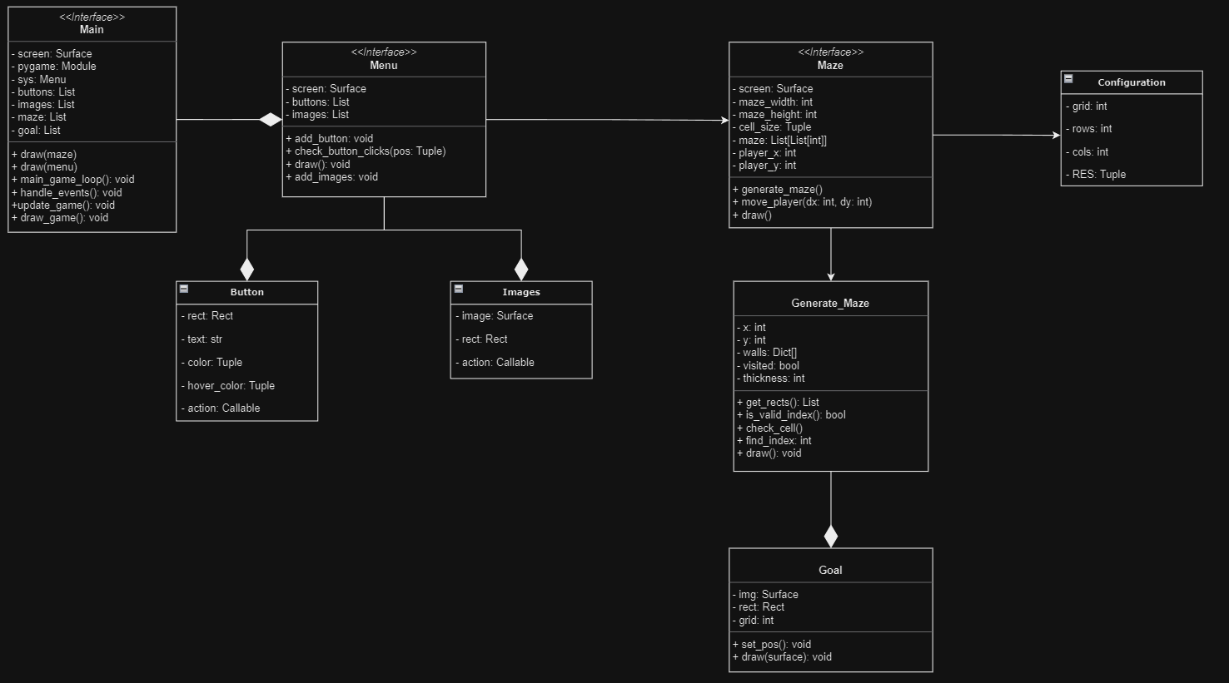
figure 1. Initial UML plan

Term 1
Week 2 | Research required software and tools  Find the resources necessary to build base game
Week 3 | Research necessary algorithms  Understand how they work and how to apply to code
Week 4 | Implement foundational app structure  Start coding base game creating basic UI and simple stage
Week 5-6 | Generate basic maze stages for user playability  Use AI to generate more sophisticated stages
Week 7-8 | Apply pathfinding algorithm to maze and test  Start trialing AI and test playability and function for the player
Week 9 | Research Image processing features  Understand and learn OpenCV, its features and how it integrates in game
Week 10 | Optimize game  Fix any prominent issues and ensure smooth functionality
Week 11 | Work on presentation and interim report

Term 2
Week 1-2 | Develop image processing feature structure  Apply basic structure for IP to game and ensure compatibility with game
Week 3-4 | Implement and test mazes using image processing feature  Use webcam to test limitations of different mazes in various positions
Week 5-6 | Merge Image processing features to base game  Implement pathfinding code to mapped image
Week 7-8 | Test playability and bugfix
Week 9 | Refine UI and cleanup code
Week 10 | Evaluate game as whole  Ensure seamless gameplay and optimal performance
Week 11 | Final report preparation

Survey of Related Information

Methods of Maze Generations

Methods of Maze Solving

Choice of Programming Language
Since the program is a game, I needed to find the most suitable language and framework for 2D-based objects and fulfilment to my objectives. The options were C++, C#, Java, Python and Lua. Python with the Pygame library was the optimal choice as other options like C# using Unity are more focused on resource intensive 3D games which does not meet the requirements to achieve my goals.

Time Complexity

User Interface
Employing a theme of futuristic sci-fi elements was the decisive factor between fantasy or noir as it would complement a modern and simplistic interface allowing better user interaction. With this theme I can use a variety of colour to spark intrigue. I chose a darker monotone background which.
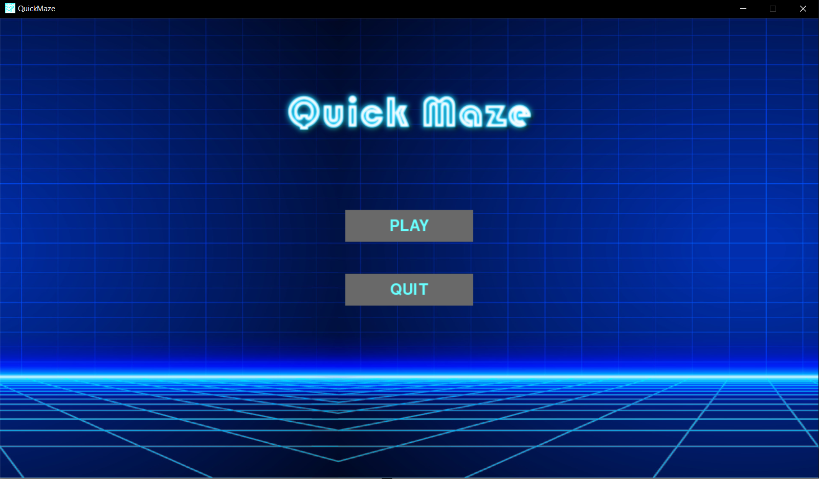
figure 2. Current start menu

Software Engineering

Testing

Code Technical Explanation

Appendix

Acronyms
AI Artificial Intelligence
IP Image Processing
UI User Interface
DFS Depth First Search
RDA Recursive Division Algorithm
IDE Integrated development environment
AR Augmented Reality
UML Unified Modelling Language

Glossary
OpenCV Open-source computer vision, machine learning library for vision-based tasks
Python High level programming language used in various fields
VS Code IDE with versatile features and python support via extensions
GitLab Web based version control platform to manage source code
UML Model A visual representation of system architecture and design

Diary

October 20th
After researching the ideal platform and programming language to be used, I decided that python used on visual studio code would work suitably for the specification I had planned. By using the pygame module I can create a basic UI as a starting base point. Using the pygame module will allow me to create the start menu of the game and include buttons used to launch the game.

October 24th
After creating a new interface, I implemented some functionality to the game by adding a play and quit button and then started research into implementing the maze feature to the game. I must now think about the code structure and as to how to implement the actual game to the main menu when play is pressed.

October 29th
I completely restructured my code making it more object oriented. By creating object instances of menu elements and buttons I can just reuse the same screen and draw the necessary elements required making the program more efficient but at the cost of restructuring and reformatting the code to make it runnable

November 3rd
I improved the visual aesthetic of the main menu to fulfil the goal of user engagement at an early stage. I also amended the maze generation algorithm to scale correctly on the screen allowing more space for other UI elements like score, exit button and stage information indicators.

November 11th
I began developing player controls allowing navigation around the maze and establishing collider boxes which can enclose the player within the walls.

Bibliography

[1] A. Kozlova, J. A. Brown and E. Reading, "Examination of representational expression in maze generation algorithms," 2015 IEEE Conference on Computational Intelligence and Games (CIG), Tainan, Taiwan, 2015, pp. 532-533, https://doi.org/10.1109/CIG.2015.7317902

[2] E. R. Firmansyah, S. U. Masruroh and F. Fahrianto, "Comparative Analysis of A* and Basic Theta* Algorithm in Android-Based Pathfinding Games," 2016 6th International Conference on Information and Communication Technology for The Muslim World (ICT4M), Jakarta, Indonesia, 2016, pp. 275-280, https://doi.org/10.1109/ICT4M.2016.063

[3] P. H. Kim and R. Crawfis, "The quest for the perfect perfect-maze," 2015 Computer Games: AI, Animation, Mobile, Multimedia, Educational and Serious Games (CGAMES), Louisville, KY, USA, 2015, pp. 65-72, https://doi.org/10.1109/CGames.2015.7272964

[4] R. S. Deepthi and S. Sankaraiah, "Implementation of mobile platform using Qt and OpenCV for image processing applications," 2011 IEEE Conference on Open Systems, Langkawi, Malaysia, 2011, pp. 284-289, https://doi.org/10.1109/ICOS.2011.6079235

[5] Buday R, Baranowski T, Thompson D. Fun and Games and Boredom. Games Health J. 2012 Aug;1(4):257-261. https://doi.org/10.1089/g4h.2012.0026

