BST650_Reg_Assign1

Nina Dyatchenko

November 11, 2018

wcgs_df <- read.csv("C:/Users/Nina/Desktop/SASUniversityEdition/myfolders/EPH703 Tulay/wcgs.csv", header = TRUE, stringsAsFactors = FALSE)  
plot(  
 x = wcgs_df$dbp,  
 y = wcgs_df$sbp,  
 xlab = "Diastolic Blood Pressure (mmHg)",  
 ylab = "Systolic Blood Pressure (mmHg)"  
)

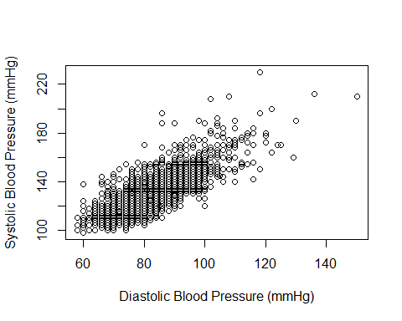

lm(sbp ~ dbp, data = wcgs_df)

##   
## Call:  
## lm(formula = sbp ~ dbp, data = wcgs_df)  
##   
## Coefficients:  
## (Intercept) dbp   
## 30.110 1.201

Write a function which takes in any two numeric vectors (x and y) and returns a named vector of the slope and intercept of the linear model $\overset{^}{y}=β_{0}+β_{1}x$. Your function should use formulas (from your other classes) to calculate these estimates directly (that is, without a call to the lm() or any other modelling function in R).

vectors <- function(x, y) {  
 SSxy <- sum( (x-mean(x)) * (y-mean(y)) )  
 SSxx <- sum( (x-mean(x))^2 )  
 slope <- SSxy/SSxx  
 inter <- mean(y) - slope * mean(x)  
 return(list(intercept=inter, slope=slope))  
}  
  
x <- c(3, 3, 5, 7)  
y <- c(9, 4, 6, 8)  
  
vectors(x, y)

## $intercept  
## [1] 5.318182  
##   
## $slope  
## [1] 0.3181818

Test om wcgs_df.

vectors(x = wcgs_df$dbp, y = wcgs_df$sbp)

## $intercept  
## [1] 30.1102  
##   
## $slope  
## [1] 1.201268