R Assignment 4

Nina Dyatchenko

September 12th, 2018

## Assignment 4: Due Sunday, 16 September at 23:59PM

*For help with Rmarkdown for reports, see this* [*white paper*](http://www.stat.cmu.edu/~cshalizi/rmarkdown/#math-in-r-markdown) *from Carnegie Mellon University’s Department of Statistics and Data Science.*

For each the seven statistical distributions we covered in the last assignment (Normal, Student’s , , , Binomial, Negative Binomial, and Poisson),

### 1. Generate and store a random vector of 10,000 observations, using the same parameters as the last homework:

i. $N(\mu = 2, \sigma ^ 2 = 5 )$,

set.seed(1)  
xNorm_n10000 <- rnorm(n=10000, mean=2, sd = sqrt(5))

ii. $t_{\nu = 4}$,

set.seed(2)  
xrt_n10000 <- rt(n=10000, df=4)

iii. $\chi^2_{\nu = 2}$,

set.seed(3)  
xChi_n10000<- rchisq(n=10000, df=2, ncp=0)

iv. $F_{n = 90,\ m = 12}$,

set.seed(4)  
xFd_n10000<- rf(n=10000, df1=90, df2=12)

v. $Bin(n = 9, p = 2/3)$,

set.seed(5)  
xBD_n10000 <- rbinom(n=10000, size=9, prob=2/3)

vi. $NBin(n = 5, p = 1/2)$, and

set.seed(6)  
xNB_n10000 <- rnbinom(n = 10000, size = 5, prob = 0.5)

vii. $Pois(\lambda = 3)$.

set.seed(7)  
xP_n10000 <- rpois(n=10000, 3)

### 2. Subset the first values from the vector, and of this subset

i. calculate the 5-Number Summary,  
ii. plot the histogram of the subset, and  
iii. plot the estimated density of this subset. (Density assumes as normal).

Normal:

NormSubs6<- xNorm_n10000[1:6]  
summary(NormSubs6)

## Min. 1st Qu. Median Mean 3rd Qu. Max.   
## 0.1315 0.2738 1.5049 1.9351 2.6553 5.5672

hist(NormSubs6)

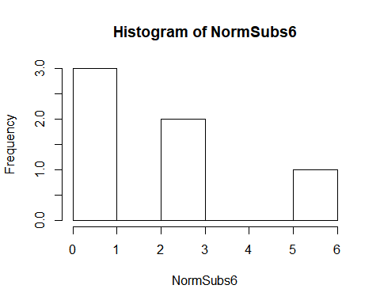

plot(density(NormSubs6))

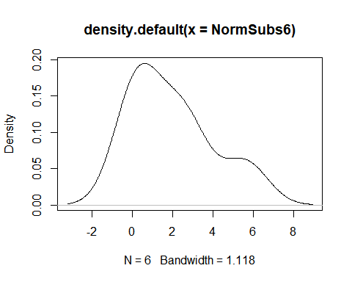

Student’s :

TSubs6<- xrt_n10000[1:6]  
summary(TSubs6)

## Min. 1st Qu. Median Mean 3rd Qu. Max.   
## -0.96300 -0.14891 0.03367 0.61769 1.06361 3.40464

hist(TSubs6)

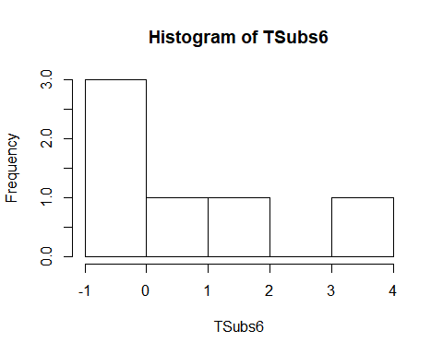

plot(density(TSubs6))

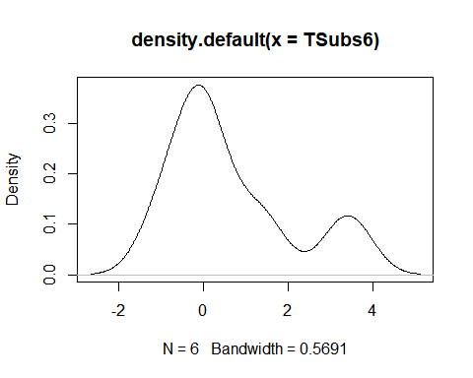

(Not normal)

ChiSubs6<- xChi_n10000[1:6]  
summary(ChiSubs6)

## Min. 1st Qu. Median Mean 3rd Qu. Max.   
## 0.03434 0.19385 0.74322 0.72766 1.16498 1.52891

hist(ChiSubs6)

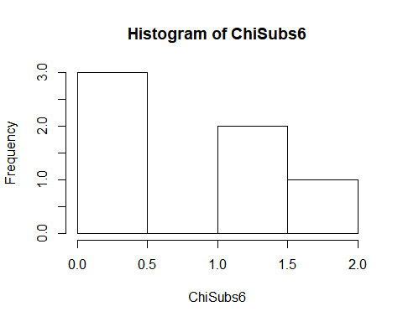

plot(density(ChiSubs6))

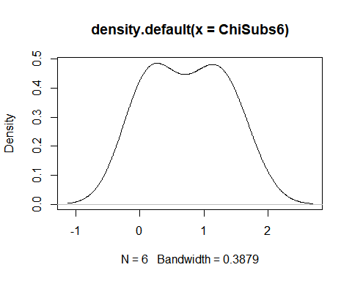

-Distribution

FSubs6<- xFd_n10000[1:6]  
summary(FSubs6)

## Min. 1st Qu. Median Mean 3rd Qu. Max.   
## 0.5374 0.7094 1.1642 1.1845 1.3596 2.2585

hist(FSubs6)

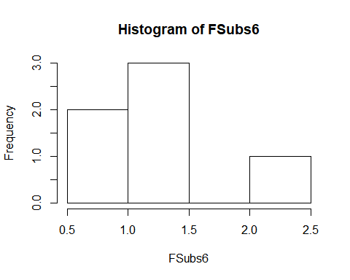

plot(density(FSubs6))

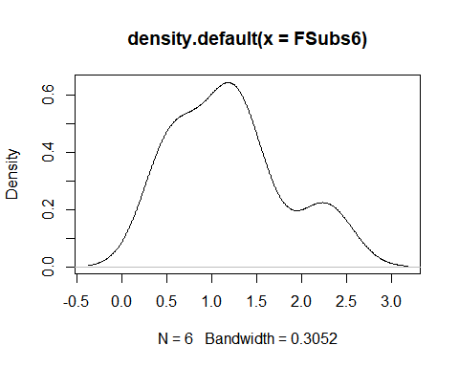

Binomial

BDSubs6<- xBD_n10000[1:6]  
summary(BDSubs6)

## Min. 1st Qu. Median Mean 3rd Qu. Max.   
## 4 5 6 6 7 8

hist(BDSubs6)

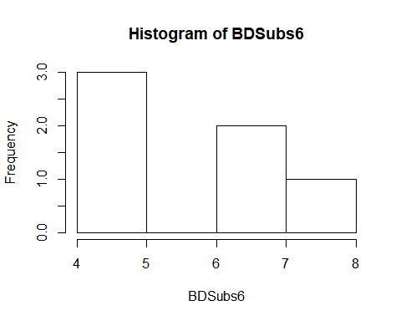

plot(density(BDSubs6))

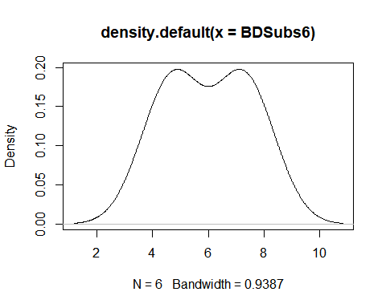

Negative binomial

NegSubs6<- xNB_n10000[1:6]  
summary(NegSubs6)

## Min. 1st Qu. Median Mean 3rd Qu. Max.   
## 2.00 3.00 3.50 4.50 6.25 8.00

hist(NegSubs6)

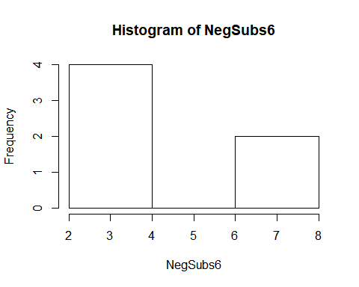

plot(density(NegSubs6))

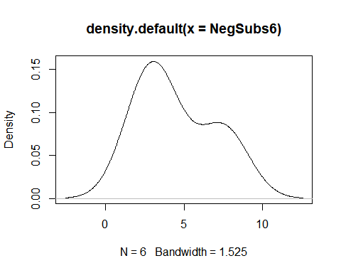

Poisson

PoisSubs6<- xP_n10000[1:6]  
summary(PoisSubs6)

## Min. 1st Qu. Median Mean 3rd Qu. Max.   
## 1.00 1.25 2.00 3.00 3.50 8.00

hist(PoisSubs6)

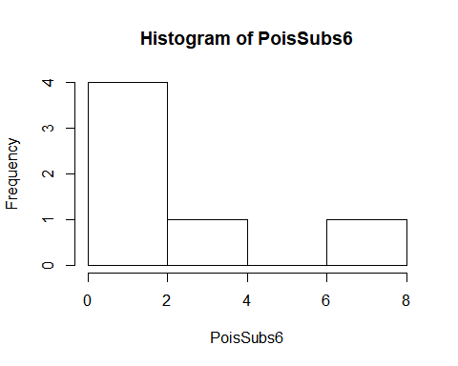

plot(density(PoisSubs6))

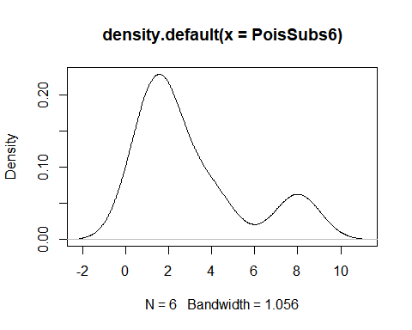

### 3. Repeat Item 2 for the first values from the random vector you generated in Item 1. Remark on the changing behaviour as the sample size increases.

Normal: as sample size increases, Normal distribution approaches Gaussian shape centered at the mean ():

NormSubs10<- xNorm_n10000[1:10]  
summary(NormSubs10)

## Min. 1st Qu. Median Mean 3rd Qu. Max.   
## 0.1315 0.7787 2.5737 2.2956 3.2381 5.5672

hist(NormSubs10)

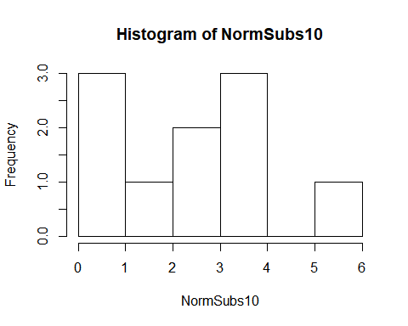

plot(density(NormSubs10))

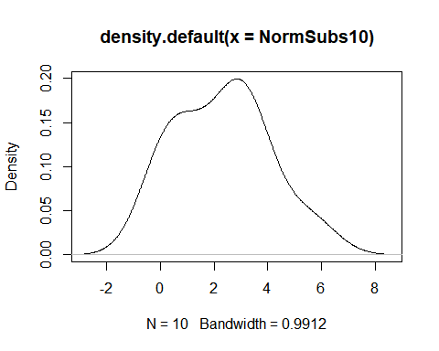

NormSubs20<- xNorm_n10000[1:20]  
summary(NormSubs20)

## Min. 1st Qu. Median Mean 3rd Qu. Max.   
## -2.952 1.141 2.804 2.426 3.697 5.567

hist(NormSubs20)

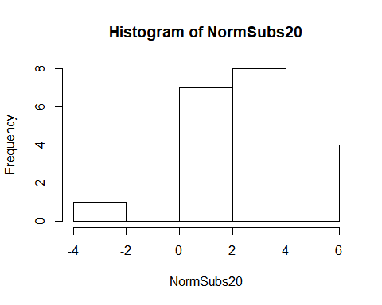

plot(density(NormSubs20))

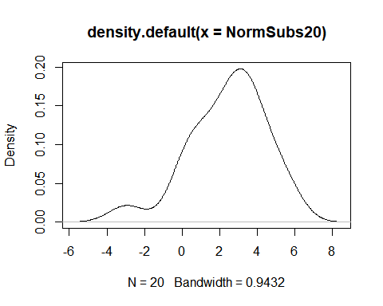

NormSubs30<- xNorm_n10000[1:30]  
summary(NormSubs30)

## Min. 1st Qu. Median Mean 3rd Qu. Max.   
## -2.952 1.027 2.574 2.184 3.585 5.567

hist(NormSubs30)

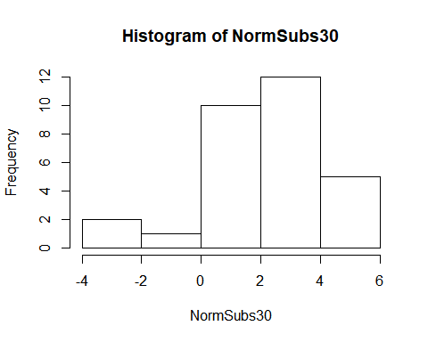

plot(density(NormSubs30))

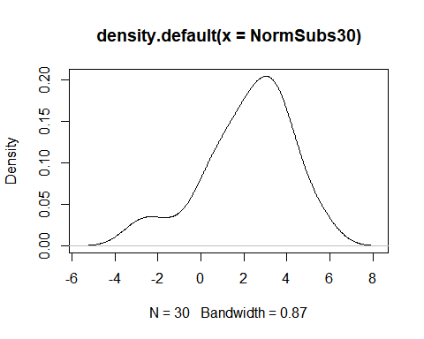

NormSubs50<- xNorm_n10000[1:50]  
summary(NormSubs50)

## Min. 1st Qu. Median Mean 3rd Qu. Max.   
## -2.952 1.168 2.289 2.225 3.628 5.567

hist(NormSubs50)

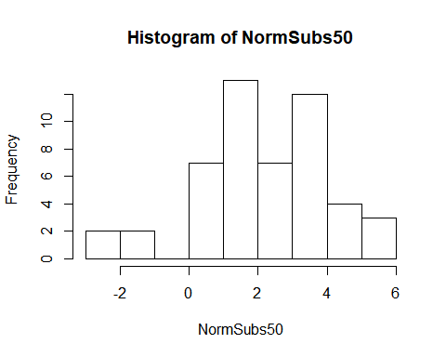

plot(density(NormSubs50))

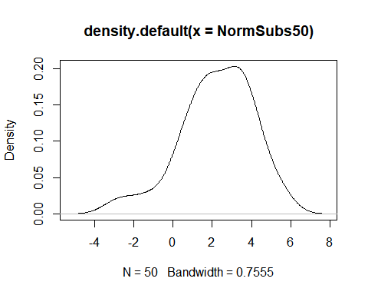

Student’s : as sample size increases, the distribution shapes up as normal around mean ():

TSubs10<- xrt_n10000[1:10]  
summary(TSubs10)

## Min. 1st Qu. Median Mean 3rd Qu. Max.   
## -0.9630 -0.1489 0.5992 0.9656 1.2625 4.7326

hist(TSubs10)

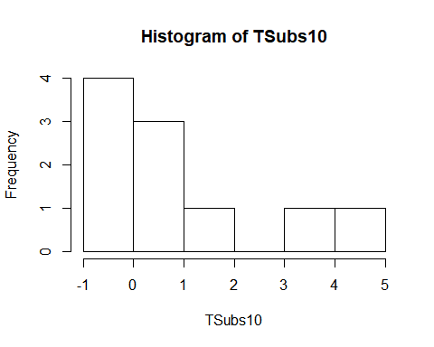

plot(density(TSubs10))

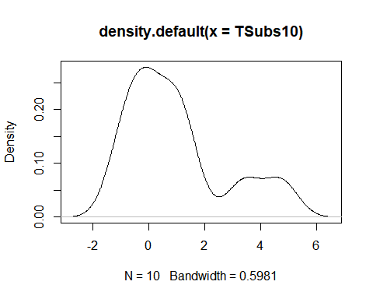

var(TSubs10)

## [1] 3.343344

TSubs20<- xrt_n10000[1:20]  
summary(TSubs20)

## Min. 1st Qu. Median Mean 3rd Qu. Max.   
## -2.3694 -0.5698 0.2301 0.4317 1.0323 4.7326

hist(TSubs20)

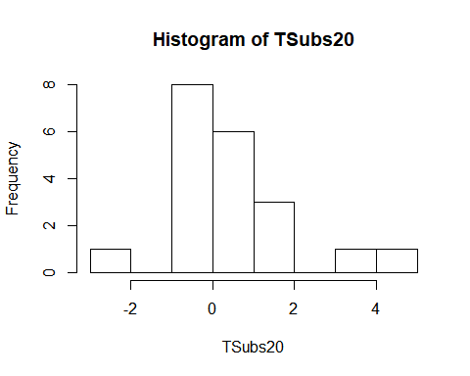

plot(density(TSubs20))

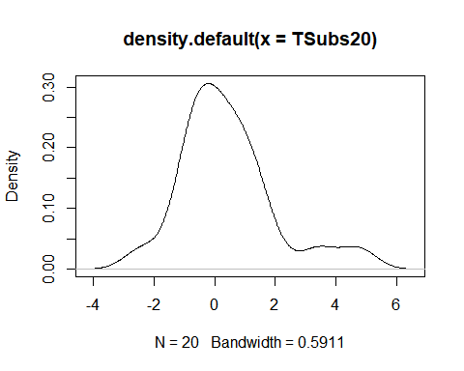

var(TSubs20)

## [1] 2.523075

TSubs30<- xrt_n10000[1:30]  
summary(TSubs30)

## Min. 1st Qu. Median Mean 3rd Qu. Max.   
## -2.36936 -0.66960 0.03367 0.29728 1.09720 4.73264

hist(TSubs30)

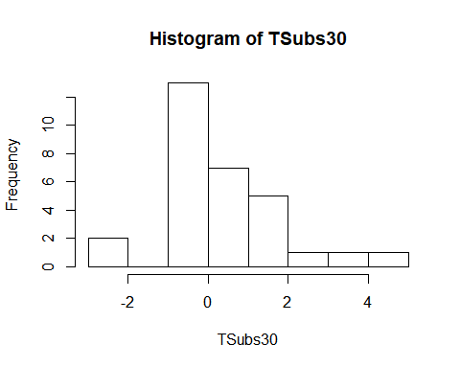

plot(density(TSubs30))

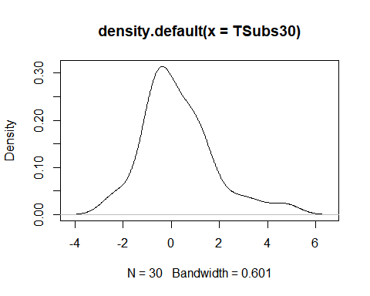

var(TSubs30)

## [1] 2.245901

TSubs50<- xrt_n10000[1:50]  
summary(TSubs50)

## Min. 1st Qu. Median Mean 3rd Qu. Max.   
## -2.3694 -0.5108 0.2383 0.4470 1.3048 4.7326

hist(TSubs50)

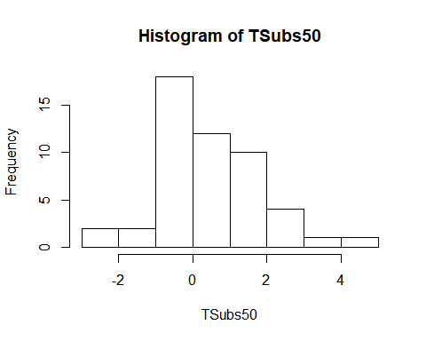

plot(density(TSubs50))

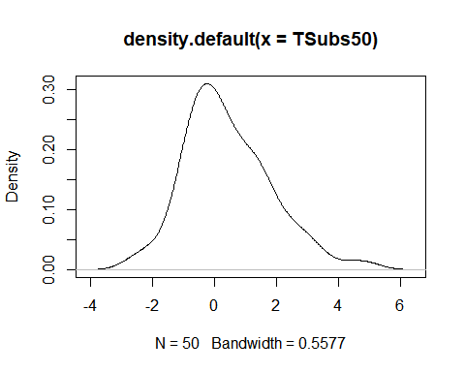

var(TSubs50)

## [1] 1.95557

: as sample size increases, the skeweness of the grapth is more accurtely defined.

ChiSubs10<- xChi_n10000[1:10]  
ChiSubs20<- xChi_n10000[1:20]  
ChiSubs30<- xChi_n10000[1:30]  
ChiSubs50<- xChi_n10000[1:50]  
  
summary(ChiSubs10)

## Min. 1st Qu. Median Mean 3rd Qu. Max.   
## 0.03434 0.37583 1.11595 1.51670 1.80707 5.75437

summary(ChiSubs20)

## Min. 1st Qu. Median Mean 3rd Qu. Max.   
## 0.03434 0.30987 0.53186 1.23980 1.62163 5.75437

summary(ChiSubs30)

## Min. 1st Qu. Median Mean 3rd Qu. Max.   
## 0.03434 0.34600 1.10074 1.51396 2.28392 5.75437

summary(ChiSubs50)

## Min. 1st Qu. Median Mean 3rd Qu. Max.   
## 0.03434 0.43565 1.19880 1.55241 2.33072 5.75437

hist(ChiSubs10)

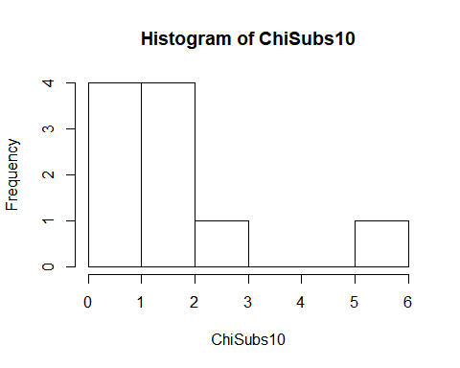

hist(ChiSubs20)

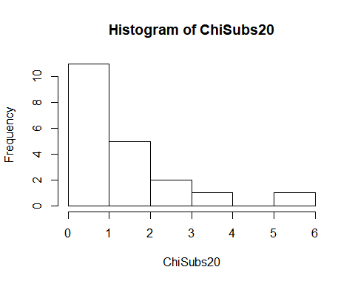

hist(ChiSubs30)

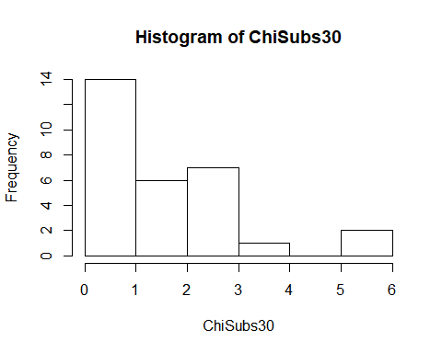

hist(ChiSubs50)

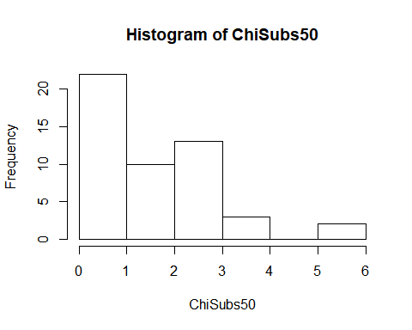

plot(density(ChiSubs10))

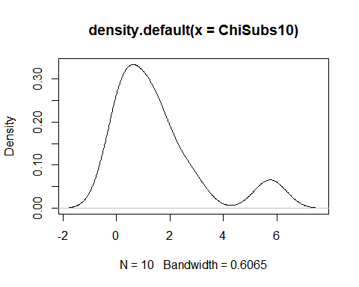

plot(density(ChiSubs20))

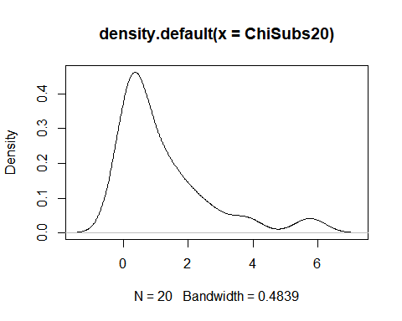

plot(density(ChiSubs30))

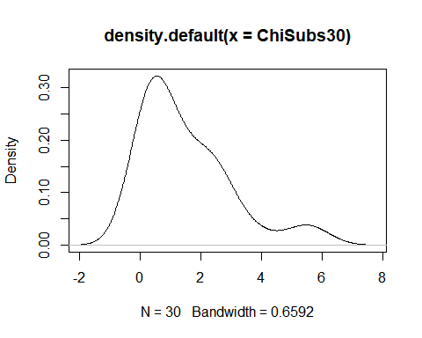

plot(density(ChiSubs50))

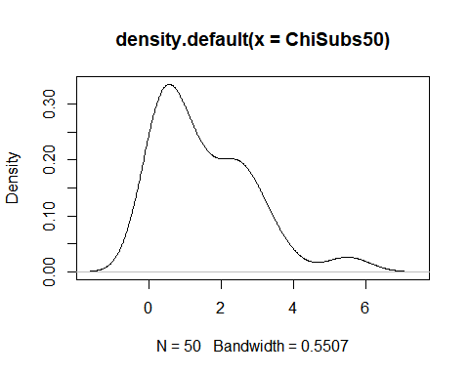

var(ChiSubs10)

## [1] 2.974062

var(ChiSubs20)

## [1] 2.152357

var(ChiSubs30)

## [1] 2.211067

var(ChiSubs50)

## [1] 1.790028

-Distribution: as sample size increases, it is still difficult to recognize if it is a normal or skewed distribution.

FSubs10<- xFd_n10000[1:10]  
summary(FSubs10)

## Min. 1st Qu. Median Mean 3rd Qu. Max.   
## 0.5374 0.7006 1.0532 1.1032 1.3596 2.2585

hist(FSubs10)

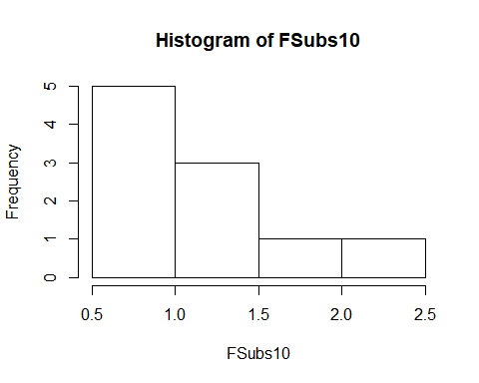

plot(density(FSubs10))

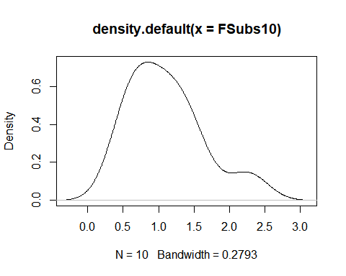

FSubs20<- xFd_n10000[1:20]  
summary(FSubs20)

## Min. 1st Qu. Median Mean 3rd Qu. Max.   
## 0.4773 0.6777 1.1642 1.1271 1.3709 2.2585

hist(FSubs20)

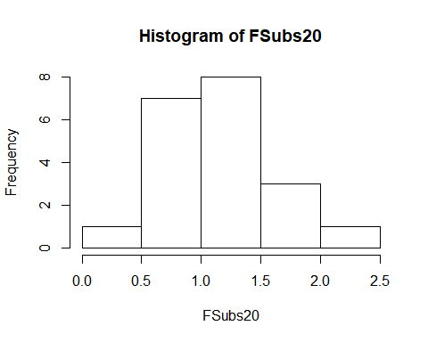

plot(density(FSubs20))

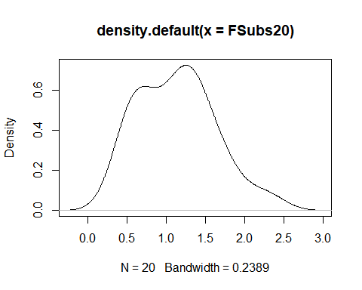

FSubs30<- xFd_n10000[1:30]  
summary(FSubs30)

## Min. 1st Qu. Median Mean 3rd Qu. Max.   
## 0.4773 0.7089 1.1642 1.1179 1.3487 2.2585

hist(FSubs30)

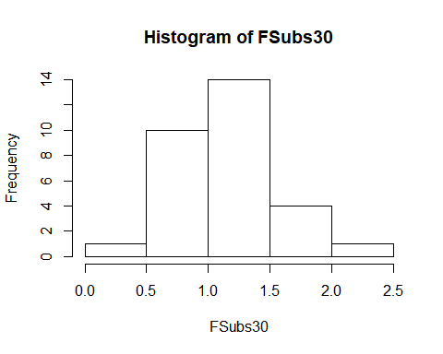

plot(density(FSubs30))

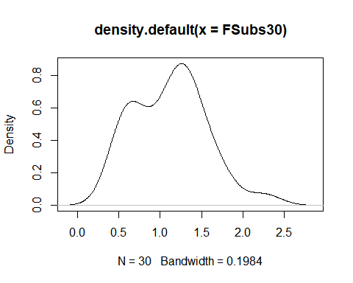

FSubs50<- xFd_n10000[1:50]  
summary(FSubs50)

## Min. 1st Qu. Median Mean 3rd Qu. Max.   
## 0.4562 0.6985 1.1751 1.1669 1.4245 2.9828

hist(FSubs50)

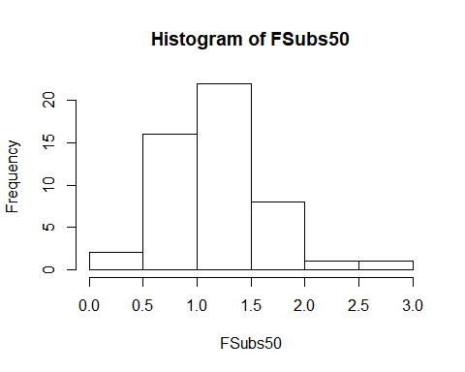

plot(density(FSubs50))

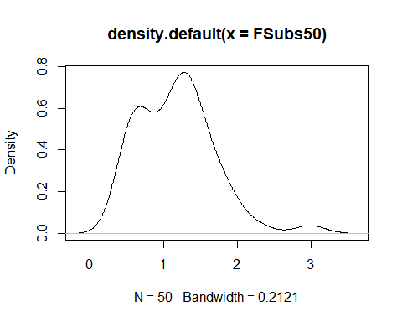

var(FSubs10)

## [1] 0.2821754

var(FSubs20)

## [1] 0.2335248

var(FSubs30)

## [1] 0.189363

var(FSubs50)

## [1] 0.2654681

Binomial: as sample size increases, the distribution becoming look normal.

BDSubs10<- xBD_n10000[1:10]  
summary(BDSubs10)

## Min. 1st Qu. Median Mean 3rd Qu. Max.   
## 4.0 5.0 5.5 5.9 7.0 8.0

hist(BDSubs10)

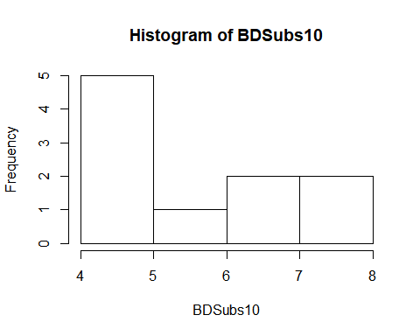

plot(density(BDSubs10))

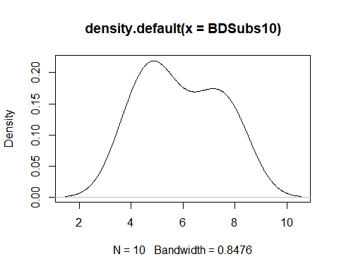

BDSubs20<- xBD_n10000[1:20]  
summary(BDSubs20)

## Min. 1st Qu. Median Mean 3rd Qu. Max.   
## 4 5 6 6 7 8

hist(BDSubs20)

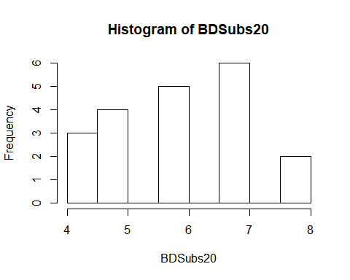

plot(density(BDSubs20))

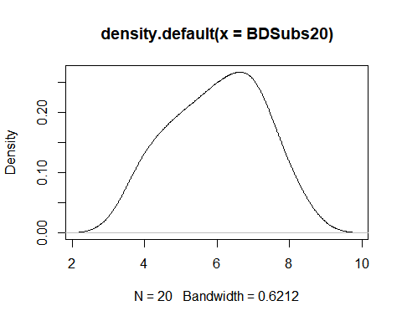

BDSubs30<- xBD_n10000[1:30]  
summary(BDSubs30)

## Min. 1st Qu. Median Mean 3rd Qu. Max.   
## 3.000 5.000 6.000 5.933 7.000 8.000

hist(BDSubs30)

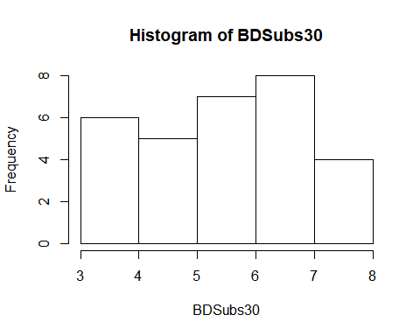

plot(density(BDSubs30))

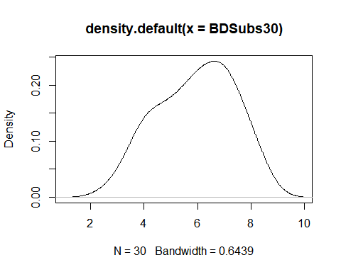

BDSubs50<- xBD_n10000[1:50]  
summary(BDSubs50)

## Min. 1st Qu. Median Mean 3rd Qu. Max.   
## 3.00 5.00 6.00 6.06 7.00 9.00

hist(BDSubs50)

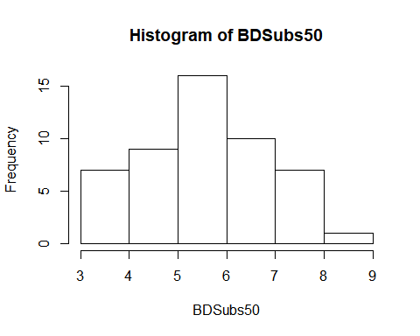

plot(density(BDSubs50))

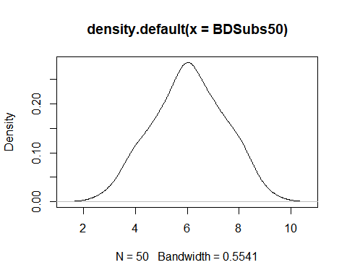

var(BDSubs10)

## [1] 2.322222

var(BDSubs20)

## [1] 1.578947

var(BDSubs30)

## [1] 1.995402

var(BDSubs50)

## [1] 1.812653

Negative binomial: as sample soze increases, the plot becomes more skewed.

NegSubs10<- xNB_n10000[1:10]  
NegSubs20<- xNB_n10000[1:20]  
NegSubs30<- xNB_n10000[1:30]  
NegSubs50<- xNB_n10000[1:50]  
  
summary(NegSubs10)

## Min. 1st Qu. Median Mean 3rd Qu. Max.   
## 2.0 3.0 4.5 5.0 7.0 9.0

summary(NegSubs20)

## Min. 1st Qu. Median Mean 3rd Qu. Max.   
## 2.00 3.00 5.50 6.20 8.25 15.00

summary(NegSubs30)

## Min. 1st Qu. Median Mean 3rd Qu. Max.   
## 2.000 3.250 5.000 5.767 7.000 15.000

summary(NegSubs50)

## Min. 1st Qu. Median Mean 3rd Qu. Max.   
## 0.00 3.00 5.00 5.38 7.00 15.00

hist(NegSubs10)

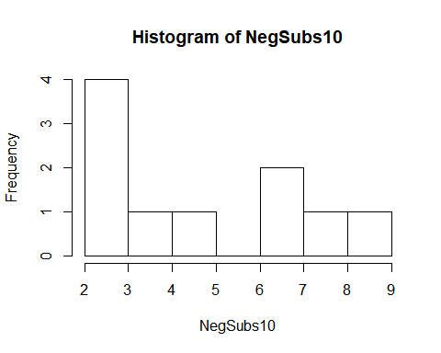

hist(NegSubs20)

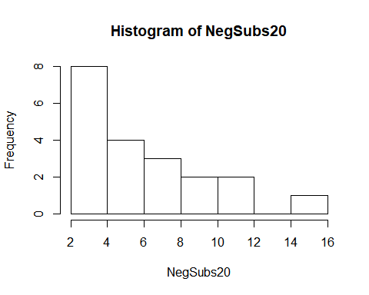

hist(NegSubs30)

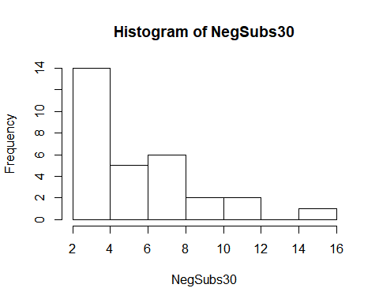

hist(NegSubs50)

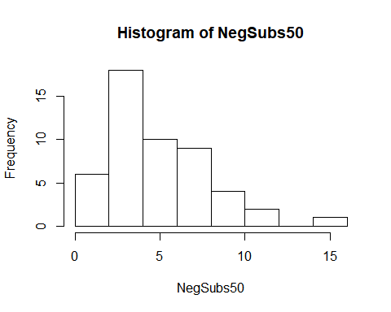

plot(density(NegSubs10))

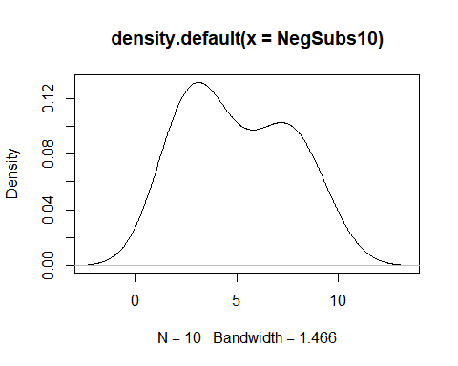

plot(density(NegSubs20))

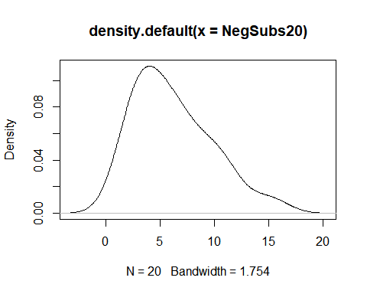

plot(density(NegSubs30))

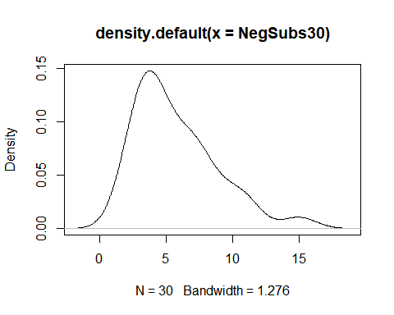

plot(density(NegSubs50))

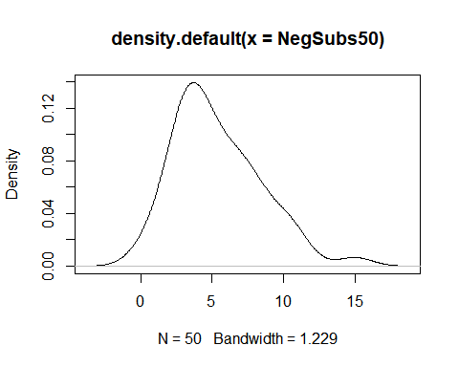

Poisson: as sample size increases, the distribution becomes clearely skewed.

PoisSubs10<- xP_n10000[1:10]  
PoisSubs20<- xP_n10000[1:20]  
PoisSubs30<- xP_n10000[1:30]  
PoisSubs50<- xP_n10000[1:50]  
  
summary(PoisSubs10)

## Min. 1st Qu. Median Mean 3rd Qu. Max.   
## 1.00 1.25 2.00 3.10 3.75 8.00

summary(PoisSubs20)

## Min. 1st Qu. Median Mean 3rd Qu. Max.   
## 0.00 1.00 2.00 2.75 3.25 8.00

summary(PoisSubs30)

## Min. 1st Qu. Median Mean 3rd Qu. Max.   
## 0.000 1.250 2.500 3.267 4.000 9.000

summary(PoisSubs50)

## Min. 1st Qu. Median Mean 3rd Qu. Max.   
## 0.00 2.00 3.00 3.32 4.75 9.00

hist(PoisSubs10)

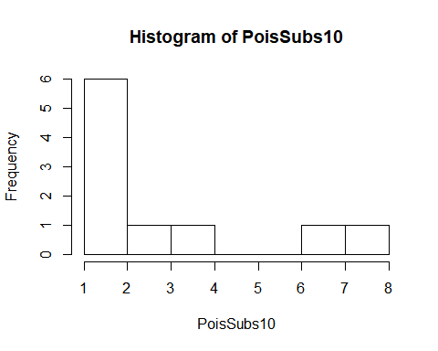

hist(PoisSubs20)

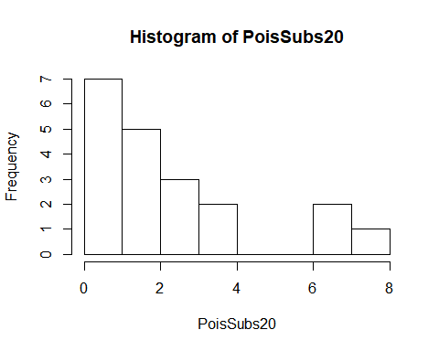

hist(PoisSubs30)

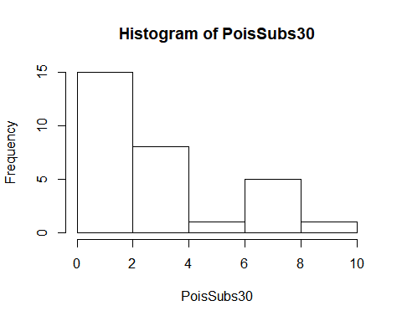

hist(PoisSubs50)

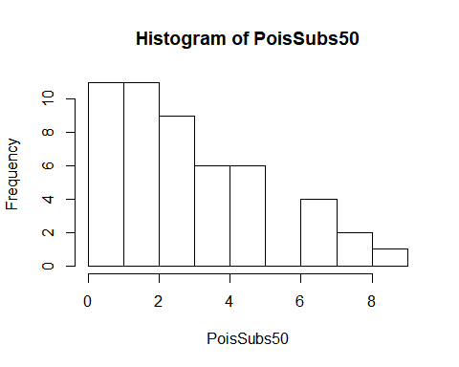

plot(density(PoisSubs10))

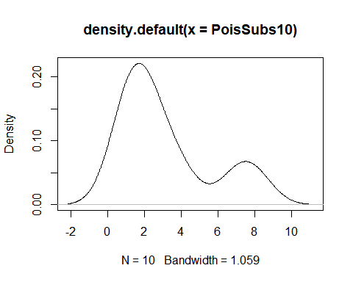

plot(density(PoisSubs20))

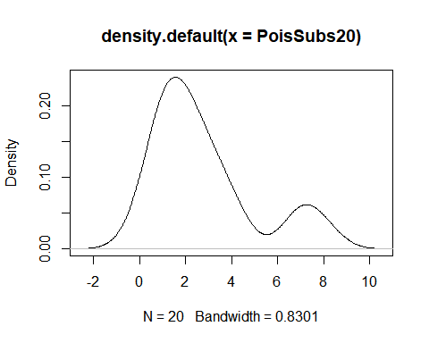

plot(density(PoisSubs30))

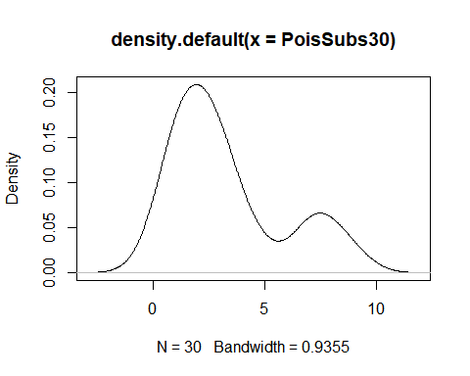

plot(density(PoisSubs50))

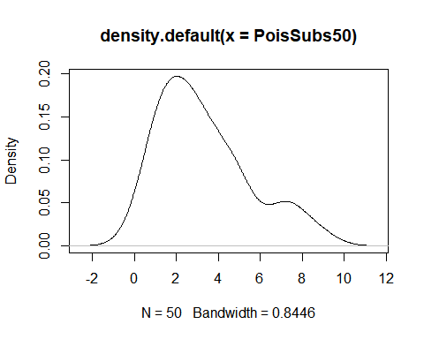

### 4. Repeat Item 2 for the entire vector (). For smaller values of from continuous distributions, which tool do you think gave a better representation of the full data: histogram or density plot? Did this change when you inspected the discrete distributions?

Histogram gives a better representation of a small sample size of continuous distributions. A histogram is best for small sample sizes of the discrete distrebutions. Density function grapth is a bad representation of a samall samples of distributions.

Normal - continuous

summary(xNorm_n10000)

## Min. 1st Qu. Median Mean 3rd Qu. Max.   
## -6.2093 0.4942 1.9644 1.9854 3.5153 10.5200

hist(xNorm_n10000)

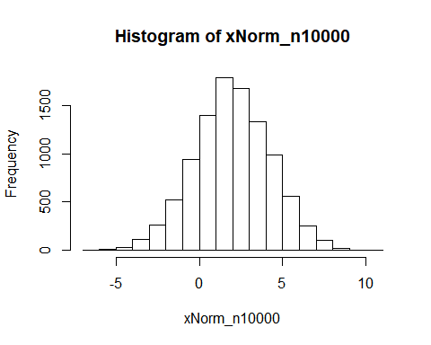

plot(density(xNorm_n10000))

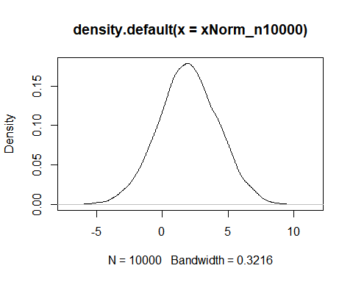

var(xNorm_n10000)

## [1] 5.124328

Student’s continuous

summary(xrt_n10000)

## Min. 1st Qu. Median Mean 3rd Qu. Max.   
## -16.581973 -0.744999 -0.004989 -0.014118 0.742671 13.393131

hist(xrt_n10000)

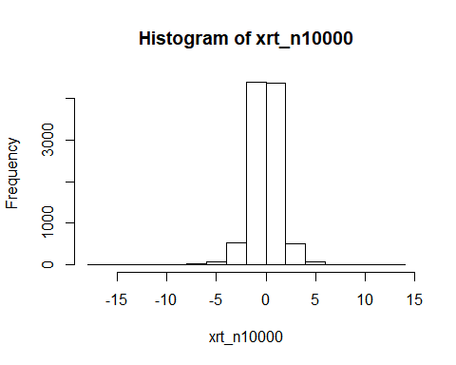

plot(density(xrt_n10000))

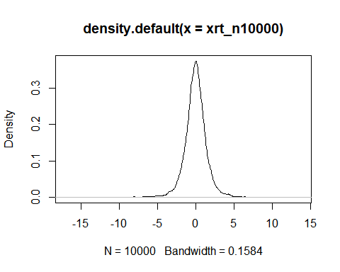

continuous skewed

summary(xChi_n10000)

## Min. 1st Qu. Median Mean 3rd Qu. Max.   
## 0.001041 0.597095 1.416917 2.042354 2.818150 24.146697

hist(xChi_n10000)

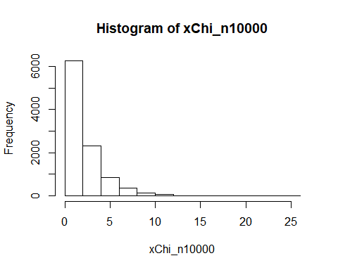

plot(density(xChi_n10000))

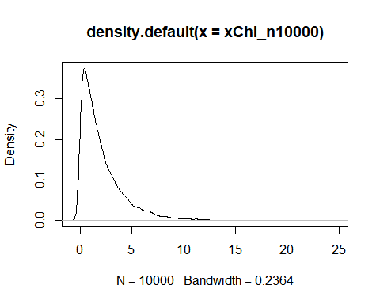

-Distribution - continuous

summary(xFd_n10000)

## Min. 1st Qu. Median Mean 3rd Qu. Max.   
## 0.2492 0.7955 1.0512 1.1985 1.4383 7.3203

hist(xFd_n10000)

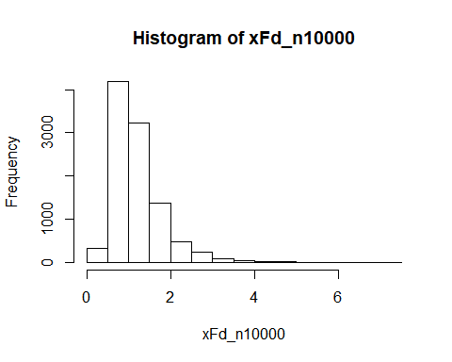

plot(density(xFd_n10000))

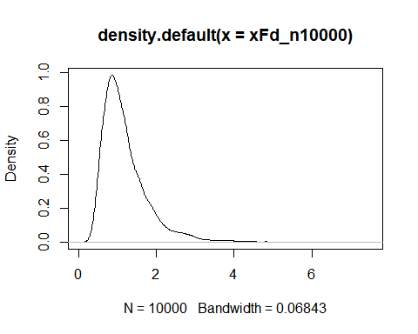

Binomial - discrete

summary(xBD_n10000)

## Min. 1st Qu. Median Mean 3rd Qu. Max.   
## 1.000 5.000 6.000 5.992 7.000 9.000

hist(xBD_n10000)

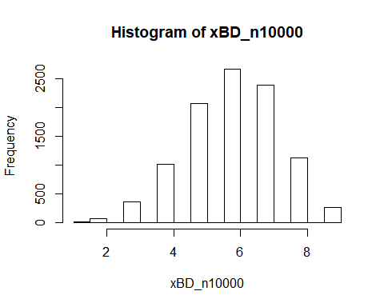

plot(density(xBD_n10000))

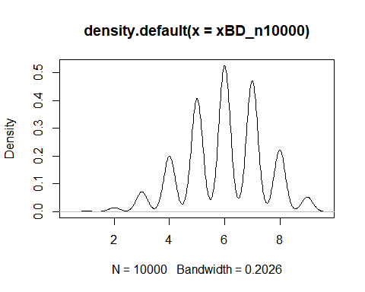

Negative binomial - discrete

summary(xNB_n10000)

## Min. 1st Qu. Median Mean 3rd Qu. Max.   
## 0.000 3.000 5.000 5.036 7.000 25.000

hist(xNB_n10000)

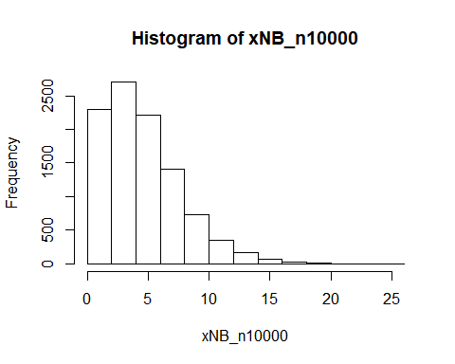

plot(density(xNB_n10000))

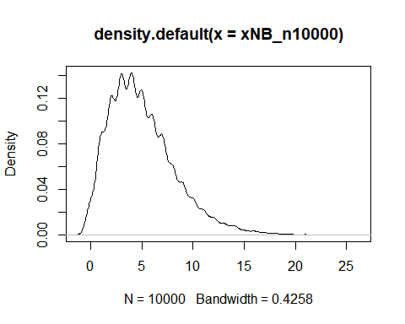

Poisson - discrete

summary(xP_n10000)

## Min. 1st Qu. Median Mean 3rd Qu. Max.   
## 0.000 2.000 3.000 3.008 4.000 12.000

hist(xP_n10000)

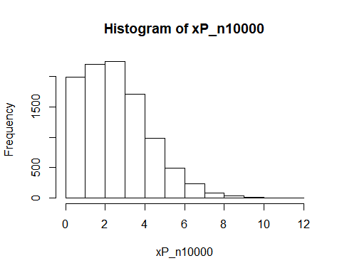

plot(density(xP_n10000))

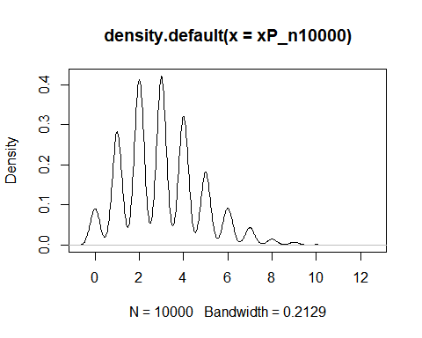

### 5. Contrast the 5-Number Summaries at each of the sample sizes (6, 10, 20, 30, 50, and 10000) for the skewed distributions (Negative binomial, , , Poisson) vs. the symmetric distributions (Binomial, , Normal).

The summaries for Symmetric distributions explaine the distributions more accurately as sample size increases. The summaries of the Skewed distributions vary without a certain pattern when sample size increases.

Normal - symmetric

summary(NormSubs6)

## Min. 1st Qu. Median Mean 3rd Qu. Max.   
## 0.1315 0.2738 1.5049 1.9351 2.6553 5.5672

summary(NormSubs10)

## Min. 1st Qu. Median Mean 3rd Qu. Max.   
## 0.1315 0.7787 2.5737 2.2956 3.2381 5.5672

summary(NormSubs20)

## Min. 1st Qu. Median Mean 3rd Qu. Max.   
## -2.952 1.141 2.804 2.426 3.697 5.567

summary(NormSubs30)

## Min. 1st Qu. Median Mean 3rd Qu. Max.   
## -2.952 1.027 2.574 2.184 3.585 5.567

summary(NormSubs50)

## Min. 1st Qu. Median Mean 3rd Qu. Max.   
## -2.952 1.168 2.289 2.225 3.628 5.567

summary(xNorm_n10000)

## Min. 1st Qu. Median Mean 3rd Qu. Max.   
## -6.2093 0.4942 1.9644 1.9854 3.5153 10.5200

var(NormSubs6)

## [1] 4.446056

var(NormSubs10)

## [1] 3.046572

var(NormSubs30)

## [1] 4.269997

var(NormSubs50)

## [1] 3.456079

var(xNorm_n10000)

## [1] 5.124328

Student’s - symmetric

summary(TSubs6)

## Min. 1st Qu. Median Mean 3rd Qu. Max.   
## -0.96300 -0.14891 0.03367 0.61769 1.06361 3.40464

summary(TSubs10)

## Min. 1st Qu. Median Mean 3rd Qu. Max.   
## -0.9630 -0.1489 0.5992 0.9656 1.2625 4.7326

summary(TSubs20)

## Min. 1st Qu. Median Mean 3rd Qu. Max.   
## -2.3694 -0.5698 0.2301 0.4317 1.0323 4.7326

summary(TSubs30)

## Min. 1st Qu. Median Mean 3rd Qu. Max.   
## -2.36936 -0.66960 0.03367 0.29728 1.09720 4.73264

summary(TSubs50)

## Min. 1st Qu. Median Mean 3rd Qu. Max.   
## -2.3694 -0.5108 0.2383 0.4470 1.3048 4.7326

summary(xrt_n10000)

## Min. 1st Qu. Median Mean 3rd Qu. Max.   
## -16.581973 -0.744999 -0.004989 -0.014118 0.742671 13.393131

var(TSubs6)

## [1] 2.42724

var(TSubs10)

## [1] 3.343344

var(TSubs20)

## [1] 2.523075

var(TSubs30)

## [1] 2.245901

var(TSubs50)

## [1] 1.95557

var(xrt_n10000)

## [1] 2.018343

Binomial-symmetric

summary(BDSubs6)

## Min. 1st Qu. Median Mean 3rd Qu. Max.   
## 4 5 6 6 7 8

summary(BDSubs10)

## Min. 1st Qu. Median Mean 3rd Qu. Max.   
## 4.0 5.0 5.5 5.9 7.0 8.0

summary(BDSubs20)

## Min. 1st Qu. Median Mean 3rd Qu. Max.   
## 4 5 6 6 7 8

summary(BDSubs30)

## Min. 1st Qu. Median Mean 3rd Qu. Max.   
## 3.000 5.000 6.000 5.933 7.000 8.000

summary(BDSubs50)

## Min. 1st Qu. Median Mean 3rd Qu. Max.   
## 3.00 5.00 6.00 6.06 7.00 9.00

summary(xBD_n10000)

## Min. 1st Qu. Median Mean 3rd Qu. Max.   
## 1.000 5.000 6.000 5.992 7.000 9.000

var(BDSubs6)

## [1] 2.4

var(BDSubs10)

## [1] 2.322222

var(BDSubs20)

## [1] 1.578947

var(BDSubs30)

## [1] 1.995402

var(BDSubs50)

## [1] 1.812653

var(BDSubs6)

## [1] 2.4

var(xBD_n10000)

## [1] 2.016938

-Distribution - skewed

summary(FSubs6)

## Min. 1st Qu. Median Mean 3rd Qu. Max.   
## 0.5374 0.7094 1.1642 1.1845 1.3596 2.2585

summary(FSubs10)

## Min. 1st Qu. Median Mean 3rd Qu. Max.   
## 0.5374 0.7006 1.0532 1.1032 1.3596 2.2585

summary(FSubs20)

## Min. 1st Qu. Median Mean 3rd Qu. Max.   
## 0.4773 0.6777 1.1642 1.1271 1.3709 2.2585

summary(FSubs30)

## Min. 1st Qu. Median Mean 3rd Qu. Max.   
## 0.4773 0.7089 1.1642 1.1179 1.3487 2.2585

summary(FSubs50)

## Min. 1st Qu. Median Mean 3rd Qu. Max.   
## 0.4562 0.6985 1.1751 1.1669 1.4245 2.9828

summary(xFd_n10000)

## Min. 1st Qu. Median Mean 3rd Qu. Max.   
## 0.2492 0.7955 1.0512 1.1985 1.4383 7.3203

var(FSubs6)

## [1] 0.4046693

var(FSubs10)

## [1] 0.2821754

var(FSubs20)

## [1] 0.2335248

var(FSubs30)

## [1] 0.189363

var(FSubs50)

## [1] 0.2654681

var(xFd_n10000)

## [1] 0.3668258

Negative binomial - skewed

summary(NegSubs6)

## Min. 1st Qu. Median Mean 3rd Qu. Max.   
## 2.00 3.00 3.50 4.50 6.25 8.00

summary(NegSubs10)

## Min. 1st Qu. Median Mean 3rd Qu. Max.   
## 2.0 3.0 4.5 5.0 7.0 9.0

summary(NegSubs20)

## Min. 1st Qu. Median Mean 3rd Qu. Max.   
## 2.00 3.00 5.50 6.20 8.25 15.00

summary(NegSubs30)

## Min. 1st Qu. Median Mean 3rd Qu. Max.   
## 2.000 3.250 5.000 5.767 7.000 15.000

summary(NegSubs50)

## Min. 1st Qu. Median Mean 3rd Qu. Max.   
## 0.00 3.00 5.00 5.38 7.00 15.00

summary(xNB_n10000)

## Min. 1st Qu. Median Mean 3rd Qu. Max.   
## 0.000 3.000 5.000 5.036 7.000 25.000

var(NegSubs6)

## [1] 5.9

var(NegSubs10)

## [1] 6.666667

var(NegSubs20)

## [1] 12.58947

var(NegSubs30)

## [1] 9.633333

var(NegSubs50)

## [1] 9.260816

var(xNB_n10000)

## [1] 10.47404

Poisson - skewed

summary(PoisSubs6)

## Min. 1st Qu. Median Mean 3rd Qu. Max.   
## 1.00 1.25 2.00 3.00 3.50 8.00

summary(PoisSubs10)

## Min. 1st Qu. Median Mean 3rd Qu. Max.   
## 1.00 1.25 2.00 3.10 3.75 8.00

summary(PoisSubs20)

## Min. 1st Qu. Median Mean 3rd Qu. Max.   
## 0.00 1.00 2.00 2.75 3.25 8.00

summary(PoisSubs30)

## Min. 1st Qu. Median Mean 3rd Qu. Max.   
## 0.000 1.250 2.500 3.267 4.000 9.000

summary(PoisSubs50)

## Min. 1st Qu. Median Mean 3rd Qu. Max.   
## 0.00 2.00 3.00 3.32 4.75 9.00

summary(xP_n10000)

## Min. 1st Qu. Median Mean 3rd Qu. Max.   
## 0.000 2.000 3.000 3.008 4.000 12.000

var(PoisSubs6)

## [1] 7.2

var(PoisSubs10)

## [1] 6.322222

var(PoisSubs20)

## [1] 5.039474

var(PoisSubs30)

## [1] 6.271264

var(PoisSubs50)

## [1] 4.793469

var(xP_n10000)

## [1] 3.026635