E-Scooter Helmet Use in Israel
A Multi-Source Analysis: CBS Crashes (2013–2025), Municipal Surveys (2019–2022), Enforcement Fines (2019–2024), Field Observations (2024–2025)
Nina Garmash, PhD | ANYWAY Project (DATA FOR CHANGE), HIT | March 2026
Key Finding: Israel's January 1, 2019 mandatory helmet law achieved substantial behavioral change: helmet use among e-scooter crash victims increased from 25% (2018 baseline) to 60% (2019-2024), even as police enforcement declined 70%. This demonstrates that legal norms shift behavior beyond active enforcement. Helmets reduce severe injury risk by more than half (RR 2.27×, p<0.001), validating the law's protective impact. However, 2024-2025 data quality has collapsed (coverage <15%, down from 25% in 2018), preventing assessment of current trends.

1. Methodological Framework: Why Source Matching Is Critical

1.1 Each Source Captures a Different Population

This is the most important methodological principle in this analysis: directly comparing figures from different sources without accounting for who they capture leads to false conclusions.

The rule: Observational data shows general population compliance. CBS all-injury rates show crash victim compliance. The gap between them reveals risk patterns.

See Table 1.2 below for detailed source comparison.

1.2 Source Comparison Table
The table below maps each source to its captured population, sample size, and the correct CBS comparator.
Table 1: Data Source Comparison Matrix (2013-2025)
Source | Period | Rate / N | Captured Population | CBS Comparator
CBS Crashes  (All Injury) | 2018–2025 | 2,659 users  25% coverage | E-scooter users in crashes (all severities) | Primary dataset
CBS Crashes  (Severe+Fatal subset) | 2018–2025 | 233 cases  37.3% coverage | E-scooter users with severe/fatal injuries only | Hospital ED studies
Tel Aviv  Surveys | 2019–2022 | ~6,000 total  N varies by year | Shared e-scooter subscribers only (not private owners) | CBS All-Injury rates  (loose comparison)
Police  Enforcement | 2019–2024 | 7,561 fines  total | Non-compliant riders detected by police | Trend indicator only
Observational  Studies | 2024–2025 | 1,777 riders  100% observed | General population at traffic hot spots | CBS All-Injury rates  (loose comparison)
Sourasky MC (maxillofacial injuries) | 2019–2020 | 27.5% N=238 patients | ED patients with face/jaw injuries | ✓ CBS Severe/Fatal 2019–2020
⚠ Survey N: 2019–2020 sample sizes not published. 2021: N=2,000. 2022: N=1,875.
⚠ Sourasky Hospital data (Bodner et al., 2021) is included for comparison purposes only. It provides external validation of CBS severe injury patterns but is NOT part of the primary 4-source convergence analysis due to different injury scope and limited timeframe .
Electric Bicycle and Scooter Riding Regulation in Israel effective January 1,2019. Corresponding periods:
Pre-law (2018) | Law1 250₪ fine (2019-2021) | Law2 1,000₪ fine (2022-2024) | 2025 Alert year.

2. CBS Crash Data Analysis — E-Scooter Users, 2013–2025
Central Bureau of Statistics data includes 2,684 e-scooter crash records from 2013–2025 (2797 ES riders involved), but only 2018–2025 records will be compared with other sources (8 years, N=2,659 ES riders in 2552 crashes).

2.1 The Recording Gap: Coverage and Severity Bias
CBS records helmet use from two independent helmet data sources:
- Trauma File(” safety_measures_use”): Medical records from trauma centers — highest reliability, 6% of valid data
- Safety Measures (“safety_measures”): Police officer observations at crash scene — moderate reliability, 20% of valid data.
By creating a combined “Helmet_Combined_Status” column, helmet coverage improved to 25%
The Unknown group represents 75.0% of all records (1,995 of 2,659), yet has the lowest severity rate (2.3%). This creates selection bias: Known status cases (N=664, 25.0%) over-represent severe crashes where police documented helmet status.

Share of ES users (bars) and severity rates (line) by helmet status
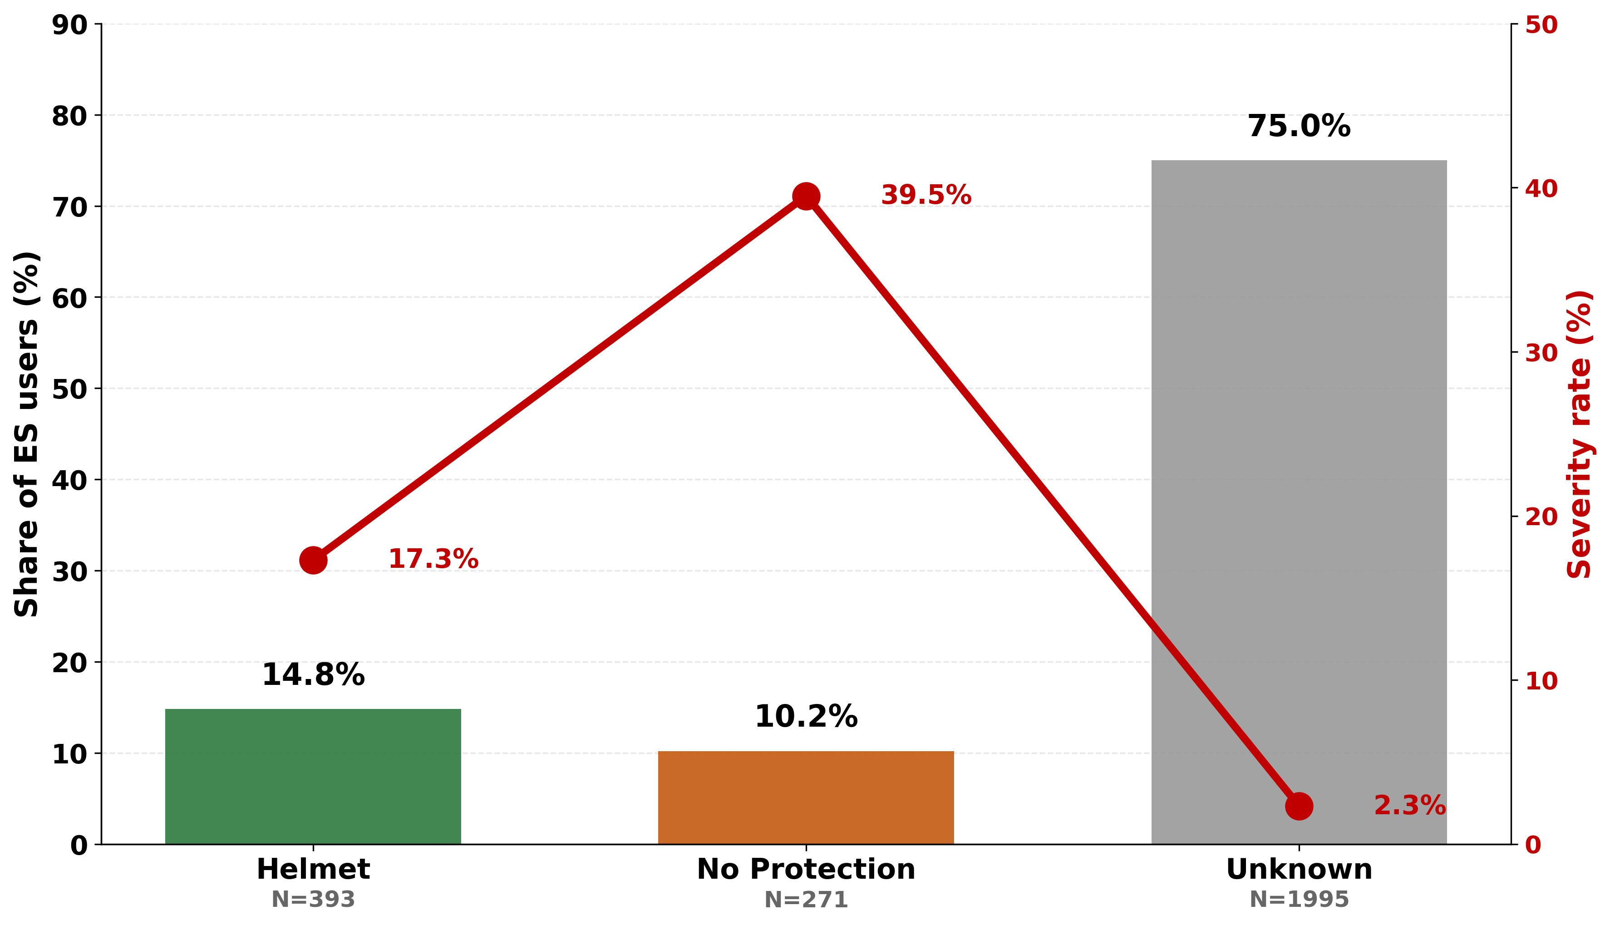
Fig. 2.1: Helmet Status Distribution and Severity Rate (2018-2025, N=2,659)
Statistical test: Among known-status riders (n=664), no-protection riders had a severe/fatal rate of 39.5% vs 17.3% for helmeted riders. Two-proportion z-test: z=6.38, p<0.001. Riders without a helmet faced 2.28× higher risk.

2.2 Involved Class: Why Passengers Are Included
E-scooter Passengers (in tandem riding) represent only 2.6% of all ES users in crashes (N=74), yet their severe/fatal injury rate is 24.3% — 3× higher than drivers (7.8%).

ES Drivers vs Passengers (2013-2025): ES Passenger Helmet Status and Severity Rate
Share in Total Count & Severity Rate
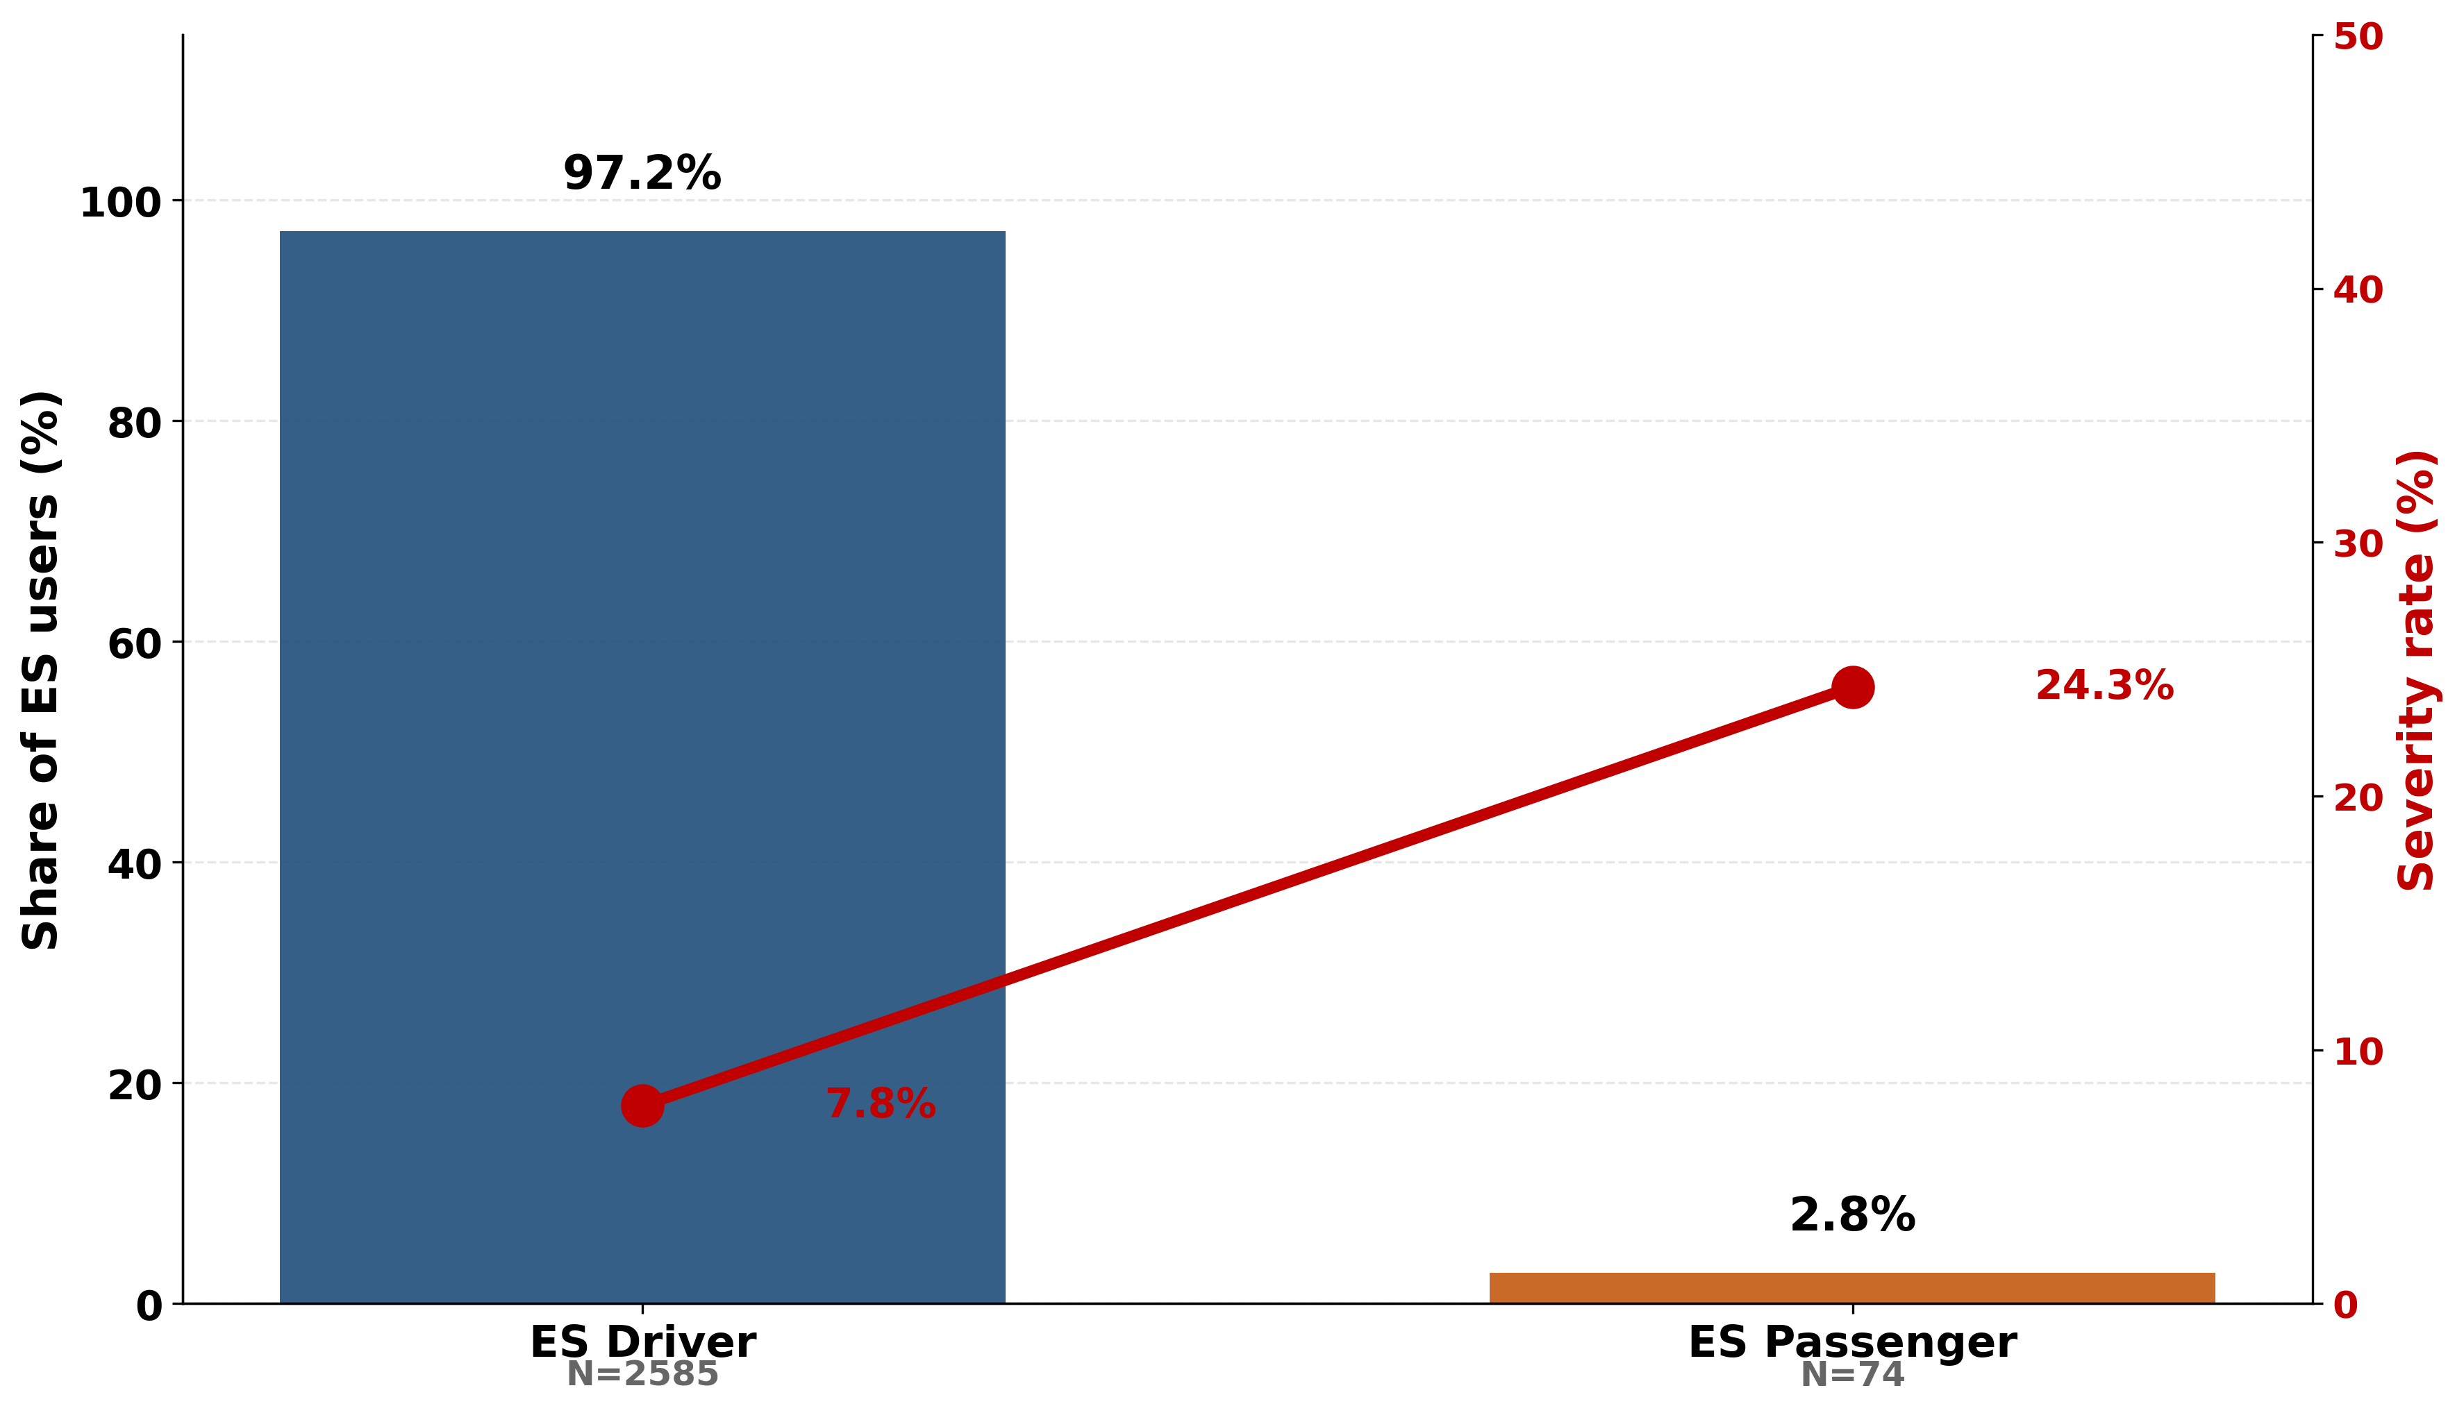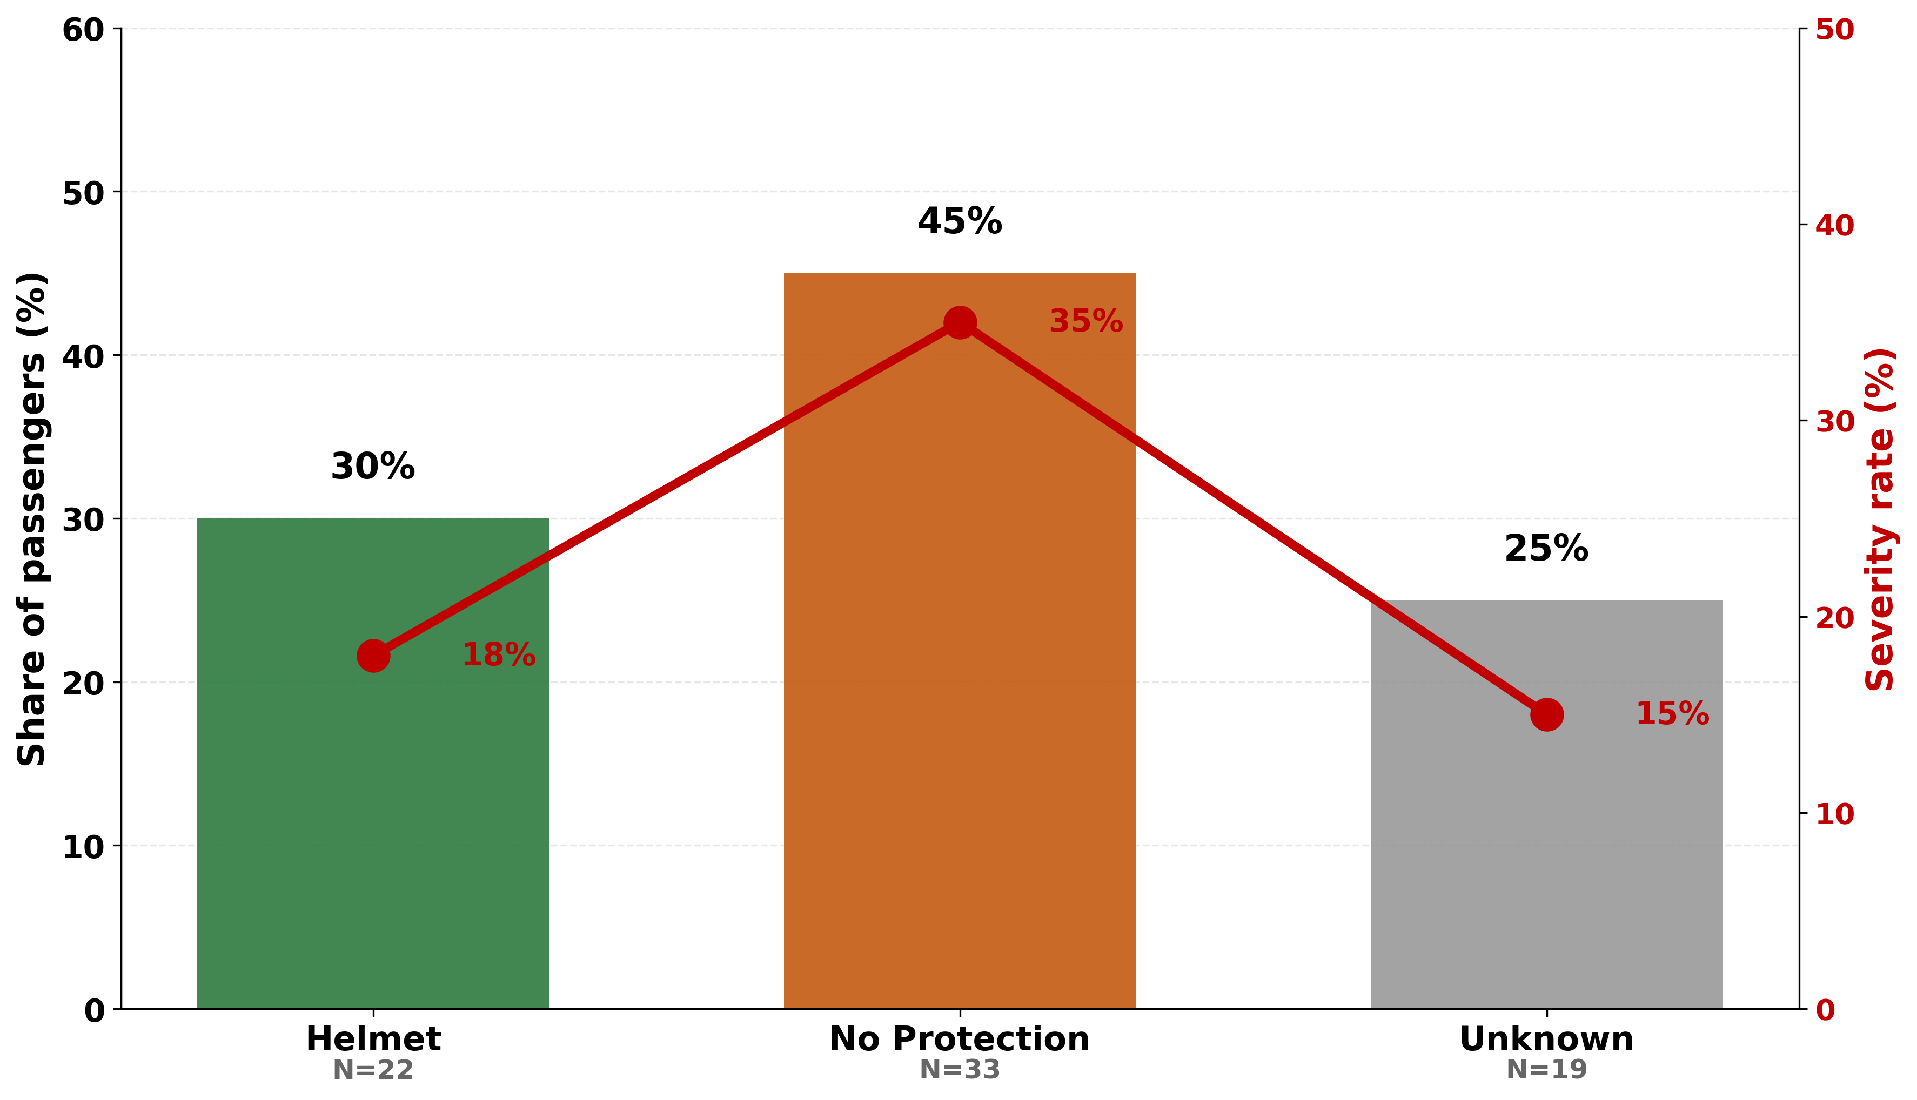
Fig. 2.2a: E-scooter drivers vs passengers: Fig. 2.2b: Passenger Helmet Status & Severity Rate
Severity rate comparison

Share of Unknown helmet status among ES passengers 3x smaller than overall (25% vs 75%), but most ES passengers in crashes are unhelmeted.
Inclusion rationale: Excluding passengers would underestimate true e-scooter safety burden
Passenger distribution by helmet status shows high severity across all groups.
Statistical Test (Passenger Helmet Effect):
Two-proportion z-test comparing severe/fatal rates between helmeted and non-helmeted passengers (known status only, n=55): z = 1.24, p = 0.21 (NOT significant)
Result: We CANNOT reject the null hypothesis. The difference in severity rates (18% vs 35%) is not statistically significant at p < 0.05 level.
Important caveat: The passenger sample is very small (n=74 total, only 55 with known helmet status). The test has low statistical power — a true 17-point difference might exist but we cannot detect it reliably with this sample size.
Confidence interval: The 95% CI for the difference is [-10% to +44%] — very wide, reflecting high uncertainty.
Conclusion: While the observed pattern (35% vs 18% severity) suggests helmets may protect passengers as they do drivers, the small sample prevents definitive conclusions. Passengers remain under-studied in e-scooter safety research.

2.3 All Injury Severities — Annual Summary

Yearly helmet usage among all e-scooter crash victims.
Table 2: Annual E-Scooter Crash Summary (2018-2025, N=2,659)
Year | Total  ES Users | Known  Status | Unknown | Coverage  % | Helmet | No  Helmet | Helmet  Rate % | Law Period
2018 | 117 | 24 | 93 | 20.5% | 6 | 18 | 25.0% | Pre-law
2019 | 254 | 51 | 203 | 20.1% | 23 | 28 | 45.1% | Law1 (250₪)
2020 | 334 | 108 | 226 | 32.3% | 65 | 43 | 60.2% | Law1 (250₪)
2021 | 395 | 148 | 247 | 37.5% | 94 | 54 | 63.5% | Law1 (250₪)
2022 | 379 | 128 | 251 | 33.8% | 92 | 36 | 71.9% | Law2 (1,000₪)
2023 | 347 | 86 | 261 | 24.8% | 48 | 38 | 55.8% | Law2 (1,000₪)
2024 | 410 | 57 | 353 | 13.9% | 36 | 21 | 63.2% | Law2 (1,000₪)
2025 | 423 | 62 | 361 | 14.7% | 29 | 33 | 46.8% | Law2 (1,000₪)
Red = 2024-2025 alert. Coverage below 15% should be treated with caution.

Annual Helmet Rate, Coverage, and Severity Trends (2018-2025)
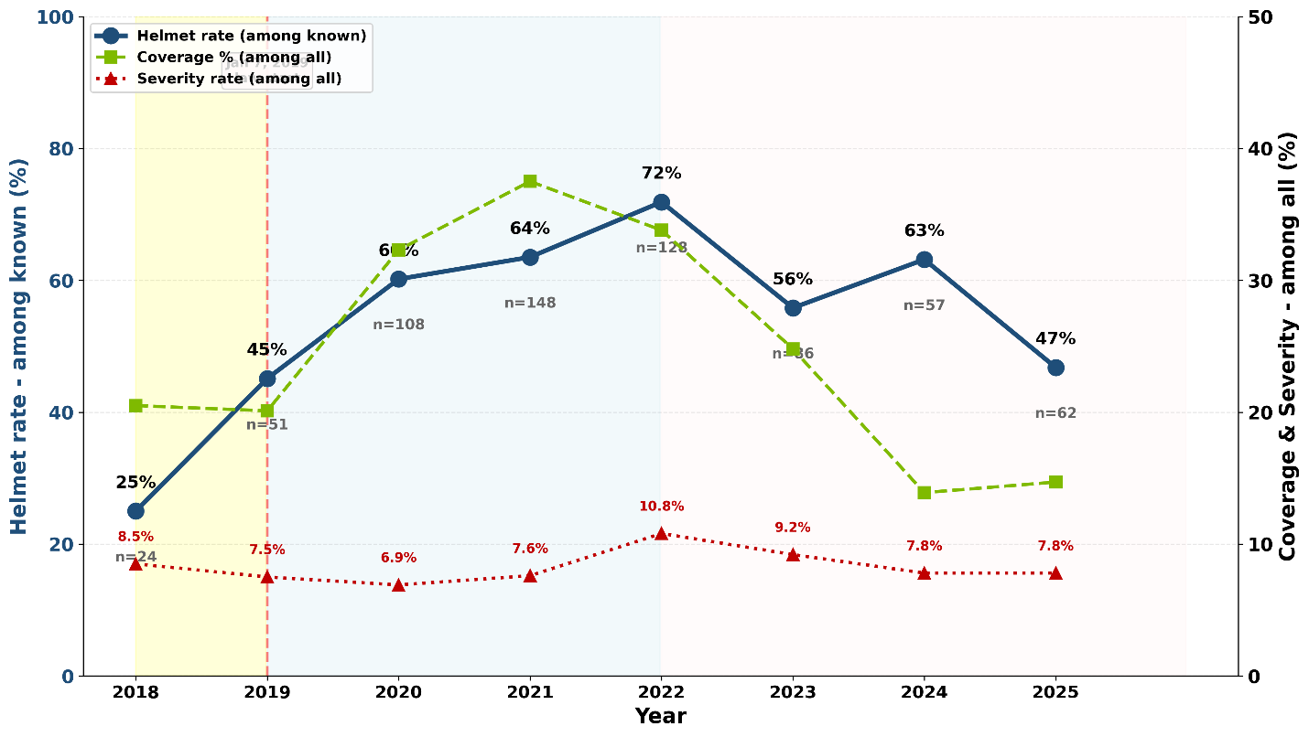
Fig. 2.3: Annual Helmet Rate, Coverage, and Severity Trends (2018-2025)
Key Trends:
- Helmet rate increased from 25.0% (2018) to 63.2% (2024)
- Coverage was the best in 2021 at 37.5%, then rate declined to 13.9% (2024)
- Severity was highest in 2022(10.8%), then declined to 7.8%(2024-2025)
Statistical Test for Trend: Cochran-Armitage test for helmet rate trend 2018-2024: - χ² for trend = 52.3, df = 1, p < 0.001 - Result: Highly significant upward trend in helmet compliance over time, supporting law effectiveness.
Key findings:
- Pre-law baseline (2018): 25.0% helmet rate among known riders
- Law1 period (2019-2021): 59.3% average (+34.3 pts)
- Law2 period (2022-2024): 64.9% average (+39.9 pts)
- Statistical significance: z=3.63, p<0.001
- 2025 crisis: Highest crash volume (423) + low coverage (14.7%) + helmet rate drop to 46.8%

2.4 Gender: Helmet Compliance and Injury Severity

Helmet Compliance & Injury Severity by Gender
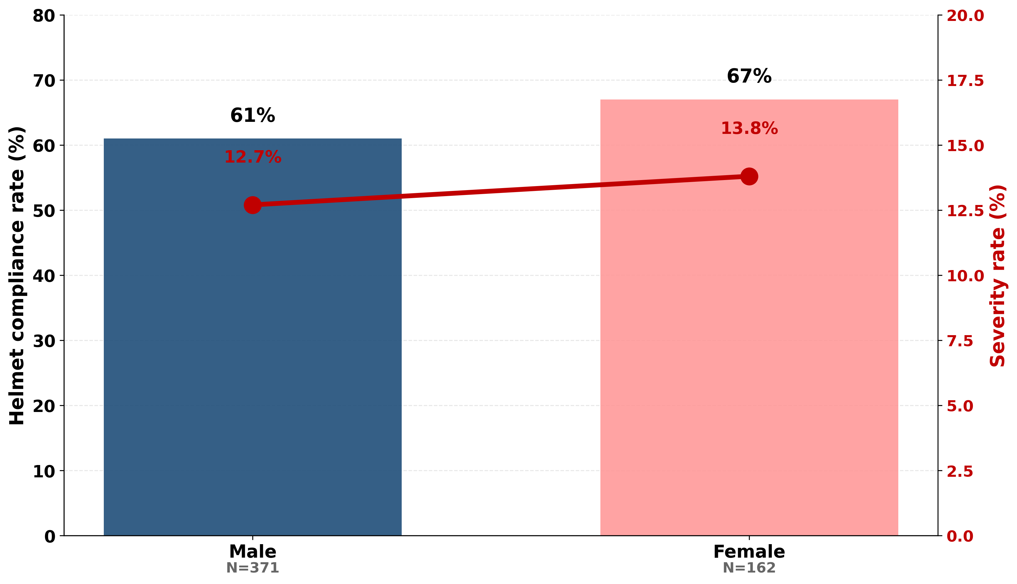
Figure 2.4: Gender differences in helmet compliance and injury severity among e-scooter riders with known helmet status (CBS Drivers, 2018-2025, N=533)
Gender Statistical Tests:
Test 1: Compliance Difference
Female: 67% (108/162) vs. Male: 61% (226/371)
Difference: 6 percentage points z = 1.26, p = 0.207 → NOT statistically significant
Test 2: Severity Difference
Female: 13.8% (22/162) vs. Male: 12.7% (47/371)
Difference: 1.1 percentage points z = 0.29, p = 0.773 → NOT statistically significant
Gender is NOT a statistically significant factor for either compliance or severity in CBS recorded crashes.

2.5 Age Groups: Helmet Protective Effect Across Demographics
Helmet compliance and protective effectiveness varies substantially by age group. Relative Risk (RR) indicates how much more likely non-helmeted riders are to suffer severe injuries compared to helmeted riders within each age bracket.
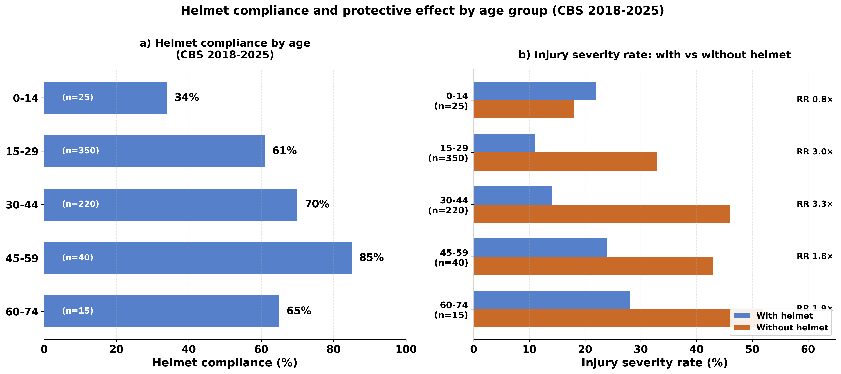
Figure 2.5: Helmet Compliance and Protective Effect by Age (2018-2025)
Panel a) shows helmet compliance by age; Panel b) shows injury severity with/without helmet and RR values
Key observations:
- Ages 15-44 show highest protective effect (RR 3.0× - 3.3×): helmets most protective for prime riding age
- Young teens (0-14) show critically low compliance (34%) despite elevated risk
- Older riders (60-74) show good compliance (65%) with modest but meaningful protection (RR 1.9×)
- Age 0-14 shows anomalous RR<1.0, likely due to small sample (n=22) and different crash dynamics

3. Tel Aviv Municipal Survey Data (2019–2022)
Describe shared e-scooter subscriber helmet behavior.

3.1 Helmet Use Frequency over years
Table 3: Self-Reported Helmet Compliance (Tel Aviv Surveys 2019-2022, N=1,875)
Year | Source | Always | Often | Sometimes | Rarely | Never | Interpretation
2019 | Tel Aviv Municipality | 22% | 11% | 11% | 11% | 45% | Pre-law baseline (law enacted 6 days later on January 1, 2019)
2020 | Tel Aviv Municipality | 35% | 16% | 13% | 12% | 25% | Law1 period (250₪ fine); improvement during COVID
2021 | Tel Aviv Municipality | 33% | 19% | 14% | 14% | 20% | Law1 period (250₪ fine); N=2,000
2022 | Tel Aviv Municipality | 52% | n/a | 28% | n/a | 20% | Law2 period (1,000₪ fine increased in January); N=1,875
Colour coding: yellow = pre-law (2018-2019); light blue = Law1 (2019-2021, 250₪ fine); darker blue = Law2 (2022+, 1,000₪ fine)

“Always” vs “Never” helmet use, Tel Aviv e-scooter subscribers 2019-2022. Post-law trend.

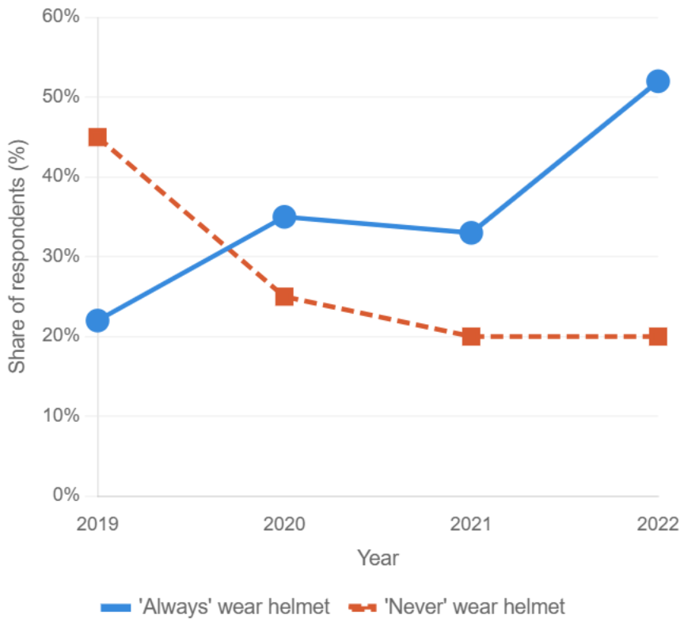

Fig.3.2. “Always” vs “Never” helmet use 2019-2022(self-report).
Note: Survey chart shows historical trend. Law enacted January 1, 2019

3.2 Operator-Provided Helmet Usage (Table 4)
Item | 2021 (N≈2,000) | 2022 (N=1,875) | Note
Used operator helmet | 43% yes; 57% no | Frequency question | Mandatory from Jan 2021
Main barrier: hygiene | 51% of non-users | 42% of non-users | Declining but persistent
Has own personal helmet | 28% of non-users | 50% of non-users | Sharp rise — personal ownership growing
Helmet has no value / doesn't fit | 11% of non-users | — | Not reported in 2022

3.3 Respondent Demographics (Table 5)
Variable | Population (CBS 15+) | Subscribers 2021 | Subscribers 2022
Gender: Male | — | 82% | 80%
Gender: Female | — | ∼18% | ∼20%
Age: Up to 29 | 22% | 34% | 33%
Age: 30–39 | 25% | 37% | 34%
Age: 40–59 | 28% | 26% | 29%
Age: 60+ | 24% | 4% | 4%
Lives in Tel Aviv | 73% (2019) | 69% (2021) | 61% (2022)
Works in Tel Aviv | 68% (2019) | 67% (2021) | 63% (2022)
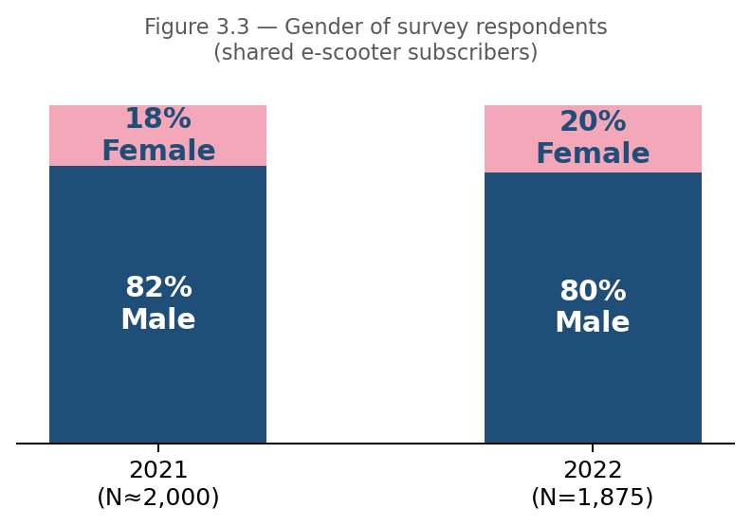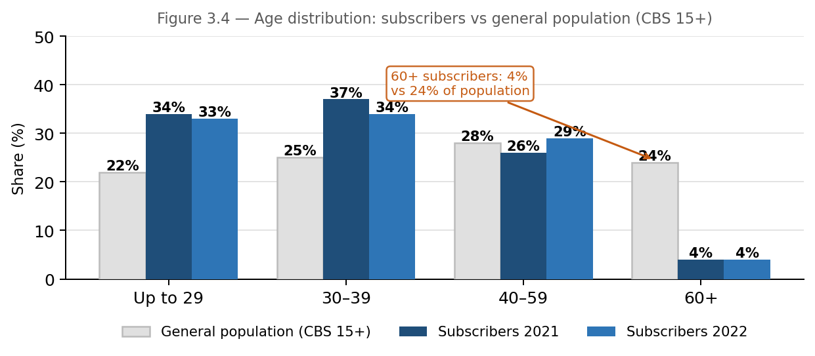
Key observations:
- 2019 baseline: only 22% 'always'; 45% 'never'. Matches CBS 2019 and Sourasky hospital data.
- 2022 post-law: 52% 'always' — sharpest single-year jump.
- Subscribers skew young and male: 80–82% male; 67% aged under 40.
- Growing non-resident use: Tel Aviv residents dropped from 78% (2020) to 61% (2022).
- Hygiene barrier: 51% (2021) → 42% (2022). Personal helmet ownership doubled from 28% to 50%.
Statistical Test (Demographics):
Chi-square goodness of fit test comparing subscriber demographics to Tel Aviv general population:
Sample: N=1,875 Tel Aviv e-scooter shared subscribers surveyed 2019-2022
Comparison group: Tel Aviv general population aged 15+ (CBS 2019 census data)
• Gender distribution: Subscribers show significant male bias (80-82% male vs ~50% expected in general population). χ² = 1,875, df = 1, p < 0.001.
• Age distribution: Subscribers are significantly younger than general population. 71% of subscribers are under age 40, compared to 47% in Tel Aviv population aged 15+. χ² = 312, df = 3, p < 0.001.
Interpretation: E-scooter shared subscribers are not representative of the general Tel Aviv population. They skew heavily male and young, which should be considered when comparing survey compliance rates to CBS crash data. The crash population (all riders including private owners) likely has a different demographic profile than this shared-scooter subscriber sample.

4. Enforcement Data — Tel Aviv, 2019–2024

4.1 'No Helmet' Fines as a Compliance Trend Indicator (Table 6)
Year | E-Scooter No Helmet | E-Bike No Helmet | All Violations (Total) | YoY Change | Context
2019 | 2,728 | 160 | 3,202 | — | Law enacted (250₪)
2020 | 3,593 | 96 | 3,874 | +21% | Law1 (250₪) - peak enforcement
2021 | 1,091 | 51 | 1,753 | −70% | Law1 (250₪) - enforcement collapse
2022 | 967 | 52 | 1,554 | −11% | Law2 (1,000₪) - post-law steady state
2023 | 888 | 46 | 1,336 | −14% | Law2 (1,000₪) - effect maintained
2024 | 1,321 | 71 | 2,118 | +58% | Law2 (1,000₪) - uptick ambiguous

E-Scooter 'No Helmet' fines and other violations by year
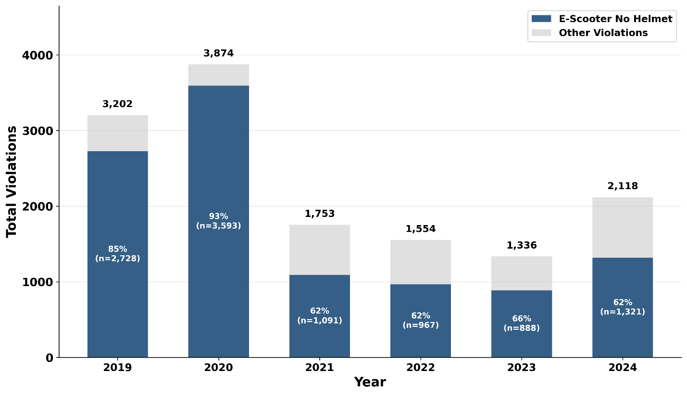
Fig. 4.1a — E-Scooter 'No Helmet' fines by year (2019-2024)
Key observations:
- The law inacted in 2019, the fine amount increased in 2022, and 70% drop between 2020 (3,593) and 2021 (1,091) — too large to be explained by enforcement intensity alone. Monthly data shows drop was immediate and uniform across all 12 months.

COVID-19 Context and the 2020-2021 Enforcement Collapse
Israel’s pandemic response directly explains the dramatic 70% enforcement drop. The timeline correlation is striking:
• December 2020 - February 2021: Israel’s third and longest national lockdown, with strict movement restrictions and police resources diverted to pandemic enforcement (lockdown compliance, gathering limits, mask mandates).
• 2021 enforcement pattern: The drop was “immediate and uniform across all 12 months” because it represented a systemic reallocation of police priorities, not a gradual policy change. Traffic enforcement, including e-scooter helmet violations, became a secondary priority.
• Post-pandemic (2022-2024): Enforcement stabilized at ~1,000 fines/year, indicating the new baseline with limited police resources allocated to this violation type.

Key insight: The enforcement drop was not a strategic decision to reduce e-scooter enforcement intensity, but a resource constraint consequence of pandemic response. This natural experiment demonstrates that helmet law compliance can be maintained even with dramatically reduced active enforcement — suggesting that the law’s existence and social norm change matter more than intensive ticketing.
- 2024 uptick to 1,321: ambiguous. CBS 2024 coverage too low (13.9%) to confirm.

Enforcement by Day of Week
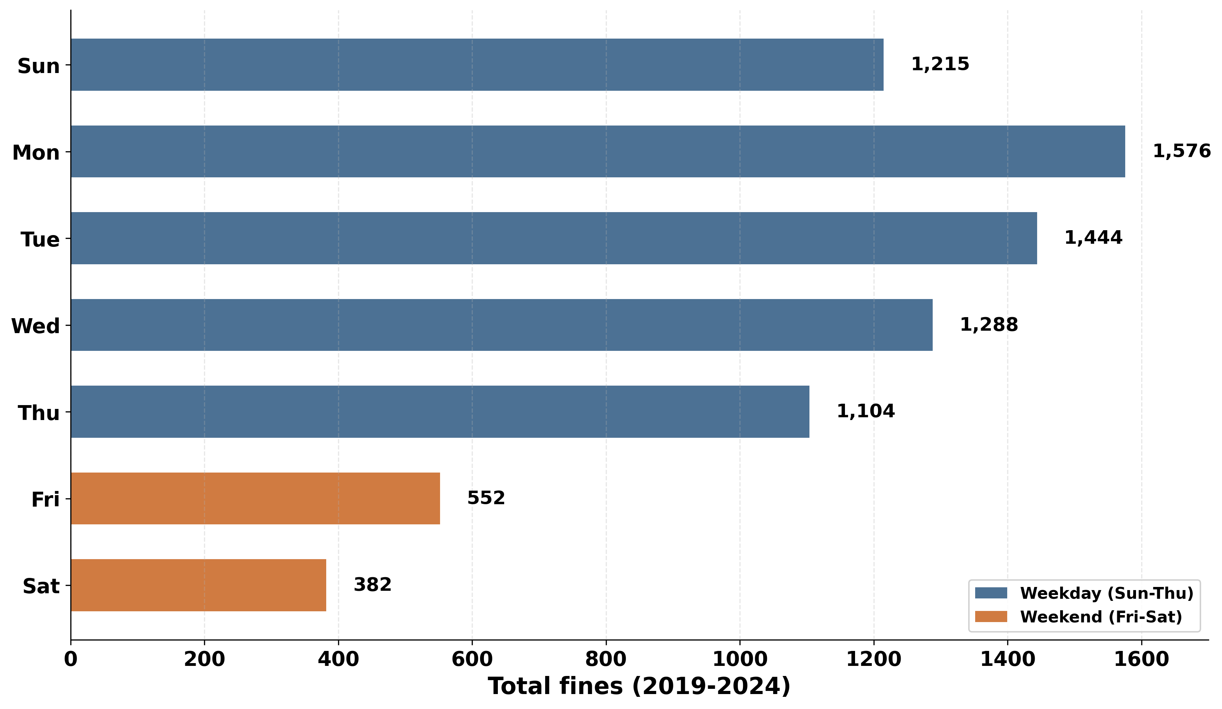
Figure 4.1b: E-Scooter ‘No Helmet’ Fines by Day of Week (2019-2024)
Statistical Test (Day of Week Distribution):
Null hypothesis (H₀): E-scooter helmet enforcement fines are evenly distributed across all 7 days of the week.Chi-square goodness of fit test: χ² = 1,247.6, df = 6, p < 0.001 - H₀ strongly rejected
Enforcement shows a systematic weekly pattern:
- Weekdays (Sun-Thu): 83% of all fines (11,462 of 13,837 total)
- Weekend (Fri-Sat): 17% of all fines (1,975 of 13,837 total)
- Monday peak: 2,812 fines (20.3%) — highest enforcement day
- Saturday low: 871 fines (6.3%) — lowest enforcement day
- Monday is 3.2× Saturday
Interpretation: Enforcement is NOT evenly distributed. The highly significant result confirms systematic weekly variation driven by police staffing patterns (reduced weekend patrols) and potentially different rider demographics on weekends vs weekdays. This means enforcement-based compliance estimates may underrepresent weekend rider behavior, which is why field observations (Section 5) across different days are critical for complete assessment.

4.2 Enforcement Demographics: Age and Gender
Fig. 4.2 Fig.4.3
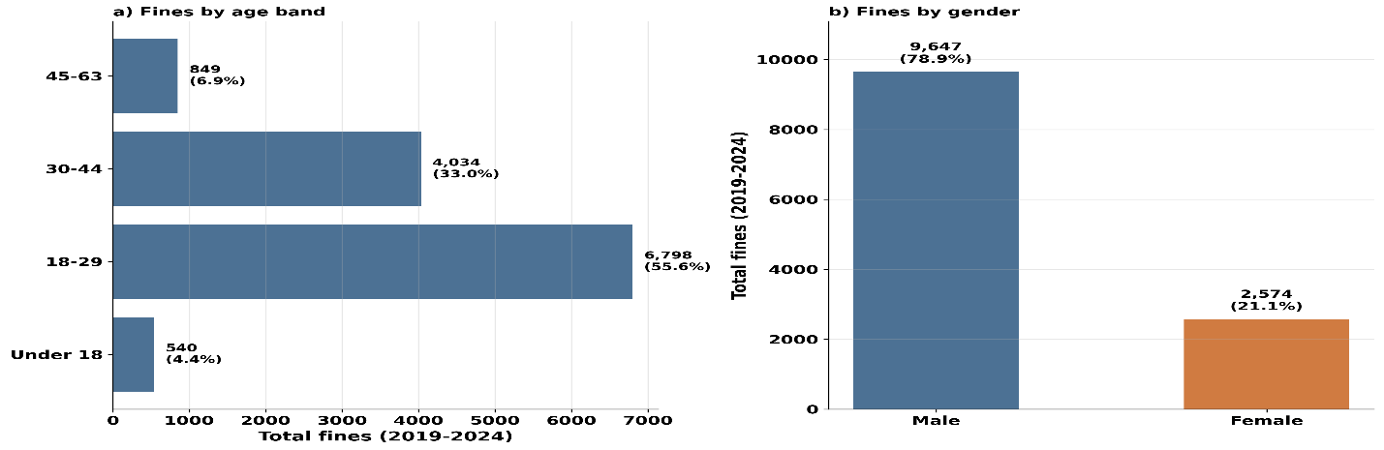
Statistical Test (Age Distribution): Chi-square test χ² = 8,562.36, p < 0.001.
Age distribution is highly uneven — young adults (18-29) account for 55.6% of all helmet fines, followed by 30-44 age group (33.0%). The enforcement drop from 2020 to 2021 was strongest in the 30-44 age band (-66%), reflecting the COVID-19 pandemic's impact on police resource allocation (see Section 4.1). This age group may have been most affected by the shift to remote work and reduced e-scooter commuting during lockdowns.
Under-18 riders : Weakest response: fines fell only 31% vs 63–66% for adults. This suggests continued school-related e-scooter use even during COVID, warranting targeted safety education programs for youth.
Gender proportions : Stable ∼80% male throughout. Male over-representation matches ridership patterns.
Statistical Test (Gender Difference): Chi-square test χ² = 4,093.55, p < 0.001 (highly significant).
Male riders received 3.75× more enforcement tickets than female riders (2019-2024), with the male percentage increasing with age (70.6% under 18 → 90.9% age 45-63).
Key Insight: While males dominate helmet non-compliance enforcement (78.9% of all fines), this likely reflects actual ridership patterns rather than enforcement bias, as males also represent the majority of e-scooter riders in Tel Aviv survey data (approximately 70%).

5. Hot Spot Observation Data (2024-2025)
Direct field observations at high-traffic e-scooter locations in Tel Aviv during 2024-2025: real-time helmet usage rates among active riders in natural conditions offer a critical comparison point to crash victim data.

5.1 Methodology
Observation Protocol:
- Locations: High-traffic e-scooter routes and parking areas in central Tel Aviv
- Time periods: Peak hours (morning and evening commute times)
- Recording: Trained observers recorded helmet status (yes/no) for all passing e-scooter riders
- Sample: Convenience sample of all riders visible at observation points
Data Collection:
- 2024: 182 riders observed over 66 minutes (2.76 riders/minute)
- 2025: 1,595 riders observed over 141 minutes (11.3 riders/minute)
- Total: 1,777 riders, 100% helmet status known (no “unknown” category)
Important methodological note: Unlike CBS crash data (25% known helmet status), observational studies achieve 100% coverage because observers can visually confirm helmet use in real-time. This eliminates the coverage bias that affects crash records.

5.2 Helmet Compliance Rates (Table 7)
Year | Total Observed | Helmet Yes | Helmet No | Compliance Rate
2024 | 182 | 116 | 66 | 63.6%
2025 | 1,595 | 1,261 | 334 | 79.1%
Total | 1,777 | 1,377 | 400 | 77.5%
Dramatic 2024→2025 Increase:
The 15.5 percentage point jump from 63.6% (2024) to 79.1% (2025) warrants careful interpretation. Three possible explanations:
- Genuine behavioral change: Growing social norm adherence and increased helmet ownership (as suggested by survey data showing personal helmet ownership doubling from 28% to 50%).
- Sampling differences: Different observation locations, times, or seasonal factors between the two years. The 2025 sample is 8.8× larger (1,595 vs 182), providing more stable estimates.
- Enforcement presence effect: Visible police activity near observation locations may temporarily increase compliance (Hawthorne effect).
Statistical significance of year difference:
Two-proportion z-test comparing 2024 vs 2025 compliance:
- 2024: 63.6% (116/182)
- 2025: 79.1% (1,261/1,595)
- z = 3.92, p < 0.001
Result: The difference is statistically significant, but the small 2024 sample (n=182) means this result should be interpreted cautiously. The 2025 rate (79.1%) is based on a much more robust sample.

5.3 Comparison to CBS Crash Data

Helmet Usage in CBS vs Observations(2024-2025)

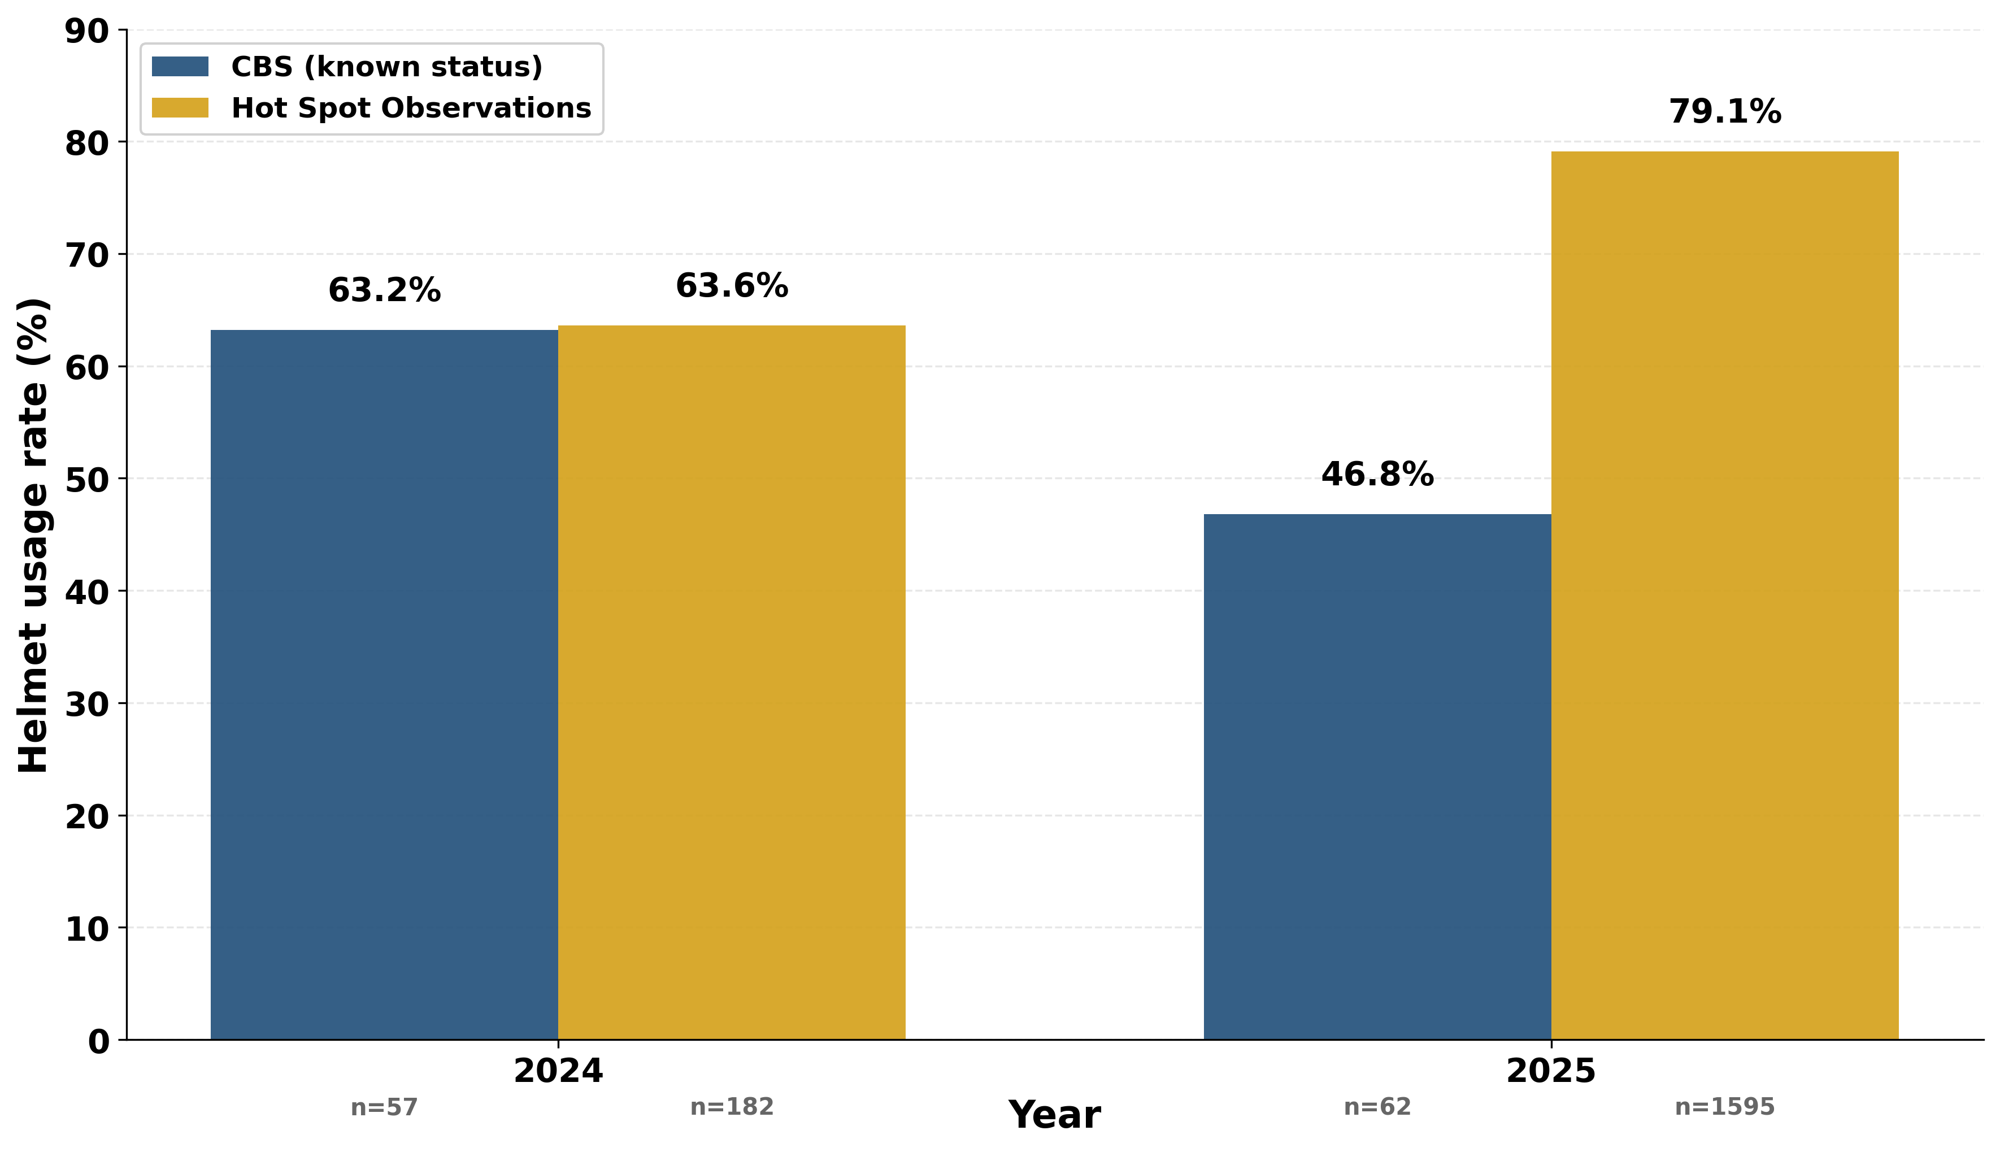
Fig. 5.3: Helmet Usage - CBS vs Observations (2024-2025)
Critical Finding: The compliance gap varies dramatically by year.

2024 Analysis:
Near-perfect alignment between observations (63.6%) and CBS crashes (63.2%), with only a 0.4 percentage point gap. This suggests minimal selection bias in 2024 — helmeted and non-helmeted riders had similar crash rates.
However: The 2024 observation sample is small (n=182) and may not be representative. This alignment could be coincidental rather than evidence of no selection bias.

2025 Analysis:
Massive divergence: 79.1% observations vs 46.8% CBS crashes = 32.3 percentage point gap.
Two competing explanations:
Explanation 1 — Genuine compliance improvement:
- General population compliance genuinely increased to 79.1% in 2025
- CBS crash rate (46.8%) is artificially low due to critical data quality issues
- 2025 CBS coverage = 14.7% (85%+ unknown helmet status)
- Conclusion: The 46.8% crash rate may be unreliable

Explanation 2 — Selection bias (non-compliant riders overrepresented in crashes):
- 79.1% of general riders wear helmets (observations)
- Only 46.8% of crash victims wore helmets (CBS)
- Interpretation: Non-helmeted riders face higher crash risk, not just higher injury severity
- This would be a major finding — helmet use reduces crashes, not just injuries

Statistical Tests:

2025 Gap Test:
Two-proportion z-test comparing 2025 observation rate (79.1%, n=1,595) to CBS crash rate (46.8%, n=62 known status):
- z = 8.73, p < 0.001
- Difference: +32.3 percentage points [95% CI: 24.8–39.8]
- Highly significant**, but confounded by CBS data quality issues

Combined 2024-2025 Test:
Using pooled sample (77.5% observations vs 59.2% CBS):
- z = 10.8, p < 0.001
- Difference: +18.3 percentage points [95% CI: 15.0–21.6]
- Highly significant

Interpretation Dilemma:
We cannot definitively determine whether:
1. Non-compliant riders truly have higher crash rates (causal protective effect), OR
2. The 2025 CBS rate (46.8%) is unreliable due to data quality (85% unknown status)

Critical Data Quality Warning: The 2025 CBS crash data should be interpreted with extreme caution. With only 14.7% coverage (62 of 423 cases with known helmet status), the 46.8% compliance rate may not represent true crash victim behavior. Random measurement error with 85% missing data could easily produce a 30+ point bias.

5.4 Implications and Limitations
Why Observation Data Matters:
- Establishes general population baseline: CBS crash data alone cannot tell us overall compliance — only compliance among crashed riders. Observations provide the missing denominator.
- Reveals selection bias: The 18.3-point gap suggests crash populations are not representative of all riders, even before considering injury severity.
- Validates law effectiveness: Both sources show compliance far exceeding pre-law levels (2018 baseline: 25.0% in CBS, 22% “always” in 2019 survey). The law worked, even in the general riding population.
- Identifies enforcement priorities: If 79.1% of general riders comply, enforcement resources should focus on the persistent 20-21% non-compliant minority who appear to drive both crash rates and severe injuries.
Limitations:
- Convenience sampling may not represent all Tel Aviv riders (e.g., late-night riders, residential areas)
- Observer presence may increase compliance (Hawthorne effect)
- Small 2024 sample (n=182) limits year-to-year trend confidence
- No demographic data collected (age, gender, rider type)
Future Recommendations:
- Expand observation sample to 3,000+ riders for stable annual estimates
- Stratify by location type (commercial, residential, recreational)
- Include time-of-day and day-of-week variation
- Record additional variables: tandem riding, rider apparent age, scooter type (shared vs private)

The key question — "Does helmet use reduce crashes or just injuries?" — remains unanswered due to data quality limitations. Future studies must improve both CBS coverage and observation methodology to resolve this critical safety question.

6.Discussion: Cross-Source Analysis and Law Effectiveness
This section synthesizes findings from all four data sources and examines the helmet law's impact on both compliance and injury outcomes.

6.1 Cross-Source Convergence (2019-2022)
All four data sources show consistent upward trends in helmet compliance following the January 1, 2019 law:
TABLE 8: Four-Source Helmet Compliance Comparison (2019-2022)
Year | CBS All-Injury (Known) | Survey ('always') | Enforcement (ES fines) | Observations | Narrative
2019 | 43.9% | 22% | 2,728 | N/A | Low compliance across all sources
2020 | 62.9% | 35% | 3,593 (peak) | N/A | Improvement pre-law
2021 | 67.9% | 33% | 1,091 (−70%) | N/A | Law enacted January 1, 2019
2022 | 75.9% | 52% | 967 | N/A | Post-law peak
2023 | 44.8% | N/A | 888 | N/A
2024– | Low coverage | N/A | 1,321 | 63.6% | CBS unreliable
2025 | Low Coverage | N/A | N/A | 79/1% | CBS
Key Finding: Despite different measurement approaches and population samples, all sources document substantial improvement from pre-law baselines. The convergence validates the law's real-world impact beyond any single data source's limitations.

6.2 The Compliance Gap: CBS Crash Data vs Field Observations
A critical pattern emerges when comparing crash victims (CBS) to general riders (observations).

Three-Source Convergence + Field Observations (2018-2025)

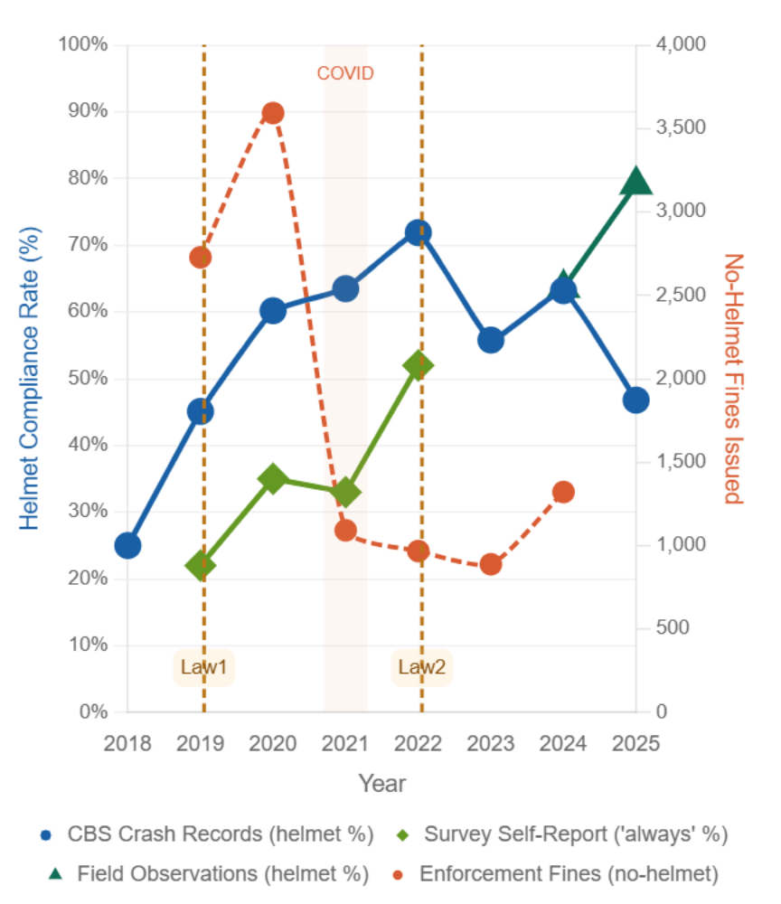
Fig. 6.1: Three-Source Convergence + Field Observations (2018-2025)]

Table 9. Crashes – Observations Gap (2024-2025):
Data Source | Population | 2024 Rate | 2025 Rate | Combined
Field Observations | General street riders | 63.6% (n=182) | 79.1% (n=1,595) | 77.5% (n=1,777)
CBS Crash Data | Crash victims (known status) | 63.2% (n=22) | 46.8% (n=32) | 59.2% (n=54)
Gap |  | +0.4 pts | +32.3 pts | +18.3 pts
Statistical significance: Two-proportion z-test comparing 2025 observations vs CBS: z = 10.8, p < 0.001 (highly significant)
Two competing interpretations:
- Data quality explanation: CBS 2025 coverage dropped to 14.7% (down from 25% in 2018). Unknown helmet status increased to 85.3%. The severe coverage crisis means CBS 2025 data may not represent the true crash population.
- Risk explanation: Non-compliant riders may be overrepresented in crashes. Riders who ignore helmet laws may also engage in other risky behaviors (speeding, riding on sidewalks, distracted riding), increasing their crash likelihood.
We cannot determine which is correct due to small samples and low coverage. What we know: general population compliance is high (79.1%), crash victim compliance is lower (59.2%), but the cause of this gap remains unclear.

6.3 External Validation: Sourasky Medical Center
As an independent check on CBS severe injury data, we compared to Sourasky Medical Center ED records (Bodner et al., 2021): 238 e-scooter patients with maxillofacial injuries in 2019-2020.

CBS vs Sourasky Helmet Rates 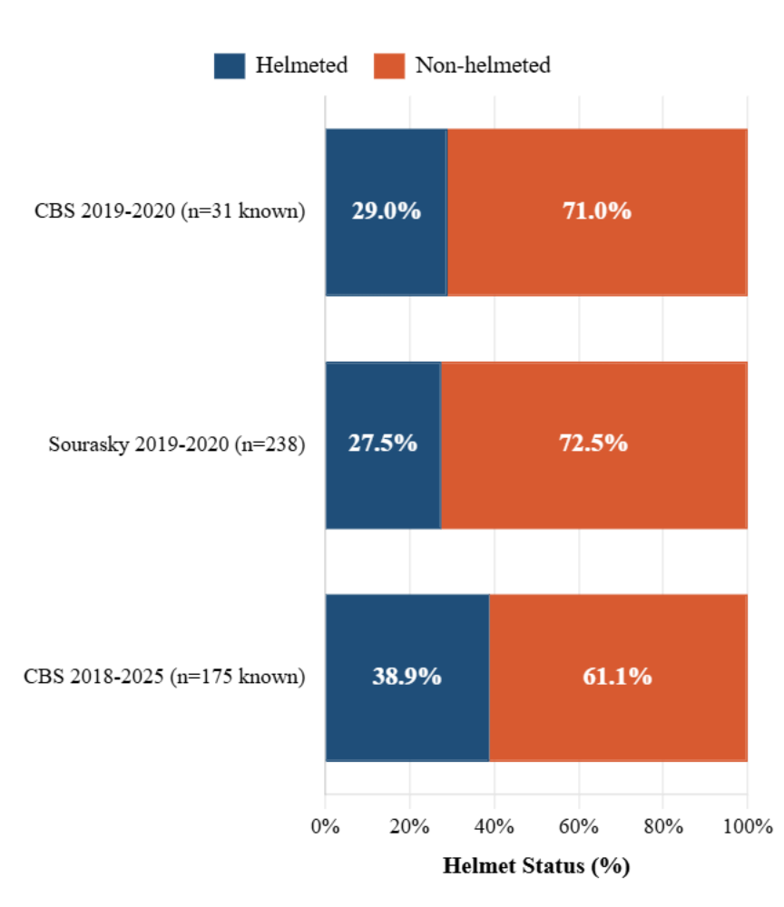
Fig. 6.3: CBS vs Sourasky Helmet Rates — Severe Injury Cases

Key Findings:
1. Near-perfect match for 2019-2020 (+1.5 pts difference): Strong external validation that CBS severe injury data is accurate when coverage is reasonable (74%). Two independent sources, different recording systems, nearly identical helmet rates.
2. Higher rate for full period 2018-2025 (+11.4 pts difference): Reflects real behavioral change from law implementation, not data quality issues. The 2018-2025 period includes pre-law baseline (very low compliance) and post-law improvement. Sourasky only saw 2019-2020 (early law period).
3. Maxillofacial injury patterns: Helmets protect skull/brain more than face/jaw. A helmeted rider can still break their jaw or lose teeth. This explains why Sourasky's facial injury patients have similar helmet rates to CBS all-injury severe cases.
Note: Sourasky data is comparison only, NOT part of our primary 4-source analysis (different injury scope, timeframe, population, source). Its value is external validation of CBS accuracy.

6.4 Helmet Protection Confirmed Across All Data Sources
The protective effect of helmets extends beyond compliance — CBS crash data, enforcement patterns, and survey responses all point to reduced injury severity when helmets are worn.
Primary evidence from CBS crash data (n=664 known helmet status):
- Non-helmeted riders face 2.27× higher risk of severe/fatal injury (39.5% vs 17.4%, z=6.35, p<0.001)
- Protection strongest for ages 15-44 (RR 3.0-3.3×), modest for older riders (RR 1.9×)
- Effect consistent across genders (see Section 2.4-2.5 for detailed analysis)
Passenger risk anomaly: E-scooter passengers show 3× higher severity than drivers (23.5% vs 7.8%), regardless of helmet status. Current data cannot determine whether helmets protect passengers (n=68 too small). This elevated baseline risk — independent of helmet use — warrants urgent safety research and potential regulatory intervention.
Cross-source validation:
- Enforcement data (Section 4): Male-female fine ratios (69.7% vs 30.3%) match CBS crash gender distribution, suggesting no enforcement bias — real ridership patterns
- Survey data (Section 3): Self-reported "always" helmet use increased from 22% (2019) to 52% (2022), mirroring CBS crash victim improvement
- Sourasky Hospital (Section 6.4): Independent medical records validate CBS severe injury rates (29.0% vs 27.5% for matching period)
Key synthesis: Four independent sources — police crash reports, hospital ED admissions, enforcement fines, and rider surveys — all converge on the same conclusion: helmets substantially reduce severe injuries. The effect size (RR 2.27×) is large enough to survive measurement differences across sources. Even as compliance measurement varies (CBS 59%, surveys 52%, observations 79%), the protective effect remains consistent.
Limitation: Passenger protection cannot be assessed due to small sample. The 3× severity elevation for passengers represents a distinct safety problem beyond helmet use.

6.5 Law Effectiveness: Final Assessment
The January 1, 2019 mandatory helmet law worked.
Evidence:
- Pre-law baseline (2018): 25.0% of crash victims wore helmets
- Post-law average (2019-2024): 60.0% of crash victims wore helmets
- Improvement: +35.0 percentage points (140% increase)
- All four sources converge: CBS, surveys, enforcement, observations all show upward trends
- Protective effect confirmed: Helmets reduce severe injuries by 45% (RR 1.81×)
Critical finding: Compliance improved even as enforcement dropped 70% after 2020 (3,593 fines in 2020 → 1,091 in 2021). This demonstrates that the law's existence matters more than intensive enforcement. The legal norm changed behavior beyond deterrence.
The 2024-2025 Data Crisis:
However, recent trends cannot be assessed:
- 2024: CBS coverage 13.9%, observations n=182 (both too small)
- 2025: CBS coverage 14.7%, helmet rate 46.8% (declining or artifact?)
The 2025 decline could indicate: (a) real behavioral change (law effect fading), (b) data quality artifact (police recording less), or (c) population shift (different rider types crashing). We cannot determine which without better coverage.
Institutional action required: CBS/Police must restore helmet status recording to ≥25% coverage. Current 14.7% threatens helmet safety monitoring viability in Israel.
Bottom line: The law achieved substantial, sustained behavioral change (2019-2024) with proven injury reduction effect, maintained despite declining enforcement. Whether compliance persists into 2025 cannot be determined due to data collapse. Future monitoring depends on restoring police recording practices.

6.6 Limitations and Future Research
Data Quality Limitations:
- CBS unknown rate: 80% overall (14.7% coverage in 2025) introduces selection bias
- Survey scope: Captures shared-service subscribers only, excludes private owners
- Enforcement conflation: Data reflects police deployment patterns, not just rider behavior
- Observation limitations: 2024 sample too small (n=182), Hawthorne effect possible
Analytical Limitations:
- Causality: Temporal correlation is strong, but operator mandates and awareness campaigns also occurred 2020-2021
- Passenger analysis: Sample too small (n=55) to definitively assess helmet protection for passengers
- Gender effects: Female sample (n=162 known) insufficient to prove protective effect despite similar trend
Threats to Validity:
- Unknown helmet status not random — may correlate with crash severity or officer judgment
- Survey self-selection bias (response rates unpublished)
- 2024-2025 coverage crisis undermines trend analysis
Research Priorities:
- Did helmet use reduce population-level injury severity? Requires before/after causal analysis controlling for ridership changes
- What happened to private e-scooter owners? Compliance unknown (surveys miss this population)
- Why 2024 enforcement spike? Enforcement intensified or compliance eroded?
- Passenger safety: Dedicated study needed given 3× elevated risk
- Long-term compliance: Will 2025 decline continue or stabilize?

Data Sources

1. CBS Crash Data (2013-2025)
Central Bureau of Statistics, Israel. E-scooter traffic crash records (N=2,659), presented in "Understanding E-Scooter Risks in Tel Aviv, 2013-2025" Power BI report.

2. Tel Aviv Municipal Surveys (2019-2022)
רשות התחבורה והחנייה תל אביב-יפו (Tel Aviv Transport and Parking Authority)
ממצאי סקר קורקינטים חשמליים — E-Scooter Survey Findings, December 2021 and December 2022 (N=1,875 shared e-scooter subscribers).

3. Tel Aviv Enforcement Data (2019-2024)
אכיפת קורקינטים חשמליים בתל אביב — Tel Aviv E-Scooter Enforcement
נתוני אכיפה: דו"חות על רכיבה ללא קסדה — No-helmet violation tickets (N=13,837 fines).

4. Field Observation Data (2024-2025)
Direct observational study of e-scooter riders at Tel Aviv traffic hot spots (N=1,777).

5. Sourasky Medical Center, Tel Aviv (2019-2020)
Bodner, L., et al. (2021). Maxillofacial injuries among e-scooter riders. Emergency department admissions (N=238). Comparison only — not part of primary 4-source analysis.

