Spatial Risk Prioritisation of Tel Aviv City Quarters
E-Scooter Crash Analysis, 2020–2025

Nina Garmash, PhD | ANYWAY Project / DATA FOR CHANGE | HIT — Holon Institute of Technology
Reference model: escooter_TA_new_0413.pbix | April 2026

Purpose and Scope

This report compares Tel Aviv's 15 city quarters (Q1-Q15) on e-scooter crash risk and builds a priority ranking for municipal intervention. The score is now based on the 2020-2025 yearly correlation evidence: redundant metrics are grouped into clusters, distinct dimensions are retained, and crash volume is used as an action-scale and reliability signal rather than as a separate full risk dimension.

The analysis covers calendar years 2020–2025, using CBS crash microdata (fact_Accidents, Is_Scooter = TRUE, Tel Aviv scope), Populus MDS shared trip data (quarterly weighted exposure, subset covering all 15 quarters, 2020–2025), and QGIS-derived bike path and street length data from the Tel Aviv Municipality OpenData bike routes layer.
⚠ Scope note: Populus MDS data is available for 2020–2025 only. Quarter-level trip exposure is absent for 2013–2019. The priority matrix therefore uses 2020–2025 data throughout for consistency. All reported figures in this section refer to 2025 unless otherwise stated.

Metrics and Variable Roles

The score separates variables by role before weighting. This prevents highly correlated measures from being counted several times. Exposure and urban scale variables include daily trips, VKT, street length, and trip density. Crash-burden variables include ES crash count and crashes per km2. Infrastructure variables include BP share of the street network, BP density, and crashes per 10 km of BP. Outcome variables include crashes per 10 million trips and severity percentage.
The 2025 display table can still show the full variable set, but the score uses only cluster representatives. VKT is retained as context because it is nearly interchangeable with trips. Crashes per 10 km street and crashes per 10 km BP are retained as diagnostic rates but are not used as full independent score components because their yearly correlations show they largely reinforce the same crash-density signal.

3. Yearly Correlation Evidence, 2020-2025

Figure 3.1. Spearman Correlation Matrix, Q15 Quarters, 2025

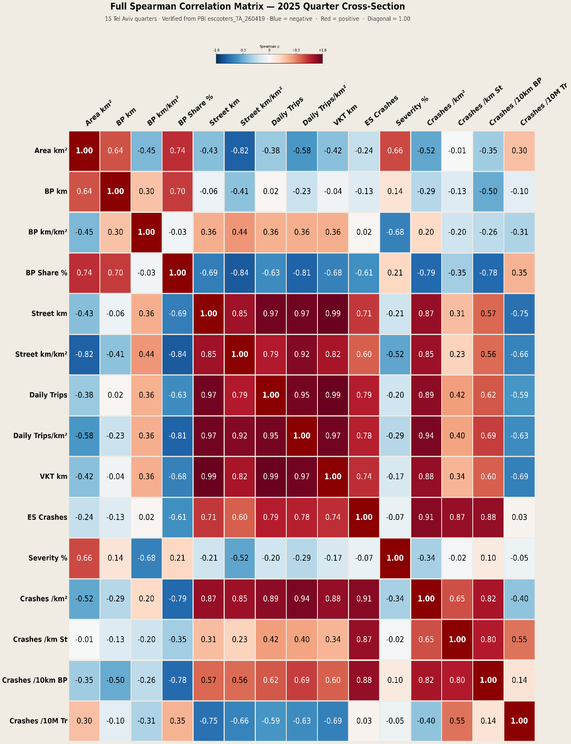

The yearly Q15 correlation analysis was calculated separately for each year from 2020 through 2025, then summarized across years. This is stronger than relying on a single 2025 cross-section because it checks whether variable relationships are stable over time.
Stable redundancy is concentrated in the crash-burden cluster. Daily trips and crash density are strongly associated across years (mean rho = 0.843), ES crash count and crash density are nearly redundant (mean rho = 0.912), and crash density strongly reinforces crashes per 10 km BP (mean rho = 0.847). These results mean that a score should not give full independent weight to crash count, crash density, and BP-normalized crash rate at the same time.
The distinct dimensions are exposure-adjusted risk and severity. Crashes per 10 million trips is consistently different from crash density (mean rho = -0.307), so it identifies quarters where each trip is relatively risky rather than just quarters with many crashes. Severity is essentially independent of both crash count (mean rho = 0.036) and crash density (mean rho = 0.008), so it should remain in the score but needs low-n suppression because the percentage is noisy when crash counts are small.
Infrastructure coverage should be represented as a protective gap indicator, not as another crash-rate burden indicator. BP Share % is consistently negatively associated with crash density across all six years (mean rho = -0.824). Therefore, the optimized score uses inverse BP Share % as a smaller infrastructure-gap component, while avoiding a full extra weight for crashes per 10 km BP.

Optimized Priority Score
The optimized score is a cluster-balanced intervention index. Each component is range-normalized within the 2025 Q15 cross-section from 0 to 1, where 1 is the highest-priority value. Suppressed components receive 0 rather than a missing-data penalty.

Score formula:
0.30 x crashes/km2 + 0.25 x crashes/10M trips + 0.20 x severity % + 0.15 x inverse BP Share % + 0.10 x ES crash volume gate.

Crashes/km2 receives the largest weight because it is the most stable spatial burden indicator. Crashes/10M trips receives high weight because it captures ride-level danger after exposure is considered.
Severity % receives a substantial but smaller weight because it captures harm, while remaining statistically noisy.
Inverse BP Share % captures the infrastructure gap without double-counting crash density.
ES crash count is used as an action-scale gate so that high-volume quarters are not treated the same as very small-n quarters with unstable rates.
Suppression rules: severity and crashes/10M trips are suppressed when ES crashes < 8; infrastructure-rate diagnostics are interpreted cautiously when ES crashes < 5. These thresholds protect the score from unstable percentages and denominator-driven rates.

5. 2025 Optimized Ranking
Table 5.1 ranks the verified 2025 Q15 quarter table using the optimized score. Scores are relative to the 2025 cross-section: they identify which quarters are worst relative to other quarters in the same year, not an absolute probability of injury.
Rank | Q | Score | Tier | Primary drivers | Action
1 | Q5 | 0.662 | Critical | Crash density + infrastructure gap | Immediate corridor audit: protected lane continuity, conflict-point treatment, enforcement around dense crash streets, monthly monitoring.
2 | Q15 | 0.595 | Urgent | Per-trip risk + infrastructure gap | High per-trip-risk and low-coverage zone: close bike-path gaps, protect access links, audit locations generating severe outcomes.
3 | Q8 | 0.575 | Urgent | Crash density + per-trip risk | High-volume burden zone: junction/corridor engineering, parking/loading conflict control, enforcement in densest crash corridors.
4 | Q9 | 0.530 | Urgent | Crash density + per-trip risk | High-volume and medium per-trip risk: strengthen north-south continuity, treat recurring conflict points, monitor post-infrastructure change.
5 | Q13 | 0.505 | Urgent | Crash density + infrastructure gap | Compact high-density crash zone with low BP share: prioritize targeted infrastructure extension — engineering problem is tractable.
6 | Q10 | 0.505 | Urgent | Per-trip risk + infrastructure gap | Highest per-trip risk: investigate hot spots, improve safe access to network, check whether low trip volume masks concentrated hazards.
7 | Q6 | 0.484 | Elevated | Crash density + infrastructure gap | Elevated density and low BP share: incremental protected links, conflict-point redesign, enforcement around dense riding corridors.
8 | Q7 | 0.409 | Elevated | Crash density + infrastructure gap | Medium-density burden with visible trip risk: targeted corridor improvements and monitoring.
9 | Q14 | 0.361 | Elevated | Infrastructure gap + crash density | Infrastructure gap with moderate burden: fill local network discontinuities and watch crash density trend.
10 | Q4 | 0.337 | Watch/  diagnose | Infrastructure gap + crash density | Moderate density and low BP share, suppressed severity; monitor and reassess if crash volume rises.
11 | Q3 | 0.330 | Watch/  diagnose | Infrastructure gap + crash density | Moderate crash density and low BP share; data monitoring and opportunistic infrastructure improvements.
12 | Q1 | 0.311 | Watch/  diagnose | Severity + infrastructure gap | Severity-led diagnostic: investigate severe crashes and speed environment; network coverage is not the main weakness.
13 | Q12 | 0.078 | Lower priority | Infrastructure gap + crash density | Low current burden; maintain monitoring, improve exposure coverage before major intervention.
14 | Q2 | 0.052 | Lower priority | Infrastructure gap + crash density | Low current burden; maintain monitoring, no immediate intervention beyond routine network planning.
15 | Q11 | 0.000 | Lower priority | Infrastructure gap + crash volume | Lowest current priority; monitor for future exposure growth.
Table 5.1. Optimized 2025 Q15 priority ranking. Components: crash density 30%, per-trip risk 25%, severity 20%, inverse BP Share 15%, crash-volume gate 10%.

6. Intervention Tiers and Recommended Actions

Tier 1 - Critical (score >= 0.60): Q5. Q5 combines the highest crash density, the highest crash volume, and the largest infrastructure gap. It should receive immediate engineering and enforcement attention, with a focus on protected continuity and conflict-point treatment.

Tier 2 - Urgent (0.50-0.60): Q15, Q8, Q9, Q13, Q10. These quarters are not identical. Q15 and Q10 are driven especially by per-trip risk; Q8 and Q9 by volume and exposure burden; Q13 by compact high-density crash concentration and very low BP share. Actions should be tailored rather than generic.

Tier 3 - Elevated (0.35-0.50): Q6, Q7, Q14. These quarters have meaningful burden or infrastructure gaps but are less extreme than the urgent group. Recommended action is incremental protected-link completion, targeted conflict treatment, and annual reassessment.

Tier 4 - Watch / diagnose (0.15-0.35): Q4, Q3, Q1. Q4 and Q3 are moderate-density watch zones with infrastructure gaps. Q1 is different: the score is driven mainly by severity, so the correct response is a targeted diagnostic review of severe crashes and speed environment rather than broad network intervention.

Tier 5 - Lower priority (< 0.15): Q12, Q2, Q11. These quarters currently have low observed crash burden and suppressed unstable rate components. They should remain in annual monitoring, especially if exposure grows.

7. Modeling Implications
The score is a prioritization tool, not a causal model. For modeling relationships over time, the correct next step is a quarter-year panel model using the 2020-2025 Q15 panel. Crash count should be modeled with exposure offset, for example a Poisson or negative-binomial model with log(annual trips) as an offset and quarter/year effects. Per-trip risk and severity should be modeled separately because the yearly correlations show they do not behave like simple extensions of crash volume.
Recommended modeling sequence: first model ES crash count with exposure and fixed effects; then model crashes per 10M trips as exposure-adjusted risk; then model severity separately with low-n safeguards. Infrastructure variables should be tested as current and lagged BP Share %, because infrastructure effects may appear after network changes rather than in the same year.

8. Methodological Notes and Limitations

Score relativity: the composite score is normalised annually to the cross-section of quarters. A score of 0.70 in 2025 means "close to worst on multiple dimensions relative to other quarters in 2025" — not "70% of some absolute danger maximum." Year-to-year score comparisons measure rank changes, not absolute improvement or deterioration.

Populus coverage: the quarter-weighted BQW dataset covers 13,225 edges across all 15 quarters for 2020–2025. The 2025 series combines ES and ES_Standing (standing-start trip weighting), which slightly increases 2025 trip counts relative to prior years. This does not affect 2025 intra-year quarter comparisons but should be noted when comparing 2024 vs 2025 per-trip rates.

CBS solo crash underreporting: CBS crash records are initiated by police report. Solo e-scooter falls without a second party (the most common real-world crash type) are substantially underreported. Survey data (Tel Aviv Municipality, 2021–2022) indicates 69–77% of real e-scooter crashes are solo falls, versus ~10.6% in CBS records. This underreporting is likely non-uniform across quarters — quarters with higher tourist activity or fewer nearby police stations may have lower reporting rates. All metrics in this analysis are therefore best interpreted as lower bounds on true crash burden.

The spatial priority ranking is robust to underreporting if reporting rates are approximately uniform across quarters. If reporting varies systematically (e.g., lower in peripheral quarters), the relative rankings of peripheral quarters may understate their true risk. Quarters Q2, Q11, and Q12 — all in the outer north — should be interpreted with this caveat.

Infrastructure data currency: bike path lengths use the QGIS cumulative time-series derived from the Tel Aviv Municipality OpenData layer (bitzua opening-year field). The 2025 city total is 188.0 km. Street lengths use a static 2025 snapshot (QGIS spatial join of the TLV streets layer). Street-normalised rates are therefore constant across years for a given quarter; only BP-normalised rates change over time as new paths open.

