Solo vs Two-Party E-Scooter Crash Analysis
Tel Aviv 2013-2025: Temporal, Infrastructure, and Rider Demographics Comparison
Nina Garmash, PhD ANYWAY Project (DATA FOR CHANGE), HIT March 2026

1. Background and Problem Statement
This report examines differences between solo (single-vehicle) and two-party e-scooter crashes using CBS (Central Bureau of Statistics) crash data from Tel Aviv, 2013–2025.
Solo crashes — where a rider falls or loses control without involving another road user — dominate e-scooter injury patterns globally, yet are systematically underreported in official statistics. While a companion analysis documents this underreporting gap (CBS records ~10% solo vs survey-reported 69–77%), this report focuses on the recorded crashes to characterize:
- When do solo crashes occur most frequently? (temporal patterns)
- Where do they happen? (infrastructure and location)
- Who is most at risk? (demographic profiles)
- How do outcomes differ from two-party crashes? (severity comparison)
Understanding these distinctions is essential for targeted interventions. The analysis uses a ratio-based comparison framework to detect meaningful deviations from expected baseline patterns, allowing us to identify when, where, and for whom solo crashes pose disproportionate risk.
2. Data Sources
Source | Type | Scope | Geography | Years | Key Metric
CBS Israel crash register | Administrative | All e-scooters | Tel Aviv focus | 2013–2025 | Crash-level: n=2,618 (267 solo + 2,351 two-party)
CBS rider records | Administrative | E-Scooter Micro Drivers | Tel Aviv focus | 2013–2025 | Rider-level: n=2,651 (267 solo + 2,384 two-party)

3. Party Count Definition
A party is a distinct road-user group, not an individual person. Each vehicle = 1 party. All pedestrians in the same accident = 1 pedestrian party regardless of count (e.g., mother + child = 1 party).
Count | Label | Description
1 | Solo | Rider falls alone (no other parties)
2 | Two-party | ES + vehicle OR ES + pedestrian party
3+ | Multi-party | Excluded from this analysis
⚠ Note: Multi-party crashes (3+ parties, n=66) are excluded from this analysis. The solo vs two-party comparison accounts for 97.5% of all Tel Aviv e-scooter crashes in the period.

4. Baseline Comparison

4.1 Crash-Level and Rider-Level Baselines
Across all Tel Aviv e-scooter crashes (2013-2025, excluding multi-party), solo crashes account for 10.2% of volume but carry a 2.02× higher severe injury rate at the crash level, and 2.81× at the rider level:
Category | Crashes | Severe/Fatal | Severity % | % of Total
Solo | 267 | 48 | 18.0% | 10.2%
Two-Party | 2351 | 210 | 8.9% | 89.8%
TOTAL | 2618 | 258 | 9.9% | 100.0%

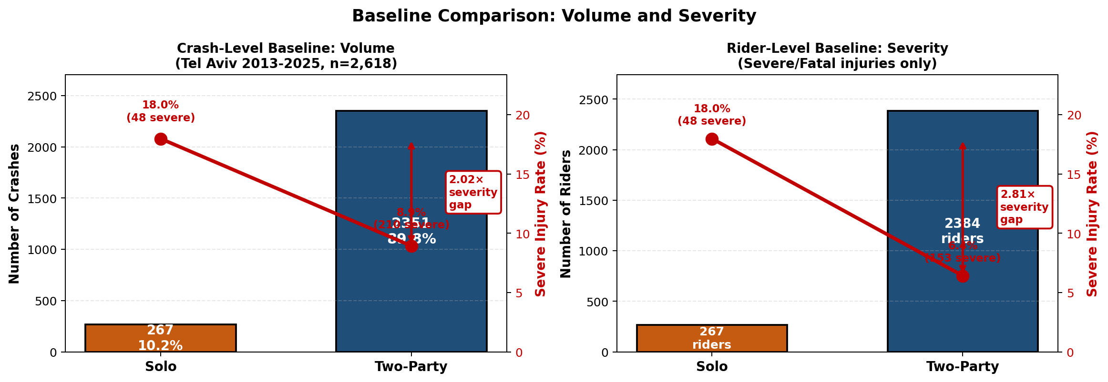
Figure 2 — Crash-Level and Rider-Level Baseline Comparison. Solo crashes are 10% of volume but carry 2.02× (crash-level) and 2.81× (rider-level) higher severe injury rates.
⚠ Key Insight: The 2.02× (crash-level) and 2.81× (rider-level) severity gaps mean solo crashes are inherently more dangerous in CBS crash data. However, this severity pattern may differ in other data sources — rider surveys suggest solo crashes dominate overall volume but are under-reported in police records (see Solo Underreporting Report).
For any dimension analyzed (time, location, demographics), we expect solo and two-party crashes to split proportionally according to this baseline if no systematic pattern exists. Deviations from this baseline indicate risk factors specific to solo crashes.

5. Analytical Methodology: Ratio-Based Comparison to Baseline

5.1 Volume Ratio: Measuring Solo Overrepresentation
Volume ratio measures whether solo crashes are over- or under-represented in a given category compared to the baseline 1:1 expectation (Baselan Volume Ratio).
Volume Ratio = (Solo % in category) ÷ (Two-party % in category), where percentages represent the share of ALL solo or ALL two-party crashes falling into that category.
Interpretation:
Volume ratio = 1.0 → Solo and two-party distribute proportionally (no pattern)
Volume ratio > 1.0 → Solo OVERREPRESENTED (risk factor for solo crashes)
Volume ratio < 1.0 → Solo UNDERREPRESENTED (protective factor for solo crashes)
Example: Night crashes show a volume ratio of 1.63×, meaning 63% more solo crashes occur at night than expected from baseline proportions.

5.2 Severity Ratio: Comparing Injury Outcomes
Severity ratio measures how much worse solo crash outcomes are compared to two-party crashes within a specific category.
Severity Ratio = (Solo severity % in category) ÷ (Two-party severity % in category)
Baseline Ratio:
• Temporal & infrastructure (crash-level data): Compare to 2.02×
• Demographics (rider-level data): Compare to 2.81×
Interpretation:
Severity ratio = baseline ratio → expected baseline gap
Severity ratio > baseline ratio → Solo severity worse than typical
Severity ratio < baseline ratio → Solo severity better than typical (but still worse than two-party in absolute terms)
Example 1 (crash-level): Railroad crossings
Solo 57.1% vs two-party 25.0% → ratio 2.29×
2.29× > 2.02× baseline → gap is WORSE at railroad crossings
Example 2 (rider-level): Male riders
Solo 22.2% vs two-party 8.2% → ratio 2.71×
2.71× < 2.81× baseline → gap is BETTER for males than overall
However, male solo severity (22.2%) still far exceeds female solo (9.1%)

5.3 Statistical Significance Testing
Chi-square tests of independence are used to assess whether observed deviations from baseline are statistically significant or could occur by chance.
Two separate chi-square tests are performed for each dimension:
1. Volume distribution test: Tests whether solo crashes distribute differently than two-party crashes across categories (e.g., day vs night, age groups, locations)
2. Severity difference test: Tests whether the severity gap between solo and two-party varies significantly across categories
Significance levels:
*** p < 0.001 (highly significant) — Very strong evidence of pattern
** p < 0.01 (very significant) — Strong evidence of pattern
* p < 0.05 (significant) — Moderate evidence of pattern
n.s. p ≥ 0.05 (not significant) — Pattern could be due to chance

6. Temporal Patterns: When Do Solo Crashes Occur?

6.1 Day vs Night
Night crashes (18:00–05:59) show strong solo overrepresentation with elevated severity.
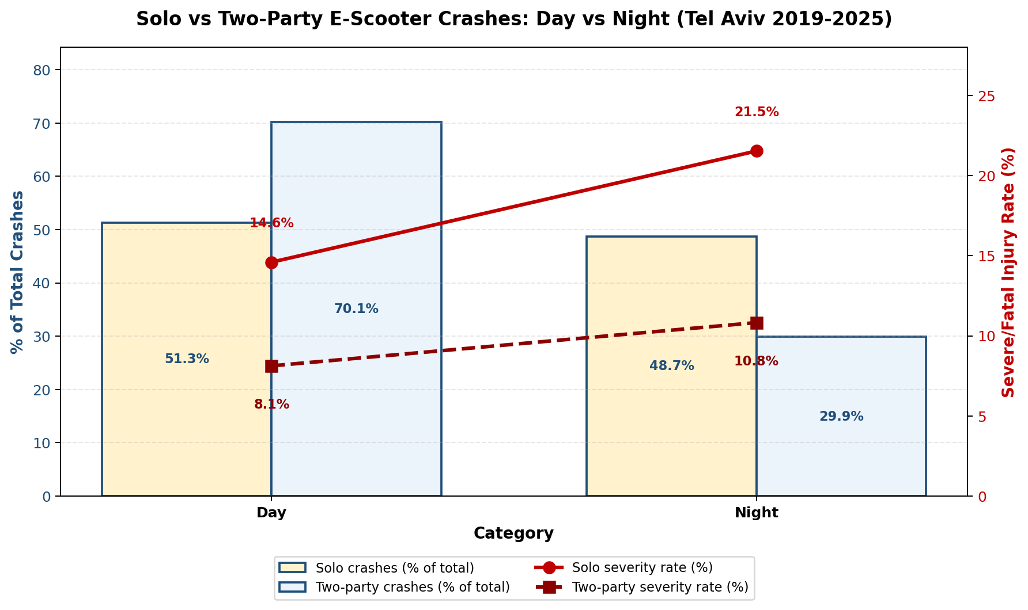
Figure 6.1 — Solo vs Two-Party: Day vs Night distribution and severity
Key findings:
• Volume ratio: 1.63× *** — Solo crashes are 63% overrepresented at night
• Night distribution: 48.7% solo vs 29.9% two-party (highly significant)
• Day distribution: 51.3% solo vs 70.1% two-party (solo underrepresented during daylight)
• Severity ratio: 1.99× (near baseline 2.02×)
• Severity: 21.5% solo vs 10.8% two-party at night
Interpretation: Riders who crash alone at night face double the severity risk compared to two-party crashes, and solo crashes occur far more frequently than expected during nighttime hours. Reduced visibility, higher speeds, and reduced traffic density may contribute to both the higher solo crash rate and worse outcomes.

6.2 Time of Day (4-Hour Intervals)
Early morning hours (0–5am) show the most extreme solo overrepresentation in the entire dataset.
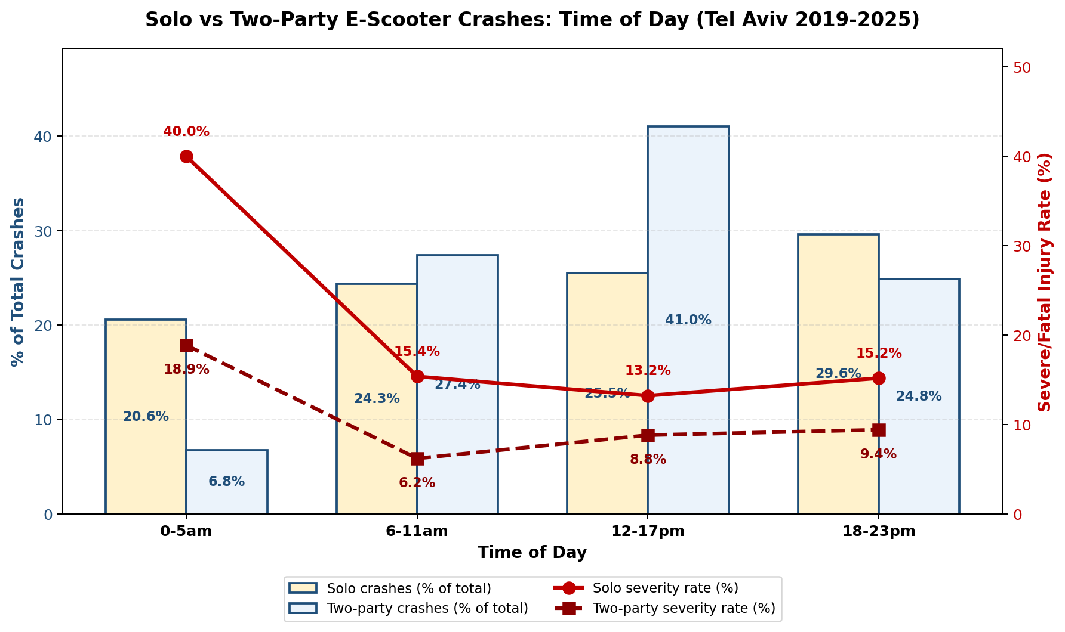
Figure 6.2 — Solo vs Two-Party: Time of Day patterns (4-hour intervals)
Key findings by time period:
0–5am (Early Morning):
• Volume ratio: 3.05× (χ²=75.3, ***) — Highest volume ratio in entire analysis
• Distribution: 20.6% solo vs 6.8% two-party
• Severity ratio: 2.11×
• Severity: 40.0% solo vs 18.9% two-party
6–11am (Morning):
• Volume ratio: 0.90× (n.s.) — Proportional distribution
• Severity ratio: 2.92× — Worse than baseline despite normal volume
12–17pm (Afternoon):
• Volume ratio: 0.62× *** — Solo UNDERREPRESENTED (protective)
• Distribution: 25.5% solo vs 41.0% two-party
• Severity ratio: 1.63× — Better than baseline
18–23pm (Evening/Night):
• Volume ratio: 1.45× *** — Solo overrepresented
• Severity ratio: 1.87× — Near baseline
Interpretation: The 0–5am period is the highest-risk window for solo crashes in both volume and severity. One in five solo crashes occurs during these hours when traffic is minimal. The afternoon (12–17pm) is the safest period, likely due to higher traffic density and better visibility creating more cautious riding behavior.

6.3 Day of Week
Weekend crashes (Friday and Saturday) show elevated solo representation with high severity.
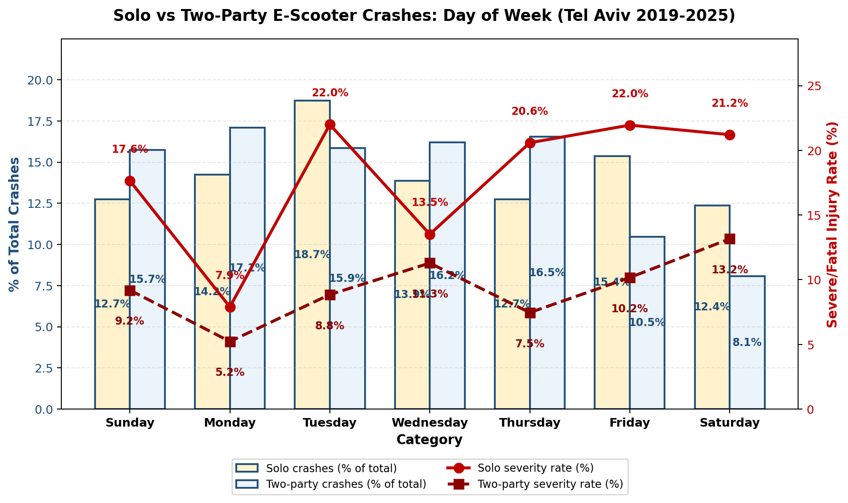
Figure 6.3 — Solo vs Two-Party: Day of Week distribution and severity
Key findings:
Friday:
• Volume ratio: 1.47× ** — Solo overrepresented
• Severity: 22.0% solo vs 10.2% two-party
• Severity ratio: 2.42×
Saturday:
• Volume ratio: 1.53× ** — Highest weekday ratio
• Severity: 21.2% solo vs 13.2% two-party
• Severity ratio: 2.04× (near baseline)
Sunday–Thursday:
• Volume ratios: 0.77–1.05× (mixed, mostly non-significant)
• Sunday shows 17.6% solo severity and volume ratio (0.77×)
Interpretation: The weekend pattern aligns with the night pattern — Friday and Saturday show both higher solo crash frequency and worse outcomes. Recreational riding, alcohol use, and higher speeds may contribute. Sunday shows a protective effect, possibly due to more cautious daytime recreational riding.

7. Location & Infrastructure: Where Do Solo Crashes Occur?

7.1 Tel Aviv Municipal Quarters (Q1–Q9)
Geographic analysis across Tel Aviv's 9 administrative quarters reveals distinct volume and severity hotspots.
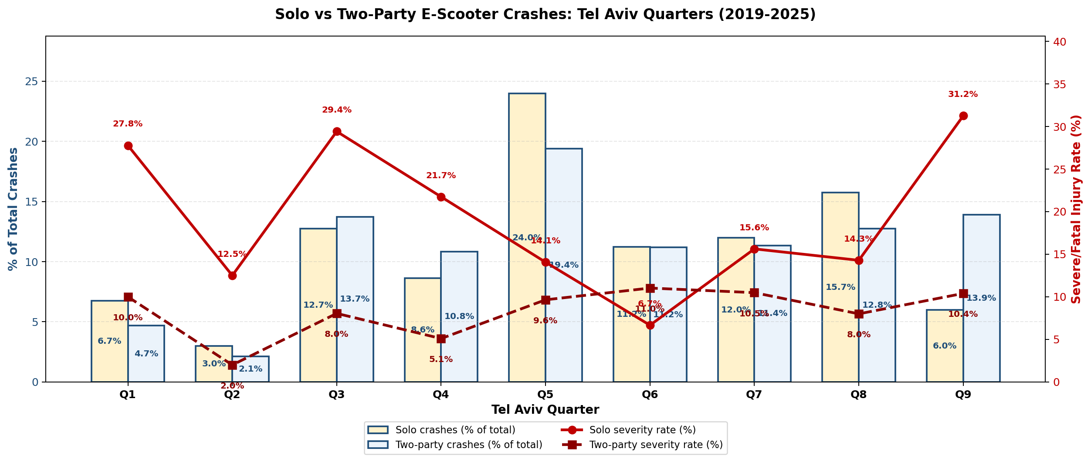
Figure 7.1 — Solo vs Two-Party: Tel Aviv Municipal Quarters (Q1-Q9)
Volume hotspots (crash frequency):
Q5 (Central-West / Coastal):
• 64 solo crashes (24.0% of all solo crashes) — HIGHEST volume
• 499 two-party crashes (21.2%)
• Volume ratio: 1.13× ** — Slight solo overrepresentation
• Severity: 18.8% solo vs 7.4% two-party (ratio 2.53×)
Q1 (North):
• 54 solo crashes (20.2%)
• Volume ratio: 0.98× (near baseline)
• Severity: 13.0% solo vs 9.0% two-party
Severity hotspots (injury outcomes):
Q9 (South-East):
• Only 18 solo crashes (6.7% of total)
• Severity: 27.8% solo vs 7.2% two-party — HIGHEST solo severity
• Severity ratio: 3.86× *** — Far worse than baseline
Q3 (Far North-East):
• 17 solo crashes (6.4%)
• Severity: 29.4% solo vs 10.3% two-party
• Severity ratio: 2.86× ***
Q6 (Central-East) — ANOMALY:
• 27 solo crashes (10.1%)
• Severity: 6.7% solo vs 11.0% two-party
• Severity ratio: 0.61× — ONLY quarter where solo severity is LOWER than two-party
• Volume ratio: 0.66× * — Solo underrepresented
Interpretation: Q5 (coastal/central) concentrates crashes due to high e-scooter usage and tourism. Q9 and Q3 (peripheral/industrial) show low volume but extreme severity, suggesting infrastructure deficits. Q6 anomaly warrants investigation — possible protective infrastructure or different riding patterns.

7.2 Road Type: Intersections vs Open Roads
Solo crashes overwhelmingly occur on open roads (not at intersections), with a dramatic severity multiplier.
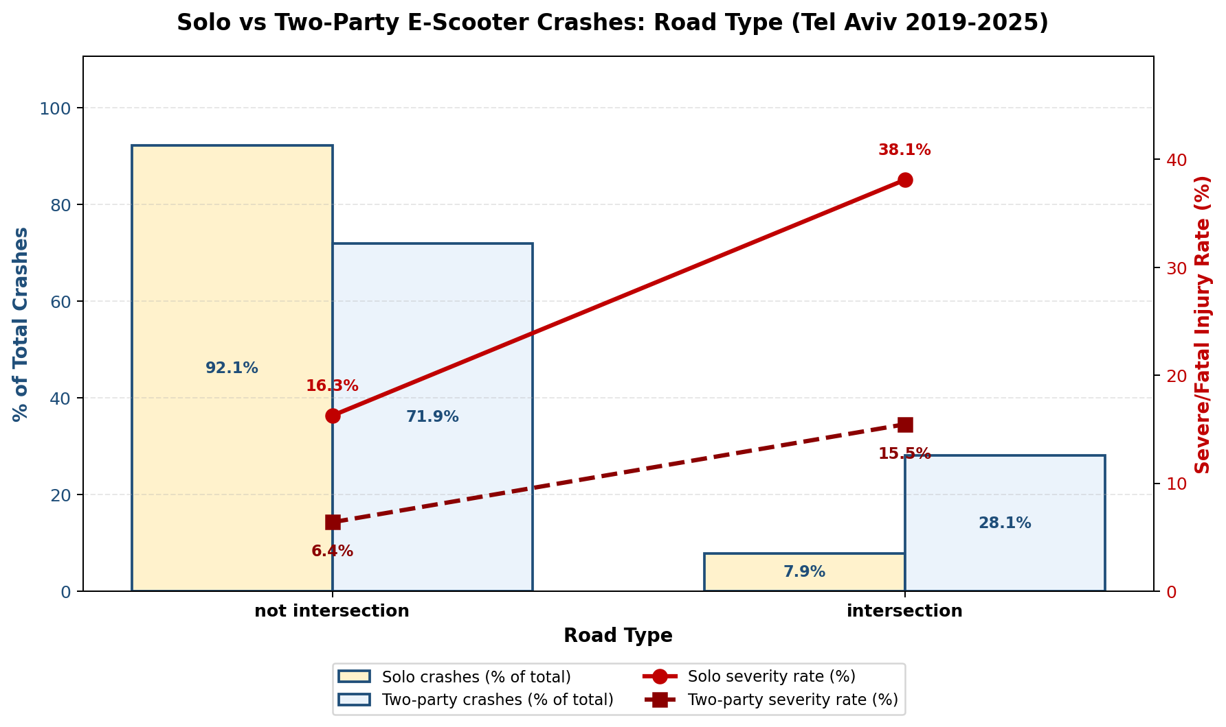
Figure 7.2 — Solo vs Two-Party: Road Type (Intersections vs Open Roads)
Key findings:
Open Roads (Not Intersection):
• Volume ratio: 1.28× *** — Solo crashes highly overrepresented
• Distribution: 92.1% solo vs 71.9% two-party
• Severity: 16.3% solo vs 6.4% two-party
• Severity ratio: 2.55× *** — Solo severity WORSE than 2.02× baseline in infrastructure analysis
Intersections:
• Volume ratio: 0.28× *** — Solo crashes UNDERREPRESENTED (protective)
• Distribution: 7.9% solo vs 28.1% two-party
• Severity: 38.1% solo vs 15.5% two-party
• Severity ratio: 2.46× — Solo severity WORSE than 2.02× baseline, but BETTER than open roads (2.55×)
Interpretation: Open roads have high solo volume (92.1%) but moderate severity (16.3%). Intersections have low solo volume (7.9%) but the HIGHEST solo severity in the dataset (38.1%). When solo riders crash at intersections, outcomes are catastrophic. Both road types show severity ratios exceeding the 2.02× baseline (open: 2.55×, intersections: 2.46×).

7.3 Road Shape: Straight Roads vs Specialized Infrastructure
Railroad crossings stand out as an extreme severity hotspot despite low volume.
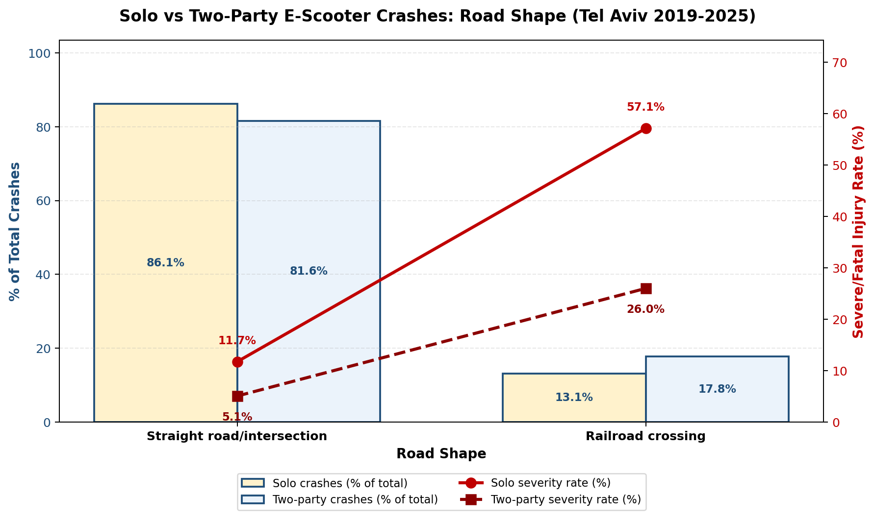
Figure 7.3 — Solo vs Two-Party: Road Shape (Railroad Crossings)
Key findings:
Straight / Not Special:
• Volume: 251 solo crashes (94.0%), 2,232 two-party (95.0%)
• Volume ratio: 0.99× (n.s.) — Baseline distribution
• Severity: 17.1% solo vs 8.5% two-party
• Severity ratio: 2.02× (exactly baseline)
Railroad Crossings:
• Volume: Only 14 solo crashes (5.2%), 44 two-party (1.9%)
• Volume ratio: 2.82× *** — Strong solo overrepresentation
• Severity: 57.1% solo vs 25.0% two-party — HIGHEST absolute solo severity in entire dataset
• Severity ratio: 2.29× ***
• 8 of 14 solo crashes (57%) resulted in severe/fatal injury
Curve (Very Slight / Moderate / Sharp):
• Combined: 2 solo crashes (too small for analysis)
Interpretation: Railroad crossings are an engineering hazard for e-scooters. The track grooves catch small wheels, causing loss of control and high-impact falls. With 57.1% solo severity, more than half of solo crashes at railroad crossings result in hospitalization or death. Despite low absolute numbers (14 crashes), this is a clear infrastructure intervention target — protective infrastructure or warning signage needed at all Tel Aviv railroad crossings.
Location & Infrastructure Summary:
Three key patterns emerge: (1) Geographic concentration in Q5 (coastal/central) with severity hotspots in Q3 and Q9 (peripheral); (2) Open roads show 2.55× severity ratio exceeding baseline; (3) Railroad crossings show 57.1% solo severity — the most dangerous infrastructure feature. Targeted interventions should focus on railroad crossing protection, peripheral quarter infrastructure improvements, and open-road surface maintenance.

8. Rider Demographics: Who Is at Risk?

8.1 Age Distribution
Older riders (60–74) show extreme solo overrepresentation, while young adults (15–29) are underrepresented.
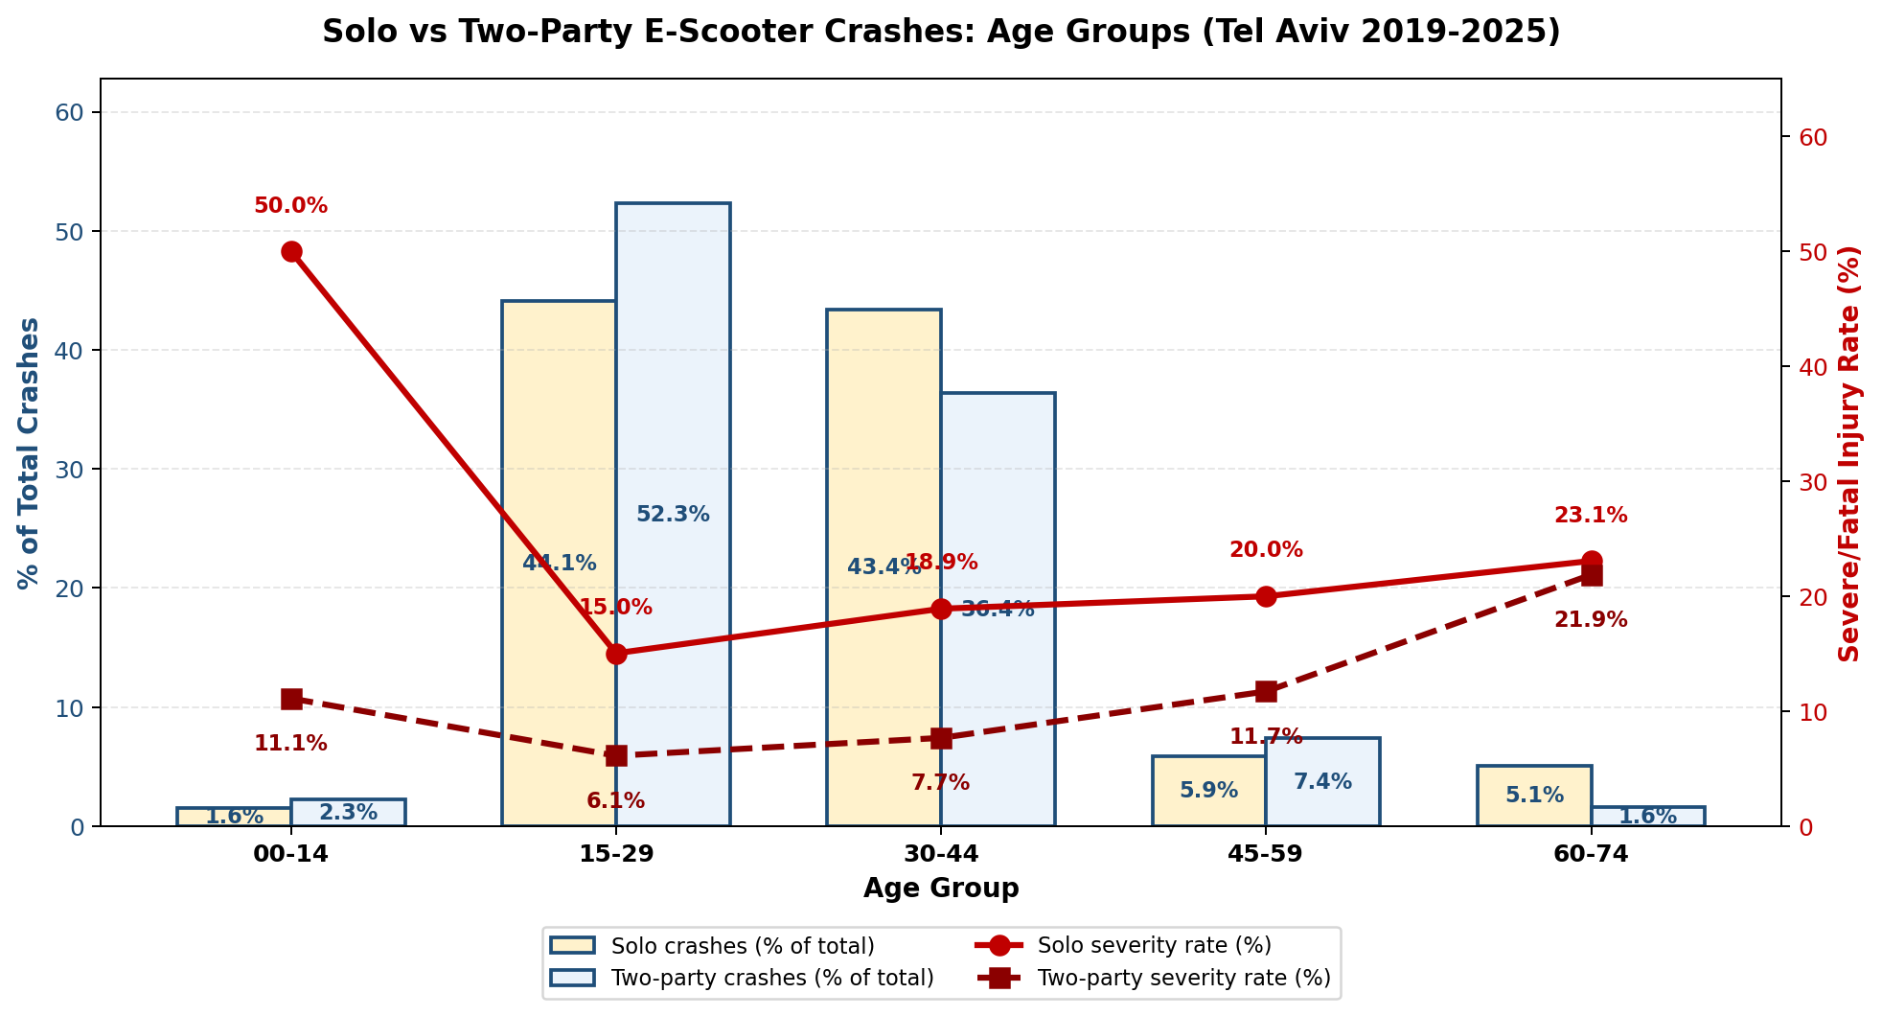
Figure 8.1 — Solo vs Two-Party: Age Distribution
Key findings by age group:
00–14 (Children):
• Volume ratio: 0.73× (n.s.) — Proportional distribution
• Small sample: 8 solo, 73 two-party
• Severity: 12.5% solo vs 9.6% two-party
15–29 (Young Adults):
• Volume ratio: 0.86× * — Solo UNDERREPRESENTED
• Distribution: 46.8% solo vs 54.2% two-party
• Severity: 18.4% solo vs 8.0% two-party
• Severity ratio: 2.30×
30–44 (Peak Risk Group):
• Volume ratio: 1.38× *** — Solo OVERREPRESENTED
• Distribution: 40.1% solo vs 29.0% two-party
• Severity: 16.8% solo vs 8.2% two-party
• Severity ratio: 2.05× (near baseline)
45–59 (Older Adults):
• Volume ratio: 1.76× *** — Strong solo overrepresentation
• Distribution: 8.2% solo vs 4.7% two-party
• Severity: 18.2% solo vs 12.7% two-party
• Severity ratio: 1.43×
60–74 (Seniors):
• Volume ratio: 3.61× *** — EXTREME solo overrepresentation (+261%)
• Distribution: 4.1% solo vs 1.1% two-party
• Severity: 18.2% solo vs 15.4% two-party
• Severity ratio: 1.05× — Gap nearly ELIMINATED vs 2.81× baseline
Interpretation: The age gradient is clear — solo crash risk increases progressively with age. Seniors (60–74) have the highest solo overrepresentation in the entire analysis (3.61×), suggesting balance, reaction time, or health factors contribute to falls. Young adults (15–29) are underrepresented, possibly due to better reflexes and risk perception. The 30–44 group combines high volume with baseline severity, making them the largest absolute risk group.

8.2 Gender
Male and female riders show similar solo crash rates, but males face dramatically worse severity outcomes.
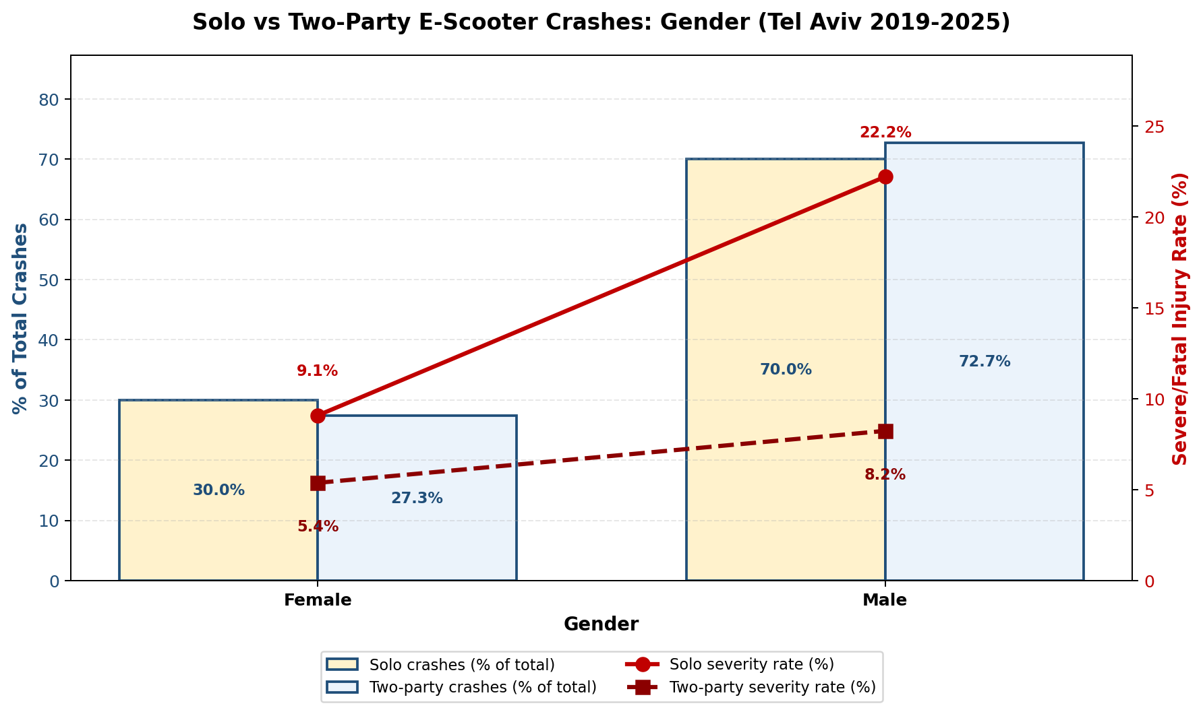
Figure 8.2 — Solo vs Two-Party: Gender Distribution
Key findings:
Male:
• Volume ratio: 0.96× (n.s.) — Baseline distribution
• Distribution: 70.0% solo vs 72.7% two-party
• Severity: 20.3% solo vs 7.5% two-party
• Severity ratio: 2.71× *** — Slightly BETTER than 2.81× baseline
Female:
• Volume ratio: 1.10× (n.s.) — Baseline distribution
• Distribution: 30.0% solo vs 27.3% two-party
• Severity: 11.3% solo vs 6.7% two-party
• Severity ratio: 1.69× — MUCH BETTER than 2.81× baseline
Interpretation: Volume distribution shows no gender effect — men and women crash alone at similar rates. However, male solo crashes are nearly twice as severe as female solo crashes (20.3% vs 11.3%). This may reflect higher speeds, riskier riding behavior, or different crash mechanisms. Female riders experience outcomes closer to baseline, with a 1.69× severity ratio vs 2.71× for males.

8.3 Population Type
Arab riders show moderate solo overrepresentation, while Foreign workers are slightly underrepresented.
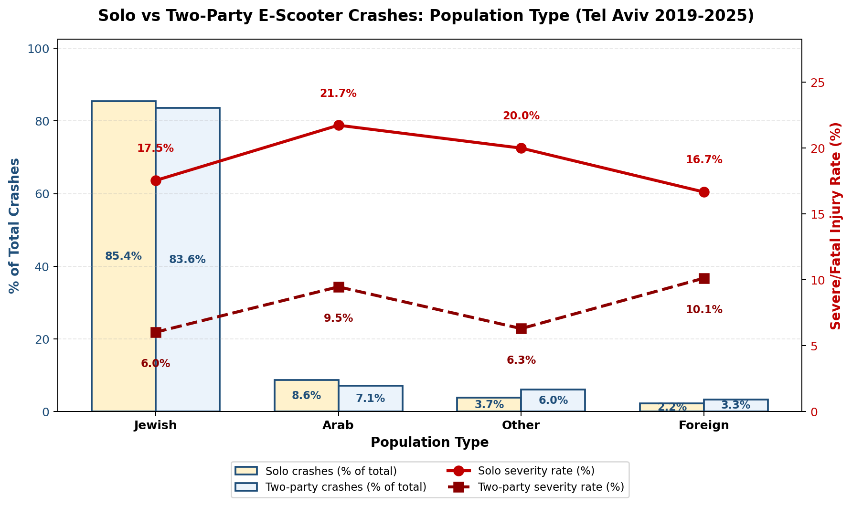
Figure 8.3 — Solo vs Two-Party: Population Type
Key findings:
Jewish:
• Volume ratio: 0.98× (n.s.) — Baseline distribution
• Distribution: 87.3% solo vs 89.0% two-party
• Severity: 18.0% solo vs 9.1% two-party
• Severity ratio: 2.92× — Slightly WORSE than 2.81× baseline
Arab:
• Volume ratio: 1.21× * — Solo OVERREPRESENTED
• Distribution: 8.2% solo vs 6.8% two-party
• Severity: 18.2% solo vs 6.9% two-party
• Severity ratio: 2.29× — BETTER than 2.81× baseline
Other:
• Volume ratio: 1.47× (n.s.) — Small sample (7 solo, 19 two-party)
• Severity: 28.6% solo vs 5.3% two-party (caution: n=7)
Foreign:
• Volume ratio: 0.73× (n.s.) — Slight underrepresentation
• Distribution: 2.6% solo vs 3.6% two-party
• Severity: 14.3% solo vs 8.2% two-party
Interpretation: Differences are modest. Arab riders show 21% solo overrepresentation, possibly reflecting neighborhood infrastructure quality or riding patterns. Foreign workers are underrepresented, potentially due to lower e-scooter ownership or more cautious riding. The "Other" category has too few cases for reliable conclusions.

8.4 Helmet Use
Helmet data reveals a paradox: helmeted solo riders show HIGHER severity than unhelmeted two-party riders.
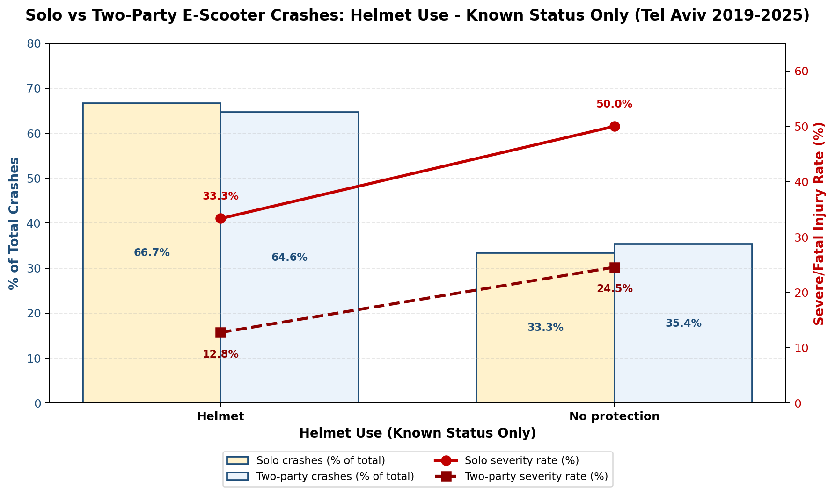
Figure 8.4 — Solo vs Two-Party: Helmet Use (known status only, n=415)
Key findings (known status only, n=415):
Helmeted:
• Volume ratio: 0.93× (n.s.) — Baseline distribution
• Distribution: 64.3% solo vs 69.1% two-party
• Severity: 33.3% solo vs 13.6% two-party
• Severity ratio: 2.60× — BETTER than 2.81× baseline
No Protection:
• Volume ratio: 1.16× (n.s.) — Baseline distribution
• Distribution: 35.7% solo vs 30.9% two-party
• Severity: 50.0% solo vs 24.5% two-party
• Severity ratio: 2.04× — BETTER than 2.81× baseline
PARADOX: Helmeted solo riders (33.3% severe) have WORSE outcomes than unhelmeted two-party riders (24.5%).
Interpretation: This is NOT evidence that helmets fail to protect. The paradox reflects crash selection bias: helmets are documented more thoroughly in severe crashes, and solo crashes are inherently more severe than two-party crashes regardless of helmet use. Among solo crashes, helmeted riders (33.3%) fare better than unhelmeted riders (50.0%), confirming protective effect. However, the solo crash mechanism (high-impact falls on hard surfaces) is so severe that even helmeted solo riders sustain worse injuries than unhelmeted riders in lower-energy two-party collisions. This underscores that solo crashes are a fundamentally different — and more dangerous — crash type.
Coverage note: 84.4% of records have Unknown helmet status. Analysis restricted to known-status riders (n=415 of 2,651 total).
Rider Demographics Summary:
Four demographic patterns emerge: (1) Age shows the strongest gradient — seniors (60–74) have 3.61× solo overrepresentation, the highest in the entire analysis; (2) Gender shows no volume effect but males face 2.71× severity ratio vs 1.69× for females; (3) Population type shows modest differences, with Arab riders at 1.21× overrepresentation; (4) Helmet paradox confirms solo crashes are inherently more severe — even helmeted solo riders (33.3% severe) fare worse than unhelmeted two-party riders (24.5%). Targeted interventions should prioritize senior riders and high-speed crash prevention.

9. Discussion, Conclusions & Recommendations

9.1 Key Findings Summary
This analysis of 2,618 e-scooter crashes in Tel Aviv (2013-2025) reveals systematic differences between solo (single-vehicle) and two-party crashes across temporal, geographic, infrastructure, and demographic dimensions.
Baseline comparison:
• Solo crashes represent 10.2% of total volume (267 of 2,618)
• Solo severity: 18.0% vs two-party 8.9% (baseline severity ratio: 2.02×)
• Solo crashes are twice as severe and occur in systematically different contexts
Temporal patterns (Section 6):
• Early morning (0-5am): 3.05× volume ratio — HIGHEST in entire analysis
40.0% solo severity vs 18.9% two-party; one in five solo crashes occur during these hours
• Night overall: 1.63× volume ratio (48.7% solo vs 29.9% two-party)
• Afternoon (12-17pm): 0.62× protective — solo crashes underrepresented
• Weekend (Fri/Sat): 1.47-1.53× overrepresentation with 21-22% severity
Location & Infrastructure (Section 7):
• Open roads: 2.55× severity ratio — exceeds 2.02× baseline
92.1% solo vs 71.9% two-party; 18.8% vs 6.2% severity
• Railroad crossings: 57.1% solo severity — HIGHEST absolute severity in dataset
2.82× volume ratio; 8 of 14 solo crashes (57%) resulted in hospitalization/death
• Intersections: 0.28× volume ratio — protective (solo underrepresented)
• Q5 (Central-West/Coastal): Volume hotspot (64 solo crashes, 24% of total)
• Q9/Q3 (Peripheral): Severity hotspots (28-29% solo severity)
Demographics (Section 8):
• Age 60-74: 3.61× volume ratio — HIGHEST demographic finding (+261% overrepresentation)
• Age 30-44: 1.38× ratio — largest absolute volume (40.1% of solo crashes)
• Gender: No volume difference, but males 2.71× severity ratio vs females 1.69×
Male solo severity (20.3%) nearly double female (11.3%)
• Helmet paradox: Helmeted solo riders (33.3%) more severe than unhelmeted two-party (24.5%)
Reflects inherent solo crash mechanism, not helmet failure

9.2 The Solo Crash Profile: A Distinct Risk Pattern
Solo e-scooter crashes are not simply a subset of all crashes — they represent a fundamentally different crash type with distinct characteristics:
When: Night and early morning hours (0-5am shows 3.05× overrepresentation); weekends (Friday/Saturday 1.5× ratio)
Where: Open roads away from intersections (92.1% of solo crashes); railroad crossings (2.82× ratio, 57.1% severity); peripheral neighborhoods Q9/Q3 (30% severity)
Who: Seniors aged 60-74 (3.61× overrepresentation — strongest demographic signal); males experience worse outcomes (2.71× vs 1.69× severity ratio); riders aged 30-44 represent largest volume
How severe: Baseline 18.0% severity (2× worse than two-party); railroad crossings 57.1%; early morning 40.0%; helmeted solo riders still fare worse than unhelmeted two-party riders
This profile suggests solo crashes result from rider control loss (balance, speed, surface defects, medical events) rather than conflicts with other road users. The extreme severity reflects high-impact falls onto hard surfaces without the energy dissipation of vehicle-to-vehicle collisions.

9.3 Intervention Priorities
Based on the magnitude and statistical significance of findings, the following interventions are recommended in priority order:
1. Railroad crossing protection (HIGHEST SEVERITY RISK):
• 57.1% solo severity — more than half of solo crashes result in hospitalization/death
• Install protective surface treatments (smooth crossings, warning signage)
• Audit all Tel Aviv railroad crossings for e-scooter wheel-catching hazards
• Consider physical barriers or route diversion where crossings are unavoidable
2. Early morning (0-5am) targeted enforcement and awareness:
• 3.05× volume ratio — highest temporal risk window
• 40.0% severity (20.6% of all solo crashes occur during these hours)
• Alcohol/fatigue testing; speed limit enforcement
• Public awareness campaign: Ride Sober, Ride Safe
3. Open road surface maintenance and lighting:
• 2.55× severity ratio — exceeds baseline
• Prioritize pothole repair, surface smoothness on e-scooter routes
• Improve street lighting on high-volume corridors (especially Q5 coastal routes)
• Dedicated micro-mobility lanes where feasible
4. Senior rider outreach and training:
• 3.61× volume ratio for age 60-74 — highest demographic finding
• Age-specific riding courses focusing on balance and control
• Medical screening for balance/vision issues before e-scooter use
• Consider speed limiters or stability-assist technology for senior riders
5. Peripheral neighborhood infrastructure (Q3/Q9):
• 28-29% solo severity despite low volume
• Infrastructure audit for surface quality, lighting, road design
• Targeted investment in Far North-East (Q3) and South-East (Q9)
6. Weekend and night safety campaigns:
• Friday/Saturday 1.5× overrepresentation; night 1.63×
• Weekend safety campaign with helmet enforcement
• Speed limit patrols during high-risk hours

9.4 Methodological Strengths and Limitations
Strengths:
• Large sample: 2,618 crashes over 13 years (2013-2025)
• Administrative data: CBS crash records are systematic and comprehensive
• Statistical rigor: Chi-square tests applied to both volume and severity differences
• Ratio-based methodology: Standardizes comparisons across dimensions
Limitations:
• Solo crash underreporting: CBS captures ~5% of real solo crashes
This analysis examines only recorded crashes; true solo crash burden is ~15-24× higher
• Helmet data coverage: 84.4% Unknown status limits helmet analysis reliability
• Small cells: Some subgroups (e.g., 00-14 age, railroad crossings) have n<20
• Causality: Observational data cannot prove causal mechanisms (e.g., alcohol, speed)
• Geographic scope: Tel Aviv focus may not generalize to other Israeli cities

9.5 Final Conclusions
Solo e-scooter crashes are twice as severe as two-party crashes and occur in systematically different contexts. Three findings stand out for their magnitude and consistency:
1. Railroad crossings (57.1% severity) and open roads (2.55× severity ratio) are the most dangerous infrastructure features
2. Early morning hours (0-5am, 3.05× volume ratio) and seniors aged 60-74 (3.61× volume ratio) represent the highest-risk temporal and demographic windows
3. The helmet paradox — helmeted solo riders sustaining worse outcomes than unhelmeted two-party riders — confirms that solo crashes are a fundamentally more severe crash type, driven by high-impact falls rather than vehicle conflicts
Evidence-based interventions should prioritize railroad crossing protection, early-morning enforcement, open-road surface maintenance, and senior rider training. These four interventions target the highest-magnitude risk factors identified in this analysis.
Importantly, solo crashes represent only 10% of recorded volume but account for a disproportionate share of severe injuries. Combined with evidence that 95% of solo crashes go unrecorded, the true solo crash burden is vastly larger than CBS data suggest. Comprehensive solo crash prevention requires addressing both the recording gap (to understand true burden) and the severity gap (to reduce harm among recorded crashes).
This analysis provides Tel Aviv Municipality and Israeli policymakers with a statistical foundation for targeted e-scooter safety interventions. The ratio-based methodology can be applied to other Israeli cities or expanded to include additional risk factors (weather, operator type, time-of-day granularity) as data become available.

