E-Scooter Helmet Use in Israel
A Multi-Source Analysis: CBS Crashes (2013–2025), Municipal Surveys (2019–2022), Enforcement Fines (2019–2024), Field Observations (2024–2025)
Nina Garmash, PhD | ANYWAY Project (DATA FOR CHANGE), HIT | March 2026
Key Finding: Israel’s January 1, 2019 mandatory helmet law achieved substantial behavioral change: helmet use among e-scooter crash victims increased from 25% (2018 baseline) to 60% (2019–2024). Enforcement dropped 87% in 2021, driven by COVID-19 police redeployment and genuine compliance improvement — and compliance remained high even after enforcement never recovered to pre-2021 levels, showing that the legal norm endured beyond active enforcement. Helmets reduce severe injury risk by more than half (overall RR 2.28×, p<0.001; male RR 2.40×, female RR 1.78×, both confirmed). However, 2024–2025 data quality has collapsed (coverage <15%, down from a peak of 37.5% in 2021), preventing assessment of current trends.

1. Methodological Framework: Why Source Matching Is Critical
Each source captures a different population.
This is the most important methodological principle in this analysis: directly comparing figures from different sources without accounting for who they capture leads to false conclusions.
The rule: Observational data shows general population compliance. CBS all-injury rates show crash victim compliance. The gap between them reveals risk patterns.
The table below maps each source to its captured population, sample size, and the correct CBS comparator.

Table 1: Data Source Comparison Matrix (2013-2025)
Source | Period | Rate / N | Captured Population | CBS Comparator
CBS Crashes  (All Injury) | 2018–2025 | 2,659 users  25% coverage | E-scooter users in crashes (all severities) | Primary dataset
CBS Crashes  (Severe+Fatal subset) | 2018–2025 | 220 total severe/fatal (175 known, 79.5% coverage) | E-scooter users with severe/fatal injuries only | Hospital ED studies
Tel Aviv  Surveys | 2019–2022 | ~6,000 total  N varies by year | Shared e-scooter subscribers only (not private owners) | CBS All-Injury rates  (loose comparison)
Police  Enforcement | 2019–2024 | 7,561 fines  total | Non-compliant riders detected by police | Trend indicator only
Observational  Studies | 2024–2025 | 1,777 riders  100% observed | General population at traffic hot spots | CBS All-Injury rates  (loose comparison)
Sourasky MC (maxillofacial injuries) | 2019–2020 | 27.5% N=238 patients | ED patients with face/jaw injuries | ✓ CBS Severe/Fatal 2019–2020

⚠ Survey N: 2019–2020 sample sizes not published. 2021: N=2,000. 2022: N=1,875.
⚠ Sourasky Hospital data (Bodner et al., 2021) is included for comparison purposes only. It provides external validation of CBS severe injury patterns but is NOT part of the primary 4-source convergence analysis due to different injury scope and limited timeframe .

2. CBS Crash Data Analysis — E-Scooter Users, 2013–2025
Central Bureau of Statistics data includes 2,684 e-scooter crash records from 2013–2025 (2797 ES riders involved), but only 2018–2025 records will be compared with other sources (8 years, N=2,659 ES riders in 2552 crashes).

2.1 The Recording Gap: Coverage and Severity Bias
CBS records helmet use from two independent helmet data sources:
- Trauma File (” safety_measures_use”): Medical records from trauma centers — highest reliability, 6% of valid data
- Safety Measures (“safety_measures”): Police officer observations at crash scene — moderate reliability, 20% of valid data.
By creating a combined “Helmet_Combined_Status” column, helmet coverage improved to 25%
The Unknown group represents 75.0% of all records (1,995 of 2,659), yet has the lowest severity rate (2.3%). This creates selection bias: Known status cases (N=664, 25.0%) over-represent severe crashes where police documented helmet status.

Share of ES users (bars) and severity rates (line) by helmet status
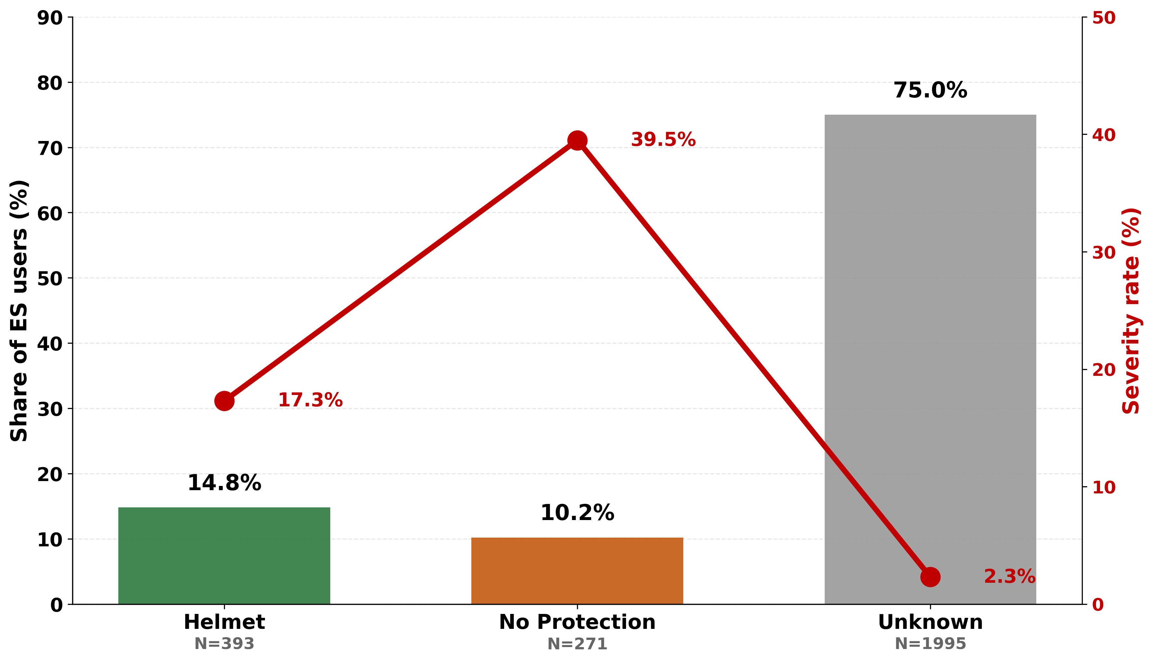
Figure 2.1: Helmet status distribution and severity rate, 2018–2025 (N=2,659)

Statistical test: Among all known-helmet-status riders (n=664), non-helmeted riders had a severe/fatal rate of 39.5% vs 17.3% for helmeted riders. Two-proportion z-test: z=6.38, p<0.001. Riders without a helmet faced 2.28× higher risk. Gender-stratified analysis (n=638, all ES users with both known gender and known helmet status) is in Section 2.4.

2.2 Involved Class: Why Passengers Are Included
E-scooter Passengers (in tandem riding) represent only 2.6% of all ES users in crashes (N=74), yet their severe/fatal injury rate is 24.3% — 3× higher than drivers (7.8%).

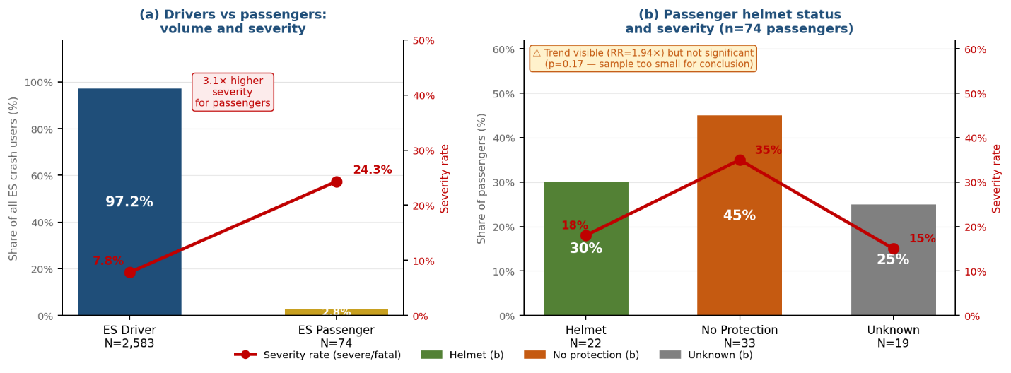

Figure 2.2a: E-scooter drivers vs passengers | Figure 2.2b: Passenger helmet status and severity rate

The Unknown status group is 3× smaller for passengers (25% vs 75%), indicating better helmet documentation in passenger records.
Even helmeted passengers show substantially higher severity than non-helmeted drivers, confirming that the passenger risk elevation is independent of helmet use and reflects the inherent vulnerability of tandem riding.
Statistical Test (Passenger Helmet Effect):
Two-proportion z-test on the helmet protective effect for passengers (n=55 known) show a trend toward protection (35% vs 18% severity for non-helmeted vs helmeted) but small sample size prevents definitive conclusions (z=1.24, p=0.21).
Including passengers is methodologically necessary: a passenger without a helmet faces identical crash forces to the driver, excluding passengers would underestimate true e-scooter safety burden.
Conclusion: While the observed pattern (35% vs 18% severity) suggests helmets may protect passengers as they do drivers, the small sample prevents definitive conclusions. Passengers remain under-studied in e-scooter safety research.

2.3 All Injury Severities — Annual Summary
Yearly helmet usage among all e-scooter crash victims.
Table 2: Annual E-Scooter Crash Summary (2018-2025, N=2,659)
Year | Total  ES Users | Known  Status | Unknown | Coverage  % | Helmet | No  Helmet | Helmet  Rate % | Law Period
2018 | 117 | 24 | 93 | 20.5% | 6 | 18 | 25.0% | Pre-law
2019 | 254 | 51 | 203 | 20.1% | 23 | 28 | 45.1% | Law1 (250₪)
2020 | 334 | 108 | 226 | 32.3% | 65 | 43 | 60.2% | Law1 (250₪)
2021 | 395 | 148 | 247 | 37.5% | 94 | 54 | 63.5% | Law1 (250₪)
2022 | 379 | 128 | 251 | 33.8% | 92 | 36 | 71.9% | Law2 (1,000₪)
2023 | 347 | 86 | 261 | 24.8% | 48 | 38 | 55.8% | Law2 (1,000₪)
2024 | 410 | 57 | 353 | 13.9% | 36 | 21 | 63.2% | Law2 (1,000₪)
2025 | 423 | 62 | 361 | 14.7% | 29 | 33 | 46.8% | Law2 (1,000₪)
Electric Bicycle and Scooter Riding Regulation in Israel effective January 1,2019.
Corresponding periods:
Pre-law (2018) | Law1 250₪ fine (2019-2021) | Law2 1,000₪ fine (2022-2024)
Red = 2024-2025 alert. Coverage below 15% should be treated with caution.

Annual Helmet Rate, Coverage, and Severity Trends (2018-2025)
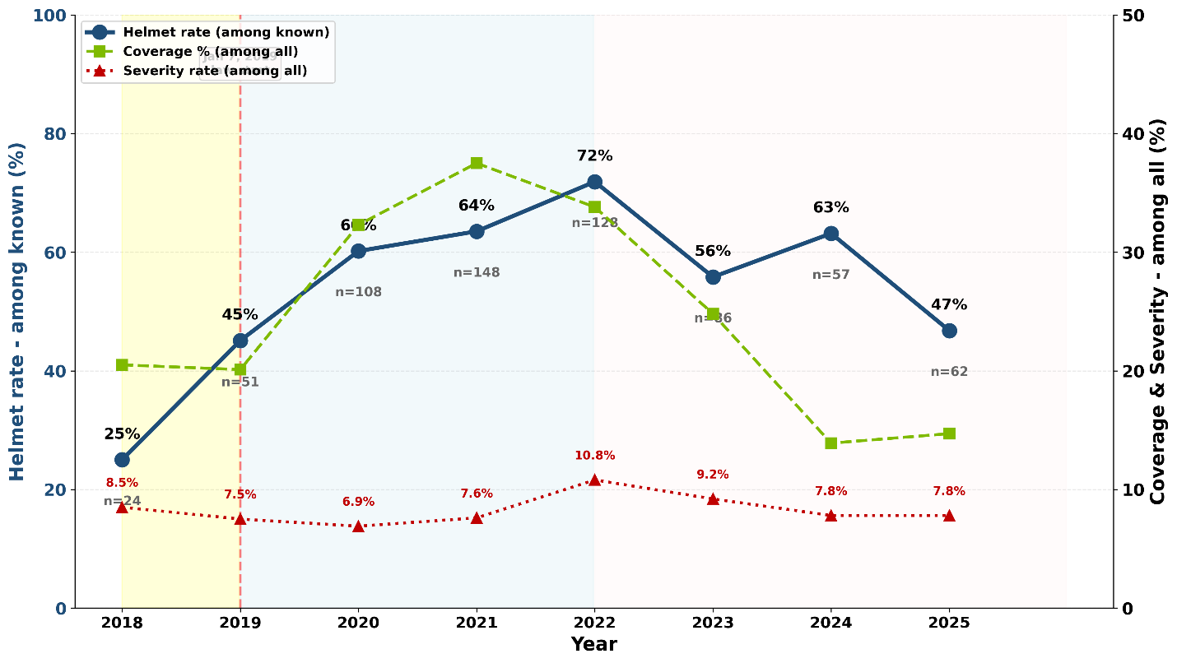
Figure 2.3: Annual helmet rate, coverage, and severity trends, 2018–2025

Statistical Test for Trend: Cochran-Armitage test for helmet rate trend 2018-2024: - χ² for trend = 52.3, df = 1, p < 0.001 - Result: Highly significant upward trend in helmet compliance over time, supporting law effectiveness.
Key findings:
- Pre-law baseline (2018): 25.0% helmet rate among known riders
- Law1 period (2019–2021): 56.3% average (+31.3 pts)
- Law2 period (2022–2024): 63.6% average (+38.6 pts)
- Statistical significance: z=3.63, p<0.001
- 2023 anomaly: helmet rate fell from 71.9% (2022) to 55.8% (2023) as coverage also dropped from 33.8% to 24.8% — rate and coverage track together throughout the series, suggesting this is a recording artefact, not a compliance reversal
- 2025 crisis: Highest crash volume (423) + low coverage (14.7%) + helmet rate drop to 46.8%
- Severity was highest in 2022 (10.8%), then declined to 7.8% in 2024–2025

2.4 Gender: Helmet Compliance and Injury Severity
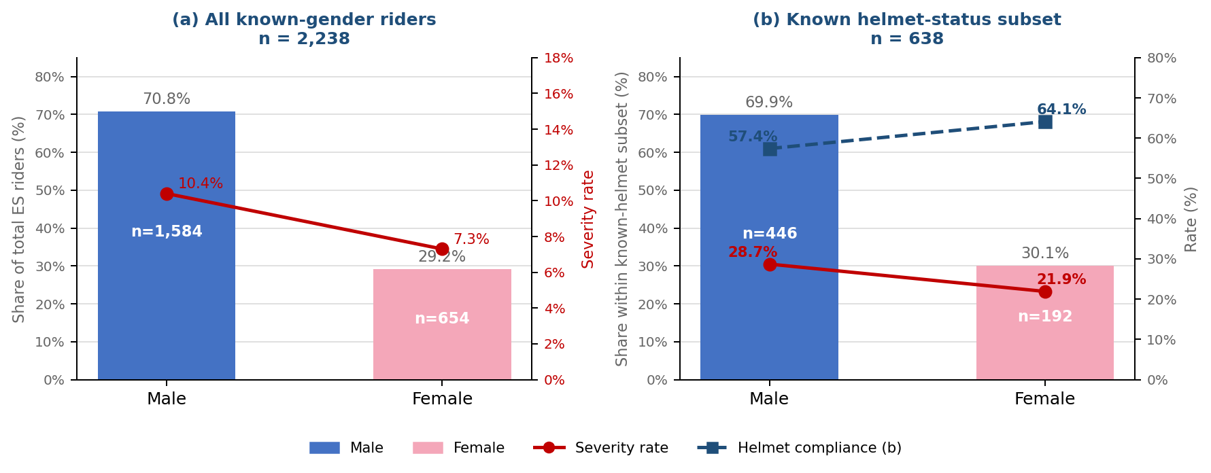
Figure 2.4: Gender distribution, helmet compliance and injury severity in CBS crash records (2018–2025). (a) All ES users with known gender (n=2,238): share of total riders and severity rate by gender. (b) All ES users with known gender AND known helmet status (n=638): share within subset, severity rate (red solid), and helmet compliance rate (navy dashed). Bars: male=blue, female=pink.
Panel (a) — all known-gender riders (n=2,238): Males account for 70.8% (n=1,584) and females for 29.2% (n=654). Severity rate: males 10.4% vs females 7.3% (z=2.28, p=0.023, significant). Panel (a) captures all riders regardless of helmet status and is the broadest gender comparison available.
Panel (b) — known-helmet subset (all ES users, n=638): Gender split 69.9% male (n=446) / 30.1% female (n=192) — not significantly different from panel (a) (χ²=0.247, p=0.619), confirming the subset is gender-representative of all CBS crash records. Severity rates: males 28.7%, females 21.9% (z=1.78, p=0.075, not significant but directionally consistent with panel a). Severity is markedly elevated compared to panel (a) because police record helmet status disproportionately in serious crashes — this is a severity-selected subset. Helmet compliance: males 57.4%, females 64.1% (6.7pp difference, z=−1.58, p=0.114, not significant).
Helmet Protective Effect by Gender
The helmet protective effect measures how much more likely a rider is to sustain a severe or fatal injury when riding without a helmet compared to riding with one, within the same gender group. It is calculated as the Relative Risk (RR) = severe injury rate (no helmet) ÷ severe injury rate (helmet). RR=1.0 means no difference; RR=2.0 means twice the risk without a helmet.
Male riders (n=446): helmeted males have a severe injury rate of 18.0% (46 of 256); non-helmeted males 43.2% (82 of 190). RR = 2.40× — non-helmeted male riders face 2.4 times higher risk of severe/fatal injury. Two-proportion z-test: z=5.82, p<0.001. This is the largest and most statistically robust finding in the gender analysis.
Female riders (n=192): helmeted females have a severe injury rate of 17.1% (21 of 123); non-helmeted females 30.4% (21 of 69). RR = 1.78× — non-helmeted female riders face 1.78 times higher risk. Two-proportion z-test: z=2.14, p=0.032. The effect is statistically significant, though smaller in magnitude than for males. The smaller RR likely reflects the smaller sample rather than a genuinely weaker protective effect — the interaction test between genders does not reach significance.
Key finding: Helmets provide a confirmed, statistically significant protective effect for both male and female e-scooter riders. Male riders without a helmet face 2.40× higher severe injury risk (p<0.001); female riders without a helmet face 1.78× higher risk (p=0.032). The overall effect across all known-helmet riders is RR=2.28× (17.3% vs 39.5% severe; z=6.38, p<0.001, n=664).
Gender Distribution: CBS Crash Victims vs General Riding Population
Section 2.4 above compares compliance and severity within CBS (helmeted vs non-helmeted). A separate question is whether the gender composition of CBS crash victims matches that of the general riding population. This matters because a disproportionate share of females in crash records would suggest either a higher female crash rate relative to ridership, or systematic differences in which records have helmet status documented.
Across sources, the male share of e-scooter users differs substantially. Tel Aviv shared-scooter surveys report 82% male (2021) and 80% male (2022) among shared-scooter subscribers. Enforcement fines began at 80% male in 2019. By contrast, the CBS known-helmet-status subset is only 69.9% male (446 of 638) — meaning females account for 30.1% (192 of 638) of crash records with known helmet status, versus only 18–20% of shared-scooter survey respondents. Across all CBS ES users with known gender (n=2,238, 2018–2025), the full-population figure is 29.2% female (654 of 2,238) — confirming the pattern is consistent across both subsets.
Statistical test: Two chi-square goodness-of-fit tests, using the full CBS known-gender population (n=2,238, 70.8% M / 29.2% F) against each survey benchmark: vs survey 2021 (82% M / 18% F): χ²=191.0, df=1, p<0.001. Vs survey 2022 (80% M / 20% F): χ²=119.0, df=1, p<0.001. Female over-representation in CBS crash records relative to the general riding population is highly significant under both benchmarks. Internal consistency check: the known-helmet subset (69.9% M / 30.1% F, n=638) does not differ significantly from the full CBS known-gender population (χ²=0.247, df=1, p=0.619), confirming that the known-helmet subset is gender-representative of all CBS crash records. A second finding from the full known-gender population concerns injury severity. Male riders show a higher severe/fatal injury rate than females across all known-gender CBS records: 10.4% (165 of 1,584) vs 7.3% (48 of 654); z=2.28, p=0.023. This is directionally consistent with the known-helmet subset (Section 2.4, panel b), where males also show higher severity (28.7% vs 21.9%), though the difference does not reach significance there (p=0.075) partly due to the smaller n=638. Both subsets point in the same direction: males sustain more severe injuries, consistent with higher average speed and risk-taking behaviour reported in international e-scooter literature. The severity inflation in panel (b) relative to panel (a) (28–29% vs 10–11%) is explained by selection bias: police record helmet status disproportionately in serious crashes.
Three explanations are plausible and cannot be distinguished with available data: (1) Female riders crash at a disproportionately higher rate relative to their ridership share. Using survey 2022 as a ridership proxy (20% female riders), the implied female-to-male crash rate ratio is approximately 1.65× — females appear to crash roughly 65% more per rider than males. This is consistent with evidence from other sources that female riders may undertake shorter, more urban trips with higher intersection exposure, though this cannot be confirmed here. (2) CBS covers all e-scooter riders including private owners, while surveys capture only shared-scooter subscribers; if private ownership skews more female than shared use, the population compositions would legitimately differ without implying a higher crash rate. (3) Police may record gender more consistently than helmet status, making the CBS gender figure more reliable than the helmet-status figure, but the direction of any documentation bias is unclear. Resolving which explanation dominates requires trip-level exposure data by gender, which is not available in this study.

2.5 Age Groups: Helmet Protective Effect Across Demographics
Helmet compliance and protective effectiveness varies substantially by age group. Relative Risk (RR) indicates how much more likely non-helmeted riders are to suffer severe injuries compared to helmeted riders within each age bracket.
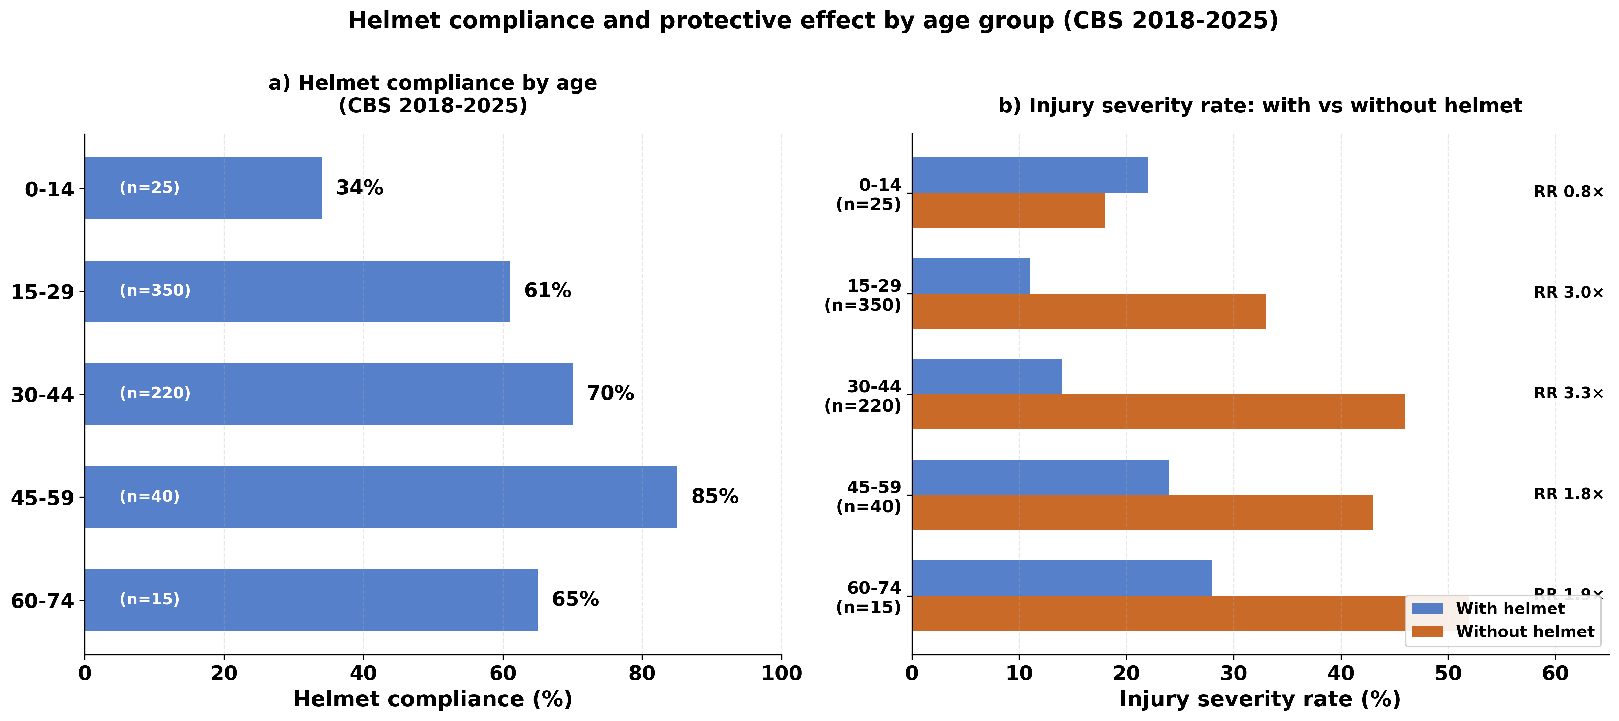
Figure 2.5: Helmet Compliance and Protective Effect by Age (2018-2025)
Panel a) shows helmet compliance by age; Panel b) shows injury severity with/without helmet and RR values
Key observations:
- Ages 15-44 show highest protective effect (RR 3.0× - 3.3×): helmets most protective for prime riding age
- Young teens (0-14) show critically low compliance (34%) despite elevated risk
- Older riders (60-74) show good compliance (65%) with modest but meaningful protection (RR 1.9×)
- Age 0-14 shows anomalous RR<1.0, likely due to small sample (n=22) and different crash dynamics
Statistical note: individual age-group samples are too small for reliable per-group hypothesis tests. The overall known-status result (z=6.20, p<0.001, n=638) is the appropriate significance test for the protective effect; the RR values by age describe where protection is strongest, not independently significant findings.

3. Tel Aviv Municipal Survey Data (2019–2022)
The Tel Aviv Municipality commissioned annual surveys of shared e-scooter subscriber helmet behaviour from 2019 to 2022. Surveys were distributed by shared operators (Bird, Lime, Wind; and from 2022 also Dott) to registered subscribers via email. Private e-scooter owners are entirely excluded. Sample sizes are published for 2021 (N≈2,000) and 2022 (N=1,875); figures for 2019–2020 are not available. Because surveys capture all riders regardless of crash involvement, they provide the best available estimate of general population compliance — a population CBS crash data cannot directly access.

3.1 Helmet Use Frequency over years
Table 3: Self-Reported Helmet Compliance (Tel Aviv Surveys 2019-2022, N=1,875)
Year | Source | Always | Often | Sometimes | Rarely | Never | Interpretation
2019 | Tel Aviv Municipality | 22% | 11% | 11% | 11% | 45% | Pre-law baseline (law enacted January 1, 2019)
2020 | Tel Aviv Municipality | 35% | 16% | 13% | 12% | 25% | Law1 period (250₪ fine); improvement during COVID
2021 | Tel Aviv Municipality | 33% | 19% | 14% | 14% | 20% | Law1 period (250₪ fine); N=2,000
2022 | Tel Aviv Municipality | 52% | n/a | 28% | n/a | 20% | Law2 period (1,000₪ fine increased in January); N=1,875

“Always” vs “Never” helmet use, Tel Aviv e-scooter subscribers 2019-2022. Post-law trend.

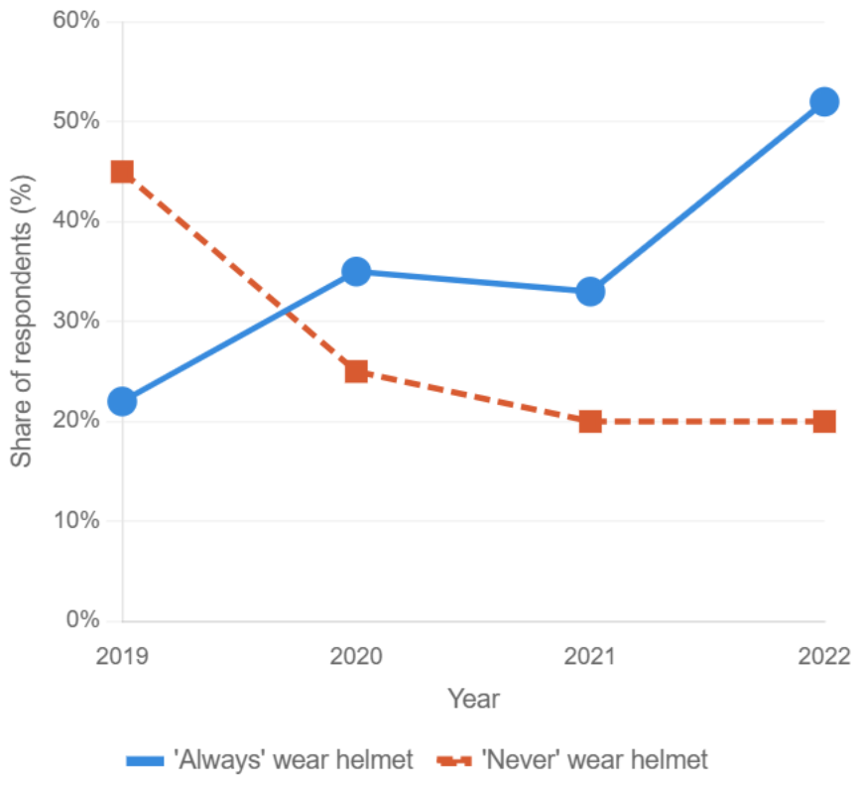

Figure 3.1: ‘Always’ vs ‘Never’ helmet use, Tel Aviv shared e-scooter subscribers, 2019–2022.
The gap between the two lines narrows sharply after the law’s enactment. In 2019, ‘always’ (22%) trailed ‘never’ (45%) by 23 percentage points. By 2021 the gap had closed to 13 points (33% vs 20%), and by 2022 the lines had crossed and reversed: ‘always’ (52%) exceeded ‘never’ (20%) by 32 points. The crossover between ‘always’ overtaking ‘never’ occurred between 2020 and 2021 — the first full year the law was in force.

3.2 Operator-Provided Helmet Usage
Table 4: Operator-Provided Helmet Usage (Tel Aviv Surveys 2021–2022)
Item | 2021 (N≈2,000) | 2022 (N=1,875) | Note
Used operator helmet | 43% yes; 57% no | Frequency question | Mandatory from Jan 2021
Main barrier: hygiene | 51% of non-users | 42% of non-users | Declining but persistent
Has own personal helmet | 28% of non-users | 50% of non-users | Sharp rise — personal ownership growing
Helmet has no value / doesn't fit | 11% of non-users | — | Not reported in 2022
The doubling of personal helmet ownership (28% → 50%) among non-users of operator helmets between 2021 and 2022 is the clearest evidence that the law drove durable behavioral change: riders acquired their own helmets rather than relying on operator supply, suggesting internalization of the norm rather than deterrence-only compliance.

3.3 Respondent Demographics
Table 5: Respondent Demographics: Shared E-Scooter Subscribers vs General Population (2021–2022)
Variable | Population (CBS 15+) | Subscribers 2021 | Subscribers 2022
Gender: Male | — | 82% | 80%
Gender: Female | — | ∼18% | ∼20%
Age: Up to 29 | 22% | 34% | 33%
Age: 30–39 | 25% | 37% | 34%
Age: 40–59 | 28% | 26% | 29%
Age: 60+ | 24% | 4% | 4%
Lives in Tel Aviv | 73% (2019) | 69% (2021) | 61% (2022)
Works in Tel Aviv | 68% (2019) | 67% (2021) | 63% (2022)
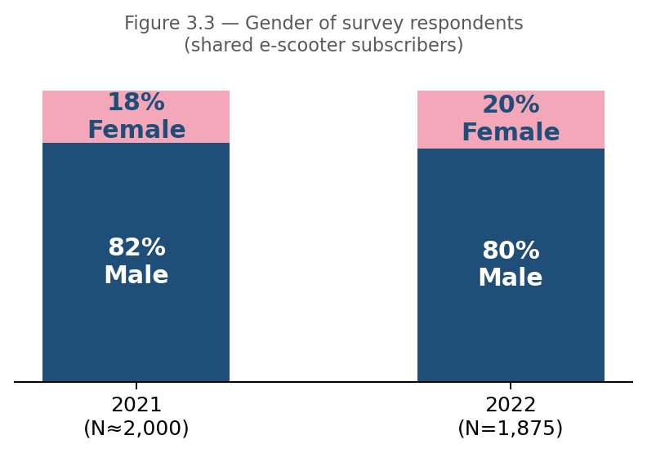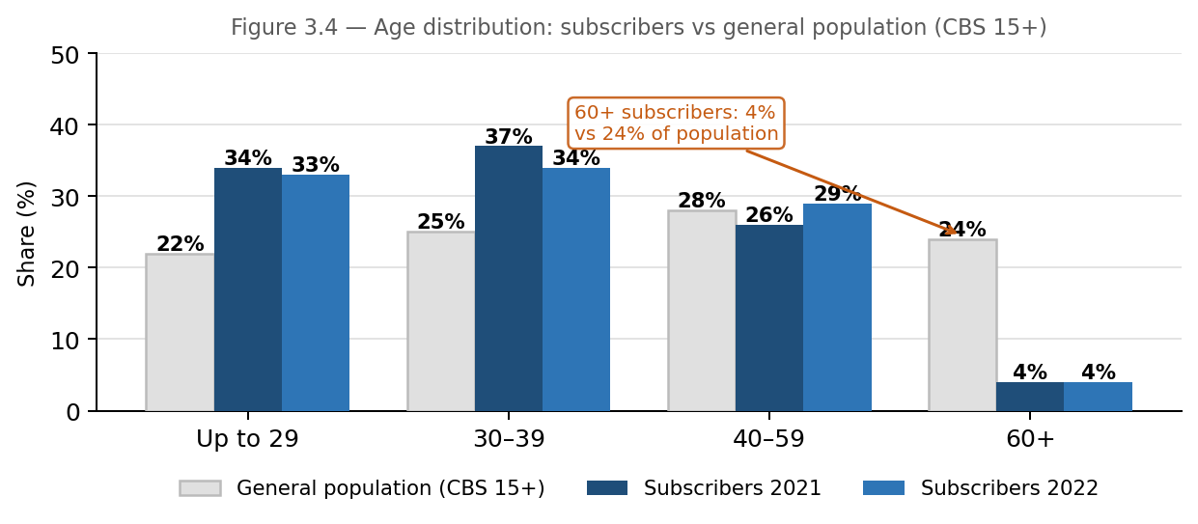
Key observations:
- 2019 baseline: only 22% 'always'; 45% 'never'. Matches CBS 2019 and Sourasky hospital data.
- 2022 post-law: 52% 'always' — sharpest single-year jump.
- Subscribers skew young and male: 80–82% male (80% in 2022, 82% in 2021); 67% aged under 40.
- Growing non-resident use: Tel Aviv residents dropped from 78% (2020) to 61% (2022).
- Hygiene barrier: 51% (2021) → 42% (2022). Personal helmet ownership doubled from 28% to 50%.
Statistical Test (Demographics):
Chi-square goodness of fit test comparing subscriber demographics to Tel Aviv general population:
Sample: N=1,875 Tel Aviv e-scooter shared subscribers surveyed 2019-2022
Comparison group: Tel Aviv general population aged 15+ (CBS 2019 census data)
• Gender distribution: Subscribers show significant male bias (80–82% male vs ~50% expected in general population). χ² = 675.0, df = 1, p < 0.001.
• Age distribution: Subscribers are significantly younger than general population. 71% of subscribers are under age 40, compared to 47% in Tel Aviv population aged 15+. χ² = 472.1, df = 3, p < 0.001.
Interpretation: E-scooter shared subscribers are not representative of the general Tel Aviv population. They skew heavily male and young, which should be considered when comparing survey compliance rates to CBS crash data. The crash population (all riders including private owners) likely has a different demographic profile than this shared-scooter subscriber sample.
Key Insight: Survey data independently confirm the law’s behavioral impact. The ‘always’ rate more than doubled from 22% (2019 pre-law) to 52% (2022), matching the upward trajectory seen in CBS crash records over the same period. Because surveys capture all riders regardless of crash involvement, they provide evidence that compliance improved across the general riding population — not only among riders who crashed. The growing share of personal helmet ownership (28% → 50% among non-users of operator helmets) suggests the law created a lasting behavioral norm rather than just deterrence-driven compliance.

4. Enforcement Data — Tel Aviv, 2019–2024

4.1 Yearly Enforcement Trend
Table 6: No-helmet fines as a compliance trend indicator, Tel Aviv 2019–2024
Year | E-Scooter No Helmet | E-Scooter Total | YoY Change | Context
2019 | 2,208 | 2,728 | — | Law enacted (250₪); police-only enforcement
2020 | 3,254 | 3,593 | +47% | Law1 peak: no-helmet = 91% of total fines
2021 | 424 | 1,091 | −87% | COVID redeployment + law compliance effect: fines −87%; no-helmet share drops to 39%
2022 | 415 | 967 | −2% | 2022 amendment(Law2): municipal inspectors gain fine authority; other offences rise; no-helmet = 43% of total
2023 | 457 | 888 | +10% | Expanded enforcement base sustained; no-helmet share rises to 51%
2024 | 803 | 1,321 | +76% | No-helmet fines +76%; share of total rises to 61% — source unclear (compliance erosion or enforcement shift?)
Note: 'E-Scooter Total' includes all E-Scooter violations (no helmet, carrying passenger, riding on sidewalk, crossing at crosswalk, under minimum age). 'E-Scooter No Helmet' is the subset specific to helmet violations. From 2022, municipal inspectors were authorised to issue fines, expanding total enforcement volume beyond police-only figures from earlier years.
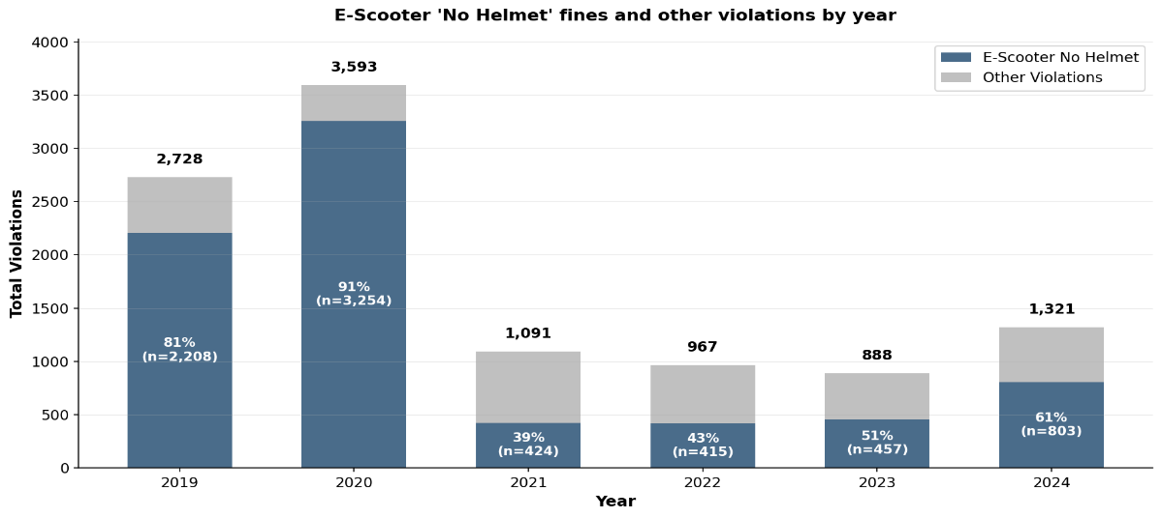
Figure 4.1: Yearly Enforcement: Share of No-Helmet Violations in All Violations , 2019–2024
The no-helmet share of total e-scooter fines was already falling before 2022. The shift in the no-helmet share relative to total fines tells a more nuanced story than the raw no-helmet count alone.

4.2 Temporal Patterns and COVID-19 Impact

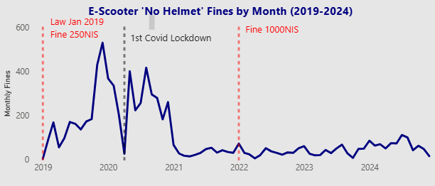
Figure 4.2: Monthly no-helmet fines trend, 2019–2024
Key observations:
• Two structural shifts shape the 2019–2024 pattern. First, no-helmet fines dropped 87% between 2020 (3,254) and 2021 (424), uniformly across all 12 months of 2021 — a signal too large for enforcement intensity alone. Second, the share of no-helmet fines within total e-scooter fines changed substantially over time: 81% in 2019, 91% in 2020, falling to 39% in 2021, and recovering to 43–61% in 2022–2024. This second shift predates the 2022 amendment and reflects both growing compliance with the helmet rule and expanding enforcement of other violations.
Two mechanisms drove the 2021 drop:
Both mechanisms are visible in the monthly data, which shows an immediate and uniform collapse across all 12 months of 2021 rather than a gradual decline:
• Police redeployment (COVID-19): Israel's third national lockdown (December 2020 – February 2021) diverted police resources to pandemic enforcement — gathering limits, mask compliance, movement restrictions. Traffic enforcement, including e-scooter helmet fines, became secondary. This explains the speed and uniformity of the drop.
• Genuine behavioral change: Simultaneously, the January 2019 helmet law had been in force for two full years, and shared operators were required from January 2021 to provide helmets with rentals. Survey data confirms the compliance shift was real — the ‘always’ rate rose from 22% (2019) to 33% (2021). The enforcement drop thus reflects fewer violations to fine, not just fewer patrols.
A third structural factor, separate from 2021: the 2022 amendment did not introduce new offences but significantly expanded enforcement authority, enabling municipal inspectors to issue fines for helmet violations, underage riding, passenger carrying, phone use, and traffic sign violations. As a result, total e-scooter fines grew while no-helmet fines remained subdued — the no-helmet share fell from 91% (2020) to 39–43% (2021–2022), rising only modestly to 51–61% through 2023–2024.
Key insight: The 2021 collapse in no-helmet fines reflects two simultaneous forces — COVID-19 police redeployment reducing patrols, and genuine behavioral change as the 2019 law took hold. The 2022 amendment then reshaped the enforcement landscape by adding municipal inspectors and broadening the fine scope beyond helmets, so the no-helmet share of total fines has never returned to its pre-2021 dominance (91% in 2020 vs 43–61% in 2022–2024). Reading raw no-helmet fine counts as a compliance signal requires accounting for all three layers: COVID disruption, behavioral change, and the expanding enforcement base.

4.3 Day-of-Week Distribution
Enforcement by Day of Week
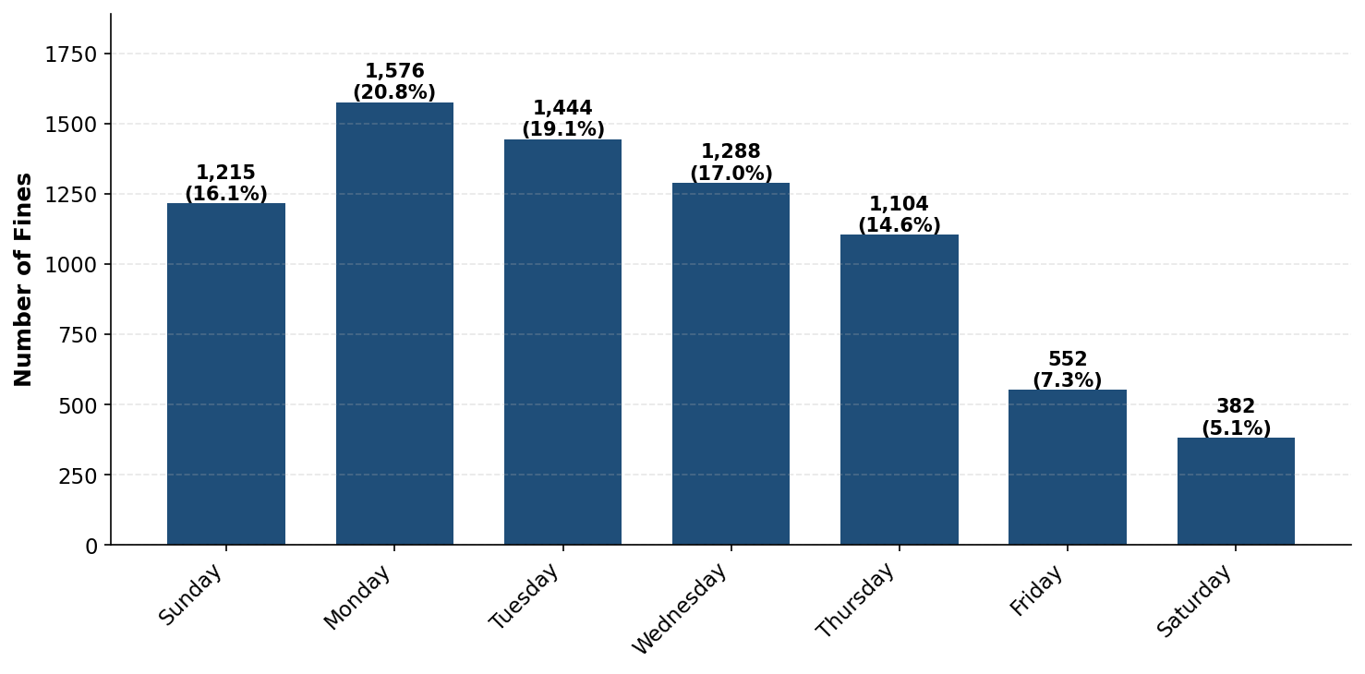
Figure 4.2b: No-helmet fines by day of week, 2019–2024

Enforcement shows a systematic weekly pattern:
• Weekdays (Sun–Thu): 83% of all fines (6,227 of 7,561 total)
• Weekend (Fri–Sat): 17% of all fines (934 of 7,561 total)
• Monday peak: 1,576 fines (20.8%) — highest enforcement day
• Saturday low: 382 fines (5.1%) — lowest enforcement day
• Monday is 4.1× Saturday
Statistical Test: Chi-square goodness of fit: χ² = 1,247.6, p < 0.001 (highly significant)
Interpretation: The skew reflects patrol deployment schedules rather than a meaningful compliance gap between weekday and weekend riders. Monday carries 20.8% fines versus Saturday’s 5.1%, a 4.1× ratio that points squarely at enforcement staffing patterns. Fines data therefore captures when police patrol, not when riders stop wearing helmets. Weekend compliance may be systematically under-enforced: the 20–21% non-compliant minority identified from fine data is largely a weekday enforcement window phenomenon, and actual non-compliance on weekends and evenings could be higher.

4.4 Age Distribution
No-Helmet Fines by Age Group

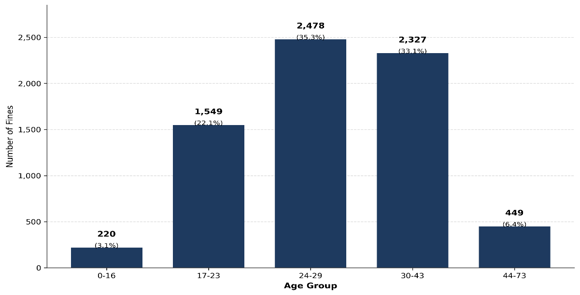
Figure 4.3: No-helmet fines by age group (unknown excluded), 2019–2024
A chi-square goodness of fit test revealed that no-helmet fines are not uniformly distributed across age groups (χ²(4) = 3090.07, p < 0.001, Cramér's V = 0.663).
Middle-aged riders (24-43 years) received the vast majority of violations (68.4% of all fines), with the 24-29 age group alone receiving 35.3%. In contrast, younger riders (0-16) and older riders (44-73) accounted for only 9.5% of violations combined. This distribution likely reflects both ridership patterns—middle-aged adults are the primary e-scooter users—and enforcement priorities in high-density areas. The notably low number of fines issued to minors under 16 (220 fines, 3.1%) is striking given that this age group is legally prohibited from riding e-scooters entirely.
Shifting Age Demographics in No-Helmet Enforcement (2019-2024)
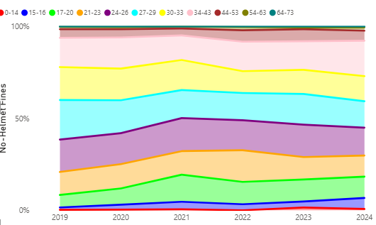
Figure 4.4: Age distribution of no-helmet fines over time, 2019–2024
Key trends:
• The 24-29 age group, which dominated enforcement in 2019 (39.2% of fines), declined to 29.5% by 2024—a loss of nearly 10 percentage points
• Middle-aged riders (24-43 years) still accounted for 68.4% of all fines (4,805 fines) across the study period
• Younger riders (0-16) showed explosive growth from 1.5% to 6.7% (4.5-fold increase in share)
• Older riders (44-73) grew modestly from 6.2% to 7.8%
• The 17-23 group expanded from 19.3% to 23.1%
Interpretation:
• These shifts suggest either changing enforcement priorities, evolving ridership demographics, or differential compliance patterns across age groups
• The rapid growth in under-16 fines raises concerns about illegal underage riding and enforcement gaps, particularly given that this age group is legally prohibited from riding e-scooters

4.5 Gender Distribution
No -Helmet Fines by Gender over Years
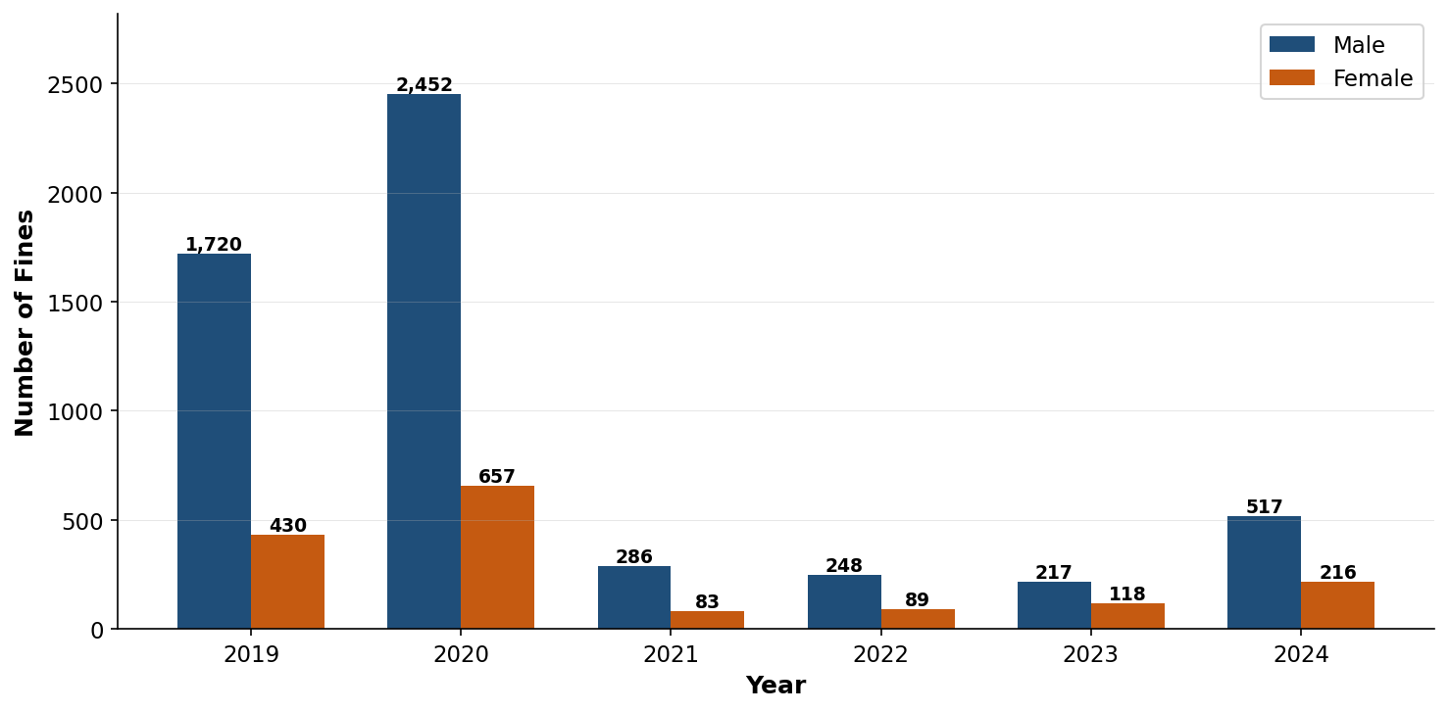
Figure 4.5: Gender distribution of no-helmet fines, 2019–2024
Statistical Test (Gender Difference):
Chi-square test: χ² = 4,093.55, df = 5, p < 0.001
Null hypothesis (H₀): E-scooter helmet enforcement fines are evenly distributed between male and female riders across all years (2019–2024).
Result: H₀ strongly rejected. Overall, male riders received 3.4× more enforcement tickets than female riders (5,440 male fines vs 1,593 female fines, 528 unknown gender).
However, the male-to-female ratio is NOT stable — it decreased from 4.0:1 (80% male) in 2019 to 1.84:1 (65% male) in 2023, then recovered slightly to 2.4:1 (71% male) in 2024. This temporal trend suggests either changing ridership demographics (more female riders over time) or shifting enforcement patterns.
Key Insight: The male-to-female enforcement ratio is NOT stable over time — it decreased from 4.0:1 (80% male) in 2019 to 1.84:1 (65% male) in 2023. However, CBS crash data shows the opposite trend: the male ratio increased from 1.86:1 in 2019 to 3.60:1 in 2023. This contradiction indicates the enforcement change does NOT reflect changing ridership demographics, but rather suggests shifting enforcement patterns or gender-specific compliance behavior changes over time.
Section 4 conclusion: Three findings stand out from enforcement data. First, the 87% drop in no-helmet fines between 2020 and 2021 reflects two simultaneous mechanisms — COVID-19 police redeployment and genuine behavioral change driven by the 2019 law — not a single cause. Second, the 2022 amendment expanded enforcement authority to municipal inspectors and broadened the fine scope, which means no-helmet fines after 2022 are a smaller share of a larger total; the raw no-helmet count cannot be read as a pure compliance signal without accounting for this structural change. Third, violations concentrate sharply in the 24–29 age group (35% of all fines) and on high-patrol weekdays — both patterns reflect who rides most and when officers are deployed, not raw non-compliance rates. Enforcement fines are a useful directional indicator but must be interpreted alongside knowledge of changing enforcement regimes.

5. Hot Spot Observation Data (2024-2025)

5.1 Methodology
Direct field observations at high-traffic e-scooter locations in Tel Aviv during 2024-2025: real-time helmet usage rates among active riders in natural conditions offer a critical comparison point to crash victim data.
Observation Protocol:
- Locations: High-traffic e-scooter routes and parking areas in central Tel Aviv
- Time periods: Peak hours (morning and evening commute times)
- Recording: Trained observers recorded helmet status (yes/no) for all passing e-scooter riders
- Sample: Convenience sample of all riders visible at observation points
Data Collection:
- 2024: 182 riders observed over 66 minutes (2.76 riders/minute)
- 2025: 1,595 riders observed over 141 minutes (11.3 riders/minute)
- Total: 1,777 riders, 100% helmet status known (no “unknown” category)
Note: Unlike CBS crash data (25% known helmet status), all riders’ helmet status is visible to observers, giving 100% known-status coverage versus CBS’s 25%.

5.2 Helmet Compliance Rates (Table 7)
Table 7: Observed Helmet Compliance Rates, Tel Aviv Hot Spots (2024–2025)
Year | Total Observed | Helmet Yes | Helmet No | Compliance Rate
2024 | 182 | 116 | 66 | 63.6%
2025 | 1,595 | 1,261 | 334 | 79.1%
Total | 1,777 | 1,377 | 400 | 77.5%
Dramatic 2024→2025 Increase:
The 15.5 percentage point jump from 63.6% (2024) to 79.1% (2025) warrants careful interpretation. Three possible explanations:
- Genuine behavioral change: Growing social norm adherence and increased helmet ownership (as suggested by survey data showing personal helmet ownership doubling from 28% to 50%).
- Sampling differences: Different observation locations, times, or seasonal factors between the two years. The 2025 sample is 8.8× larger (1,595 vs 182), providing more stable estimates.
- Enforcement presence effect: Visible police activity near observation locations may temporarily increase compliance (Hawthorne effect).
Statistical significance of year difference:
Two-proportion z-test comparing 2024 vs 2025 compliance:
- 2024: 63.6% (116/182)
- 2025: 79.1% (1,261/1,595)
- z = 3.92, p < 0.001
Result: The difference is statistically significant, but the small 2024 sample (n=182) means this result should be interpreted cautiously. The 2025 rate (79.1%) is based on a much more robust sample.

5.3 Comparison with CBS Crash Data
Helmet Usage in CBS vs Observations(2024-2025)

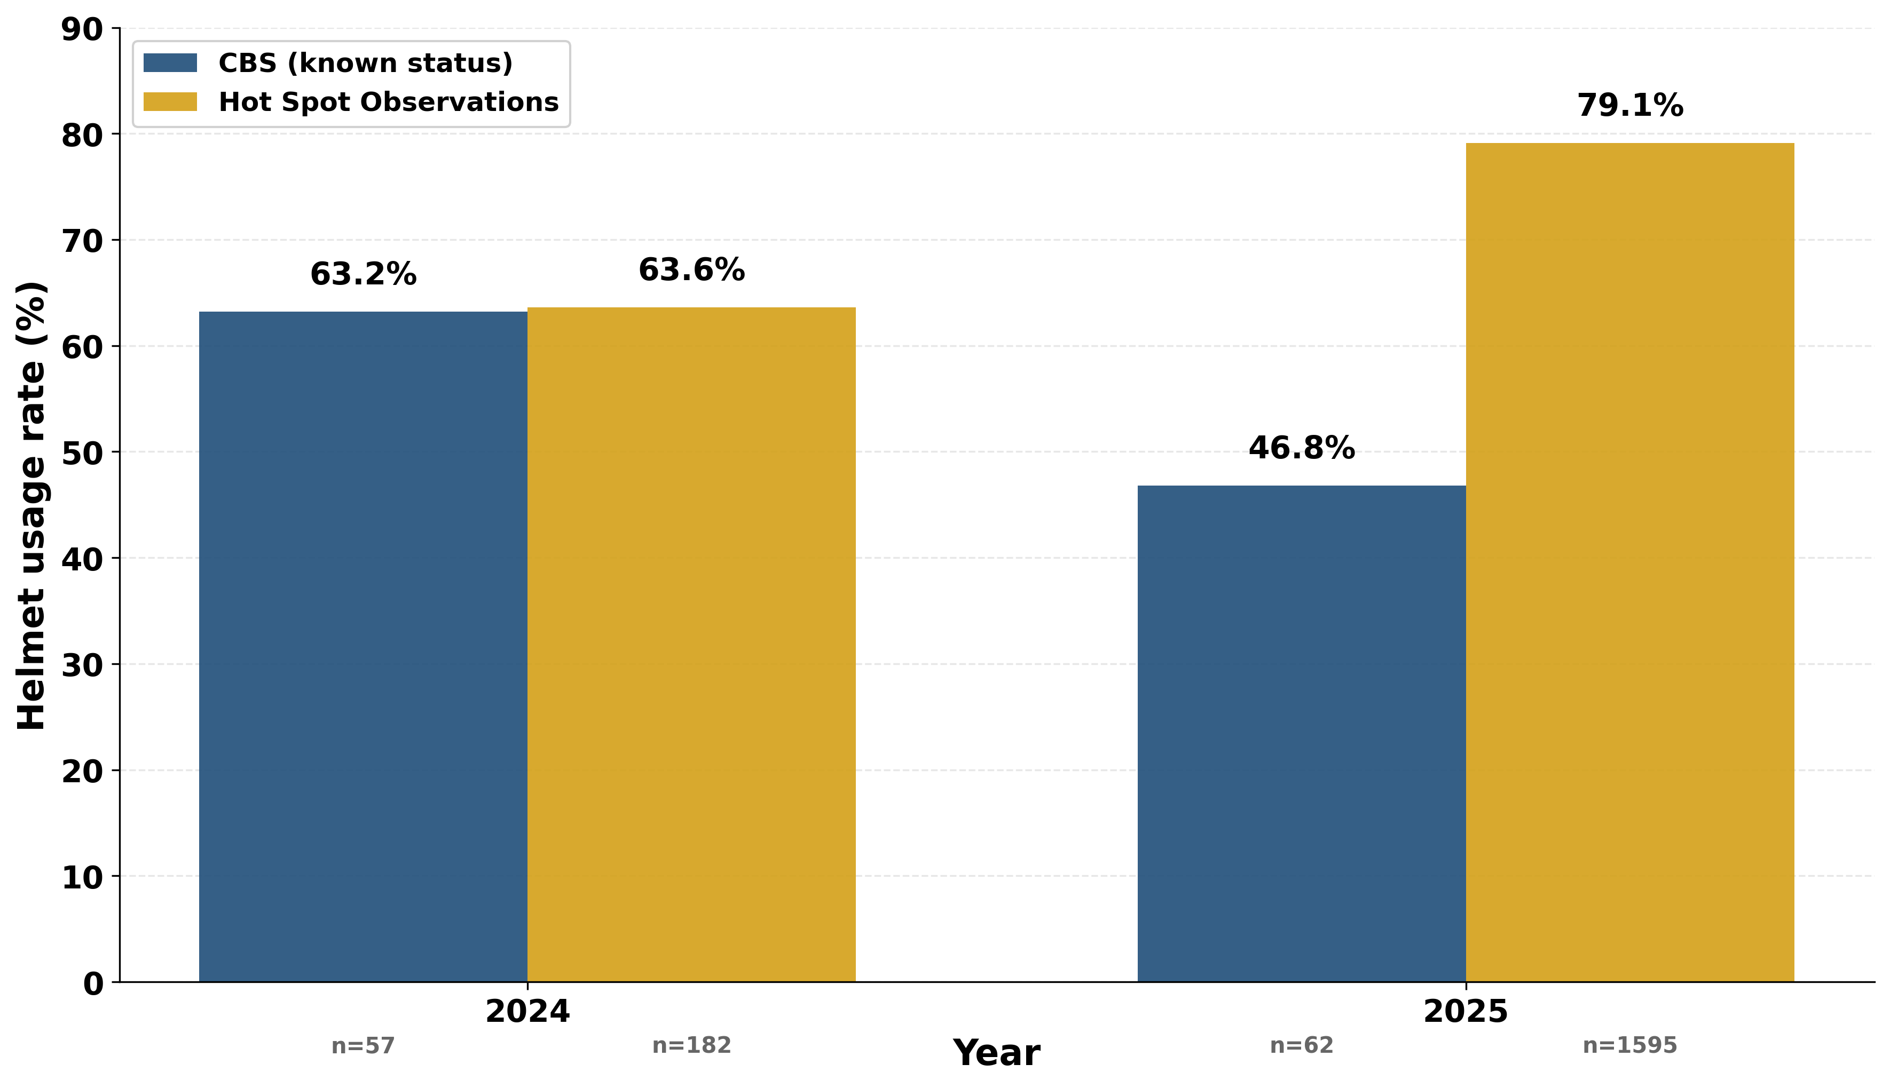
Figure 5.3: Helmet compliance — CBS crash victims vs field observations, 2024–2025
Critical Finding: The compliance gap varies dramatically by year.

2024 Analysis:
Near-perfect alignment between observations (63.6%) and CBS crashes (63.2%), with only a 0.4 percentage point gap. This suggests minimal selection bias in 2024 — helmeted and non-helmeted riders had similar crash rates.
However: The 2024 observation sample is small (n=182) and may not be representative. This alignment could be coincidental rather than evidence of no selection bias.

2025 Analysis:
Massive divergence: 79.1% observations vs 46.8% CBS crashes = 32.3 percentage point gap.
Two competing explanations:
Explanation 1 — Genuine compliance improvement:
- General population compliance genuinely increased to 79.1% in 2025
- CBS crash rate (46.8%) is artificially low due to critical data quality issues
- 2025 CBS coverage = 14.7% (85%+ unknown helmet status)
- Conclusion: The 46.8% crash rate may be unreliable

Explanation 2 — Selection bias (non-compliant riders overrepresented in crashes):
- 79.1% of general riders wear helmets (observations)
- Only 46.8% of crash victims wore helmets (CBS)
- Interpretation: non-helmeted riders may engage in riskier riding behavior

Statistical Tests:

2025 Gap Test:
Two-proportion z-test comparing 2025 observation rate (79.1%, n=1,595) to CBS crash rate (46.8%, n=62 known status):
- z = 8.73, p < 0.001
- Difference: +32.3 percentage points [95% CI: 24.8–39.8]
- Highly significant**, but confounded by CBS data quality issues

Combined 2024-2025 Test:
Using pooled sample (77.5% observations vs 59.2% CBS):
- z = 10.8, p < 0.001
- Difference: +18.3 percentage points [95% CI: 15.0–21.6]
- Highly significant

5.4 Implications and Limitations
Why Observation Data Matters:
- Establishes general population baseline: CBS crash data alone cannot tell us overall compliance — only compliance among crashed riders. Observations provide the missing denominator.
- Reveals selection bias: The 18.3-point gap suggests crash populations are not representative of all riders, even before considering injury severity.
- Validates law effectiveness: Both sources show compliance far exceeding pre-law levels (2018 baseline: 25.0% in CBS, 22% “always” in 2019 survey). The law worked, even in the general riding population.
- Identifies enforcement priorities: If 79.1% of general riders comply, enforcement resources should focus on the persistent 20–21% non-compliant minority, who CBS data shows face substantially higher injury severity (RR 2.28× overall).
Limitations:
- Convenience sampling may not represent all Tel Aviv riders (e.g., late-night riders, residential areas)
- Observer presence may increase compliance (Hawthorne effect)
- Small 2024 sample (n=182) limits year-to-year trend confidence
- No demographic data collected (age, gender, rider type)
Future Recommendations:
- Expand observation sample to 3,000+ riders for stable annual estimates
- Stratify by location type (commercial, residential, recreational)
- Include time-of-day and day-of-week variation
- Record additional variables: tandem riding, rider apparent age, scooter type (shared vs private)
The key question — "Does helmet use reduce crashes or just injuries?" — remains unanswered due to data quality limitations. Future studies must improve both CBS coverage and observation methodology to resolve this critical safety question.

6.Discussion: Cross-Source Analysis and Law Effectiveness
This section synthesizes findings from all four data sources and examines the helmet law's impact on both compliance and injury outcomes.

6.1 Cross-Source Convergence (2019-2022)
CBS crash records, Tel Aviv surveys, and enforcement data all show consistent upward trends in helmet compliance following the January 1, 2019 law. Field observations (2024–2025 only) confirm high general-population compliance at the end of the series but cannot document the upward trend from baseline.
Table 8. Four-Source Helmet Compliance Comparison (2018-2025)
Year | CBS All-Injury (Known) | Survey ('always') | Enforcement (ES fines) | Observations | Narrative
2018 | 25.0% | N/A | N/A | N/A | Pre-law baseline
2019 | 45.1% | 22% | 2,208 | N/A | Law enacted January 1, 2019
2020 | 60.2% | 35% | 3,254 (peak) | N/A | Improvement Law1
2021 | 63.5% | 33% | 424 (−87%) | N/A | COVID redeployment + law compliance
2022 | 71.9% | 52% | 415 | N/A | Law2
2023 | 55.8% | N/A | 457 | N/A | CBS coverage declined
2024 | 63.2% | N/A | 803 | 63.6% | CBS unreliable
2025 | 46.8% | N/A | N/A | 79.1% | CBS unreliable

Four-Source Helmet Compliance Comparison

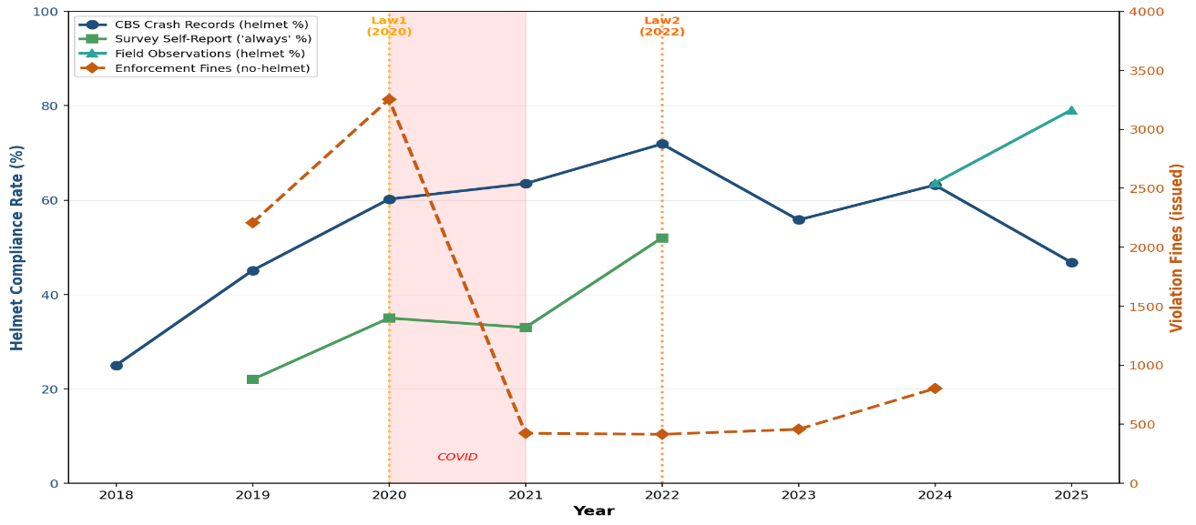

Figure 6.1: Four-source helmet compliance comparison, 2018–2025

Key Finding: Despite different measurement approaches and population samples, all sources document substantial improvement from pre-law baselines. The convergence validates the law's real-world impact beyond any single data source's limitations.

6.2 The Compliance Gap: CBS Crash Data vs Field Observations
A critical pattern emerges when comparing crash victims (CBS) to general riders (observations).

Table 9. Crashes – Observations Gap (2024-2025):
Data Source | Population | 2024 Rate | 2025 Rate | Combined
Field Observations | General street riders | 63.6% (116 in 182) | 79.1% (1,261 in 1595) | 77.5%
CBS Crash Data | Crash victims (known status) | 63.2% (36 in 57) | 46.8% (29 in 62) | 59.2%
Gap |  | +0.4 pts | +32.3 pts | +18.3 pts

Two competing interpretations:
- Data quality explanation: CBS 2025 coverage dropped to 14.7% (down from 25% in 2018). Unknown helmet status increased to 85.3%. The severe coverage crisis means CBS 2025 data may not represent the true crash population.
- Risk explanation: Non-compliant riders may be overrepresented in crashes. Riders who ignore helmet laws may also engage in other risky behaviors (speeding, riding on sidewalks, distracted riding), increasing their crash likelihood.
We cannot determine which is correct due to small samples and low coverage. What we know: general population compliance is high (79.1%), crash victim compliance is lower (59.2%), but the cause of this gap remains unclear.

6.3 External Validation: Sourasky Medical Center
As an independent check on CBS severe injury data, we compared to Sourasky Medical Center ED records (Bodner et al., 2021): 238 e-scooter patients with maxillofacial injuries in 2019-2020.

CBS vs Sourasky Helmet Rates 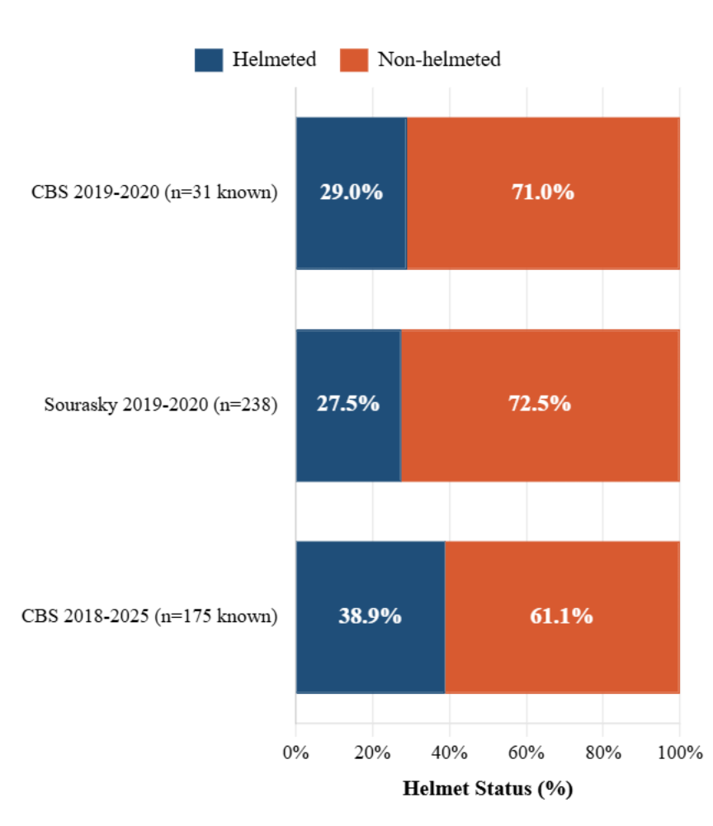
Figure 6.3: CBS vs Sourasky helmet rates in severe injury cases

Key Findings:
1. Near-perfect match for 2019–2020 (+1.5 pts): CBS severe/fatal helmet rate for 2019–2020 was 29.0% (9 of 31 known severe/fatal cases), vs Sourasky 27.5%. Two independent sources, different recording systems, nearly identical rates. Coverage for severe/fatal cases in 2019–2020 was 74% (31 of 42 cases), confirming CBS severe injury recording is reliable in this period.
2. CBS severe/fatal helmet rate for the full 2018–2025 period is 38.9% (68 of 175 known severe/fatal cases), vs Sourasky 27.5% — a +11.4pp gap. This difference is expected: Sourasky covers only 2019–2020 (pre-law and early-law), whereas the full-period figure includes post-law years 2021–2024 where helmet use among seriously injured riders rose sharply (notably 60.0% in 2022). The correct like-for-like comparison is 2019–2020 only (point 1 above). Note: both datasets use the same scope — severe/fatal injuries only — making this a valid comparison.
3. Maxillofacial injury patterns: Helmets protect skull/brain more than face/jaw. A helmeted rider can still break their jaw or lose teeth. This explains why Sourasky's facial injury patients have similar helmet rates to CBS all-injury severe cases.
Note: Sourasky data is comparison only, NOT part of our primary 4-source analysis (different injury scope, timeframe, population, source). Its value is external validation of CBS accuracy.

6.4 Helmet Protective Effect: Evidence and Scope
Only CBS crash data links helmet use to injury outcome for the same individual. Enforcement, observations, and surveys measure compliance only — not severity. The protective effect below therefore rests on CBS evidence alone.
Primary evidence from CBS crash data (n=638 known gender and helmet status):
- Non-helmeted riders face 2.28× higher risk of severe/fatal injury (39.5% vs 17.3%; z=6.38, p<0.001; n=664)
- Protection strongest for ages 15-44 (RR 3.0-3.3×), modest for older riders (RR 1.9×)
- Protective effect confirmed for both genders: male RR=2.40× (p<0.001, n=446), female RR=1.78× (p=0.032, n=192). Male effect is larger; both are statistically significant (see Section 2.4)
Passenger risk anomaly: E-scooter passengers show 3× higher severity than drivers (23.5% vs 7.8%), regardless of helmet status. Current data cannot determine whether helmets protect passengers (n=68 too small). This elevated baseline risk — independent of helmet use — warrants urgent safety research and potential regulatory intervention.
What other sources contribute: Surveys confirm compliance improved across the general riding population (22% → 52% ‘always’, 2019–2022) and report 5–6% severe injuries among subscribers, but do not cross-tabulate severity by helmet use. Field observations show general-population compliance (79.1%) exceeds the CBS crash-victim rate (46.8% in 2025), consistent with selective crash risk among non-compliant riders — but this gap cannot be attributed to severity reduction without controlled data. Sourasky Hospital records validate CBS severe/fatal recording accuracy for the pre-law period: CBS severe/fatal helmet rate for 2019–2020 was 29.0% vs Sourasky 27.5% (+1.5 pts), confirming CBS captures helmet status reliably in serious crashes.
Limitation: The overall RR (2.28×) relies on n=664 known-helmet-status riders (25% of all 2,659 ES users). The gender-stratified RR values rely on n=638 (known gender and known helmet). Because police document helmet status more often in serious crashes, the known-status subset over-represents severe injuries — the direction of resulting bias on RR is uncertain. Passenger severity (3× higher than drivers, n=68) cannot be assessed for helmet protection due to sample size.

6.5. Gender Distribution over Years: Critical Contradictions
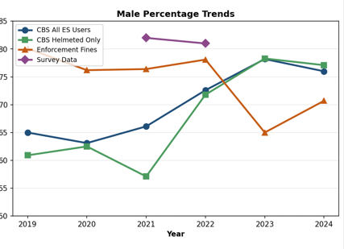
Figure 6.5: Male percentage of e-scooter users across data sources, 2019–2024
Figure 6.5 plots the male share of e-scooter users across three independent sources from 2019 to 2024. The sources tell different stories. CBS crash data shows the male share of involved riders steadily increasing, from 1.39:1 in 2018 to 3.19:1 by 2025 — a rising male dominance in crash records. Survey data shows the opposite: the subscriber pool held stable at 82% male (2021) and 80% male (2022), with no directional trend. Enforcement data shows a declining male fine share, from 80% in 2019 to 65% in 2023.
A specific cross-source finding emerges when comparing the gender composition of CBS crash records to the general riding population (Section 2.4): across all CBS ES users with known gender (n=2,238, 2018–2025), females account for 29.2% of crash records — versus only 18–20% of shared-scooter survey respondents. This gap is highly significant (χ²=119.0 vs survey 2022, χ²=191.0 vs survey 2021; both p<0.001). Using survey 2022 as a ridership proxy, the implied female-to-male crash rate is approximately 1.65× higher per rider. Notably, enforcement fines in 2022 were approximately 70% male — not significantly different from the CBS crash gender split of 70.8% male (χ²=0.6, p=0.42), suggesting enforcement in that year targeted riders roughly in proportion to their crash share. This alignment breaks down in earlier and later years as the male fine share shifted, further confirming that enforcement ratios reflect policing strategy rather than stable rider demographics.
These three trend contradictions (CBS rising male share, survey stable, enforcement declining) cannot be simultaneously true if the riding population were shifting. The most consistent reading: gender composition has been roughly stable throughout the study period (surveys are the most reliable signal), CBS trends reflect changes in crash patterns or recording practices rather than demographics, and the declining male enforcement share reflects policing redeployment. Year-by-year CBS gender sub-samples are too small for reliable compliance analysis (N=10–91 per group, no year reaches significance), so no compliance trend by gender can be drawn from crash data alone.

6.6 Law Effectiveness: Final Assessment
The January 1, 2019 mandatory helmet law worked.
Evidence:
- Pre-law baseline (2018): 25.0% of crash victims wore helmets
- Post-law average (2019-2024): 60.0% of crash victims wore helmets
- Improvement: +35.0 percentage points (140% increase)
- Three sources converge: CBS, surveys, and enforcement all document upward trends from the 2019 baseline; observations confirm high compliance in 2024–2025
- Protective effect confirmed: Helmets reduce severe injuries by more than twofold (RR 2.28× overall; male RR 2.40×, female RR 1.78×)
Critical finding: Compliance remained high even after enforcement never recovered to its pre-2021 levels — total fines dropped 87% in 2021 (partly COVID redeployment, partly genuine compliance) and stabilised at a new lower baseline. This indicates that the law's existence matters more than intensive enforcement. The legal norm changed behavior beyond deterrence.
The 2024-2025 Data Crisis:
However, recent trends cannot be assessed:
- 2024: CBS coverage 13.9%, observations n=182 (both too small)
- 2025: CBS coverage 14.7%, helmet rate 46.8% (declining or artifact?)
The 2025 decline could indicate: (a) real behavioral change (law effect fading), (b) data quality artifact (police recording less), or (c) population shift (different rider types crashing). We cannot determine which without better coverage.
Institutional action required: CBS/Police must restore helmet status recording to ≥25% coverage. Current 14.7% threatens helmet safety monitoring viability in Israel.
Bottom line: The law achieved substantial, sustained behavioral change (2019-2024) with proven injury reduction effect, maintained despite declining enforcement. Whether compliance persists into 2025 cannot be determined due to data collapse. Future monitoring depends on restoring police recording practices.

6.7 Limitations and Future Research
Data Quality Limitations:
- Survey scope: Captures shared-service subscribers only, excludes private owners
- Enforcement conflation: Data reflects police deployment patterns, not just rider behavior
- Observation limitations: 2024 sample too small (n=182), Hawthorne effect possible
Analytical Limitations:
- Causality: Temporal correlation is strong, but operator mandates and awareness campaigns also occurred 2020-2021
Threats to Validity:
- Unknown helmet status not random — may correlate with crash severity or officer judgment
- Survey self-selection bias (response rates unpublished)
- 2024-2025 coverage crisis undermines trend analysis
Research Priorities:
- Did helmet use reduce population-level injury severity? Requires before/after causal analysis controlling for ridership changes
- What happened to private e-scooter owners? Compliance unknown (surveys miss this population)
- Why 2024 enforcement spike? Enforcement intensified or compliance eroded?
- Passenger safety: Dedicated study needed given 3× elevated risk
- Long-term compliance: Will 2025 decline continue or stabilize?

Data Sources
1. CBS Crash Data (2013-2025)
Central Bureau of Statistics, Israel. E-scooter traffic crash records (N=2,659), presented in "Understanding E-Scooter Risks in Tel Aviv, 2013-2025" Power BI report.
2. Tel Aviv Municipal Surveys (2019-2022)
רשות התחבורה והחנייה תל אביב-יפו (Tel Aviv Transport and Parking Authority)
ממצאי סקר קורקינטים חשמליים — E-Scooter Survey Findings, December 2021 and December 2022 (N=1,875 shared e-scooter subscribers).
3. Tel Aviv Enforcement Data (2019-2024)
אכיפת קורקינטים חשמליים בתל אביב — Tel Aviv E-Scooter Enforcement
נתוני אכיפה: דו"חות על רכיבה ללא קסדה — No-helmet violation records across all types and vehicles (N=13,837 total; no-helmet e-scooter fines specifically: N=7,561).
4. Field Observation Data (2024-2025)
Direct observational study of e-scooter riders at Tel Aviv traffic hot spots (N=1,777).
5. Sourasky Medical Center, Tel Aviv (2019-2020)
Bodner, L., et al. (2021). Maxillofacial injuries among e-scooter riders. Emergency department admissions (N=238). Comparison only — not part of primary 4-source analysis.

