
IT342-G5
SYSTEMS INTEGRATION AND ARCHITECTURE 1

FUNCTIONAL REQUIREMENTS SPECIFICATION (FRS)

Project Title:
Prepared By: Niña Isabelle C. Tupas
Date of Submission: February 6, 2026
Version: 2

Table of Contents
1. Introduction 3
1.1. Purpose 3
1.2. Scope 3
1.3. Definitions, Acronyms, and Abbreviations 3
2. Overall Description 3
2.1. System Perspective 3
2.2. User Classes and Characteristics 3
2.3. Operating Environment 3
2.4. Assumptions and Dependencies 3
3. System Features and Functional Requirements 3
3.1. Feature 1: 3
3.2. Feature 2: 3
4. Non-Functional Requirements 3
5. System Models (Diagrams) 4
5.1. ERD 4
5.2. Use Case Diagram 4
5.3. Activity Diagram 4
5.4. Class Diagram 4
5.5. Sequence Diagram 4
6. Appendices 4

Introduction

Purpose

Scope
Describe what the system will do and its boundaries.

Definitions, Acronyms, and Abbreviations
List and define important terms used in this document.

Overall Description

System Perspective
Describe how the system fits into a larger context or environment.

User Classes and Characteristics
Identify the different types of users and their characteristics.

Operating Environment
Specify the hardware, software, and tools required to operate the system.

Assumptions and Dependencies
List any assumptions and external dependencies that may affect the system.

System Features and Functional Requirements
Describe each major feature of the system and its functional requirements.

Feature 1:
Description:
Functional Requirements:
-
-
-

Feature 2:
Description:
Functional Requirements:
-
-
-

Non-Functional Requirements
Specify system quality attributes such as performance, security, usability, reliability, etc.

System Models (Diagrams)

ERD
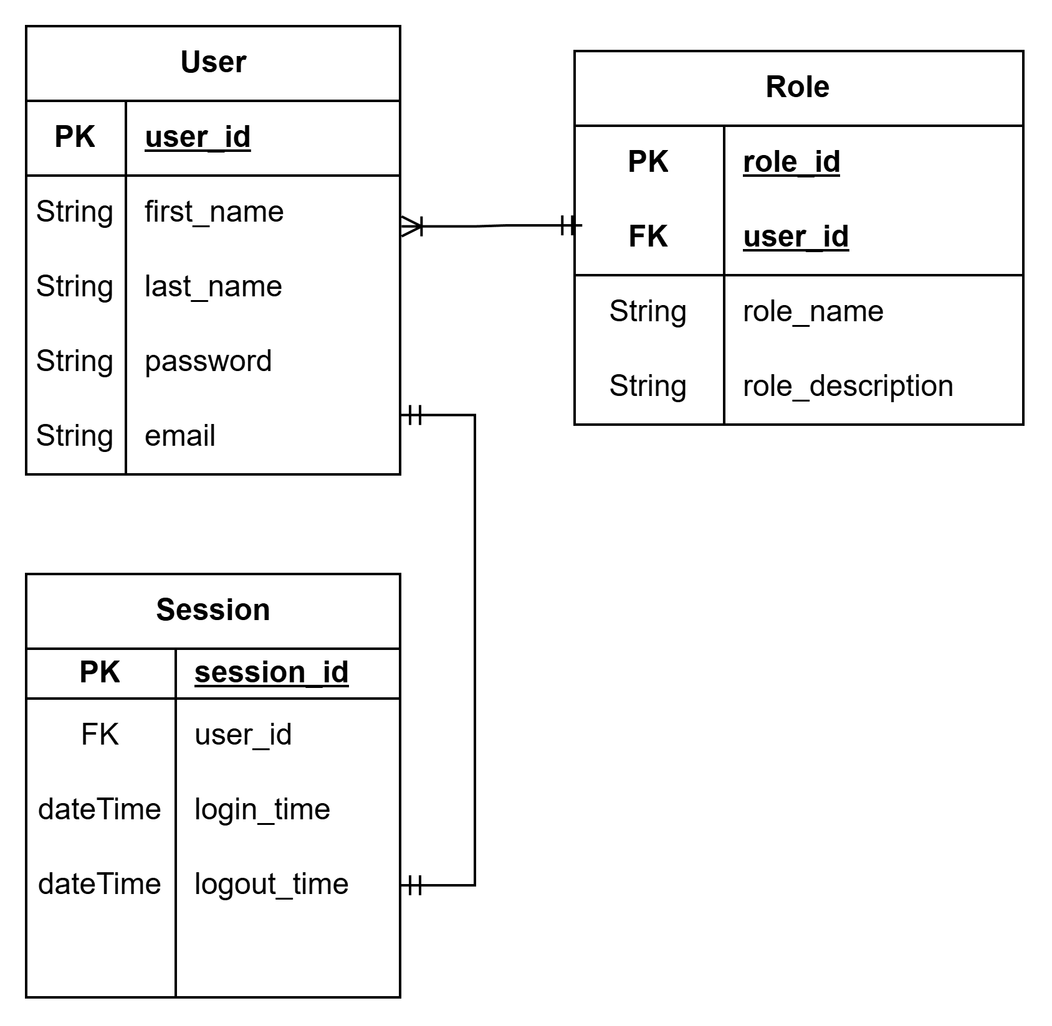

Use Case Diagram
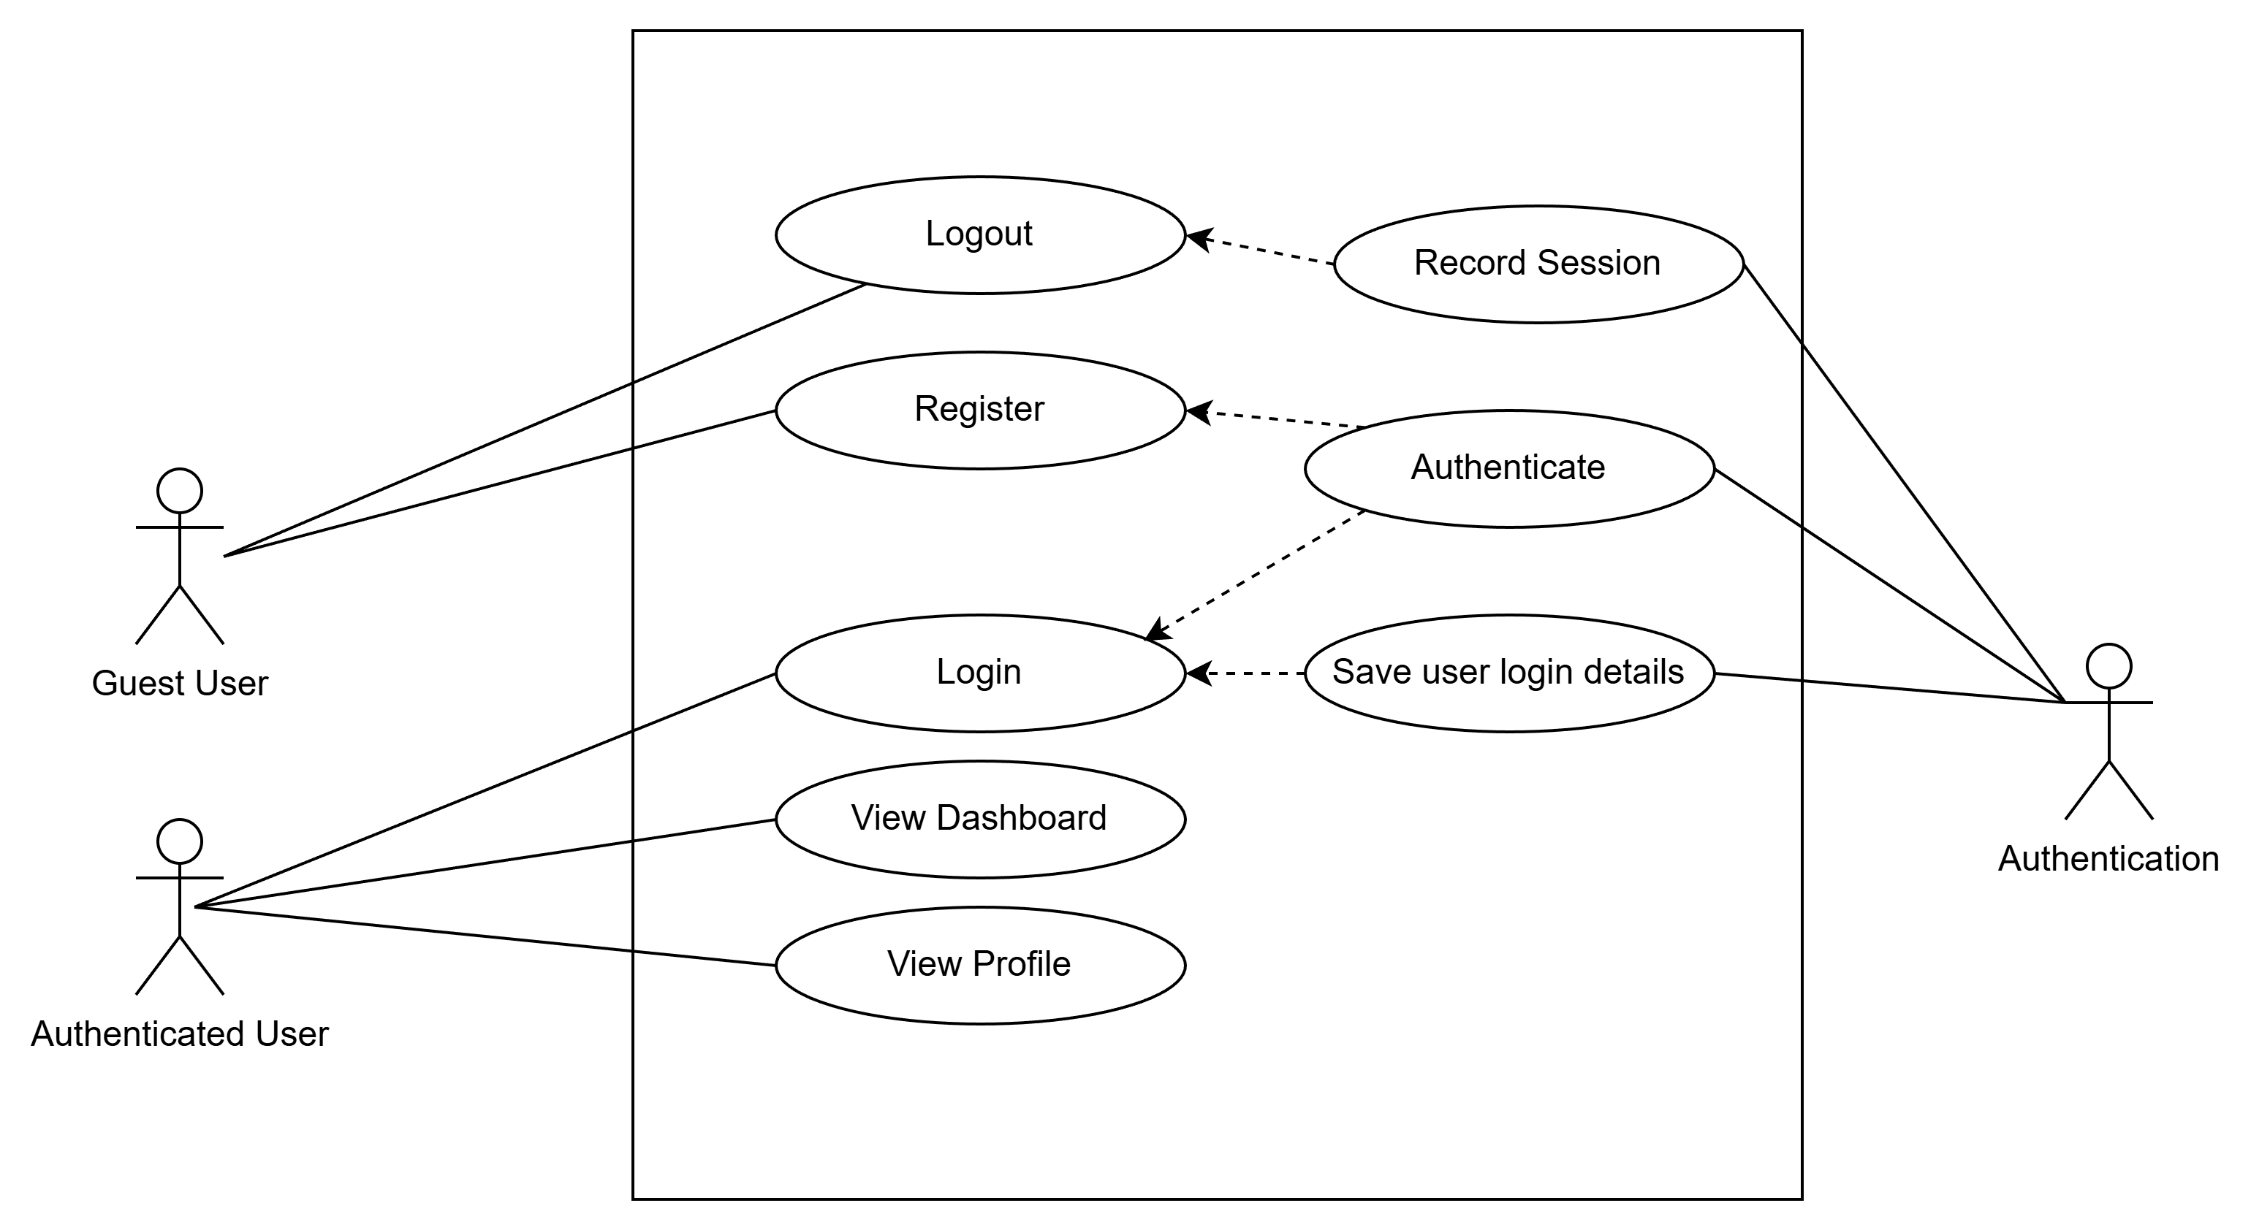

Activity Diagram
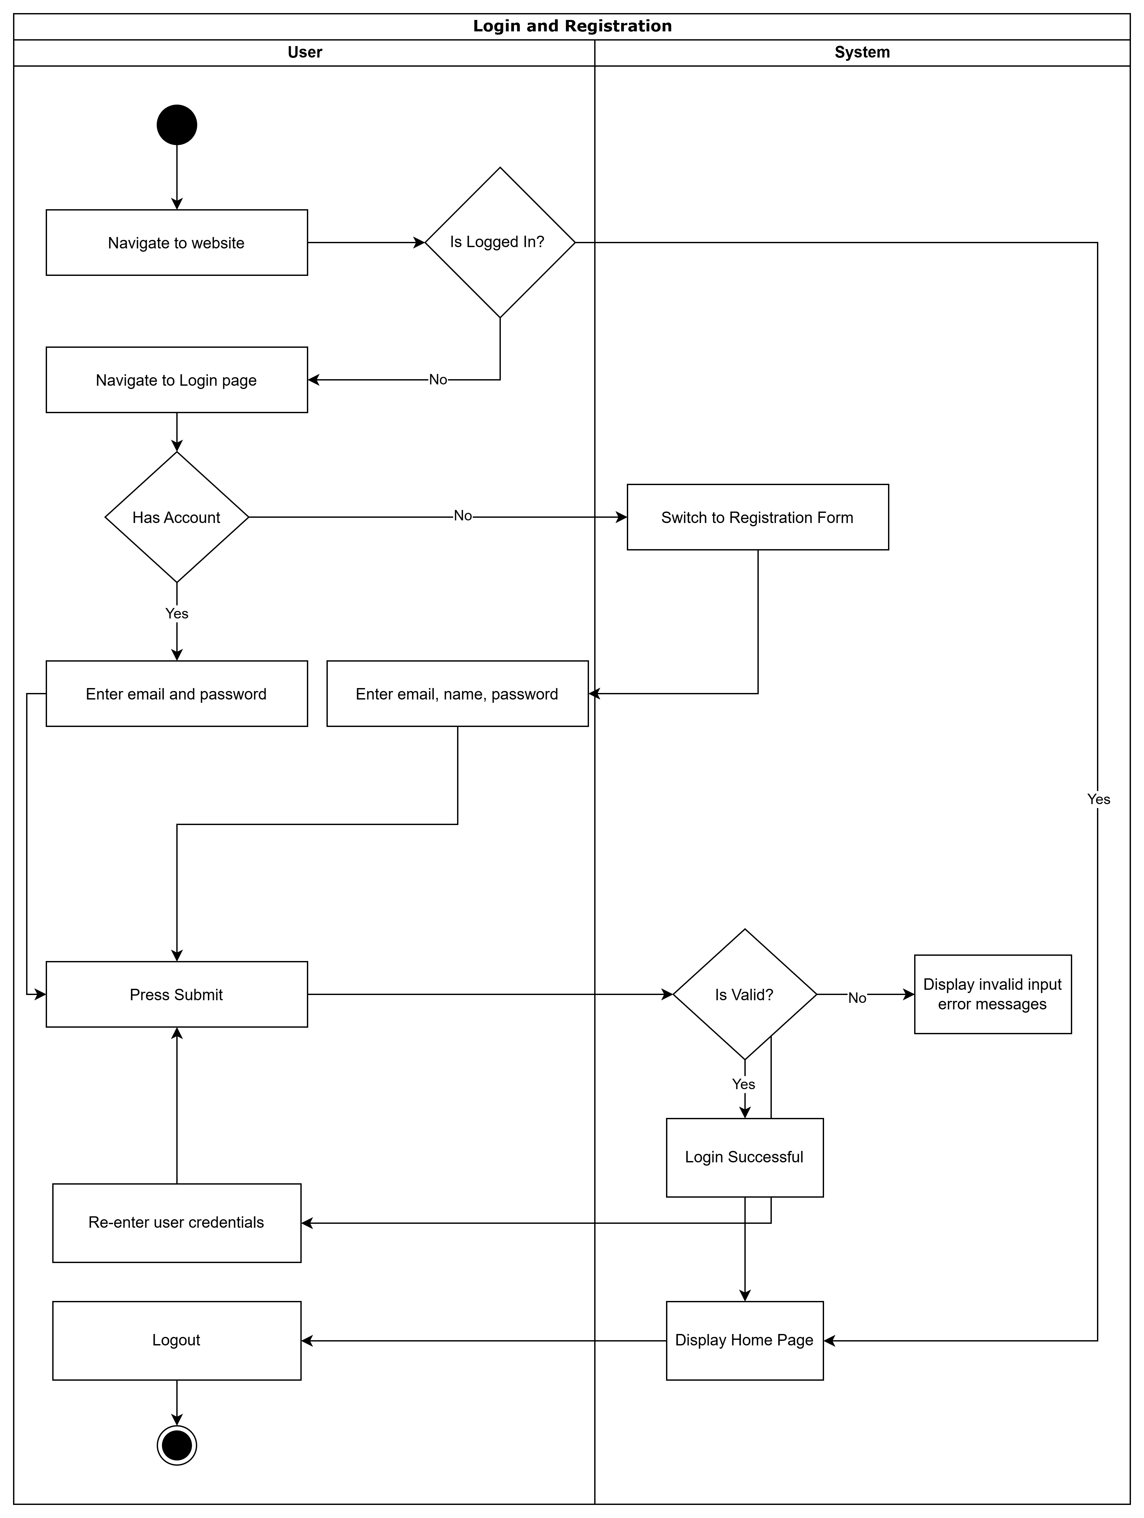

Class Diagram
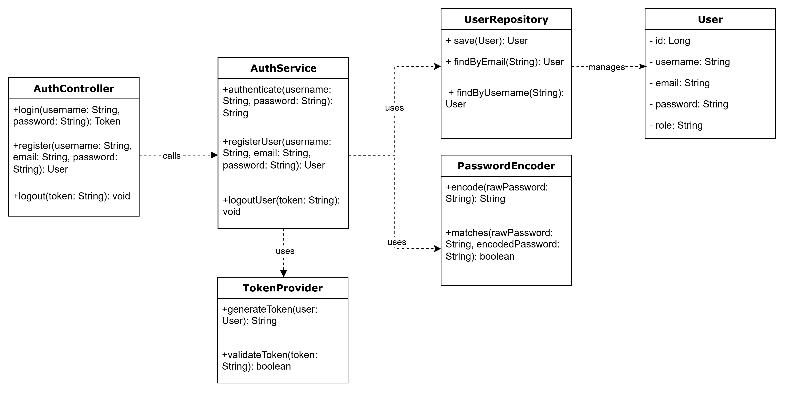

Sequence Diagram
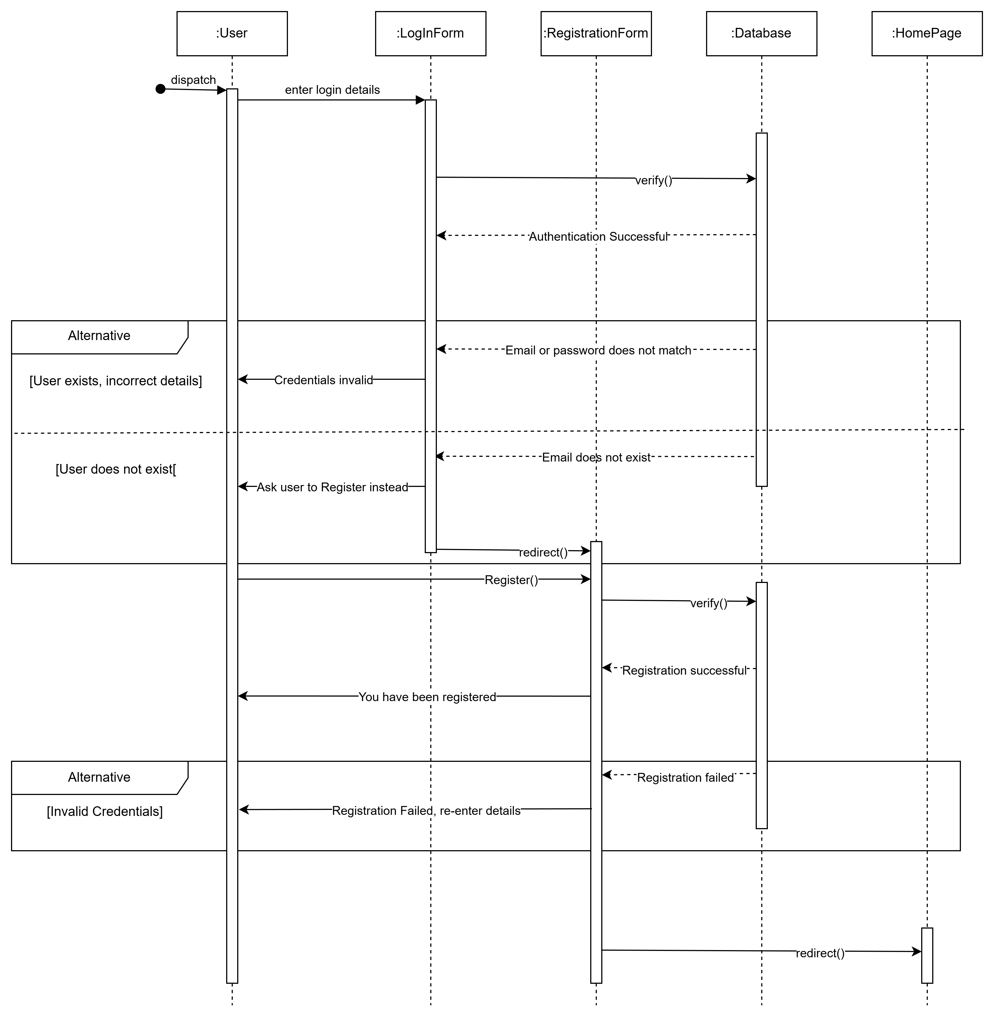

Appendices

