<https://www.mackoviahracky.sk/blog/historia-vianoc/>

<https://vedator.space/kde-sa-vzali-vianoce/>

<https://www.christianitas.sk/povod-sviatku-vianoc/>

<https://klocher.sk/ako-sa-oslavuju-vianoce-v-roznych-nabozenstvach/>

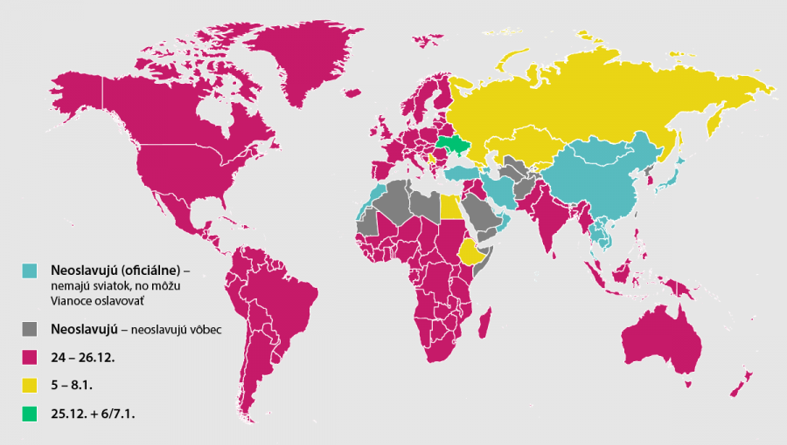

<https://vedanadosah.cvtisr.sk/priroda/zem/hladate-unik-pred-vianocami-v-tychto-krajinach-ich-nemaju/>

<http://ateisti.sk/povod-vianocnych-sviatkov/>

<https://zemavek.sk/v-saudskej-arabii-somalsku-bruneji-zakazali-vianoce-kostym-mikulasa/>

<https://www.funidelia.sk/kostymy-vianocne/3533?gclid=EAIaIQobChMIrLTa7JGa9AIVgI9oCR3iUA7JEAAYASAAEgJnUvD_BwE>

<https://www.vkmr.sk/buxus/docs/Aktuality_a_uputavky/Krizovky/Krizovka_1.pdf>

<https://www.kristuskral.sk/sutaz-pre-deti-advent/>

