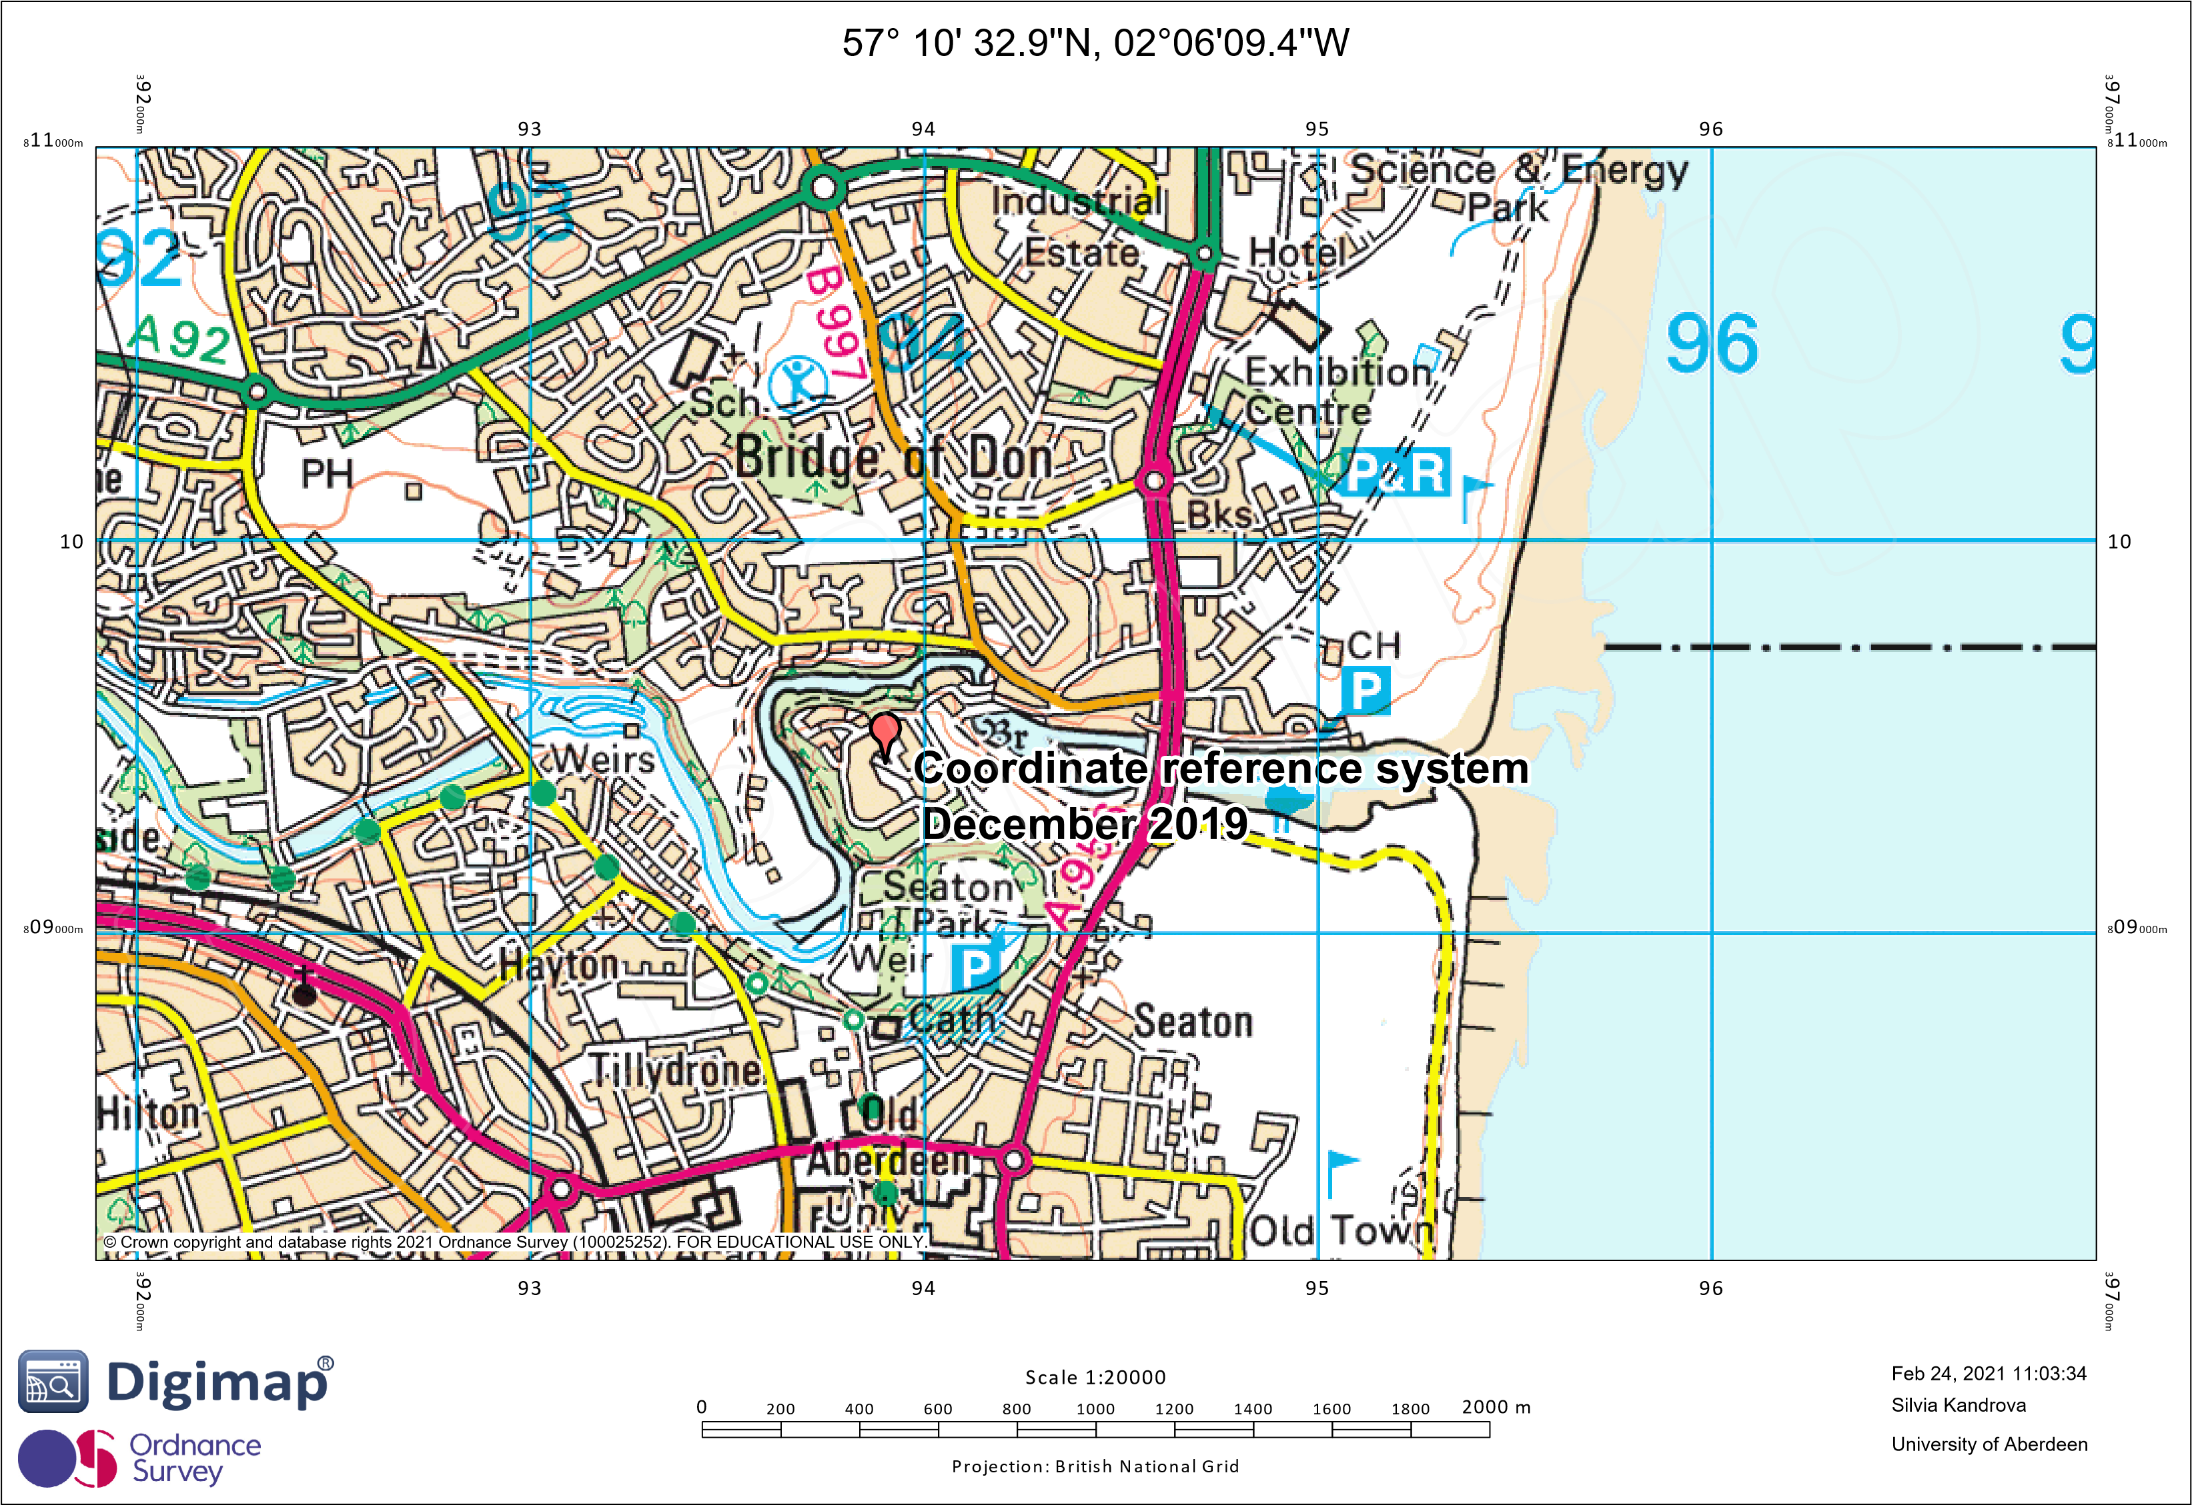

The scale 1:20 000 means that one unit on the map corresponds to 20 000 units in reality. So, let’s see the example: How long is a distance of 3.2cm in reality? 3.2cm\*20 000=64 000 cm. 100 centimetres make a meter, so 64 000/100=640 meters=0.640 km. Our real numerical scale is that 1cm on the map corresponds with the 0.64km in the reality.