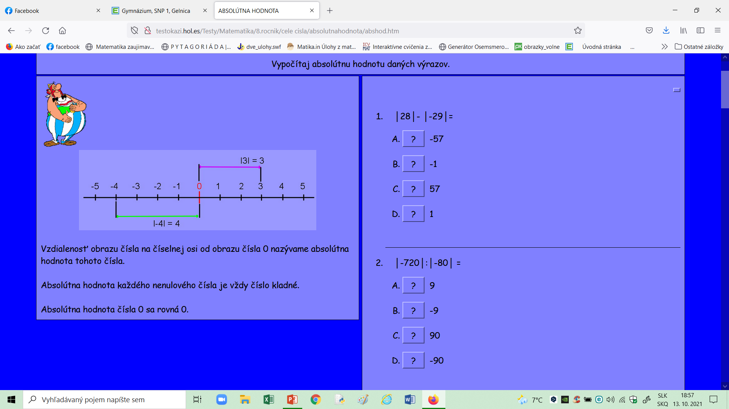

<https://www.eductify.com/sk/matematika-testy/44/zaporne-cisla-a-absolutna-hodnota>

