**Determining palaeoglacier dynamics, using clast form, strain and ice flow indicators.**

The following exercises are aimed to provide you with training in the plotting and interpretation of strain, flow and shape data. It is specifically linked to glacial data in this instance but the techniques can be applied to other 2D and 3D directional and shape data.

You will need a couple of programmes in order to facilitate plotting and analyses of the data. Follow the instructions to get these.

OpenStereo:

You can get this from the course website in the week 2 folder

Then open the zip file and extract the folder called openstereo_0.1.2f_win32 and place onto your Desktop. Open using OpenStereo.exe. If the programme fails to run then place the folder on your desktop and try again. Openstereo will be used to plot the directional data.

The file fabric_ternary.xlsx is an excel spreadsheet which will be used to plot the eigenvector statistics output from Openstereo

The file Tri_plot_RA_C40.xlsx will be used to plot both the clast shape data and the RA (roundness-angularity) data. It is a modified version of Graham and Midgley (2000).

The file drumlins_azimuth is an excel spreadsheet which will be used to plot the azimuth of the longitudinal axis of a series of drumlins using Openstereo

For ease of use during the data analyses it is suggested that you place both of these files into the openstereo_0.1.2f_win32 folder. Likewise it is recommended that you create subfolders to hold the various data files you will generate.

All of the data files are supplied as scanned flat pdf images from my various notebooks i.e. you have to type the data into the spread sheet yourself – this is what normally happens. You collect data in your field notebook and then type it into the computer at a later date. Data input in this manner is a potential source of error so be careful. If you have any problems reading any of the data it just shout (some of the handwriting is mine – most is not – but I can read all of it). It is entirely acceptable to work as a team to enter the data e.g. one reads and one of you types in the data, again this is normal procedure. This will allow you to enter the data rapidly. Be careful data entry is a potential source of error! There are a lot of images to include in the report (these do not have to be full pages each just make sure they are readable!) but thee allow assessment of the work even if the answers are wrong so it is of benefit to you.

**Exercises:**

1. **Striate directions**

Background: The site (Øksfjordjøkelen, North Norway) was a glacier foreland which had been glaciated during the Little Ice Age (Fig. 1). There was evidence for intense abrasion and one component of the investigation was to see if there was any deviation in ice flow which had occurred as the ice margin thinned and retreated from the LIA max or if there was a signature of more extensive glaciation when iceflow could have been oblique across the site.

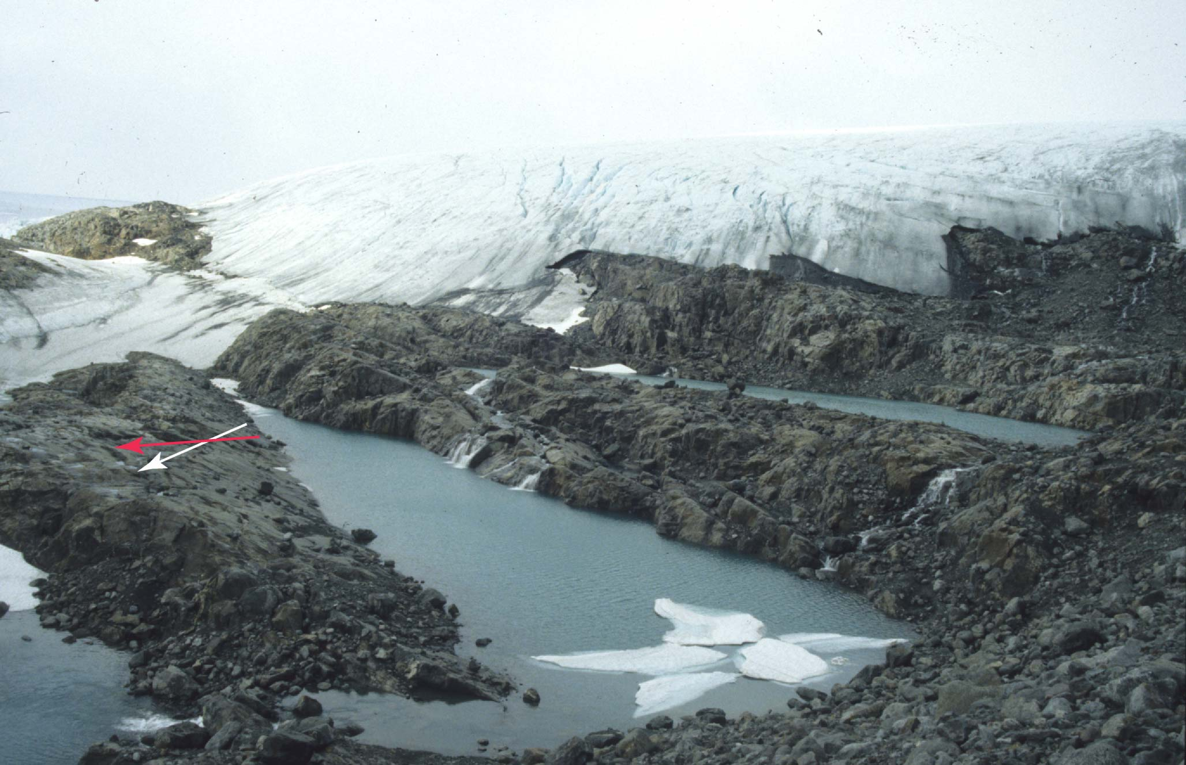

Fig 1. Rock step dominated foreland showing two potential ice flow directions (white [~N-S]– LIA and red [~NE-SW] – last glaciation).

The file striate_data.pdf is a scan of real data taken from a field notebook. If you have any problems reading it please contact (Brice). The striae are all measured off roche moutonnée stoss surfaces, striae readings for each site are taken within an area of ~1m2 and the four sites are located within about a 40 m diameter. There was no obvious difference in striae depths or dimensions between the sites. The file is provided as a flat pdf image i.e. you cannot copy and paste the data into a data file! You need to type in the directions into column A of a spreadsheet and inset 0 (zero) in the corresponding rows of column B. IMPORTANTLY you must save this as a .csv file! Create one file for each striae data set. Then open OpenStereo File Open Linear Data (Trend/Plunge) select CSV and import desired file. Select Rose diagram, poles to lines, Trend, 360 deg, Frequency and the remainder you can choose to best present the data. Click plot. You may change the radio buttons and Plot to pretty it up. Save each file off separately and if unsure if you have completely cleared the old data it may be simplest to close and reopen OpenStereo each time. Import the rose diagrams into you final report, provide suitable titles and tabulate the mean direction and ±95% confidence interval from each striae data set into a single table (1 CGS mark for ALL being correct). Then answer the following briefly (1 CGS).

1. How many standard deviations does the 95% ± error equate to?
2. Do you think these striae represent a single phase of ice flow or are there more than 1? Consider the 95% confidence intervals. (2-3 lines)

Starter ref:

Elias, S.A. 2007. Encyclopaedia of Quaternary Science. (Relevant chapter – GLACIAL LANDFORMS, EROSIONAL FEATURES/Micro to Macro Scale Forms. - available as an electronic resource)

1. **Clast fabric plots**:
2. Crevasse Squeeze Ridges (CSR)

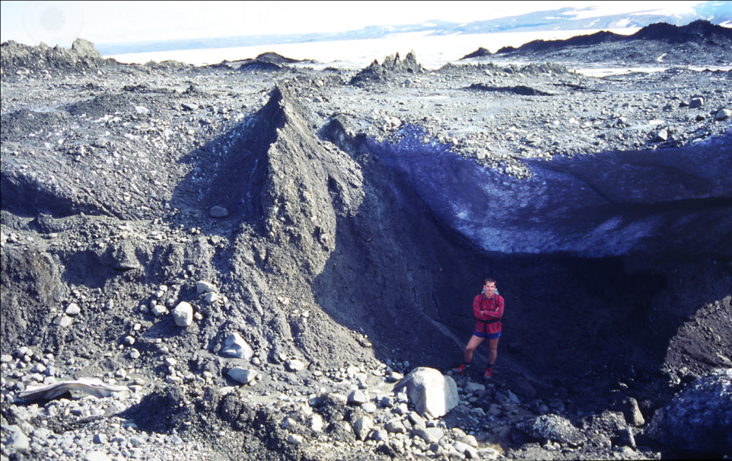Background: Crevasse squeeze ridges are generally reported in association with surging glaciers. However, their actual origin has been debated. The data you are provided with in this section is taken from the area just in front of Osbournebreen a surge type glacier located in Svalbard. The data were collected in order to help elucidate the origin of the sediment infilling of the CSR and its relation to the deforming till layer below.

Fig 2. Crevasse squeeze ridge melting out at the margin of Brúarjökull, Iceland showing the contact with the subglacial till. The dark ridge in the top left is a much larger ridge also melting out of the ice margin.

The file CSR_sub_CSR_data.pdf contains two fabric datasets: the first CSR comes from a crevasse squeeze ridge (CSR) and the second sub-CSR comes from the beneath the CSR where it connected with the deforming subglacial bed. The data come from the foreland of Osbournebreen, a tidewater calving surge type glacier in Svalbard. As before you need to type the data up into two separate files for each dataset. Azimuth in Column A and dip in Column B. Import data into OpenStereo as before but this time you want to plot a stereonet, ensuring you check the eigenvectors box (check the grid box in stereonet). Save the plot then click the statistics tab and save the file. Eigenvectors (V1, V2,V3) are a statistically derived measure of the three axes of maximum, intermediate and minimum clustering (all oriented at 90 to one another i.e. orthogonal). Key for our purposes V1 the key as it is the direction of maximum clustering i.e. where the fabric is pointing. Eigen values (S1, S2,S3) indicate the degree of clustering of the fabric around the three equivalent eigenvectors. If S1 is >> than the other two then it is a cluster fabric, of all are of similar value it is isotropic and if S1~S2>> than S3 then it is a girdle fabric. There is a more full explanation in Hubbard and Glasser (2005) and yet more complete explanation in Evans and Benn (2004).

As above import your two stereoplots into the main report and give them appropriate titles and this time tabulate the normalised eigenvalues (S1, S2, S3) for each sample into a table. Open the excel file fabric_ternary.xlsx and plot in the relevant S1-S3 data into the data spreadsheet. Label each data point in the figure and put into the main report and also indicate the ice flow direction (2 CGS). Then comment briefly (3-5 lines) using the ternary eigenvalue plot and the two stereo plots if you think the till was weak or firm/stiff and if the clast fabrics can be used to support the generally accepted origin for CSR formation i.e. basal crevasse infilling probably at surge termination (2 CGS).

Starter refs:

Hubbard, B., and Glasser, N.G. 2005. Techniques in glaciology and glacial geomorphology. (available in multiple hard copies and also as an electronic resource)

Evans, D.J.A., and Benn, D.I. 2004. A practical guide to the study of glacial sediments. (available in multiple hard copies)

Evans, D.J.A. and Rea, B.R. (2003) Surging glacier landsystems. In Evans, D.J.A. (ed.), Glacial Landsystems, Arnold, 259-284.

Benn, D.I. and Evans, D.J.A. Glaciers and glaciation.

1. Flutes vs Mega Scale Glacial Lineations
2. **Flutes**:

The field site for the collection of this dataset was the proglacial area of Brúarjökull Iceland. This surge type glacier last surged in 1964 when it advanced approx 10 km in 6 months!! The flutes which formed during this advance are unusually long, low and parallel (Fig. 3).

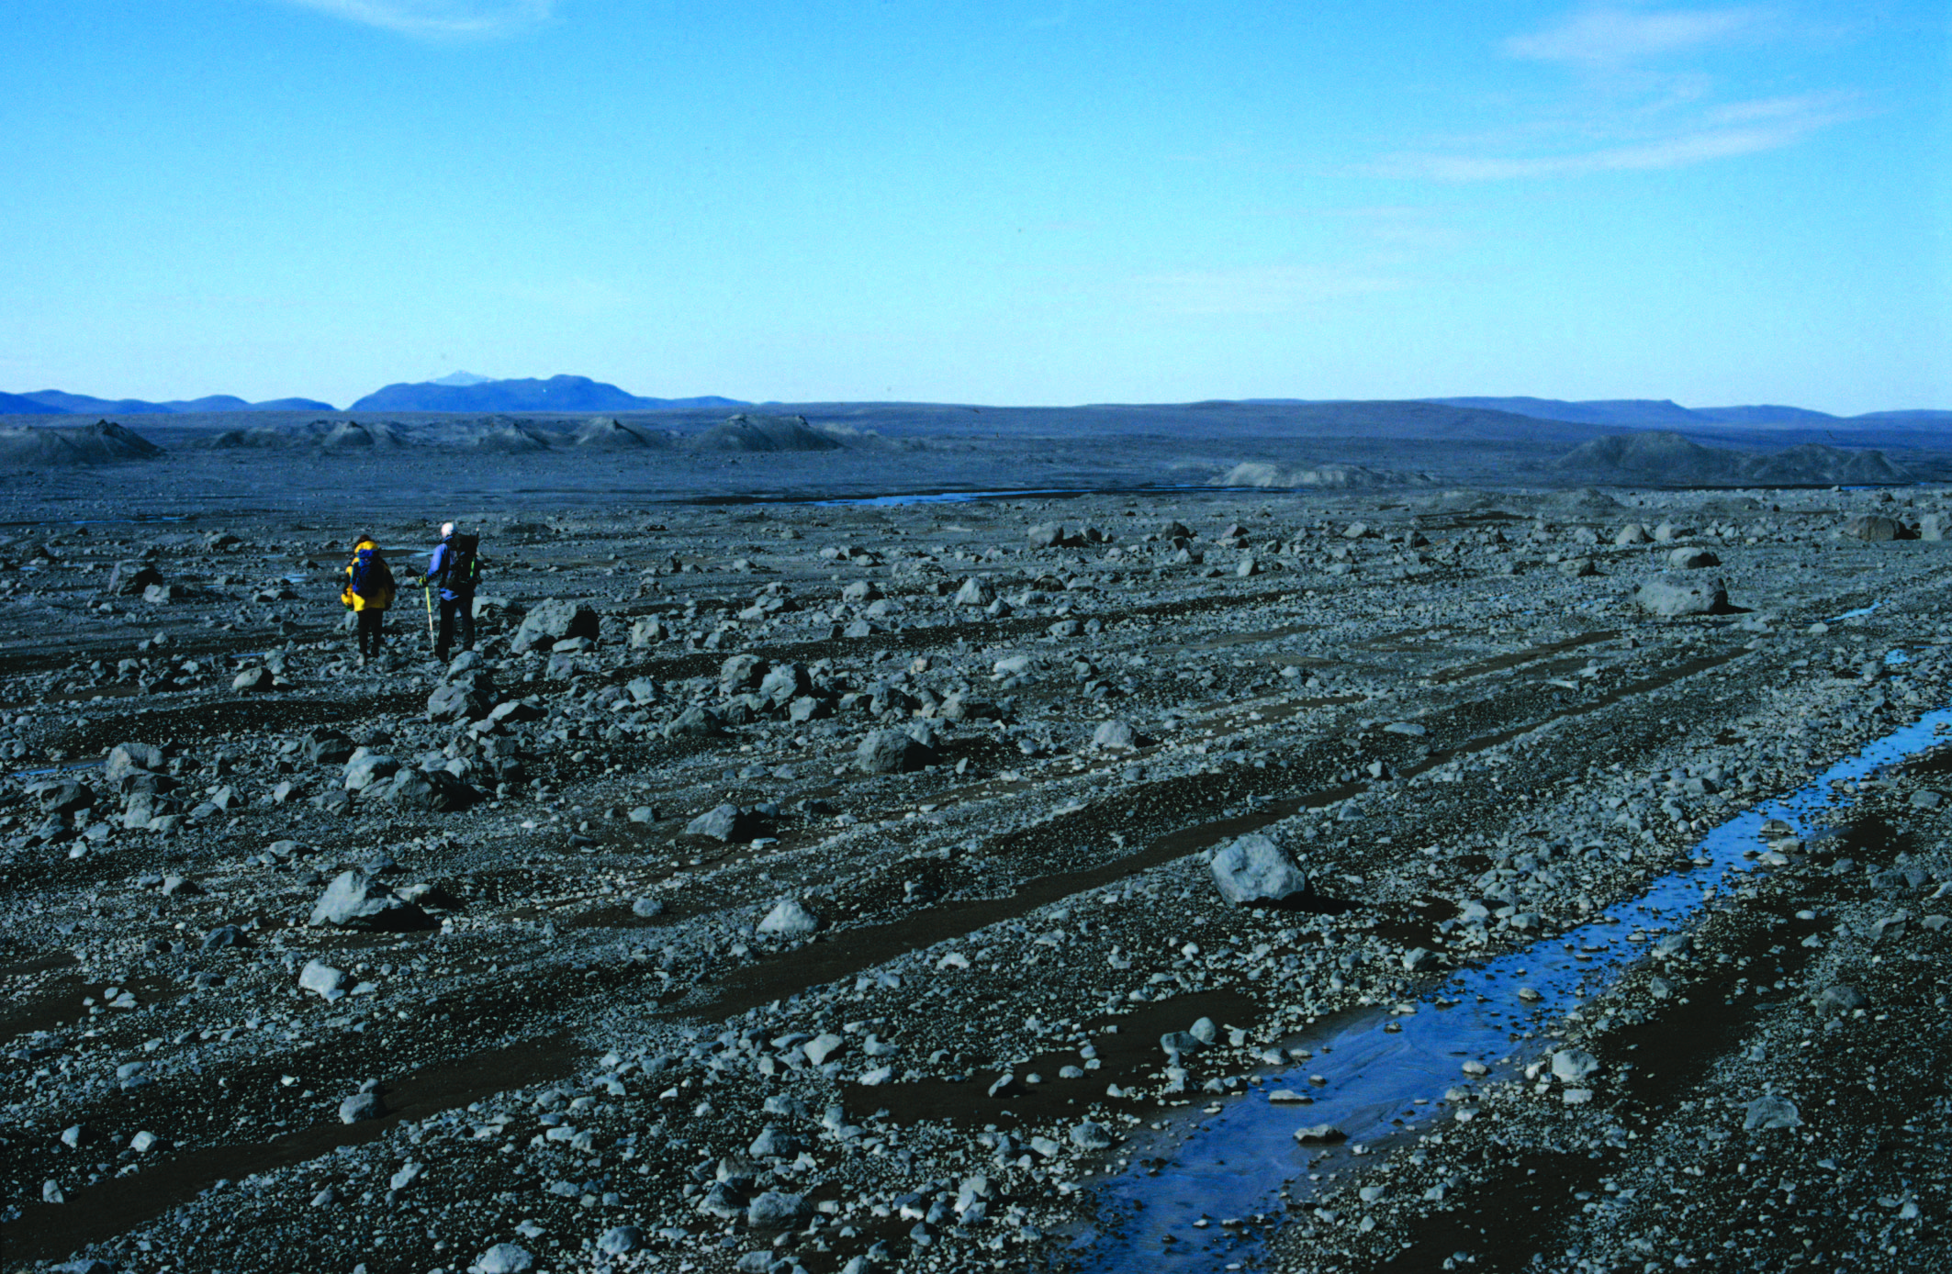Fig. 3. Long and low flutes formed during the 1964 surge of Brúarjökull. Ice flow direction was from bottom left to top right.

Ice-bed coupling during a surge is likely to be weak and this may be an explanation for the style of flutes observed. A potential test of this could be provided by the clast fabric data i.e. strong coupling should produce a strong fabric while weak coupling may produce a weaker fabric and this is why the data were collected.

For this section you need the file flutes_MSGL_data.pdf. There are three fabric data sets in the file, this time consisting of only 30 clasts. The data this time come from the foreland of Brúarjökull, Iceland and again is a surge type glacier. The flutes were in some instances very very long but this one was only on the order of a few meters long. You will see there are two operators (me and Dave – actually the same two operators collected the CSR fabric data) and we have taken a fabric from the true glacier left, right and the centre of the flute (true glacier means if you were standing on the glacier looking along the direction of flow). Trend indicates the trend of the long (flow) axis of the flute. As before type them up into .csv files and plot them onto stereonets and generate the statistics, tabulate and plot onto the ternary diagram and add all the figures into your report (with titles) (2 CGS). Now answer the following. Interpret briefly (5-6 lines) what the data inform on the sediment character during deformation, what the pattern indicates and how these fit with “classic” flute formation theory (2 CGS).

1. **MSGL**

The file MSGL_data.pdf contains three 30 clast fabric datasets taken from MSGL in Poland. They are taken in a vertical sampling plan with AF1 0.8-1 m, AF4 1.4-1.6 m and AF5 1.6-1.8 m below the surface. This depth of investigation required the opening of pits > 3m deep using a mechanical digger (Fig. 4a).

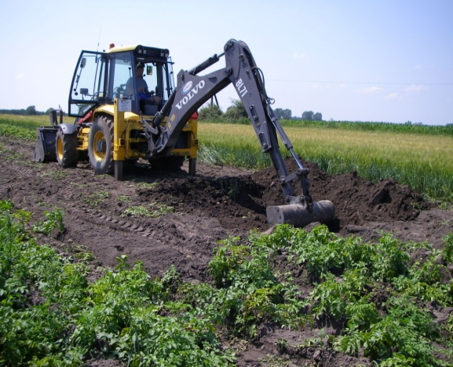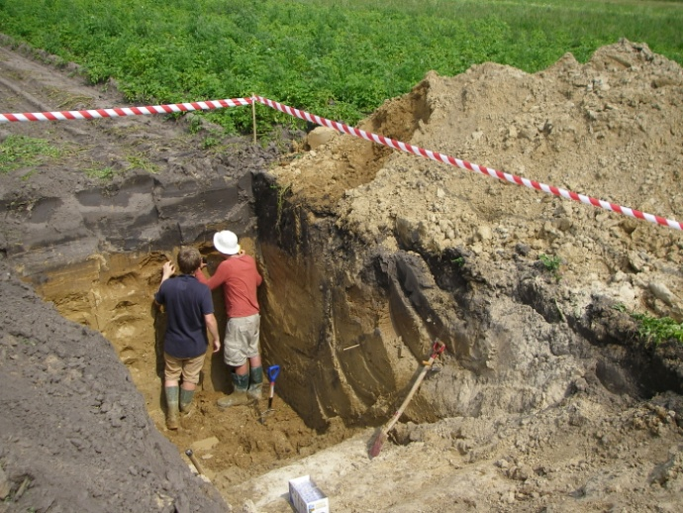

### Fig. 4. Digger and resultant pit in the top of and MSGL (nr) [Poznań](http://en.wikipedia.org/wiki/Pozna%C5%84), Poland.

There is only a small body of literature to-date on the morphometry, sedimentology and origin of MSGL and these data were collected as part of a large dataset in order to generate the most comprehensive investigation of MSGL ever undertaken. There is no consensus regarding their origin e.g. erosional or constructional (accretionary) and many assume them to be indicators of fast ice stream flow due to their great elongation.

Follow the same procedure as for the flutes and generate .csv, plots, tables and ternary diagrams (2 CGS) and then, discuss what do the fabrics suggest you regarding the ice bed coupling and formation of MSGL (5-6 lines and 2 CGS).

Starter refs:

Spagnolo, M., Clark, CD., Ely, JC., Stokes, CR., Anderson, JB., Andreassen, K., Graham, AGC. & King, EC. (2014). 'Size, shape and spatial arrangement of mega-scale glacial lineations from a large and diverse dataset'. Earth Surface Processes and Landforms, vol 39, no. 11, pp. 1432-1448.

Benn, D.I. (1994). Fluted moraine formation and till genesis below a temperate glacier: Slettmarkbreen , Jotunheimen, Norway. Sedimentology, 41,279-292.

Benn, D.I. and Evans, D.J.A. Glaciers and glaciation.

Elias, S.A. 2007. Encyclopaedia of Quaternary Science.

1. **Shape, RA & C40**

Another simple but effective sediment analysis technique is related to the shape of a sample of clasts. The folder Shape_RA contains 11 data files each of which has a a, b, c axes measurements and also RA (roundness angularity) measurements. These are for 30 clasts per data set but are better collected as 50 clast data sets. These data come from the on and around Sydbreen a glacier in the Lyngen Alps, North Norway (Fig. 5). It is an interesting glacier in terms of its dynamics (the entire valley glacier lies below the ELA fed by avalanching ice from a plateau 800m above) flow units and structures and it was investigated in order to elucidate the different modes of transport of debris on, in and beneath the glacier and their contribution to landform formation.

To plot the data and gather all of the statistics needed to plot the RA-C40 index you will need to open the file Tri_plot_RA_C40.xlsx. As previously you will have to manually enter the data from the *.pdf files. This will generate 11 triangular shape plots and 11 RA bar charts. **TABULATE** the RA and C40 data generated for each data set (2 CGS) (you do not need to put in each shape plot and RA bar chart). Using the information provided in sample_info.docx and the RA-C40 data generate a cross-plot identifying each sample type in the legend. Finally discuss the merit of the RA-C40 index method – do you think it provides a useful tool for discriminating sediment sources and mixing e.g. can it tell you anything about the moraine composition (5-6 lines for 2 CGS)?

Starter Refs:

Benn, D.I. & Ballantyne, C.K. 1994. Reconstructing the transport history of glacigenic sediments: a new approach based on the co-variance of clast form indices. Sedimentary Geology, 91, 215-27.

Benn, D.I. and Evans, D.J.A. Glaciers and glaciation.

Hubbard, B., and Glasser, N.G. 2005. Techniques in glaciology and glacial geomorphology. (available in multiple hard copies and also as an electronic resource)

Evans, D.J.A., and Benn, D.I. 2004. A practical guide to the study of glacial sediments. (available in multiple hard copies)

Elias, S.A. 2007. Encyclopaedia of Quaternary Science. (Relevant chapter – GLACIAL LANDFORMS, EROSIONAL FEATURES/ Clast Form Analysis. - available as an electronic resource)

1. Drumlin orientation

The file drumlins_azimuth.xls contains the azimuth of 597 drumlins mapped in NW Cumbria, an area that was covered by the British Ice Sheet during the last glaciation. Drumlins were originally mapped as polygons following their outline break of slope. Longitudinal axes were automatically derived and their azimuth calculated using specific GIS tools. Drumlin azimuth is very important in order to reconstruct ice “flowsets” and palaeo ice flow directions.

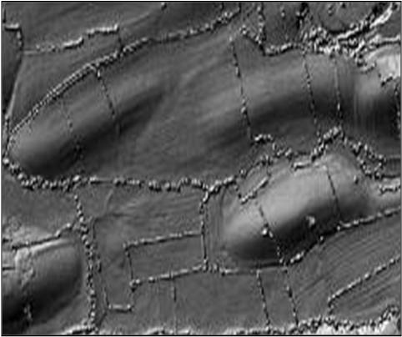

### Fig. 5. A high resolution DTM showing typical drumlins in Cumbria.

From the above plotting exercises, use the directional data provided to generate a plot that shows the overall azimuthal distribution of the mapped drumlins (2 CGS). Discuss how the data could be interpreted in terms of palaeo ice flow direction in this region (5-6 lines, 2 CGS).

Starter refs:

Dove et al. 2015. Submarine glacial landforms record Late Pleistocene ice-sheet dynamics, Inner Hebrides, Scotland. Quaternary Science Reviews, 123, 76-90

Jansson et al. 2002. Configuration and timing of Ungava Bay ice streams, Labrador-Ungava, Canada. Boreas, 32, 256-262.

# Hughes et al., 2014. Flow-pattern evolution of the last British Ice Sheet. Quaternary Science Reviews, 89, 148-168

# Hughes et al. 2010. Subglacial bedforms of the last British Ice sheet. Journal of Maps, 6, 543-563

Shaw et al. 2010. A flowline map of glaciated Canada based on remote sensing data. Canadian Journal of Earth Sciences, 47, 89-101

**Additional Ref:**

Graham, D.J., Midgley, N.G. 2000. Graphical representation of particle shape using triangular diagrams: and excel spreadsheet method. Earth Surface Process and Landforms, 25, 1473-1477.