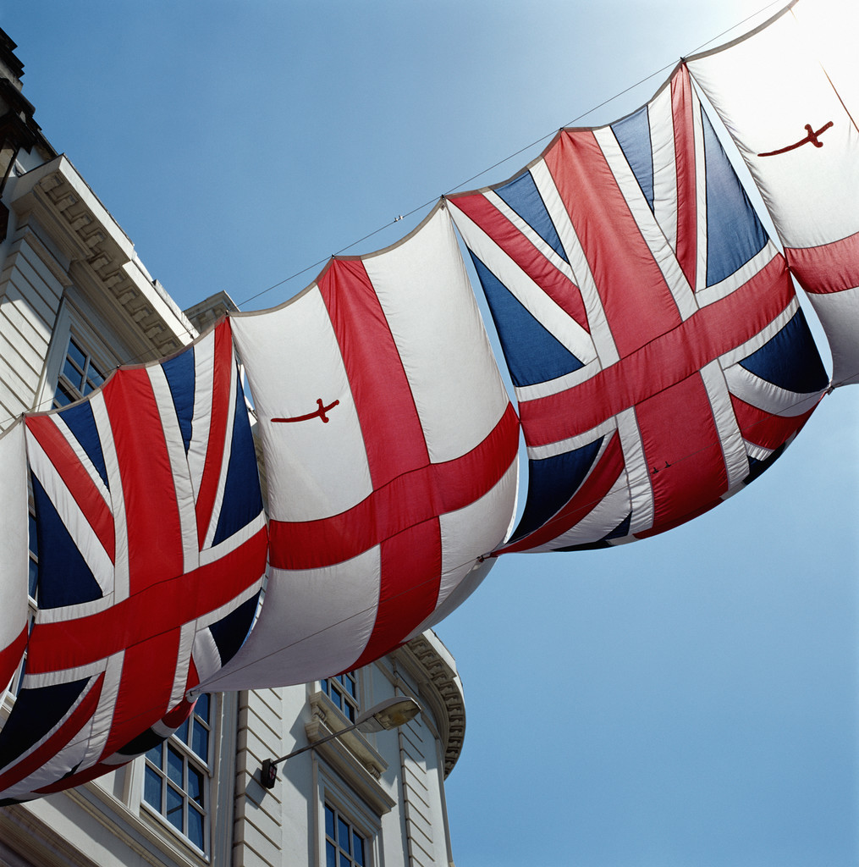
GREAT BRITAIN

English: English is one of the widespread languages in the Word. It is the mother tongue for most inhabitants of the United States of America, Canada, the United Kingdom, Ireland, Australia and New Zealand. There is a great number of countries where English is spoken as a second language, for example by immigrants. ( India, Africa, ) The English language has become a lingua franca – a language of international communication in business, science or politics. English is used in many international organisations, e.g. the E.U.

POSITION: Great Britain is situated in the British Isles in the north- east of the Antlantic Ocean. It is divided from Europe by the English Channel and the North Sea. Great Britain covers the area of 244, 021 square km. It consists of two large islands (Great Britain and Ireland) and about 5,000 smaller ones: The Isle of Man, The Orkneys, The Isle of Wight. Its neighbours are Ireland to west and France to south-east.

NAME: Great Britain consists of the geographical areas of England, Scotland and Wales. The political state is officially called the United Kingdom of Great Britain and Northern Ireland. Each part has its autonomy and constitutional arrangements.
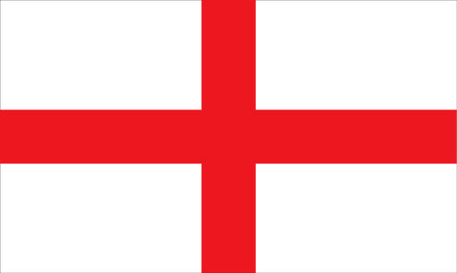
ENGLAND: England occupies the largest, southern part of G.B. It is full of historical monuments and romantic sceneries. The southwest and west are largerly plains, hills and moors. The principal mountains are the Pennines, the Cornish Heights, Cheviot Hills and The Cambrian Mountains. The east is mainly an open, cultivated plain. England has about 60 million inhabitants and it is one of the most densely populated countries in the world. It is divided into 36 counties, e.g.: Sussex, Essex or Kent. England is highly industrialized. It has a variety of industries, particularly engineering. Newcastle is a centre of iron, coal, steel and shipbuilding. Sheffield has concentrated on the iron and steel industries. Birmingham is the second largest city of England and it specializes on engineering, motor vehicle manufacture, machine tool industry. Besides these, England has a good computing, banking, insurance, commerce, finance and advertising industry.
England has a very rich architecture. Many of the greatest cathedrals and churches have been built between 1100 and 1500. The English countryside is remarkable for its green fields and trees because there are no extremes in climate. Small villages and old market towns look beautiful with their well-kept gardens and houses. The country has a long coastline with many famous seaside resorts such as Brighton, Bournemouth on the south coast. The most beautiful natural scenery can be seen in the northwest of England in the Lake District. The lakes are good for water sports- sailing, canoeing, windsurfing.
Oxford and Cambridge are the old university towns. Stradford upon Avon is the birthplace of William Shakespeare. Canterbury is an ancient city with its majestic cathedral. Bath is worth seeing for the remains of its Roman bath.
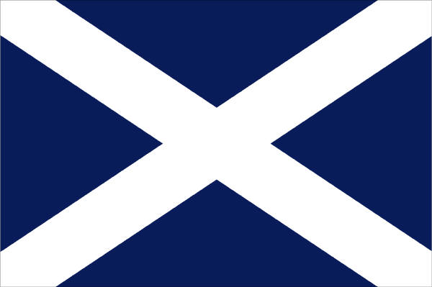
SCOTLAND: It is historically and culturally separate country from England. It has its own legal and educational systems and currency. It has many special traditions. The biggest city is Glasgow, it is the heart of Scotland. The north of the country is a large and magnificent lake and mountain area. The biggest lake here is Loch Lomond and the most famous is Loch Ness. Scotland is a wonderful country- full of traditions, colour and romance- it has its own character and way of life. Scotland has more than 5 million inhabitants. They speak Gaelic, English and an ancient Scottish language. Scotland is a country of hills, lakes, swift rivers and deep valleys. The most beautiful part of Scotland is the region known as the Highlands. The highest peak is Ben Nevis-1343 m high. The most famous lakes are Loch Lomond and Loch Ness.There are four big cities in Scotland- Glasgow, Edingurg, Dundee and Aberdeen. Edinburg-the ancient capital of Scotland, is one of the most beautiful cities in the world. It is famous for engineering, printing, electronic industries. There are also special traditions in Scotland, e.g. playing bagpipes, wearing kilts by men and women too. Some eating and drinking habits are different too- haggis made of heart, liver and lungs of the sheep together with salt, spices packed into sheep´s stomach and boiled. Scotland is famous for whisky drinking.- this country has many whisky distilleries with a long tradition. The Scottish people speak variol dialects of English or Gaelic.

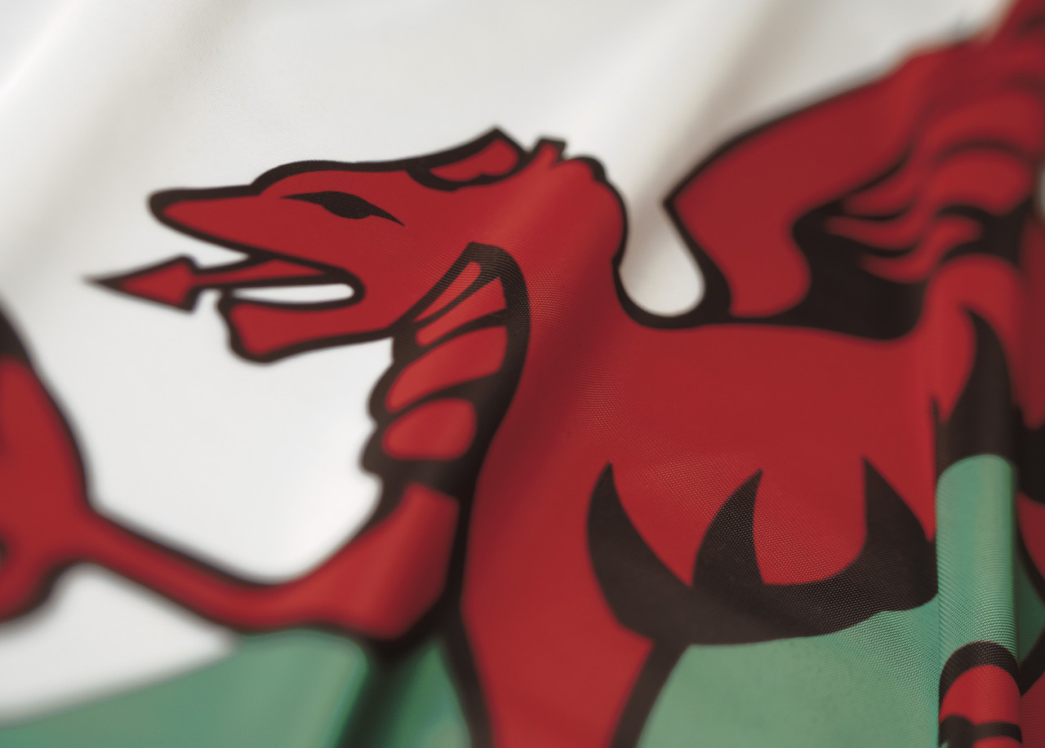
WALES: Wales is largerly mountainous country bordered by the Irish sea and The Bristol Channel. It has an eastern border with England. The oldest son of the English monarch is given the title „Prince of Wales“. Wales is famous for its long rivers, wide lakes and high hills in the north.The land is so full of mystery and beauty. The biggest cities here are Cardiff- the capital and Newport. The population is almost 3 million. There are two languages spoken- Welsh (Celtic language) and English. Wales is rich in culture and history. The Welsh people are known for their love of music and poetry.

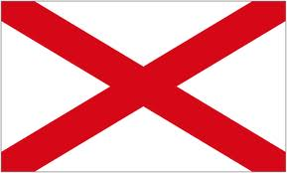
NORTHERN IRELAND: It occupies the northern fifth of Ireland. It has a population of over 1.6 million people. They speak English. Nearly half of the people live in Belfast, the capital. The city is the shopping, educational, commercial, entertainment and service centre of Northern Ireland. It is also an important port. It exports ships, aircraft, textiles. Most of the country is rural, agricultural products and livestock form a large portion of exports. There are many farms producing pigs, cattle, milk and eggs. The principal crops are potatoes, barleys and oats.
There ar economic and religious problems in the country. (Protestants and Catholics)

NATIONAL SYMBOLS: British national flag is called „Union Jack“. It symbolises the Union of England, Scotland and Ireland and dates back from 1801. The flag is made up of the crosses of the patron saints of England ( St George-red cross on a white field), Ireland (St Patrick´s red diagonals on a white field) and Scotland (St Andrew´s white diagonals on a blue field). Wales is not represented because when the flag first appeared it was already united with England. The design and colours have been the basis for a number of other flags including other Commonwealth countries. National anthem is „God save the Queen“.Each part of the Uk has its own symbol: England- red rose, Ireland- shamrock, Wales- leek, daffodil, Scotland- thistle.

POPULATION: The population is more than 60 million people. It is one of the most densely populated countries in the world- 232 people to 1 sq km. 90 per cent live in big cities: London, Manchester, Leeds, Sheffield. The population includes 4 nations: English, Scottish, Welsh and Irish and these ethnic groups: Ulster, Indian, Pakistan, Jews, Italian, Chinese, Caribbeans). The majority of people speaks English. There are minority languages which are of Celtic origin- Welsh, Scottish and Irish.

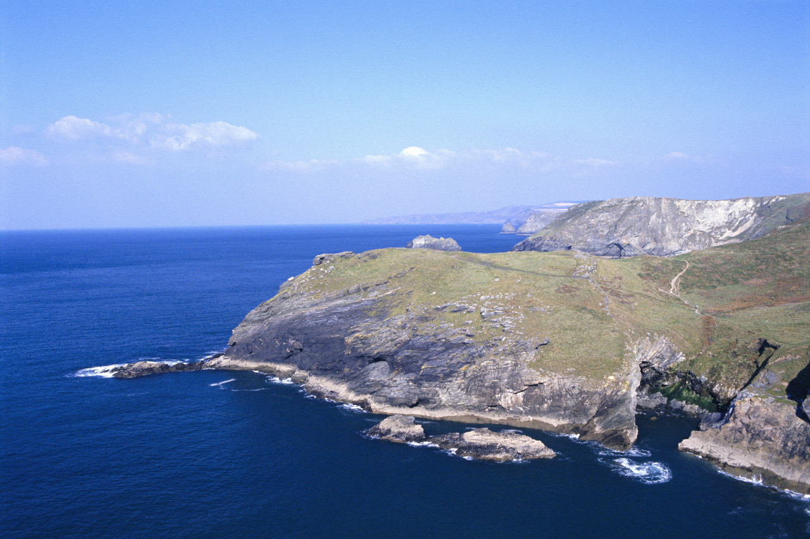
MOUNTAINS: Britain can be divided into lowland and highland areas. The mountain ranges are massifs extending about two thirds of the length of the British Isles. The most mountainous is Scotland. The highest British mountain is Ben Nevis (1, 343m). The main mountain regions here are the Cornish Heights, the Cambrians, the Cumbrian Mountains, the Pennines, the Cheviot Hills, The Highland of Scotland.

LOWLANDS: we can find them mostly in the south. Only the eastern part of England is really flat. The lowlands are most suitable for the production of agricultural crops and the soil is more fertile.

RIVERS: they are very important sources of energy and industry. Among the most important rivers is the Thames, which flows into the North Sea. It is also the biggest one. Other important rivers are The Severn (the longest), the Trent, the Humber, the Mersey, the Clyde, the Forth, the Tay, the Tweed.

LAKES: The greatest number of lakes can be found in Northern Scotland and in the Lake district. Many tourists visit Windermere Lake. The most famous Scottish lake is Loch Ness. The lakes are not important for transport but they are a big tourist attraction. Beautiful lake areas are in Cumbria and the Highlands of Scotland.

NATURAL RICHES: Britain has various natural riches. Its black coal reserves have world significance. Oil and natural gas are taken from the North Sea. Additionally, gravel, sand, chalk, limestone, clay, iron ore and salt are mined in Great Britain.

INDUSTRY: There are many branches of industry. The most advanced are chemical, textile and aviation industries, manufacturing of vehicles, electronics, plastics, banking, insurance, metals, cotton, wool and food products. The most important industrial centres are Yorkshire, London, Manchester etc. The chief agricultural products are wheat, barley, oats, potatoes, sugar beet, milk and meat, vegetables. Worldknown British cattle and sheep breeding earn lots of money. The main Britain´s trading partners are Germany, the USA, France and Holland.

NEWSPAPERS AND MAGAZINES: the best known newspapers and magazines in Britain are The times, The Independent, The Guardian, The Daily Telegraph and The Daily Mirror.

CLIMATE: It is determined by the circulation of air masses- the Gulf Stream. The sea influences positively the temperature in winter and in negative way in summer. Therefore, the winters are warm and the summers are mild. The coldest months are January and February, the hottest one is June.

POLITICS: Grat Britain is a constitutional monarchy. Parliamentary democracy is practised there, this means that the official head of the state is the monarch. Now her name is Queen Elizabeth II. Her power is limited by the constitution. The British Constitution is not written in any single document. Only some rules are written down in the form of ordinary laws passed by Parliament at various times. Parliament consists of two houses: the House of Lords and the House of Commons. It is the supreme law - making body. Elections take place after five years. The Prime Minister selects the other ministers. Twenty of them form the Cabinet. The second most powerful party forms the Opposition, it is called the Shadow cabinet. British parliamentary system is one of the oldest in the world.

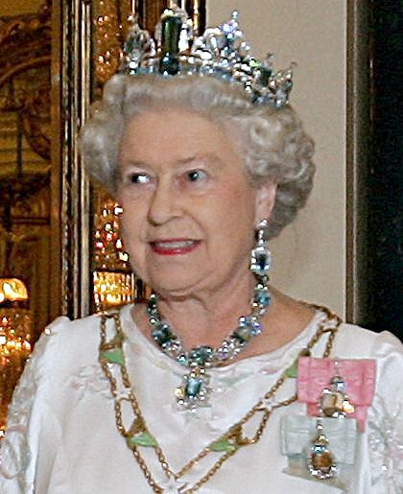
PEOPLE: The British are very conservative, reserved in manners, dress and speech, they stick to their old traditions.. They drive on the left and still wear their school uniforms. They are known for politeness and good table manners, self discipline, reliability and a specific dry kind sense of humour. They never seem to be in a hurry and are seldom agitated. They do not shake hands and kiss hello so often. „My house-my castle“ demostrates their privacy. The isles give them the feeling of security. People in the north are extrovert and friendly, while southerners seem to be more reserved and self-centred. They are also said to be taciturn, unsociable and long-suffering. The British are fond of pets (dogs, cats, caged birds) and children. Their mania for tea at any time of the day is world famous. Their country is notorious for rainy weather, but the lawns are green and fresh all the year. They are advanced in science and technology.

SPORTS: Many sports and games originated in Britain: rugby, golf, cricket and football. Football is the national sport and it is shown on TV almost every day. Other popular sports are horse racing, cricket, rugby, tenis and golf. They like to spend their summer holidays at the seaside in hot countries like Spain or France.

TV AND RADIO: There are two main public institutions ensuring television and radio broadcasting in Great Britain: BBC, IBA. The best known channels are BBC1, BBC2, ITV and Channel 4.

CITIES: The capital of England is London, the second largest city is Birmingham, the other big cities are Liverpool, Sheffield and York. Oxford and Cambridge are the old university towns. Stratford- upon- Avon is the birthplace of William Shakespeare. Canterbury is an ancient city with a majestic cathedral.

MONEY: The English currency is a pound –100 pence.

SCIENCE AND TECHNOLOGY
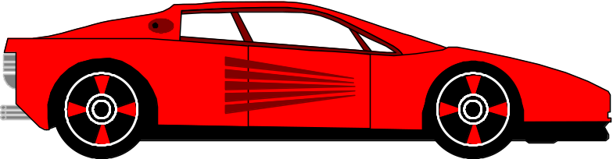
Science is an old word that comes from Latin and it means knowledge. The word scientists was invented only in 1840.
Science tries to gain knowledge of the physical world, they use scientific methods and experiments. Scientists are willing to find answers to many people ´s questions. Observing, watching, wondering, putting facts together and then testing- these are some of the main tools of science. There exist many fields of sciences- natural sciences, social , environmental sciences and so on.
Technology ( a product of science) is the application of knowledge to achieve a praktical result. Society depends on technology.
From the beginning of people´s existence they have used tools, various types of energy and materials, generally for the purposes of production of nearly everything in the world.
In early human history, the only power available was muscle power. The invention of wheel was followed by the watermill and windmill. In 18th century the steam engine was developed and improved by James WATT. Electricity was available from 19th century and it was used for electric motors and for lighting. EDISON invented the bulb and phonograph. BELL invented the telephone. The most of inventions were discovered in 20th century.
Plenty of inventions and discoveries have influenced and changed human life, such as printing, aircraft, radio, television, telephone, X-ray machines and computers.
SPACE flights represent a special application of modern technology and science. In 1961 Soviet cosmonaut YURI GAGARIN became the first human in space. The first people to step onto the Moon ´s surface on 20th July 1969 were Neil Armstrong and Edwin Aldrin.
In MEDICINE there were huge inventions which saved people life and returned health again. In 16 th century Sir Harvey discovered the circulation of blood. In 19th century Charles Darwin developed the modern theory of evolution. BANTING and BEST isoloated insulin in 1922. In 1928 FLEMING discovered penicillin. In 1938 electroshock therapy was introduced, In 1950 drugs for leukemia were developed. In the 20 th century Watson made resarch of the molecular structure of DNA and Sir Fleming investigated the properties and use of vitamin C. Science and technology has helped ease the pain of certain types of diseases, cured and prevented some incurable diseases, prolonged the life of people and made the lives of handicapped easier. Now the scientist can create life by in vitro fertilization and cloning.
Our standard of living is constantly increasing by many inventions. In our household we use many inventions which have simplified our everyday life and save our time:

THE COOKER- It is a electricial appeliance, which is in our kitchen. It is used for cooking and baking and heating water. It is very quick, it saves time. You don´t need to bring the coal or wood. The cooker can be electric or gas. Using electricity is more expensive now than using gas. In our family everybody uses a cooker , but mostly my mum when she is prepares lunch and dinner. Cooker
Advantages of this are we have hot food and we hdon´t have to use fire like in our history.Diradvantages it goes in electricity and it is expensive. I use this not so often because I don´t like cooking meals. Mums usually use this appliance.

THE WASHING MACHINE – is a good invention. It is used especially by women. It can wash our clothes easily and properly. Before, women washed the clothes in cold rivers in the villages. Now it is simple: Put the clothes, washing powder and water in the machine and set the right programme and everything is clean and ready in several minutes.
Advantages – you mustn´t wash hand made clothes, Thek can shrink.
Disadvantage- it wastes a lot of water.
My use – I use washing machine every weekend.

MICROWAVE OVEN- It is a very modern invention. It enables us to warm and refrost prepared meals. Some more expensive microwaves can be used also for cooking , baking or grilling. However, it is energy - eater and the waves are quite dangerous. It isn´t very healthy and save to stand to 1.5 metres close to it.

THE IRON – is used for ironing the clothes so that they were neat and straight. Advantage of iron is that you can make your clothes straightly fast. Disadvantage of iron is that you can burn your clothes.
It was used also in the previous century. Now we use very developed irons- inside there is water for better ironing by using the steam. In our family ,my sisters like ironing , but my mum doesn´t like it very much. I don ´t have time for using it.

THE FRIDGE-
It´s a machine where we put some meals to stay longer time fresh, healthy and nutritious. Meal is longer fresh and we can eat this meal after a few days later.
We use it every day when we want something to eat. Some frigdes have also a freezer.

THE FREEZER- It’s an electicial appliance, which is usually in our kichen, it is better than the fridge because in ice the food can be stored for a very long time without harming. It is the best to store there meat, fish and cakes, but not fruit and vegetables because they loose vitamins in the freezers and are not so tasty after freezing. We have the fridge with the freezer too. This gadget is in every family and we can use it daily.
Advantage: When we cook something and there is nobody who wants to eat it, we can give it there and eat it later.
Disadvantage: It goes in electricity, which is expensive.

THE HAIR DRIER-

It is for wet hair. If you hurry up, you take hair drier and you just dry your hair. It is used mostly by women and girls when they need to go to the party and they do not have time for waiting for having their hair dried normally on the fresh air. We use it especially in winter because it is dangerous to walk with wet hair. We can get a cold or a flu. You mustn´t dry your hair near water, because it can kill you.
You use this thing when you feel cold. Some people say that the hairdrier damages the hair by making it very dry. I use it very often because I like to make various hair styles. It can often be dangerous – it can make a fire. Sometimes it´s used when you need to unfreeze your food.
THE LAMP – It’s a small thing made from plastic and bulb. I can ´t imagine my life without having lamps at home. I use the lamp for lighting in the dark for better seeing, during reading, writing and making various activities. Sometimes, especially when it is storm , the electricity doesn´t work and it is horrible, everybody is angry and we have to use candles to see. We have many lamps in our flat, but my mum likes having many candles lit for a special atmosphere at home. Advantage is that ee don’t have to use candles.
Disadvantage: We have to pay for electricity.
We use it every day, so it is extremely useful.

THE VACUUM CLEANER- is used mostly on Saturdays when all the families tidy their households. Vacuum cleaner is very good for dirty houses.
It can clean the carpets and floors very fast and efficiently. It is very good for forming our figures because it burns many calories. Vacuum cl
Advantage is for example : Good feeling and very clean floor.
But you must clean your floor with this and it´s disadvantage.
I use it very often because I want a clean house.

THE TV- is a great time- eater. It entertains us, gives us much information about many subjects, it is suitable for all the generations.It has many channels and programmes. Children can watch fairy tales and cartoons, teenagers like watching films, shows, charts, music programmes and sport. Adults like news, political commentaries, nature films, quizzes and competitions. The old like soap operas , religious programmes and love stories. I watch TV…… My most favourite channels and programmes are…I especially enjoy…In our family…..

THE RADIO- Radio is a machine which we use for listening to music or news. We can take the small radios with us everywhere withou using an electricity. It isn´t very popular nowadays. It has one advantage: you can do whatever you want when you listen to it and you don ´t have to watch anything.
Disadvantages- We can’t see people who are speaking.I use radio everyday,when I learn or get up. On the radio there are many stations you can choose from –Funradio, Express, Jemne melodie, Slovensky rozhlas... and programmes – sport, traffic information about traffic jams, news, orange top fun...

THE WALKMAN- is a small radio, CD player and a tape recorder in one. You can take and use it everywhere because it is very small and cheap. It has a disadvantage: it needs 4 or 6 batteriesin it. Young people use it when they feel bored: in the bus, in hospital while waiting or sometimes at school too.

THE MOBILE PHONE is a great invention of these years. It is slowly replacing telephones. It has many functions .It can be a diary, alarm clock, calculator, internet, watch, stop-watch, directory, calendar, camera, but the main functions are calling and writing messages or playing games.I can use it almost everywhere (in some villages there is no signal), anytime everybody can get in touch with me when they want. The disadvantage is that sometimes it is too expensive, it can be addictive and the waves are bad for our health. I use it every day several times because my friend has free calling for one year and that is very advantageous, but also a time- eater. I pay for my mobile approximately 500 crowns a month.There are alwazs new and more developed types of mobile phones.

THE COMPUTER is the best invention ever. It has enormous possibilitie and functions. You can type, print, look for nrw information, count numbers, communicate with friends, learn, test your knowlwdge, listen to music, watch a film, translate texts, copy, scan, make pictures and tables…etc. Everybody loves using it except of old people. I use it very much and I can use it qiute well. It is my help and a friend. I have a computer at home and it helps me to write my homework.I can t imagine my life without having it. I miss a printer at home, but we will buy it in the future.
I POD- is one of the latest inventions . It is for listening music, playing games and chatting on the Internet. It is a pocket computer.
Advantages- It is small and you can use it everywhere.
Disadvantages- iPod hasn’t got very big disadvantages, but you must charge it.
I use it every day, when I’m bored. We can use it in pland, train, car, tram, bus or at school.

MY most popular invention is … because….
I can ´t imagine my life without…
I know some people who do not have…..at home. Life can be sometimes very romantic without having all these inventions, for example when we are staying in the cottage during the holidays.
Not all inventions and discoveries, however, have brought improvement and innovation for people. Laser weapons, nuclear bombs and pollution of the environment are only a few examples of how good ideas can be abused. They also cause pollution and spiritual danger and many diseases appear.

