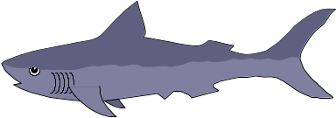MAN AND NATURE

CLIMATE: is a synthesis of weather at particular place. It determines weather conditions, seasons and weather extremes. Air temperature and precipitation are the two most importaant factors that determine an area´s climate. There are 5 kinds of climate: Moist tropical is characterised by high temperatures and much rain. Dry climate is known for little rain and huge temperature differences. Humid middle latitude climate has warm, dry summers and cool, wet winters. Continental climate is found inlands. Cold climate is a climate with permanent ice.
Slovakia has a continental climate with 4 seasons. Winters are normally cold and dry, while summers are hot and humid. The coldest month is January and the hottest one is July.
Spring: begins on 21th March, the nature awakens,the snow melts, there is mud and dirt everywhere. Trees blossom and flowers bloom. In April the weather is unstable. It rains, drizzles, there are storms, sunshine and morning frosts. Trees and grass turn green, on meadows, garden and woods the first signs of spring appear: white snowdrops, yellow primroses, birds are singing. People enjoy working in their gardens, they dig the soil, corn and seeds have to be planted. Light showers and sunny intervals are typical for this season. Days become longer because the sun sets later.
In June summer starts. The weather is great for nature lovers , hikers, campers and beach lovers. Summer heat alternates with drizzle, showers, downpours, rain, hail and thunderstorm with lightening We have a holiday and for farmers the harvest time starts. The sun shines hot, there are many storms, the wind gets faster. We can see a rainbow often, in the morning there is a dew on the grass. Weather extremes sucha s droughts and floods can spoil all the years crops. Small fruits and vegetables are cooked and preserved, people go mushrooming, or pick strawberries, blackberries, raspberries, blueberries.
In September autumn starts: the sun rises later and sets earlier. During the day the weather is nice, sunny and stable- Indian summer. Children rise their kites, while their parents clean their gardens and pick apples, pears, cabbages, cauliflowers, mushrooms, walnuts and potatoes. It is very popular because of its nice colours, grass turns yellow, there are no flowers, leaves change treir colour and start falling off the trees and will soon become bare. This is also the season of hunting. Birds migrate to the south. Days become colder and colder.the weather in unpredictable and nature changes a lot. It is foggy, misty, muddy and dump. People wear raincoats, umbrellas and Wellington boots. It keeps raining, it is gloomy and foggy, the first snows comes. The wind is very strong.
Winter: It starts in December, the temperature drops rapidly and the lowest temperatures can go as low as 20 degrees below zero. It is cold, snowy, icy, frosty, nature relaxes, there are snowdrifts, that´s why drivers have problems. Children build snowmen and throw snowballs. They enjoy skiing, sledging and skating on ice rinks or frozen ponds. Icicles hang down from the roofs. The ice and snow melts and turns int slush.
Britain has a mild and rainy climate. The maximum summer temperature is 27 d. C. and in winter –7 d. C.

WEATHER:
Weather patterns have changed and there seem to be more weather- related disasters like tornadoes, hurricanes, tsunami, floods, avalanches, and droughts. The polar icecaps are melting, so sea levels around the world are rising and scientists predict that some seaside areas will disappear under the sea in the future. Earth´s ecosystems have also been affected, so many plant and animal species are in danger of extintion and have to be protected in national parks, zoos, botanical gardens and game reserves.

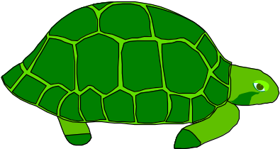 DEFINITION: The environment means surroundings in which people, animals and plants develop and exist. The branch of biology dealing with the relationships between living beings and their environment is called ECOLOGY.
HISTORY: Man has always been dependent on the natural world surrounding him. Thousands of years ago he didn´t destroy nature, he used only what he needed: he cut wood to make a fire and a shelter, he picked wild berries, he killed animals to feed his family. He didn´t need anything else for life. When he became a farmer, he needed land to build a house, plant crops and raise domestic animals. Later, when, he was able to store food and to sell it, he began to exploit nature.
The world´s population grew and people needed and wanted more. He cleared more land to build more houses, used fertilizers to plant more crops, built factories to produce more. The Industrial Revolution in the 19th century and the modern technologies have damaged and destroyed nature. Humankind´s advances have resulted in changes in the Earth´s atmosphere and the environment we live in.
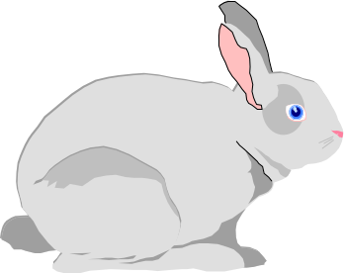 TODAY: Today, the Earth is overcrowded with more than 6 billion inhabitants. We have to realise that we cannot expand forever, beacuse the Earth´s resources are not limitless. 1 billion people live in total poverty and many children die every year of starvation. All life on our planet depends on three basic elements: air, water and soil. Now we face various threats. The air we breathe, the water we drink and the soil we plant are all polluted.
PLANTS: are an important part in the cycle of nature. There would be no life on Earth without them. Animals are depended on plants for their food supply because they cannot make their own food. Plants also produce the oxygen that we breathe. Now, some plant and animals are in danger, they are written in the Red List of Threatened species, like elephants, tigers, pandas, whales, corals, great apes, marine turtles, polar bears, rhinos, snow leopards and doplhins. In Slovakia the most endangered living animals species are chamois, marmot and lynx and from plants edelweiss.
POLLUTION: Pollution is one of the most serious problems of our area. Over the last 150 years the human race has polluted the whole planet and ecologists warn that if we do not stop damaging the environment, life on our planet will disappear. The situation is critical and humankind must find solutions to the air, water and soil pollution, the greenhouse effect, the holes in the ozone layer, acid rain, serious weather changes, deforestation - the cutting down of tropical rain forests- and the disappearance of many animal species.
CHEMICALS: We produce huge amounts of dangerous chemicals that endanger all life. Industrial and agricultural production releases huge amounts of carbon dioxide, radioactive particles, gases into the atmosphere causing serious changes. The CFCs used in fridges and plastics are able to destroy the ozone layer surrounding our planet protecting it and people from the dangerous rays of the sun. It can cause the skin cancer, eye damage – blindness, it can influence our body´s immune system negatively. Chemicals mixed with the water in the clouds make ACID RAIN which damages the buildings, trees and pollutes the soil. Chemicals are not only from factories, but also from detergents used to wash our clothes and pesticides and fertilizers. The cars produce exhaust fumes which pollute our air. Packaging, paper and plastic bottles, cans we produce are buried, polluting the soil or burned, polluting the air. All these chemicals get into the atmosphere or leak into the soil and pollute our water.
Substances like sulphur dioxide and nitrogen oxide can cause major changes in the environment which can lead to CLIMATE CHANGES.
TREES: Trees are vitally important for our life because they are the lungs of our planet. They absorb carbon dioxide from the air and give out oxygen in return. In some parts of the world, such as Asia and South America, trees are not threatened by pollution, but by people. The rain forests are being destroyed for firewood and building materials. If we lose tropical forests, it will become more difficult, perhaps even possible to breathe.
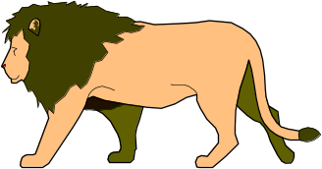 Several gases contribute to the greenhouse effect, which can cause climate change. Without this greenhouse effect there could be no life on earth because the earth is warmed up naturally by the atmosphere which traps solar radiation. But manmade atmospheric emissions, such as carbon dioxide, nitrogen oxides, CFCs, methane and wapour prevent the heat from escaping. The result is a rise in the Earth´s temperature, the melting of arctic ice and the flooding of areas situated near the sea level. Ozone is another air pollutant that contributes to the greenhouse effect. On the ground level ozone can cause asthma attacks, corrosion of certain materials and stunted growth of plants. On the other hand, ozone forms a layer in the upper atmosphere which protects life on earth from ultraviolet rays, which is a cause of skin cancer.
Smoke from coal fires which causes SMOG, also represents a considerable problem in large cities and threatens life.
DAMS: The building of dams causes flooding of large areas of nature and the dissapearance of many typical animals, birds and plants of the region.
Noise poses a considerable problem for many people. It results in stress, lack of concentration, defective hearing or sleeplessness. We should be considerate to one another. Noise from new motor vehicles and aircraft is regulated. Airport services are restricted at night.

NATURAL DISASTERS
Many countries have recently been hit by different disasters like earthquakes, fire, draughts, volcanoes, tornadoes, hurricans, floods, avalanches, tsunami waves. One of the worst one was in the Indian Ocean in 2004 when tsunami killed 283 thousand people and devastated many lands. In 2010 the Hiti earthquake with a magnitude of 7 caused major damage to the nearby capital and its sourroundings, 3 million people were affected. In 2011 earthquake in Japan was the most powerful rearthquake in the world, its tsunami waves destructed a number of residences, infrastructure and caused the nuclear accidents.
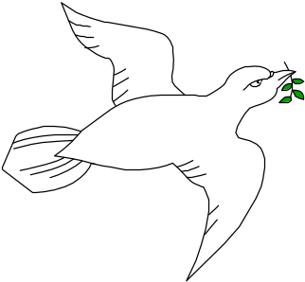 EFFORTS: There have been some efforts to stop the destruction. There is a ban of using the CFCs, most new cars run on unleaded petrol, more environmental products are being manufactured. The use of DDT was banned by law all over the world too, the use of phosphates in soaps is forbidden, catalytic converters are compulsory in many countries, ozone destroying chemicals in sprays were stopped using. Organizations like Green peace, WWF or Friends of the Earth and other voluntary organisations inform people about the importance of the protecting nature.
SOLUTIONS: We must find solutions to our ecological problems and try to save life on our planet for future generations otherwise we too are in danger of extinction. The most difficult challenge that people face tody is cleaning up the environment. We can all try to do things every day to help the environment. Firstly, there is a great need for the environmental education. Children of all ages should be taught about the man´s relationship to nature. They should be educated to a much better understanding of the fact that this planet, weather, climate, water, soil, people, animals, birds and plants create one ecosystem. No part can exist separately. They are mutually dependent.
We are responsible for teaching young people to realize all these problems and try to solve them so that they could live in a beatiful blue planet called Earth.

WHAT WE CAN DO: Here are the things we can do more:
- Join an environmental organization
- Use wind power, geothermal energy, hydroelecticity and solar energy
- Plant a tree
- Use public transport and less cars
- Clean lakes and rivers
- Compost organic trash
- Express your concern
- Pick up the litter and don´t drop any
- Recycle- it means making new things from the old ones
- Save energy
- Buy environmentally friendly products
- Separate waste at home , at school and in the office- put paper in the paper bins, glass into glass bins, plastic bottles in the containers for plastic
- Use alternative sources of energy: solar, water, wind, geothermal
- Use catalytic converters in the cars and unleaded petrol
- Be sure to turn taps off tightly so they do not drop
- Never run water continuously
- Use water from a mug for rinsing while brushing your teeth
- 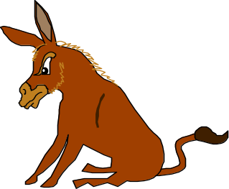Turn off the water while you are soaping or shampooing
- Short showers use less water than baths
- Never flush garbage of any kind down your toilet
- Reduce: never buy more than you really need
- Buy products which are lasting
- Re-use the things
- Buy products made of recycled materials
- Donate unuseful things to religious, social services or hospitals- clothes, books, toys, magazines, furniture
- Don´t throw the litter in the streets
- Join neighbourhood litter and pollution clean-up days or weekends

Dobrú chuť k učeniu! Nie že si to vytiahnete, ani ja to nemám rada. D. M.

