Goniometria IV – rovnice

Riešte v R:

- sin x = 
- sin x = 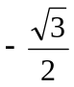
- cos x = 
- cos x = 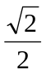

- cos x = 0
- cos x = 1
- cos x = –2
- tg x = 
- tg x = 0
- tg x = 1
- cotg x = –1
- cotg x = 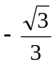

- cos( x – 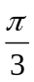) =
- cos( x – ) = 1
- sin(x + ) = 1
- sin(– x) = 1
- cos 3x = 0,5

2sin( x – ) = 1
- 2sin( 3x + ) = –1
- tg(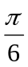– x) =
- tg(x – ) = – 1
- cotg(x + ) = – 1
- cos(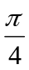– 2x) = – 1
- cotg(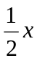 + ) = –1

- 2cos²x + 5cos x – 3 = 0
- 2sin²x – 7sin x + 3 = 0
- 2cos²x = sin x + 1
- 2 + 2cos x = 3sin² x
- cos²x + cos x = sin² x
- 2cos²x = 3sin x
- 2sin²x – 3cos x = 0
- sin x + cos 2x = 1
- 2cos²x + sin x = 1
- tg²x – 7tg x + 10 = 0
- tg x – cotg x = 1
- 2tg x – 3cotg x = 5
- cos²x + cos x = 0

sin x . cotg 2x = 0
- tg x . cotg x = 0
- sin 5x = sin 3x
- sin 2x = (sin x – cos x)²
- sin 2x = cos 3x.sin 2x
- cotg 2x = tg 3x.cotg2x
- cos x = sin 2x . cos x
- sin 2x = tg x
- cos²x – sin²x = – 0,5
- sin x + sin 3x = sin 2x + sin 4x
- 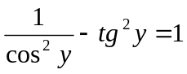
- sin²x + tg² x = 

