About you
1 Talk about you.
 Are you a sports fan? What sports do you like?
 What sports or hobbies can you do now? Could you do any of these activities when you were six?
 Are you a daredevil? Give examples.
 What daring things do you want to do in the future?

Role play
2 Complete the dialogue with the expressions. Then practise the dialogue.
are you doing anything sounds good
shall I meet you are you OK better than

A Hi, Matt. You look worried.
(1) ____________________________?
B Hi, Jess. (2) __________________________ on Friday? We’re having a party at the youth club.
B (3) ___________________________. So what’s the problem?
A We haven’t got any music!
B Don’t worry. I’ve got loads! I’ve got rock, pop, and heavy metal.
A Great. Bring the pop and rock music. It’s
(4) _________________________ heavy metal!
B OK! (5) _________________________ at the youth club, then?
A Yeah, great!
EXTENSION Imagine you are talking to some friends who are organizing a basketball match at the youth club on Saturday.
A ask your friend if he / she is OK
B explain that you are organizing a party and say when and where it is, invite your partner
A accept and ask what the problem is
B explain that you haven’t got much food
A offer to bring sandwiches or pizza
B say which food you prefer and give a reason
A agree and say when and where you’ll meet your friend

Photo description
3 Describe the photos.
Photo A
 What has happened?
 What was the person doing when it happened?
 What is the person doing now?
 What do you think is going to happen next?
 Is this sport always dangerous? Why?
Photo B
 What has happened?
 What was the person doing when it happened?
 What are the people doing now?
 What do you think is going to happen next?
 Is skateboarding always dangerous? What should people do to stop injuries?
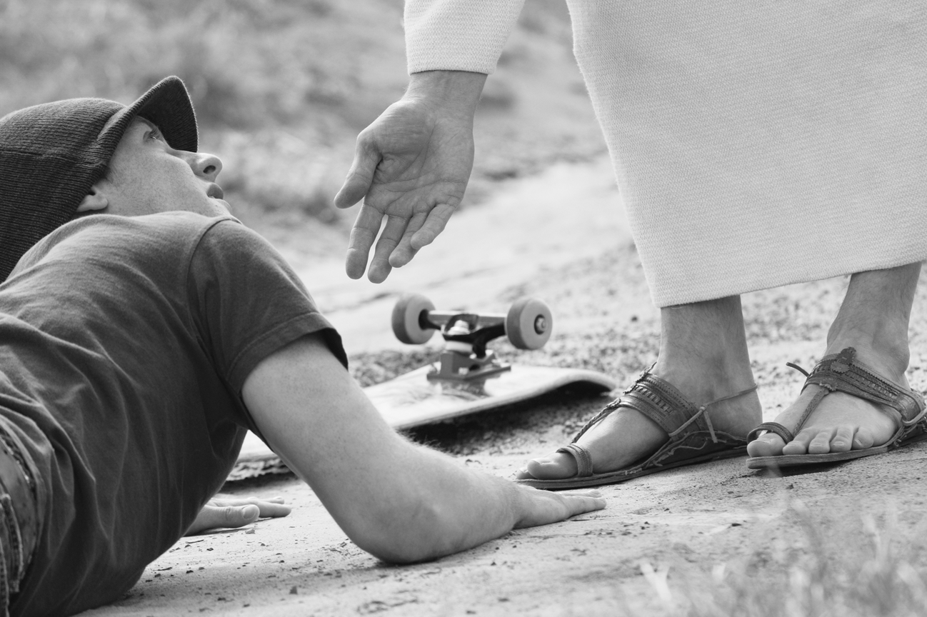
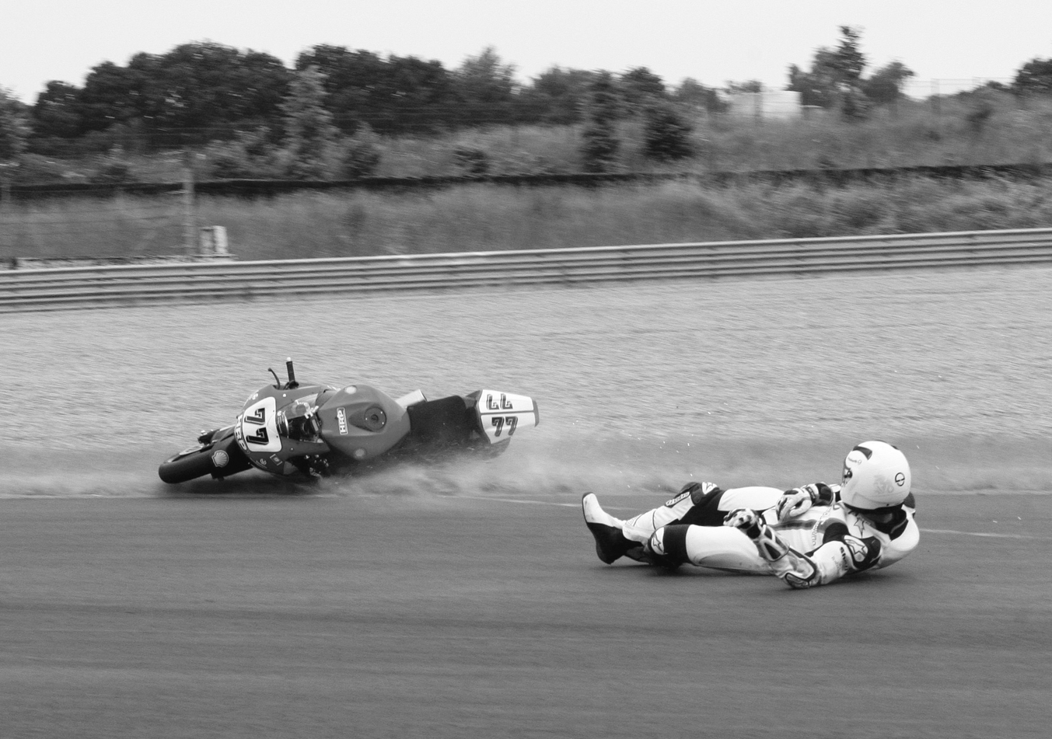
EXTENSION Answer the questions.
A
B
 Look at both photos. Which sport do you think is the most dangerous? Why?
 What sports do you think are dangerous? Why?
 Have you ever injured yourself while you were doing a sport? What happened?

