READING
Men on the moon
What is your biggest ambition? For some young men in the 1960s, it was to become an astronaut and walk on the moon. But what do you wish for if you have already walked on the moon? Very few people have ever been able to ask themselves that question.
Reaching the moon was perhaps humankind’s greatest achievement. On 20 July 1969, Neil Armstrong became the first person in recorded history to set foot on another planet. Many believed at the time that many similar successes were just around the corner. They turned out to be wrong.
Altogether, 24 astronauts have travelled to the moon, and only half of them have had a chance to step outside. All of them were American. All of them were men. And they all visited the moon in a brief interval from 1969 to 1972. Since then, nobody has travelled there. Some engineers claim today it would take us another ten to fifteen years to ever do that again. Now ask yourself this: how many moonwalkers could you name? People remember the names of pop stars, presidents, even racing car drivers long after they disappeared from the public eye. But very few of us could name a handful of people that walked on the moon.
What kind of people were they? One of them, Jack Swigert, whose only trip to the moon was the near-disaster of Apollo 13, once said it was not surprising astronauts never said anything interesting about the most momentous experience in their lives. For example, when Pete Conrad, commander of Apollo 12, stepped on the moon, he didn’t make a speech. He only said, ‘Whoopee!’
Astronauts were strong people: psychologically as well as physically. They were selected by NASA for their ability to survive in extreme conditions. They were usually patient, focused and very calm. They were not poets or artists, they were Air Force pilots. But they could never have achieved what they did if they had been less determined. They all knew that if they made just one mistake, they could die at any moment. They all came home safely. And now, when the era of the space shuttle ends with the return of the Atlantis on the 42nd anniversary of the first moon landing, we can all remember their achievement, which was just one small step for them, but one giant step for humankind.

1 Read the article. Match sentence beginnings 1–11 with endings a–l. There is one extra ending.
1 The first astronaut who walked on the moon d .
2 Twenty-four American astronauts ___
3 During the time between 1969 and 1972 ___
4 According to experts, these days ___
5 Very few people today ___
6 Astronaut Jack Swigert ___
7 Astronaut Pete Conrad ___
8 NASA selected astronauts ___
9 If astronauts make a mistake in space, ___
10 All the moon astronauts ___
11 The space shuttle Atlantis returned from its final journey ___
a who had a chance to walk on another planet.
b we would not be able to travel to the moon.
c only said one word when he arrived on the moon.
d arrived there on 20 July 1969.
e who would be able to work in difficult conditions.
f remember the names of the moon astronauts.
g returned from their expeditions safely.
h forty-two years after the first trip to the moon.
i have made a journey to the moon.
j took part in an unsuccessful trip to the moon.
k they risk death.
l there were several expeditions to the moon.
2 points for each correct answer |  | 20
2 Match the underlined words or phrases in the text with the definitions.
1 all the people in the world humankind
2 appearing in newspapers or the media __________
3 a period of history when an important __________
event or events took place
4 in the very near future __________
5 amazing __________
6 period of time between two events __________
1 point for each correct answer |  | 5

 | Reading total |  | 25
WRITING
1 Fill in the form for you.
FRIENDSHIP.NET
First name: _______
Surname (write in capital letters): _______
Gender (circle as applicable): M / F
Date of birth (dd/mm/yyyy): _______
Marital status: _______
Occupation: _______
Country: _______
City: _______
Languages spoken (indicate level):
1. _______ (elementary / intermediate / fluent / native speaker)
2. _______ (elementary / intermediate / fluent / native speaker)
3. _______ (elementary / intermediate / fluent / native speaker)
Hobbies, interests: _______
Looking for (delete where not applicable): friends / online gaming partners / serious relationship / husband / wife

Shorter writing task |  | 5
2 Write a review of a film you have seen and didn’t like. Write about:
• the director, actors, any other people involved.
• the type of film.
• the story.
• the visual style, special effects, music, etc.
• anything that was good about it.
• what you didn’t like about it, and why you wouldn’t recommend it.
Write your review in 150–180 words.
Longer writing task |  | 20

 | Writing total |  | 25

LISTENING
1 Listen to five short extracts. Write the number of the correct extract (1–5) for the summaries. There is one extra summary.
an interview with a musician ___
two school friends meeting after a long time ___
someone phoning a friend at work ___
friends talking about some family news ___
someone phoning a friend on holiday ___
someone trying to contact a travel agency ___
1 point for each correct answer |  | 5
2 Listen again. Read two statements about each extract. Write true (T) or false (F).
1 Mr Wilson is on holiday at the moment. ___
2 The caller leaves a message for Mr Wilson. ___

3 Sean’s wife had to go to hospital. ___
4 Nick buys their drinks. ___

5 The caller talks to two operators at the call centre. ___
6 The caller already knows one of the phone numbers he’s given. ___

7 Neither of the two friends has got any children. ___
8 Patrick asks Kelly to go with him to the wedding. ___

9 The tour is starting in May. ___
10 They are going to play their own songs at the festival in August. ___

2 points for each correct answer |  | 20

 | Listening total |  | 25

SPEAKING
1 Ask and answer the questions with a partner.
1 Who’s your favourite writer? Which of his/her books has impressed you the most? Why?
2 What scares you? What makes you angry? What makes you happy?
3 What gadget would you find the most difficult to live without? Why?
4 What’s your biggest ambition in life? Do you think you’ll achieve it? Why?/Why not?
5 If you could live as anyone else, whose life would you live? Why?
max. 1 point for each topic |  | 5
2 Look at the photos. Compare the different discoveries or inventions. Talk about how they have changed our lives for the better or for the worse. In your opinion, which invention has changed our world the most?


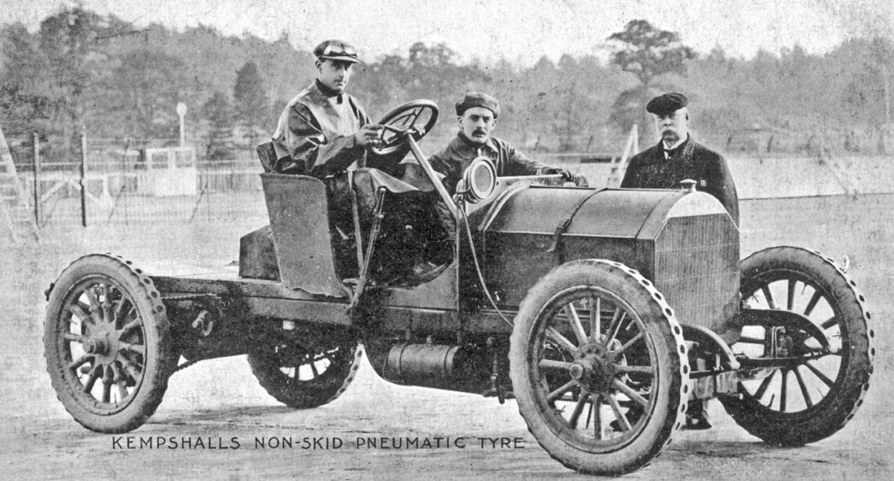

max. 10 points |  | 10
3 A Look at the information. Use the words to make five questions.
Jane Austen
1775 Steventon (Hampshire, England) – 1817 Winchester (Hampshire, England)
English novelist, one of the most popular writers in English literature
Educated at home by her father and brothers
Most famous works: Sense and Sensibility, Pride and Prejudice, Emma, and Persuasion – many successful film adaptations of her novels
Stories about the place of women in 19th century society
Seriously ill from 1816, died of unknown causes in 1817
1 when and where / be born / die ?
2 why / famous ?
3 who / taught by ?
4 what / write ?
5 why / die ?
1 point for each correct question |  | 5
B Answer the questions.
1 point for each correct answer |  | 5

 | Speaking total |  | 25

 | Skills test 4 total |  | 100

