About you
1 Talk about fears and dangers.
 Have you got any phobias? What are they?
 What things are you scared of? Why?
 Are you an adventurous person? Give an example.
 Have you ever done anything dangerous?
 What frightening things have you done?

Role play
2 Complete the dialogue with the expressions. Then practise the dialogue.
how did that hurt what’s wrong
maybe you need it really hurts

A Are you OK?
(1) ____________________________________?
B I’ve (2) __________________________ my ankle.
A Oh, no!
(3) ____________________________________ happen?
B I fell over while I was walking to school.
(4) ____________________________________!
A (5) ____________________________________ to see a nurse. I’ll get help.
B OK. Thank you.
EXTENSION Imagine there’s a problem.
A ask your partner what’s happened and if they are OK
B say what your problem is
A ask how it happened
B explain what happened
A suggest what your partner should do next
B agree

Photo description
3 Describe the photos.
Photo A
 Look at the person in the photo. What scary thing is he doing?
 How do you think he is feeling?
 Why do you think he did this?
 Are you scared of snakes? Why?
 Have you done anything similar to this?
 Do you want to do anything like this? Why?
Photo B
 Look at the person in the photo. What scary thing is she doing?
 How do you think she is feeling?
 Why do you think she did this?
 Do you think it is dangerous? Why?
 Have you been skiing? Did you enjoy it?
 Do you want to go skiing in the future? Why?
EXTENSION Answer the questions.
A
B
 Why do you think that some people like doing dangerous things?
 Do you enjoy taking risks?
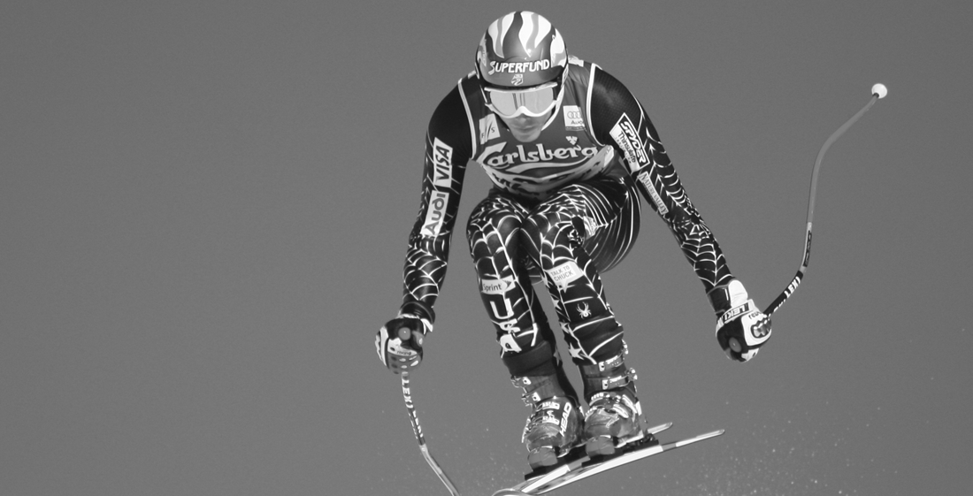
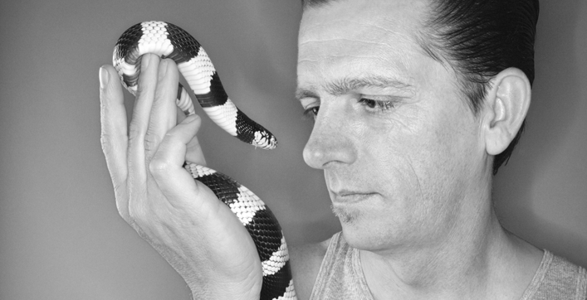
 Is it a good idea to do things you are scared of? Why?

