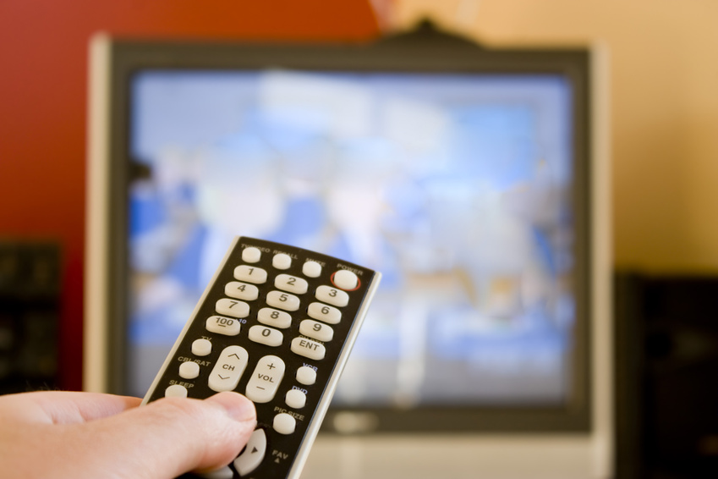
MASSMEDIA

In modern society we are in daily dontact with different types of massmedia. We receive most of our information through television, newspaper, radio or the Internet. These are the media that reach a very large audience, that is why they are called mass media. They serve, first of all, sources of information. They allow us to follow world affairs soon after the events happen. In the case of live broadcasting, we learn about current events as they happen. Most people follow the national and world news regularly to be well informed. In the case of catastrophies, such as earthquakes or terrorist attacts, the whole world follows the mass media to get the latest information. Many channels broadcast breaking news in such situations.
Mass media do not only inform, but they also educate. Documentary programmes také us to places we would never have a chance to see and provide us with information that we would otherwise not know about.
Apart from the informative and educative function, the role of mass media is to entertain. Thousands of people sit in front of their TV sets at the same time and watch a World Cup final match in football or hockey. Peple like to relax watching films, sitcoms, soap operas or series, some prefer discussions or reality shows. For many people the TV or the Internet are the only ways of entertaining themselves. The sick, the unemployed, the disabled or lonely people normally watch it much more than people who have families or who are busy. On the other hand, there are people who prefer to read, meet others or go out instead of watching TV.
There are children and young people who are obsessed with watching the TV several hours a day, which is not healthy either to their mental or physical development. It damages their eyesight and prevents them from doing sports or being outside. Watching TV is also connected to the habit of eating too much. TV prevents family members from communicating with each other. Many parents do not have time for their children and TV is a way of „solving“ this problem. Watching TV is also one of the reasons why people do not read as many books as they did before.
It is a well-known fact that violence in films influences children and the young in a very bad way. Children also sometimes have problems to differentiate between fiction and reality. Some programmes, such as reality shows, craeate different pseudo-idols and present money or physical beauty as having the highest value in life. This has a negative impact on young people´s mental development.
Advertising through TV commercials has become one of the most effective ways of selling products of different kinds. It helps finance Tv channels, especially private ones. Advertising and propaganda on TV influences viewers a lot, although they do not realise or admit it.

RADIO, TELEVISION

Slovak television is a public television network that broadcasts on analogue terrestial television, cable television and satellite TV. The first channel broadcasts mostly news, political discussions, films, series and children programmes. The second specialises in documentaries, quiz shows, educational programmes and music. It also broadcasts live football or hockey matches. These channels broadcast mainly in Slovak but also have special programmes in Hungarian. Foreign language films on Slovak Tv channels are mostly dubbed, rarely subtitled.
Commercial stations, such as Tv Markíza and Tv Joj, also enjoy wide popularity. Polular series, sitcoms, quiz shows and reality shows also form a part of their programme. The introduction of people –meters increased the competition among the channels. In 2001, TA 3, the first Slovak news channel started broadcasting. Thanks to this channel, Slovak can watch current news throughout the whole day. Its programmes cover a wide range of topics, mostly from economy, politics, technology and sport. Slovaks who receive broadcasting through cable tV can also enjoy watching several Czech channels. Thanks to no language barriers and interesting programmes, they are very popular in our country. Apart from these channels, there exist a number of local channels focusing on local interests. Some TV stations make a selected content of their programmes available on their websites. In Britain, radio and television broadcasting is provided by the state-owned BBC, which has a high international reputation for its objectivity. Besides the BBC, there are also other radio and TV broadcasters. The BBC has five national radio programmes and several television channels. The BBC´s five programmes for radio broadcasting have their specialisations. The famous BBC World Service broadcasts across the world in English and many others languages, including Slovak.
There is a variety of different types of radio and TV stations in the USA. Most non- commercial radio stations are public and educational stations which are operated by colleges and universities any by various religious groups. Hundreds of radio stations of the uSA broadcast in languages other than English for minorities, such as Chinese, french, Japanese, Polish and Portuguese. About 160 radio stations throughout the USA broadcast only in Spanish.

NEWSPAPERS

Most newspapers are daily newspapers. They are aimed at certain social classes with a certain education and political orientation. SME is a daily paper with nationwide distribution that is widely read and influential. PRAVDA is another widely read paper in our country. The best selling daily, however, is the tabloid NOVÝ ČAS whose supplements NOVÝČAS VÍKEND and NOVÝ ČAS PRE ŽENY have become very popular. Economic periodicals include teh daily HOSPODÁRSKE NOVINY and a weekly TREND. The SLOVAK SPECTATOR is a weekly English language newspaper providing information about Slovakia in English. Most of the newspapers now have their online editions which are becoming more and more popular. Besides these, there are many specialist weekly and monthly lifestyle magazines for men, women and teenagers, for people interested in sports, gardening, cars, etc.
The British communication media , press, broadcasting and TV are among the most influential in the world. There are five quality daily papers or broadsheets, The Times, the Times, the Guardian, the Financial Times, The Independent and The Daily Telegraph which contain a wide variety of national and international news, reports from parliamentary debates, reviews of the arts, features about fashion and sport and business news. Nearly all teh papers pay special attention to the reporting of sports, which play an important role in British life. Then there are papers with a high circulation, such as The Daily Mirror and The Sun which are popular papers or tabloids. They hardly publish any serious material. The articles mostly deal with sex scandals of pop stars.
The largest daily newspapers published in the USA are The Wall Street Journal, The New York Times, The Washington Post, New York Daily News, USA Today and The New York Post, followed by such titles as The Los Angeles Times, The Chicago Tribune, The Boston Globe, The Detroit News and The San Francisco Chronicle. All of these are very serious „quality papers“.

THE INTERNET

The Internet presents a true revolution in many areas of our life. It has changed teh way we study, work, entertain or communicate with family, friends, business partners and people we do not know. It has made access to any type of information easier. Nowadays, we do not have to use the phone anymore to find out about departures of trains, opening hours or details about products or services. We do not depend on encyclopedias or dictionaries to find information. Internet search engines and online books and dictionaries are gradually replacing them.
It is becoming a must for companies and different institutions and organisations to have their own website. Many professions or services depend on the Internet. Via teh Internet we send documents, buy things, book hotels, reserve tickets, transfer our money or find life partners.
These days, more and more people us ee-mail to communicate and send information or documents. Many Slovaks use the Internet as a form of entertainment. Chatting, joining different discussion groups and reading blogs is becoming very popular, especially among the young.
Access to the Internet has also become easier in our country. Most schools, companies and institutions have access to it. The high number of Internet providers has decreased and the prices of using the Internet. It is becoming normal that Slovaks also have access to the Internet at home.
Much discussion concerning the safety of the Internet has been going on in the last few years. Most of them concern the safety of personal information and the safety of bank transfers. Many hackers get into different computer systems and misuse the data. Thy also create computer viruses which can destroy the data completely.

A, Answer the questions>

What does the term Massmedia mean?
Can massmedia teach us anything?
What kinds of massmedia do you know?
Which is your most favourite type of massmedia?
Talk about each kind, mention advantages and disadvantages.
NEWSPAPER: What kinds of newspaper are there?
Why do people read newspaper?
What is the distinction between tabloid and serious newspapers?
Where can you buy newspapers?
Which newspaper do you read?
Which don ´t you like?
What are the newspapers like in Slovakia?
Which are typical women´s/ sports newspapers?
What can you normally find in newspapers and magazines?
Do you buy any magazines? Why? Which ones?
What about reading in your family?
Do you know any British or American press?
RADIO: Is radio popular nowadays?
Do you listen to the radio?
Which radio stations are there in your country?
Which stations are favourite for young and old people?
Which programmes are there in the radio?
Which ones do you listen to?
What advantages does it have?
TV: Which channels are there on TV?
Which programmes are there?
How often do you watch TV?
Which are your favourite channels and programmes?
What do you dislike watching?
What does your family watch?
Compare commercial and non commercial Tv channelss.
Can Tv have a negative influence on people? / family
What do you think of soap operas?
What do you think of TV news?
Could you live without having a TV at home?
What are the benefits of TV watching?
Aren ´t there too many programmes on TV?
What should we do instead of watching TV?
What do the children / teenagers /adults /old people like watching?
What are the differences between men and women ´s watching?
Give some examples of cartoons, soap operas, films, political programmes, documentaries, shows, quizzes.
Have you got a satellite?
INTERNET: What are the most modern forms of massmedia?
Do you use the internet? Why?
Which pages are your favourite?
Can you send e-mails?
How can Internet help people?
What do you think of chatting on the Internet?
Which form of massmedia is the cheapest and the most expensive?
Can you compare radio, TV, newspaper and Internet?
Do you read, watch or listen anything in English?

B, Write the words to the definitions>

1. weekly or monthly publication with pictures, stories and articles..................
2. a publication printed daily or weekly containing news...................................
3. a machine which receives broadcast sounds...................................................
4. a machine which can show pictures on a screen.............................................
5. software which allows users to make phone calls over the Internet................
6. the electronic network of connected computers..............................................
7. a station which sends out TV programs..........................................................
8. a newspaper with stories , scandals and entrtainment.....................................

C, Talk about the negative impacts of television on health of young people. Use these>
- Time spent in front of TV versus reading books, exercise and other activities
- Problems with eyesight
- Developing the habit of eating in front of TV
- Violence and crime in films
- Creating pseudo/idols
- Lack of communication among the family members and friends

ROLE PLAY 1
Your grandmother is very old/fashioned and has no idea about the latest mass media, such as the Internet. Explain to your grandmother what the Internet is and what it can be used for.

ROLE PLAY 2
You are 19 tomorrow and you long for connection to the Internet. Your mum is against it. Persuade her and name many reasons.

HUMAN RELATIONSHIPS

„Truly friends are hard to find, difficult to leave and impossible to forget.“ G. Randolf

 Human relationship describes the way people get on with each other, talk and behave towards each other. Relationships are created between parents, children, married couples, friends, men and women, employees and employers, etc. The quality of relationships with others reflects our own personality. It is our choice who we talk to, how we treat other people, how much time and energy we are willing to spend with them.
Families are the basic social units in which informal relationships are formed. Besides others, one of the most important roles of a parent is to raise their children in accordance with social models and patterns of behaviour. It means that children observe how their parents talk, behave to their relatives, friends, colleagues and strangers. Then, they behave accordingly in their adulthood.
Nowadays, human relationships are very complicated. Many people are stressed, busy and tired. A full valued relationship is something that cannot be bought for money. It is about feelings, empathy, understanding, trust, care, politeness and satisfaction.
There are short- term and long- term relationships. Some relationships last forever from early childhood. Some of them are created for a short period of time. It is teh same with marriages. Normally, 2 people get married because they want to spend their whole life together. However, after some time they may find out that their relationship is weakened and there are no more reasons why the should live together. The statistics shows taht a high rate of divorce is caused by love disappearing, a lack of faith and trust, financial problems and a denendence on alcohol, drugs, or gambling. Keeping a functioning relationship with a life partner, best friends, family members or colleagues is much more difficult than bringing one to an end.
A happy marriage represents the ideal human relationship in which each partner feels free to be what he or she is by nature. Similar values, ethnic backgrounds, interests, IQs, religions and lifestyles are the most important ingredients in lasting relationships. A good relationship with parents is also important. Someone still at war with his parents is probably not ready for peace and companionship with a romantic partner. Couples who can discuss honestly whatever is important to them – including their relationship – are happier and more likely to have lasting love. Sometimes it may be painful to hear that the relationship is not satisfying. But talking about feelings and listening to each other are both vital for happiness. In a fruitful agrument, each partner explains why he or she is mad while the other one listens with respect. Long-term happy couples also tend to argue calmly. Loss of control, yelling, or sobbing seldom helps to solve problems. Successful couples do not také each other for granted but work constantly at rejuvenating their good feelings for each other.
Friendship is a relationship between people who have something in common, spend a lot of time together, support and help each other when necessary. Friends are people who laugh together, speak about everything, share secrets. They show their true feelings. They accept each other as they are. They look at each other and see a great person, one they love spending time with. Friends are tied by memories, tears, laughs and smiles. True friends are people who are always there for you. Friendship is about giving and getting equally. The saying „A friend in need is a friend indeed“ shows the full value of friendship. There is no place for jealousy, ignorance and excuses. We make friends during all life stages. Some friendships last a short time , others for our whole life. If we want to keep our friends for a long time, we should stay in touch with them, send e-mails, call them, send occasional cards, exercise together or go to lunch at least once a month. Some friendships lose importance and die out. It happends when friends stop contacting each other or because of unresolved arguments. When ther is a conflict, it should be resolved by confrontation or talking it out.
Besides marriage and friendship, there are other sorts of formal relationships formed among people at school, work and in the streets. Formal relationships are not very deep and open. They are formed among people of different social positions: relationships require respect and a higher level of formality and politeness.

