The Boy Who Cried Wolf
A shepherd-boy, who watched a flock of sheep near a village, brought out the villagers three or four times by crying out, "Wolf! Wolf!" and when his neighbors came to help him, laughed at them for their pains.
The Wolf, however, did truly come at last. The Shepherd-boy, now really alarmed, shouted in an agony of terror: "Pray, do come and help me; the Wolf is killing the sheep"; but no one paid any heed to his cries, nor rendered any assistance. The Wolf, having no cause of fear, at his leisure lacerated or destroyed the whole flock.
There is no believing a liar, even when he speaks the truth.

The Miser

 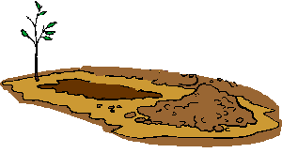
A miser sold all that he had and bought a lump of gold, which he buried in a hole in the ground by the side of an old wall and went to look at daily. One of his workmen observed his frequent visits to the spot and decided to watch his movements. He soon discovered the secret of the hidden treasure, and digging down, came to the lump of gold, and stole it. The Miser, on his next visit, found the hole empty and began to tear his hair and to make loud lamentations. A neighbor, seeing him overcome with grief and learning the cause, said, "Pray do not grieve so; but go and take a stone, and place it in the hole, and fancy that the gold is still lying there. It will do you quite the same service; for when the gold was there, you had it not, as you did not make the slightest use of it."

The Ant and the Grasshopper

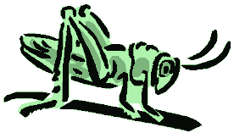 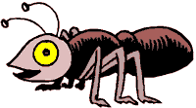
In a field one summer's day a Grasshopper was hopping about, chirping and singing to its heart's content. An Ant passed by, bearing along with great toil an ear of corn he was taking to the nest.
"Why not come and chat with me," said the Grasshopper, "instead of toiling and moiling in that way?"
"I am helping to lay up food for the winter," said the Ant, "and recommend you to do the same."
"Why bother about winter?" said the Grasshopper; "We have got plenty of food at present." But the Ant went on its way and continued its toil.
When the winter came the Grasshopper had no food and found itself dying of hunger - while it saw the ants distributing every day corn and grain from the stores they had collected in the summer. Then the Grasshopper knew: It is best to prepare for days of need.

The Tortoise and the Hare
 
The Hare was once boasting of his speed before the other animals. "I have never yet been beaten," said he, "when I put forth my full speed. I challenge any one here to race with me."
The Tortoise said quietly, "I accept your challenge."
"That is a good joke," said the Hare; "I could dance round you all the way."
"Keep your boasting till you've won," answered the Tortoise. "Shall we race?"
So a course was fixed and a start was made. The Hare darted almost out of sight at once, but soon stopped and, to show his contempt for the Tortoise, lay down to have a nap. The Tortoise plodded on and plodded on, and when the Hare awoke from his nap, he saw the Tortoise just near the winning-post and could not run up in time to save the race.
Then the Tortoise said: "Slow but steady progress wins the race."

The Fox and The Crow
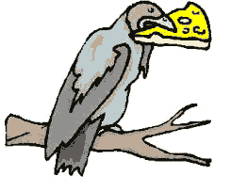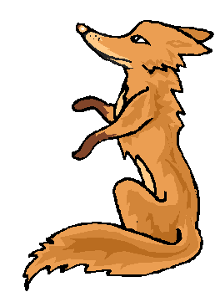
A Fox once saw a Crow fly off with a piece of cheese in its beak and settle on a branch of a tree.
"That's for me, as I am a Fox," said Master Reynard, and he walked up to the foot of the tree.
"Good day, Mistress Crow," he cried. "How well you are looking today: how glossy your feathers; how bright your eye. I feel sure your voice must surpass that of other birds, just as your figure does; let me hear but one song from you that I may greet you as the Queen of Birds."
The Crow lifted up her head and began to caw her best, but the moment she opened her mouth the piece of cheese fell to the ground, only to be snapped up by Master Fox.
"That will do," said he. "That was all I wanted. In exchange for your cheese I will give you a piece of advice for the future: "Do not trust flatterers."



A mouse was having a very bad time. She could find no food at all. She looked here and there, but there was no food, and she grew very thin.
At last the mouse found a basket, full of corn. There was a small hole in the basket, and she crept in. She could just get through the hole.
Then she began to eat the corn. Being very hungry, she ate a great deal, and went on eating and eating. She had grown very fat before she felt that she had had enough.
When the mouse tried to climb out of the basket, she could not. She was too fat to pass through the hole.
" How shall I climb out?" said the mouse. "oh, how shall I climb out?"
Just then a rat came along, and he heard the mouse.
"Mouse," said the rat, "if you want to climb out of the basket, you must wait till you have grown as thin as you were when you went in."
Belling the Cat
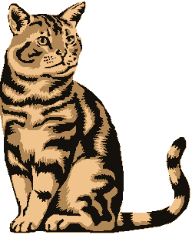 | Long ago, the mice had a general council to consider what measures they could take to outwit their common enemy, the Cat. Some said this, and some said that; but at last a young mouse got up and said he had a proposal to make, which he thought would meet the case. "You will all agree," said he, "that our chief danger consists in the sly and treacherous manner in which the enemy approaches us. Now, if we could receive some signal of her approach, we could easily escape from her. I venture, therefore, to propose that a small bell be procured, and attached by a ribbon round the neck of the Cat. By this means we should always know when she was about, and could easily retire while she was in the neighbourhood."

This proposal met with general applause, until an old mouse got up and said: "That is all very well, but who is to bell the Cat?" The mice looked at one another and nobody spoke. Then the old mouse said:
"It is easy to propose impossible remedies."
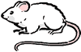

The City Mouse
and the Country Mouse

Once a little mouse who lived in the country invited a little Mouse from the city to visit him. When the little City Mouse sat down to dinner he was surprised to find that the Country Mouse had nothing to eat except barley and grain.

"Really," he said, "you do not live well at all; you should see how I live! I have all sorts of fine things to eat every day. You must come to visit me and see how nice it is to live in the city."
The little Country Mouse was glad to do this, and after a while he went to the city to visit his friend.

 | The very first place that the City Mouse took the Country Mouse to see was the kitchen cupboard of the house where he lived. There, on the lowest shelf, behind some stone jars, stood a big paper bag of brown sugar. The little City Mouse gnawed a hole in the bag and invited his friend to nibble for himself.
The two little mice nibbled and nibbled, and the Country Mouse thought he had never tasted anything so delicious in his life. He was just thinking how lucky the City Mouse was, when suddenly the door opened with a bang, and in came the cook to get some flour.

"Run!" whispered the City Mouse. And they ran as fast as they could to the little hole where they had come in. The little Country Mouse was shaking all over when they got safely away, but the little City Mouse said, "That is nothing; she will soon go away and then we can go back."

After the cook had gone away and shut the door they stole softly back, and this time the City Mouse had something new to show: he took the little Country Mouse into a corner on the top shelf, where a big jar of dried prunes stood open. After much tugging and pulling they got a large dried prune out of the jar on to the shelf and began to nibble at it. This was even better than the brown sugar. The little Country Mouse liked the taste so much that he could hardly nibble fast enough. But all at once, in the midst of their eating, there came a scratching at the door and a sharp, loud MIAOUW!

"What is that?" said the Country Mouse. The City Mouse just whispered, "Sh!" and ran as fast as he could to the hole. | 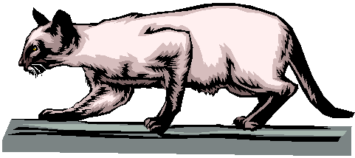
The Country Mouse ran after, you may be sure, as fast as HE could. As soon as they were out of danger the City Mouse said, "That was the old Cat; she is the best mouser in town,--if she once gets you, you are lost."
"This is very terrible," said the little Country Mouse; "let us not go back to the cupboard again."

"No," said the City Mouse, "I will take you to the cellar; there is something especial there."

So the City Mouse took his little friend down the cellar stairs and into a big cupboard where there were many shelves. On the shelves were jars of butter, and cheeses in bags and out of bags. Overhead hung bunches of sausages, and there were spicy apples in barrels standing about. It smelled so good that it went to the little Country Mouse's head. He ran along the shelf and nibbled at a cheese here, and a bit of butter there, until he saw an especially rich, very delicious-smelling piece of cheese on a queer little stand in a corner. He was just on the point of putting his teeth into the cheese when the City Mouse saw him.

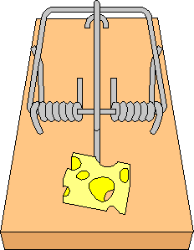 | "Stop! stop!" cried the City Mouse. "That is a trap!"  The little Country Mouse stopped and said, "What is a trap?"  "That thing is a trap," said the little City Mouse. "The minute you touch the cheese with your teeth something comes down on your head hard, and you're dead."
The little Country Mouse looked at the trap, and he looked at the cheese, and he looked at the little City Mouse. "If you'll excuse me," he said, "I think I will go home. I'd rather have barley and grain to eat and eat it in peace and comfort, than have brown sugar and dried prunes and cheese,--and be frightened to death all the time!"

So the little Country Mouse went back to his home, and there he stayed all the rest of his life. | 

The Little Red Hen

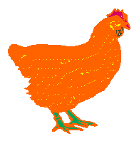The little Red Hen was in the farmyard with her chickens, when she found a grain of wheat.

"Who will plant this wheat?" she said.

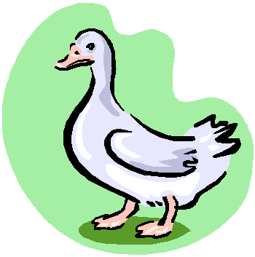"Not I," said the Goose.

"Not I," said the Duck.

"I will, then," said the little Red Hen, and she planted the grain of wheat.

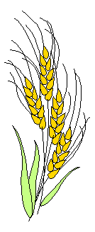When the wheat was ripe she said, "Who will take this wheat to the mill?"

"Not I," said the Goose.

"Not I," said the Duck.

"I will, then," said the little Red Hen, and she took the wheat to the mill.

When she brought the flour home she said, "Who will make some bread with this flour?"

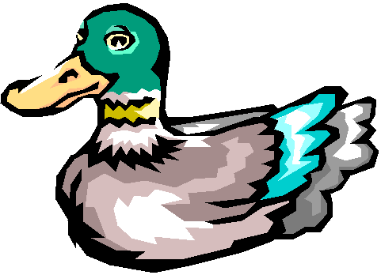"Not I," said the Goose.

"Not I," said the Duck.

"I will, then," said the little Red Hen.

When the bread was baked, she said, "Who will eat this bread?"

"I will," said the Goose

"I will," said the Duck

"No, you won't," said the little Red Hen. "I shall eat it myself. Cluck! cluck!" And she called her chickens to help her.

