Have you got a brother?
Has your brother got a dog?
Has your best friend got black hair?
Skip 3 spaces

Has New York got many buildings?
Have dogs got tails?
Has the sky got clouds today?
Have Pokιmon cards got pictures?
Has the cat got a big smile?
Has your school got many children?
Have children got toys?
Lose a turn.
Has the alligator got an umbrella?
Have tigers got big teeth?
Roll again
Have you got a sister?
Have bats got wings?
Has your bedroom got a swimming pool?
Have your friends got pet snakes?
Jump ahead 4 spaces
Has the sky got stars at night?
Has your school got students?
Has the girl got a basketball?
Have elephants got wings?
Have mice got little ears?
Has a park got trees?
Has your teacher got many books?
Has your bedroom got a TV?
Have you got a TV?
Skip 2 spaces.
Has the bug got a heart?
Has your kitchen got a door?
Has the tree got green leaves?
Have we got 4 arms?
Has the alien got an i-Pod?
Have turtles got shells?
Has the boy got a truck?
Have cats got 4 ears?
Roll again.
Go back 3 spaces
Have you got blue eyes?
Has the girl got ice skates?
Has a rainbow got many colors.
Skip 4 spaces
Has a week got 10 days?
Have birds got fur?
Has your aunt got grey hair?
Roll again
Have orange trees got lemons on them?
Have you got short blond hair?
Have dogs got feathers?
Type your text here. Try to be concise.
Has the pirate got a parrot?
Has a super hero got a cape?
Has a sunny day got sun?
Have some monsters got 4 arms?
Go back 4 spaces
Have you got 4 cousins?
Has the bird got an umbrella?
Skip 2 spaces
Has the boy got a scooter?
Have zebras got spots?
Start

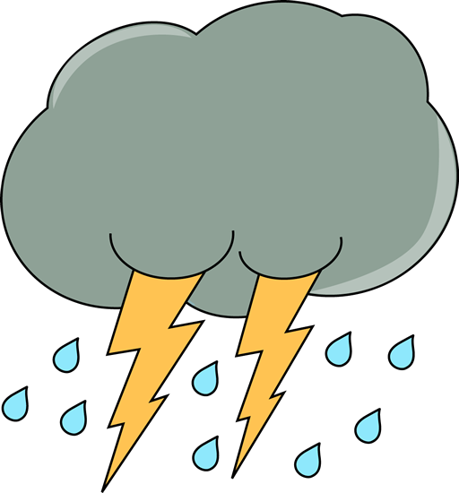
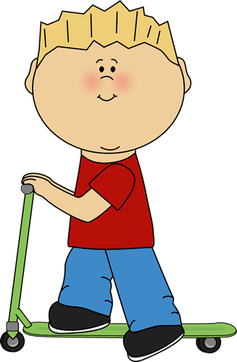
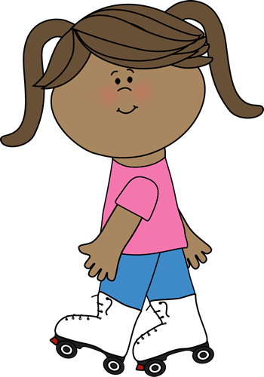


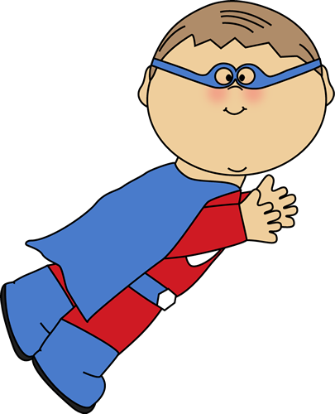
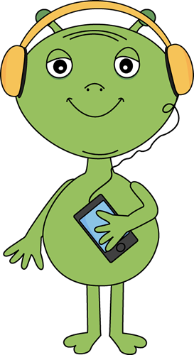
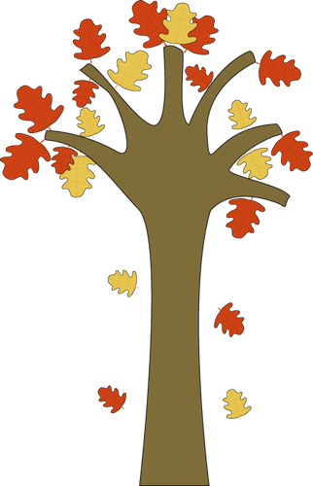
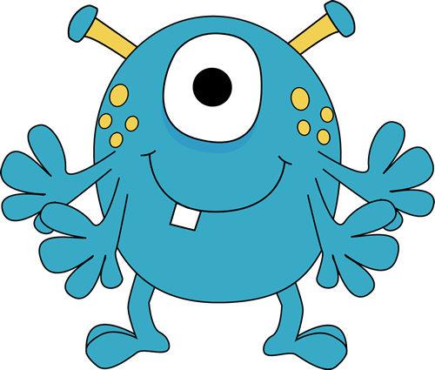
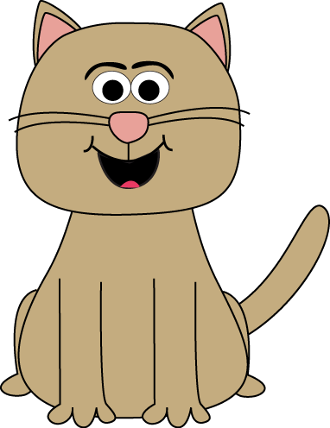
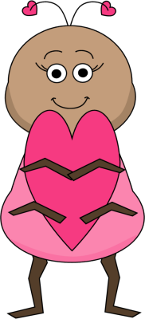
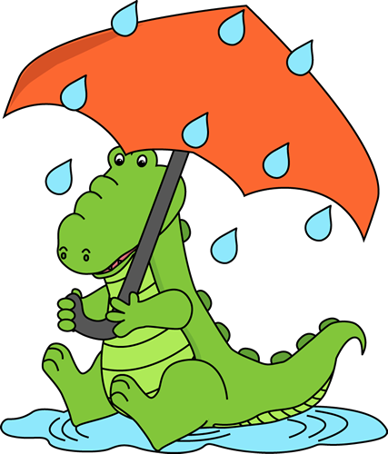

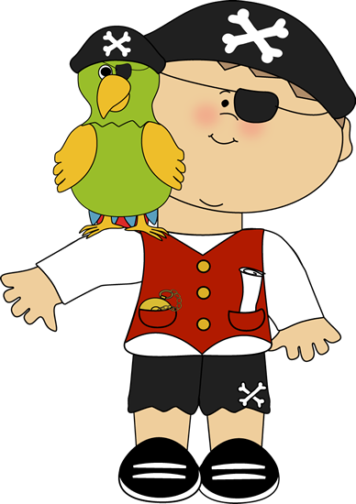

Has got? Have got?



Finish

Board Game

