READING
Blind date next door
Romance magazine talked to Dan who tells us about how he found the love of his life.
1 c
Dan Actually, we met at three very different times in our lives. We were both born in Bath and we actually grew up in the same street. Jess’s parents ran an art gallery across the road from our house. We knew each other as children but not well. Six years is a big age difference when you’re a kid.
2 ___
Dan After school I started university in Oxford. My best friend there was Paul. We’re still very close: he’s like a brother to me. One day I went round to see him for coffee. He introduced me to his cousin who was visiting. She was so attractive she took my breath away.
3 ___
Dan She was very chatty and funny. As the evening progressed, I liked her more and more. To be honest, I was quite disappointed when I found out she was just 16 – I thought she was too young for me. I was just starting my Master’s degree in English, so I was 22 then.
4 ___
Dan No, I didn’t – not then. One summer Paul and I visited my old home town. We were staying with my parents. Over dinner, Paul mentioned something about the art gallery his uncle owned across the road. That’s when I realized who Jess was.
5 ___
Dan No, we didn’t. We met years later. I went on a chatroom website, and I started exchanging messages with a very nice, 21-year-old girl. We sent each other links to songs and videos on the net that we both liked, we talked about the best places in Bath to go out to eat, that sort of thing. It took me some time to get the courage to ask her out on a date.
6 ___
Dan We agreed to meet outside the Assembly Rooms, and go from there to an Indian restaurant close by. But as I was leaving home, I ran into Jess in the street. We talked a bit, then she said she was in a hurry because she had a blind date with someone. Of course, that someone was me.
7 ___
Dan Yes and no. It was the beginning of my happiest relationship. But it wasn’t really a blind date – I have known her all my life!
1 Read the interview quickly and circle the correct letter.
Where did Dan and Jess meet when they went on their first date?
a in the street where Dan’s parents live
b at Paul’s flat in Oxford
c at the Assembly Rooms in Bath
d at Jess’s parents’ art gallery
1 point for each correct answer |  | 1
2 Complete the interview with the missing questions (a–h). There is one extra question.
a Where did you go?
b Do you think it was a successful blind date?
c When did you first meet your wife?
d Did you know she was the same girl you knew as a child?
e How old were you when you first asked her out on a date?
f When did you see her again?
g What did you think of her?
h Did you meet that summer?
2 points for each correct answer |  | 12
3 Read the interview again. Write true (T) or false (F).
1 Dan and Jess both grew up in Bath. T
2 They weren’t close friends as children because of the age difference. ___
3 They met for the second time as students at Oxford University. ___
4 Dan studied English at university. ___
5 Paul’s uncle is Jess’s father. ___
6 Jess and Dan met again online. ___
7 They were planning to visit the Assembly Rooms together. ___
2 points for each correct answer |  | 12

 | Reading total |  | 25

WRITING
1 Your best friend wants to take his/her parents out to a nice café or restaurant on their wedding anniversary. Write a short email recommending a place in your town. Write about:
• the name of the place and where it is.
• what the place is like.
• what kind of food they serve and what dishes you would recommend.
• why you like it and why you recommend it.
Write your email in 60–100 words.
Shorter writing task |  | 10
2 Write a description of your neighbours. Write about:
• how many people live next door and what their names are.
• what (you think) they do for a living.
• what they are like.
• what your relationship with them is like.
Write your description in 100–150 words.
Longer writing task |  | 15

 | Writing total |  | 25
LISTENING
1 Listen to five short extracts. Write the number of the correct extract (1–5) for the summaries. There is one extra summary.
a __ someone asking a friend for a favour
b __ the evening news on the radio
c __ a conversation at a dinner party
d __ a customer talking to shop assistants
e __ a customer ordering his/her meal in a restaurant
f __ someone telling a friend some personal news
1 point for each correct answer |  | 5

2 Listen again. Circle the correct answer.
1 When are Jack and Will meeting to celebrate?
a They’re going to Jack’s parents in the afternoon.
b At eight in the morning tomorrow.
c At nine o’clock this evening.
d In a week’s time from Monday.
2 What does the woman buy in the shop?
a Nothing – they haven’t got her size.
b She buys a pair of red trainers.
c Nothing – she’s just looking.
d A pair of size 8 trainers.
3 What is the guest drinking?
a Decaf coffee with no sugar.
b Black coffee and cold water.
c Just some mineral water.
d Regular coffee and still water.
4 Which of the following news does the newsreader NOT mention?
a A new drug against cancer.
b The opening of a new art gallery in a former prison.
c A special celebration in space.
d An important football match.
5 What favour is Sam doing for Chris?
a He’s driving him into town.
b He’s lending him some money for petrol.
c He’s taking him to the airport.
d He’s giving him a lift to the train station.
2 points for each correct answer |  | 10
3 Listen again. Write true (T) or false (F).
1 Jack and Will are celebrating that Jack’s father got better after being unwell. ___
2 The woman tries on two different sized trainers. ___
3 The guest doesn’t want to eat the dessert because of his allergy. ___
4 Zanetti played for his team for the last time. ___
5 Chris is in a hurry to meet his friend. ___
2 points for each correct answer |  | 10

 | Listening total |  | 25

SPEAKING
1 Ask and answer the questions with a partner.
1 How did you meet your best friend?
2 What do you do in your free time? Which things do you do with your friends? Are there any things you do on your own? Why?
3 What is your favourite possession and why?
4 What was the most important event in your country’s history?
5 When did you last cook a meal? What did you cook?
max. 1 point for each topic |  | 5
2 Look at the photos. Compare the different things people eat. Talk about what is good and what is bad about them. In your opinion, how healthy is your diet?
max. 10 points |  | 10


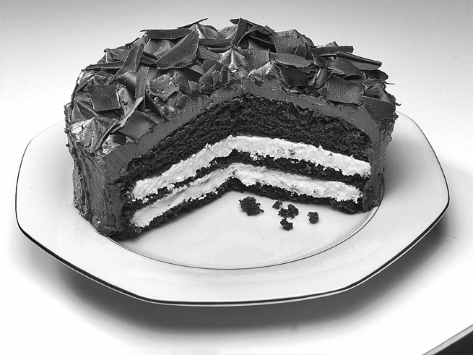

3 A Look at the information. Use the words to make five questions.
The Breakfast Club
open 6.00 a.m. to 11.00 a.m.
fried or scrambled eggs and toast
small (1 eggs) €2.00
medium (2 eggs) €3.50
large (3 eggs) €5.00
Continental breakfast €2.50
(2 bread rolls, butter and jam)
freshly-made orange juice €1.50
tea €1.75
espresso €2.00
capuccino €2.25
mineral water €1.25
1 open / lunch or dinner ?
2 when / closed ?
3 what / hot food ?
4 how much / hot drinks ?
5 what / order / €6.50 ?
1 point for each correct answer |  | 5
B Answer the questions.
1 point for each correct answer |  | 5

 | Speaking total |  | 25

 | Skills test 1 total |  | 100

