READING
Blade Runner
1 B Oscar Pistorius is a South African athlete. He was born in Johannesburg in 1986, as the middle child of a family with Italian roots. His grandmother had emigrated to Kenya from Italy. Pistorius lost both his legs below the knee when he was only 11 months old.
2 Despite his disability, he has been very active in sports all his life. He took up running after a rugby accident in 2004. In the same year he finished third in the 100 metres, and won the 200 metres with a new world record at the Paralympic Games in Athens. The following year he won both the 100 and 200 metre events at the World Cup, and broke his own world record. In 2006, he won the 100 and 200 metres and also came first in the 400-metre event at the World Championships. In 2007, he became the first sportsperson in history to set the world record for all three distances. During his career, Pistorius has broken his own world records more than 30 times!
3 Pistorius usually competes with athletes who still have one functioning leg, while he has to wear artificial limbs, whose special shape earned him the nickname, ‘Blade Runner’.
4 His lifelong ambition, however, has been to compete with able-bodied athletes. He took part in his first international event in 2007, but the International Association of Athletics Federations (IAAF) banned him from competing a year later. Scientific tests in Germany showed that his artificial legs gave him ‘an unfair advantage’.
5 He successfully challenged that decision when further tests in Houston, Texas proved that he also had disadvantages which the first tests ignored. The IAAF allowed him to try for the Beijing Olympic Games in 2008, but his times were not good enough then. He did, however, enter the Beijing Paralympic Games, and became the first runner ever to win gold in all three short-distance races.
6 2011 was a turning point for Pistorius: he successfully qualified for the 2011 World Championships and the 2012 London Olympic Games in the 400 metres. He said in an interview after the qualifying race, ‘I have dreamed for such a long time of competing in a major championship and this is a very proud moment in my life.’
7 In 2006, the President of South Africa awarded him a medal for his outstanding achievements in sport. Pistorius continues to be an inspiration for people around the world.
1 Read the article quickly and circle the correct letter.
Which full Olympic Games did Pistorius qualify for?
a Athens
b Beijing
c London
d He has never qualified for Olympic Games, but he has competed in the Paralympic Games.
1 point for each correct answer |  | 1
2 Read the article again. Match the headings (A–H) with the paragraphs. There is one extra heading.
A Achievements in disabled competitions
B A difficult start in life
C Winning the right to race
D The first Olympic victory
E Disadvantaged even among disabled athletes
F A model for the world
G The end of his greatest ambition?
H On his way to the Olympics at last
2 points for each correct answer |  | 12
3 Read the article again and circle the correct letter.
1 Oscar Pistorius is …
a a sportsman from South Africa.
b from Kenya but his family is from Italy.
c Italian but lives in South Africa.
2 As a teenager, Pistorius …
a did many sports before taking up running.
b lost both his legs below the knee.
c won rugby competitions for disabled athletes.
3 At the Paralympic Games in Athens he …
a won two running events.
b broke a world record.
c set the new world record in the 100 metres.
4 He became the first athlete ever to …
a hold the world record in the 100, 200 and 400 metres at the same time.
b break more than 30 different world records.
c compete with athletes with a less serious disability than his own.
5 The IAAF banned him from competing with able-bodied athletes …
a because they felt he had an unfair disadvantage among them.
b because he took part in an international competition in 2007.
c after the results of tests in Germany.
6 He was allowed to enter the qualifying events for the Beijing Olympics when …
a tests in Texas showed he had disadvantages the IAAF didn’t consider.
b because the IAAF realized his times would not be good enough.
c he won three gold medals at the Paralympic Games.
7 His proud moment came in 2011 …
a when he was given a medal by the President of his country.
b when he dreamed of winning a gold medal at the Olympics.
c after he qualified for the World Championships and the Olympics.
2 points for each correct answer |  | 12

 | Reading total |  | 25
WRITING
1 Circle the best word or phrase.
1 We don’t read magazines online, but / so / and we read newspapers on the internet.
2 Many people don’t use portable DVD players although / because / so their laptops can play DVDs just as well.
3 Smartphones, what / that / which have small screens, are hardly ever used to watch films.
4 Despite / The fact is / Because the lighter weight and enormous storage capacity of e-books, many people still prefer to read books printed on paper.
5 Clearly, / Finally, / Firstly, mobile phones have become much more common in the last 10 years.
6 Many people use their mobile phones to listen to mp3 music files. Although, / However, / What is more, they also use them to visit social networking sites.
1 point for each correct answer |  | 5
2 Write an essay about the pros and cons of using mobile phones. Write about:
• how people are using their mobile phones (e.g. for socializing and entertainment).
• the advantages of mobile phones compared to other devices.
• the disadvantages of mobile phones.
• how you see the future of mobile phones in these areas.
Write your essay in 150–200 words.
Writing task |  | 20

 | Writing total |  | 25
LISTENING
1 Listen and tick () five things that the lion does.
feels unwell after his meal has breakfast
eats meat works on doors and
sits in the grass windows
does exercise builds walls
sleeps takes a lunch break
1 point for each correct answer |  | 5
2 Listen again. Write true (T) or false (F). If there is no information in the story about the statement, write no information (N).
1 The lion was walking by the river one morning. F
2 The rabbit wants to help the lion build the house. ___
3 The lion wants to eat the rabbit. ___
4 The lion gets very tired after he does some exercise. ___
5 The lion is sleeping while the rabbit is working on the walls. ___
6 The rabbit doesn’t know what he would like for lunch. ___
7 The lion says there may be rain later. ___
8 The lion goes to see a doctor. ___
9 It is almost dark by the time the lion comes back. ___
10 The lion says he wants to go to sleep. ___
11 The rabbit stays at the new house for the night. ___
2 points for each correct answer |  | 20

 | Listening total |  | 25
SPEAKING
1 Ask and answer the questions with a partner.
1 If you could decide, would you rather have a sister or a brother? Why?
2 When did you last see a doctor? What was your problem? How long did it take you to get better?
3 How much do you know about your family history? Who do you admire the most? Why?
4 How much time do you spend on the internet? What do you use it/not use it for? Why?
5 What’s your dream job? Why? Do you think you are likely to get that job?
max. 1 point for each topic |  | 5
2 Look at the photos. Compare the different sports. Talk about what you think is good and bad about them. In your opinion, which sport is the best sport to do, and which is the best to watch? Why?
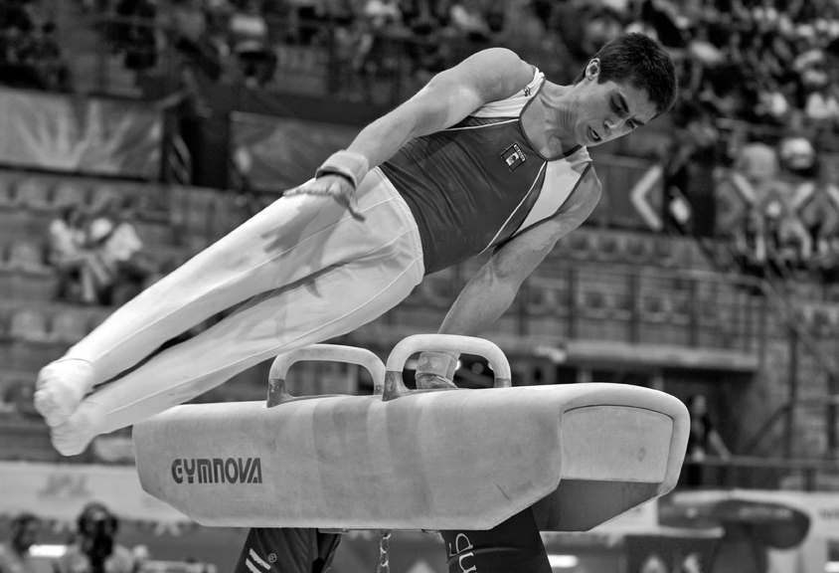
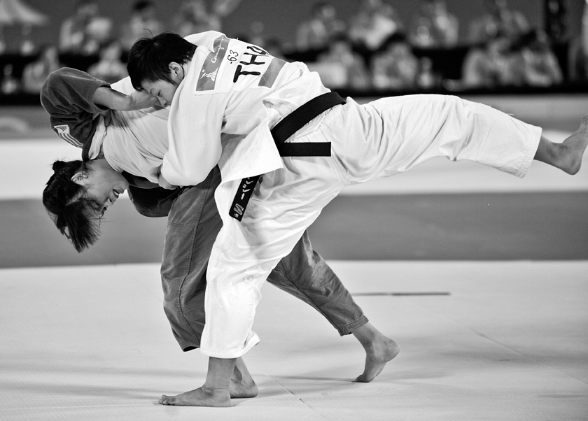
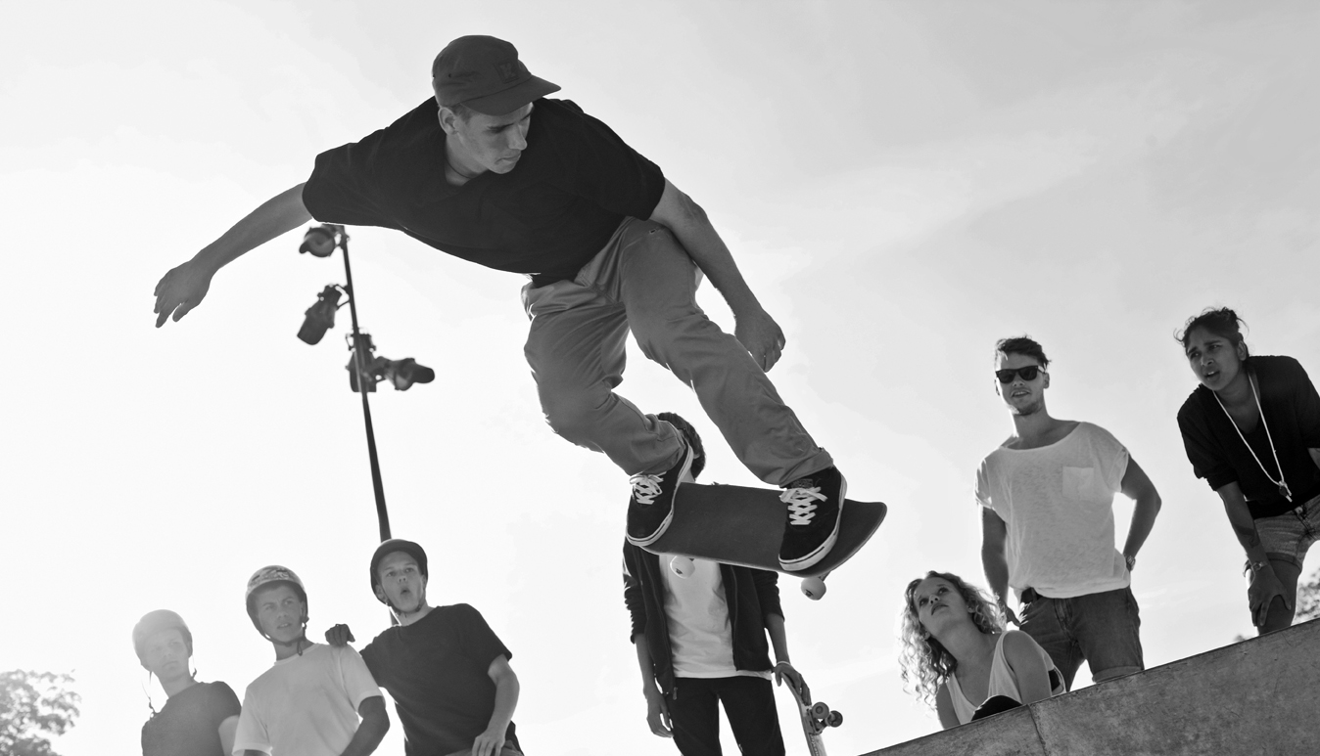
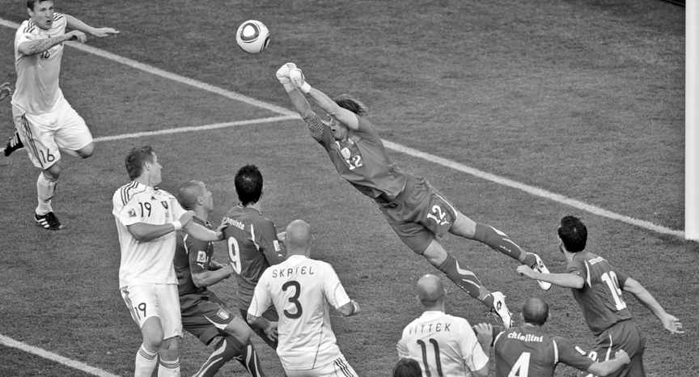
max. 10 points |  | 10
3 A Look at the information. Use the words to make five questions.
MegaPhone 1.0! Special offer!
90mm touchscreen. Weighs only 100 grams.
Plays mp3 and mp4 in hi-fi sound quality!
Built-in digital TV and radio.
64 GB disc space for all your personal files.
Up to 50 hours battery life (450 hours on standby).
Was £299, now only £89!
1 how big ?
2 what / can / do ?
3 how much / space / store files ?
4 how long / battery ?
5 how much ?
1 point for each correct question |  | 5
B Answer the questions.
1 point for each correct answer |  | 5

 | Speaking total |  | 25

 | Skills test 5 total |  | 100

