About you
1 Talk about sport.
 Are you a sports fan? Do you like watching sport? Are you a football supporter?
 What sports do you like playing? When and where do you play?
 What sports did you do when you were younger?
 What sports are you going to do in the future?
 What are you going to do next weekend?

Role play
B
A
2 Complete the dialogue with the expressions. Then practise the dialogue.
are you doing anything if you’re interested
it’s on at nothing special shall I meet you

A Hi!
B Hi! (1) ___________________________________ this evening?
A No, (2) ___________________________________.
B I’m going to go to the cinema
(3) ___________________________________.
A Yes, great. What time does the film start?
B (4) ___________________________________ seven.
A OK. Let’s meet at the cinema.
(5) ___________________________________ outside?
B Great!
EXTENSION Imagine you are making plans for
this evening.
A say hello to your partner
B respond and ask your partner if they have any plans for this evening
A respond
B say what your plans are and invite your partner to come too
A agree and ask when and where you should meet
B respond with a suggestion
A agree

Photo description
3 Describe the photos.
Photo A
 Describe your photo. Where is it? What is happening?
 What different people can you see?
 What is going to happen next?
 What is your favourite football team? Why?
Photo B
 Describe your photo. Where is it? What is happening?
 What different people can you see?
 What is going to happen next?
 Who is your favourite sports person? Why?
EXTENSION Answer the questions.
 Do you like playing team sports?
 Do you prefer individual sports like tennis and swimming? Why?
 Do you think it is good to be serious about sport? Why?
 Which sports person do you think will win a trophy this year? What will they win?
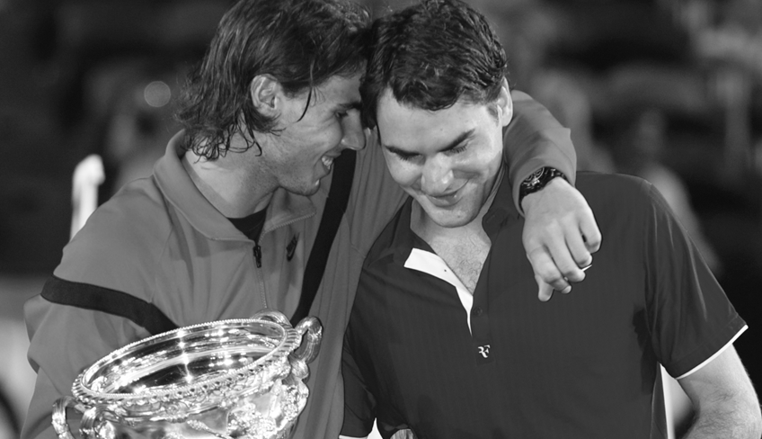
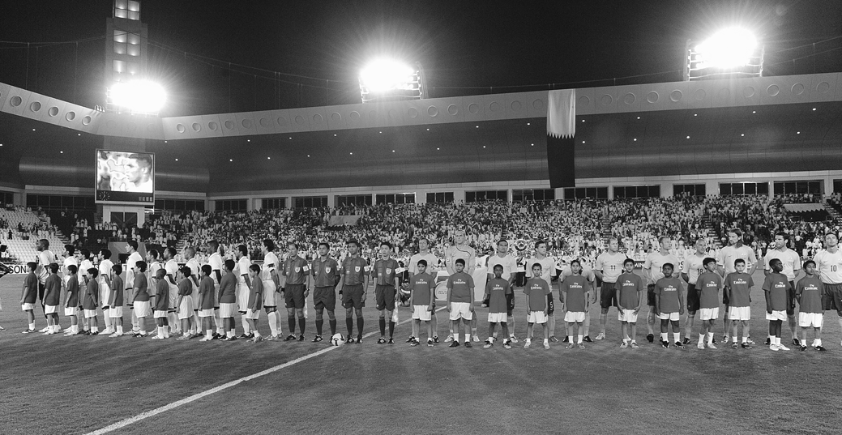
 Are you going to watch any important sporting events on TV this year? Which ones?

