About you
1 Talk about you.
 Who usually does the cleaning, tidying and washing-up in your house?
 Where do you usually do your homework? Why?
 What are your hobbies?
 What are you doing in the summer holidays?
 Have you ever been on holiday to another country? Give details.
 If you have free time tonight, what will you do?

Role play
2 Complete the dialogue with the expressions. Then practise the dialogue.
see you this evening are you doing really into
can I do anything to help having a meeting

A Hi. What (1) _____________________________?
B We’re organizing a tennis tournament.
A Great! (2) _____________________________?
B Yes, there’s a lot to do. We need to invite people, and we need some trophies.
We’re (3) _____________________________ this evening to make plans. Do you want to come?
A Yes, definitely. My brother will help, too. He’s
(4) _____________________________ tennis.
B Great!
A OK. Shall I meet you at your house?
B Yes. (5) _____________________________.
EXTENSION Imagine you are talking to a friend who is organizing a swimming competition.
A ask your partner what he or she is doing
B express interest and ask if you can help
A explain what there is to do and say that there is a meeting
B agree to come to the meeting and say who you will bring with you
A say where and when the meeting is
B suggest a place to meet
A agree

Photo description
3 Describe the photos.
Photo A
 Where is the house in this photo?
 What are the people in the photo doing?
 Do you think that the people like living here? Why?
 What do you think they do at weekends?
 Do you think that living here is better than living in a city? Why?
Photo B
 Where is this place?
 What are the people in the photo doing?
 Do you think that these people like living here? Why?
 What do you think they do at weekends?
 Do you think that living here is better than living in the countryside? Why?
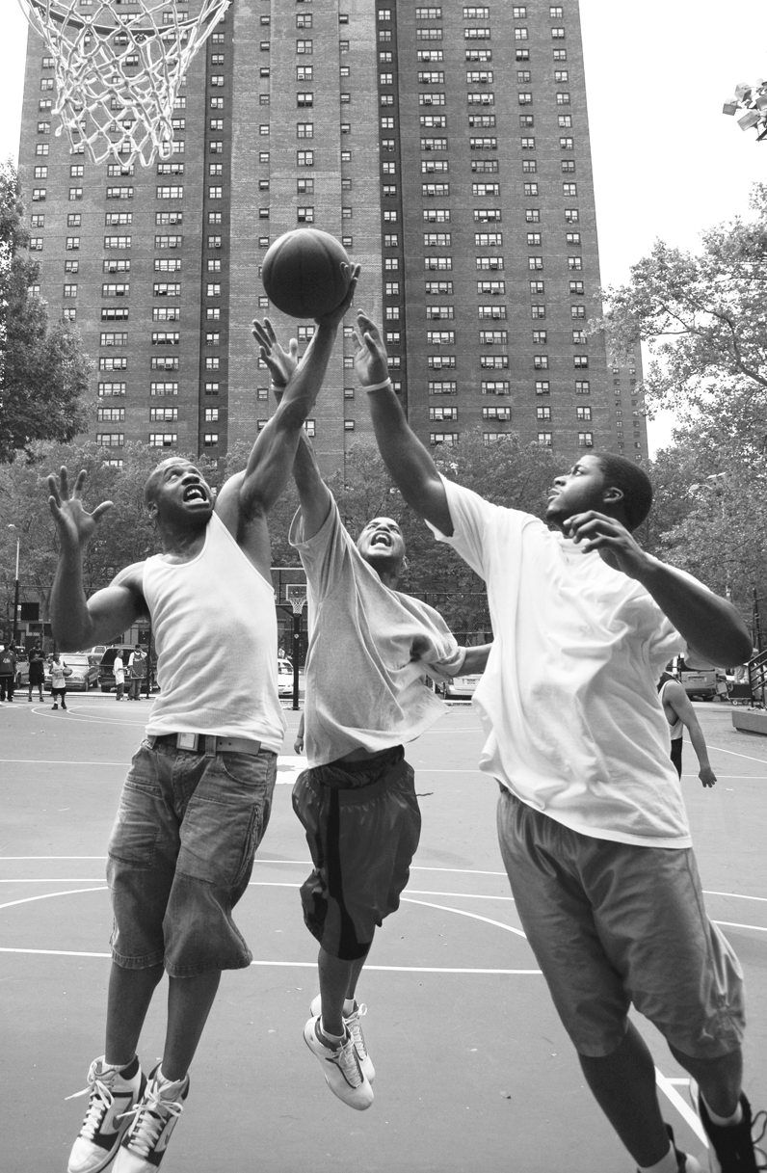
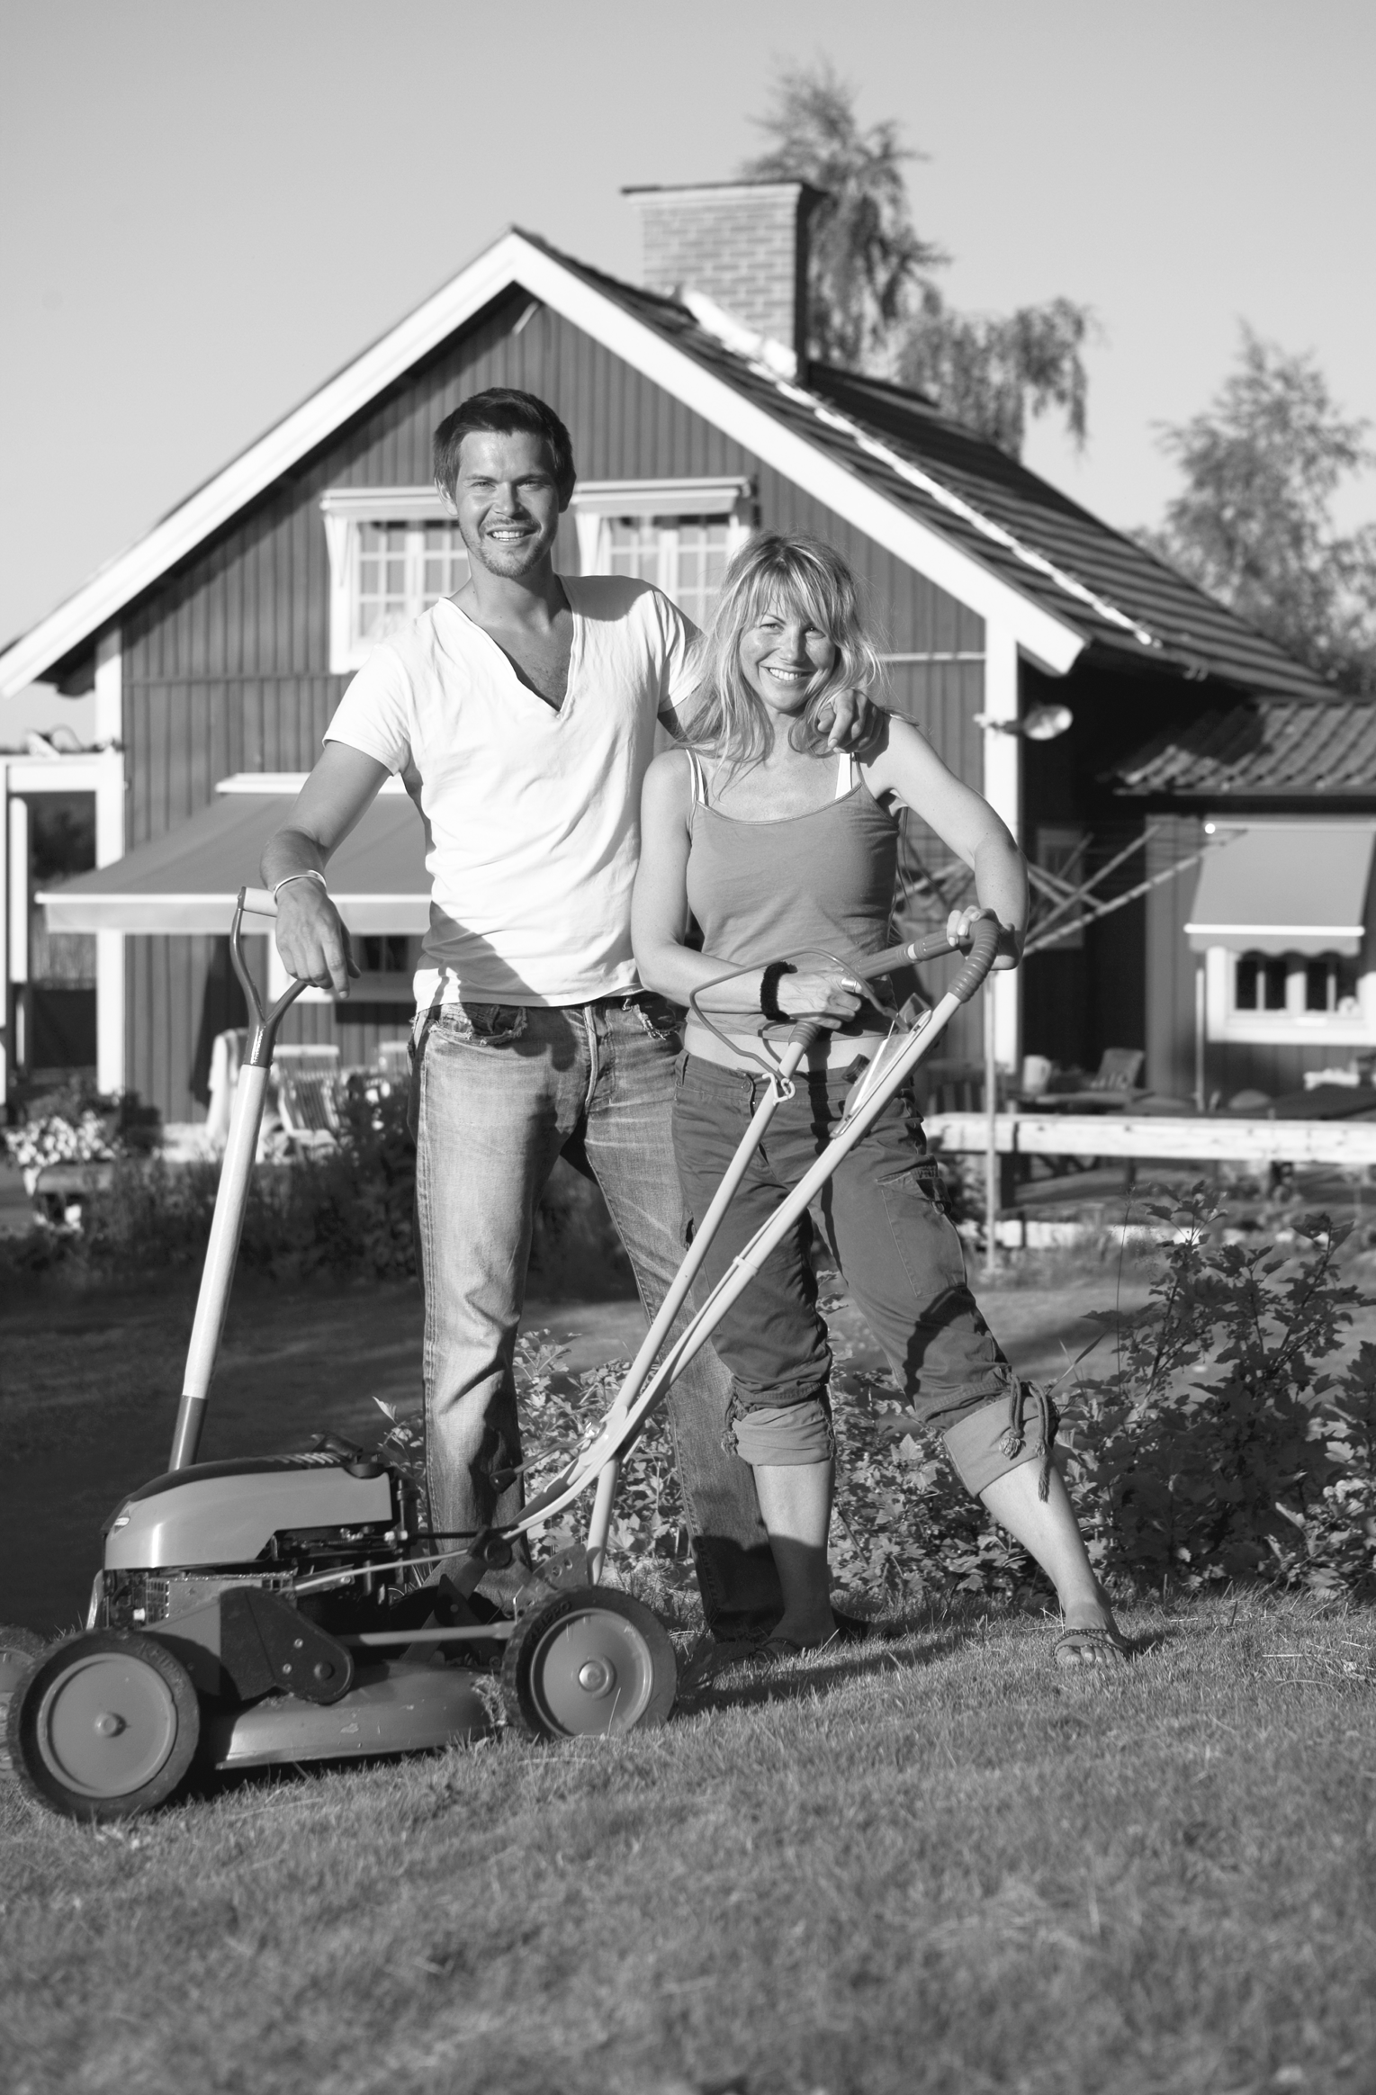
EXTENSION Answer the questions.
A
B
 Where did you live when you were young?
 Where do you want to live when you leave home? Why?
 Do you think you will live in a city? Why?
 Describe your ideal house.

