About you
B
1 Talk about your abilities.
 Can you paint, sing or cook? What things can you do well?
 Is there anything you can’t do now, but want to do in the future?
 What things couldn’t you do when you were younger, but you can do now?
 Compare yourself to someone else in your family. For example, are you more artistic than someone else in your family?
 Is there anything you are the best at in your class? What do you want to be the best at?

Role play
2 Complete the dialogue with the words in the box. Then practise the dialogue.
a bit better by into who’s

A What are you doing?
B I’m looking for a birthday present for my mum. She’s (1) _____________ music, so I want to buy her a CD.
A What do you think of this one?
B (2) _____________ it by?
A It’s (3) _____________ Coldplay.
B Well, it’s OK, but I think this one’s (4) _________.
A Do you think so?
B Yes, this one’s by Kaiser Chiefs. The other one’s (5) _____________ boring.
A Yes, I think you’re right.
EXTENSION Imagine you are buying a DVD as a present.
A ask what your partner is doing
B explain that you are looking for a DVD for a birthday present for someone, say who it is for
A ask for your partner’s opinion of a DVD
B compare your partner’s DVD with another one and explain why your DVD is better
A agree that your partner has the best DVD

Photo description
3 Describe the photos.
Photo A
 Describe the animals. Which adjectives can you use to talk about them?
 What can these animals do?
 Compare the animals. How are they similar? How are they different?
 Do you like these animals? Why?
 Which animal do you prefer? Why?
Photo B
 Describe the sea animal. Which adjectives can you use to talk about it?
 What does this animal do?
 Compare this animal to other sea animals. How is it different? How is it similar?
 Do you like this animal? Why?
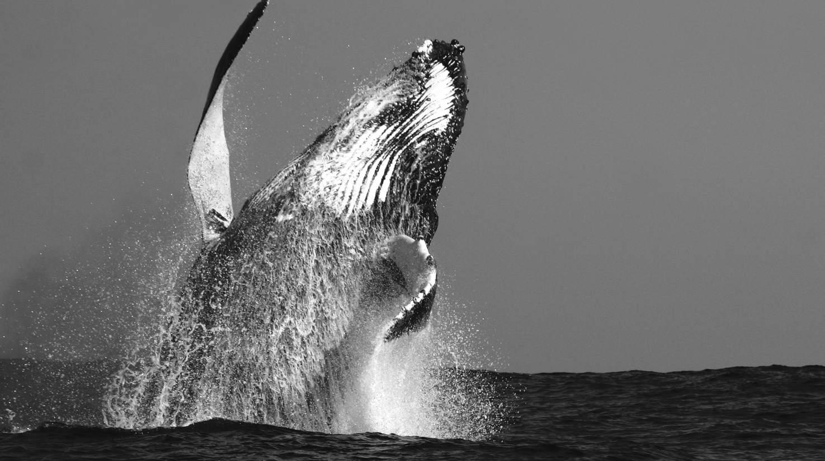
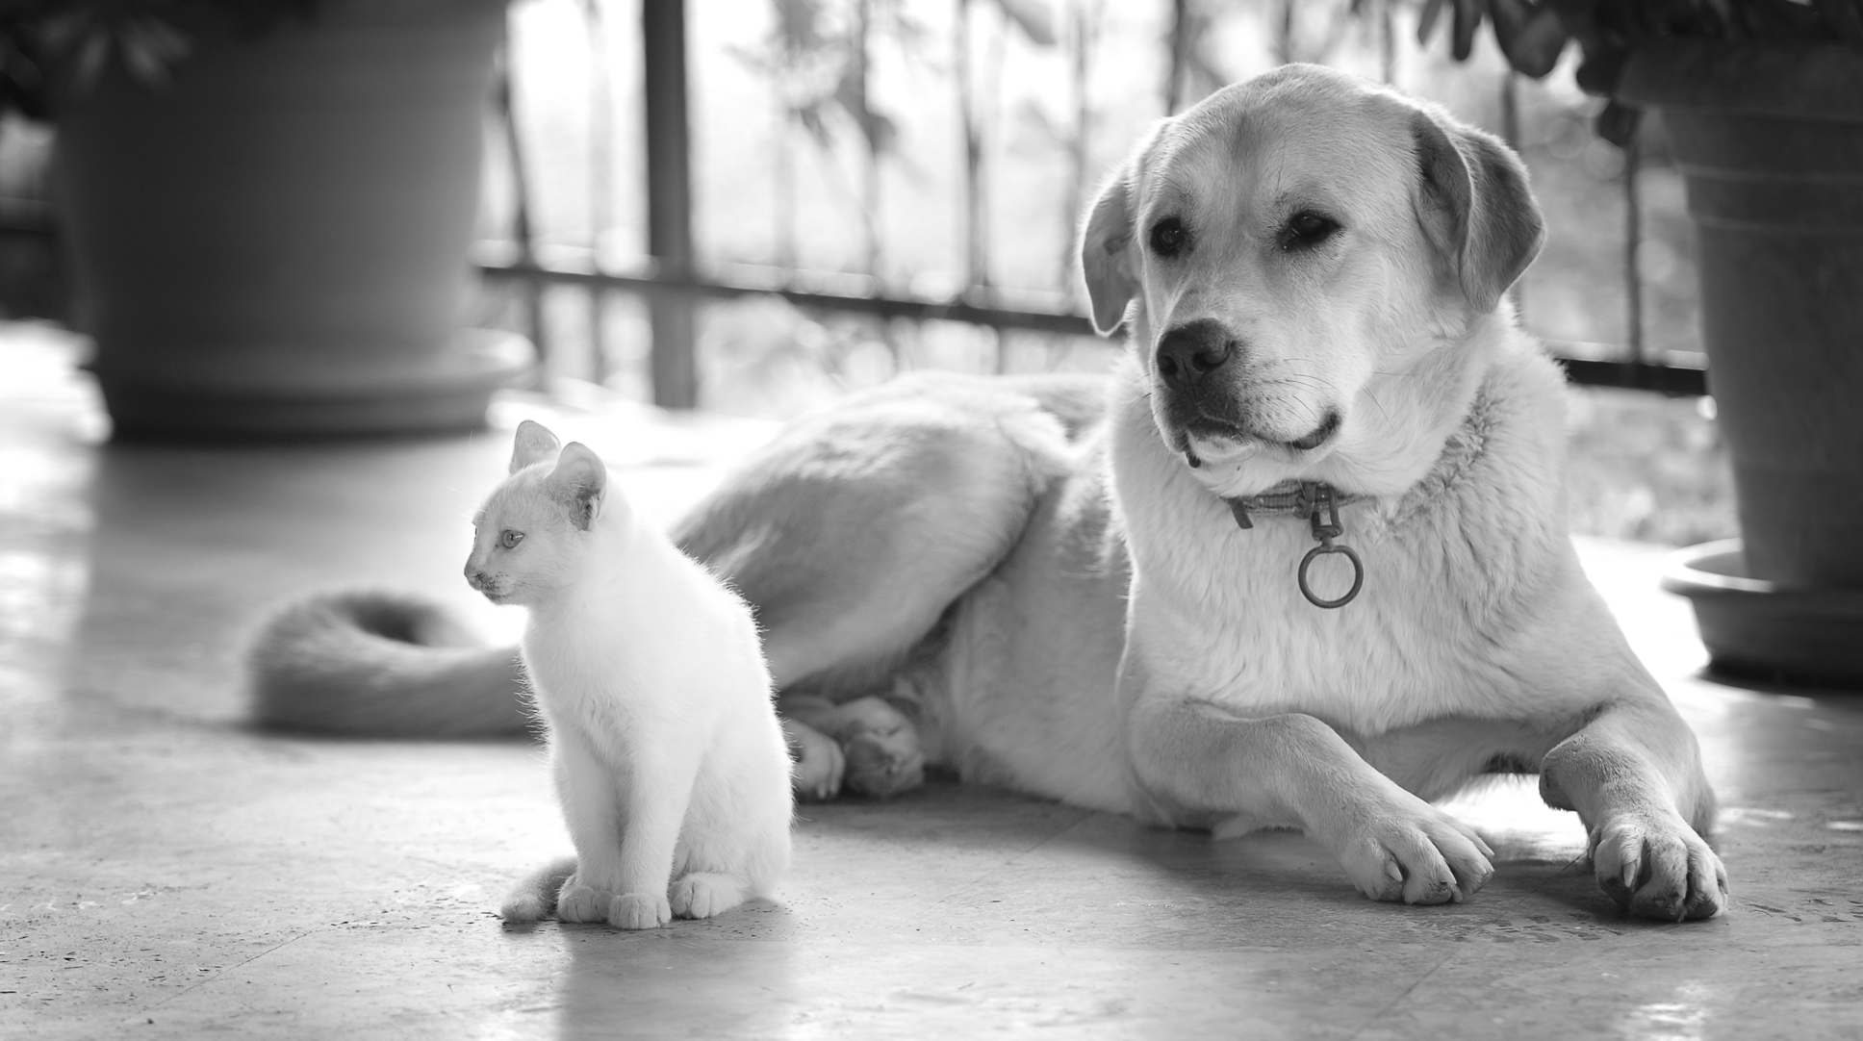
EXTENSION Answer the questions.
A
 Compare all the animals in the photos.
 What is your favourite animal? Why?
 What is the most intelligent animal? Why?
 What animals don’t you like? Why?

