A 1.-4.
5.
The scale 1:20 000 means that one unit on the map corresponds to 20 000 units in reality. So, let’s see the example: How long is a distance of 3.2cm in reality? 3.2cm*20 000=64 000 cm. 100 centimetres make a meter, so 64 000/100=640 meters=0.640 km.
Another example: The measured distance between 2 points on the ground is 1 280 metres; The map distance between the same 2 points is 20 mm. What is the scale of the map? 1 280 000/20=64000. The scale is 1:64000.
As scales decreases, the number of different features decreases also, and the map tends to be more generalized.

B.1.
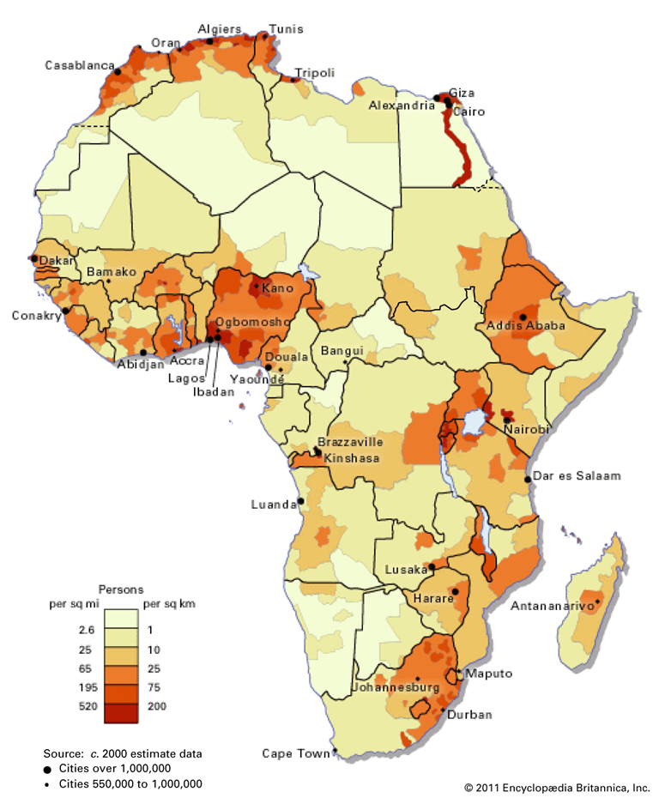
Figure 1. Population density in Africa in the year 2011. Source: Britannica, 2011. Available at: [https://www.britannica.com/place/Africa/Demographic-patterns].

2.
My map shows population density in Africa for the year 2011. The key is spilt into 6 categories: 0-1 person per sq km, 1-10 persons per sq km, 10-25 persons per sq km, 25-75 persons per sq km, 75-200 persons per sq km and >200 persons per sq km. Unfortunately, this map doesn’t provide us with ecology features such as deserts and forest, but at least lakes are illustrated. The settlement pattern is highly influenced by the differences in landscape, and we can see that the highest densities of population are concentrated near the water sources (lakes, rivers) and near the coastline. The highest population densities countries are located near the Gulf of Guinea – Nigeria, Cameroun, Ghana, Burkana Faso, Guinea and Togo. The second area with high settlement density is along the east coastline, countries such as Ethiopia, Kenya, Tanzania, Mozambique, and South Africa. In the north coast are located important harbours and airports, which are used as important connectors with Europe for tourism and delivery of goods. That’s why are people in so rich density here. The western part of the south Africa is inhabited in very low densities, as the Namib desert take a place here, as well as harsh Sahara on the North. The lowest densities are located right here and in mountainous regions. The countries where the bigger part of their territory is included into category 0-1 person per sq km are: Niger, Chad, Sudan, Somalia, Botswana, Namibia, and Mauritania. Although, some countries significantly differ in densities from one location to another, for example Algeria or Egypt.

3.
For a choropleth map, the good legend is crucial. I think that in this case the legend is well processed, there are 6 categories which gradually varies from creamy colour to orange-reddish colour, where darker shades represent high numbers, and the lighter shades represent low numbers. I appreciate that there is a division of the cities to smaller (550 000 to 1 000 000 people) and bigger cities (over 1 000 000 people). I can easily read various data on the map, but I can’t associate this various population densities (unless I remember all African states) to the concrete country, as this is missing. The map provides only a few city names without full names of countries. I think that this is a very important to include, as not everyone is able to associate the city with the state. Moreover, there is missing scale, title and coordinate system. The missing title is maybe because I found this map with description below, so the title is not necessary. The scale and coordinate systems are not that useful in this case, as choropleth map can’t be used for navigation purposes.

C.
The Aberdeen city has undertaken remarkable changes since 1850s. Nowadays, the city centre of Aberdeen is around the same size as it was whole Aberdeen in 1850s. The thrive of this city conditioned the emergence of suburban areas. Aberdeen sits on the North Sea (also known as the German Ocean until the early 20th C.) and has easy access to plentiful stocks of fish, and shipbuilding here has deep roots. The former one dock was rebuilt into two wider docks which significantly increased the capacity of the harbour. As Aberdeen has become larger, the train station with only one rail was not sufficient. In order to increase capacity, the number of rails increased several times. Further, the surrounding of this train station became the centre of transportation with train and bus station andwith the shopping centre The Union square. On the old map provided, there is missing famous Beach Boulevard which leads to the entertainment centre and to big shopping complex. The names of the main roads- King street and Union street remain the same, however the occupancy of these two streets by people and cars massively increased. Tallis map of Aberdeen 1850s illustrates features which we can’t see anymore in the modern Aberdeen, e.g. Aberdeenshire canal, or the untouched coast near the queens’ links. Tallis map also shows “Footdee” - an old fishing village at the east end of Aberdeen harbour. At the present day, it is famous thanks its unique architecture and atmosphere.
D.
1. False Clachnaben in Google Earth: 56.95°N; -2.60°W
2. Digimap: grid reference: NO 6149 8650 = 56.968108° N, 002.635003° W – True clachnaben
3. The distance between the wrong and right Clachnaben location is 2 304.33 meters.

E.1.-2.
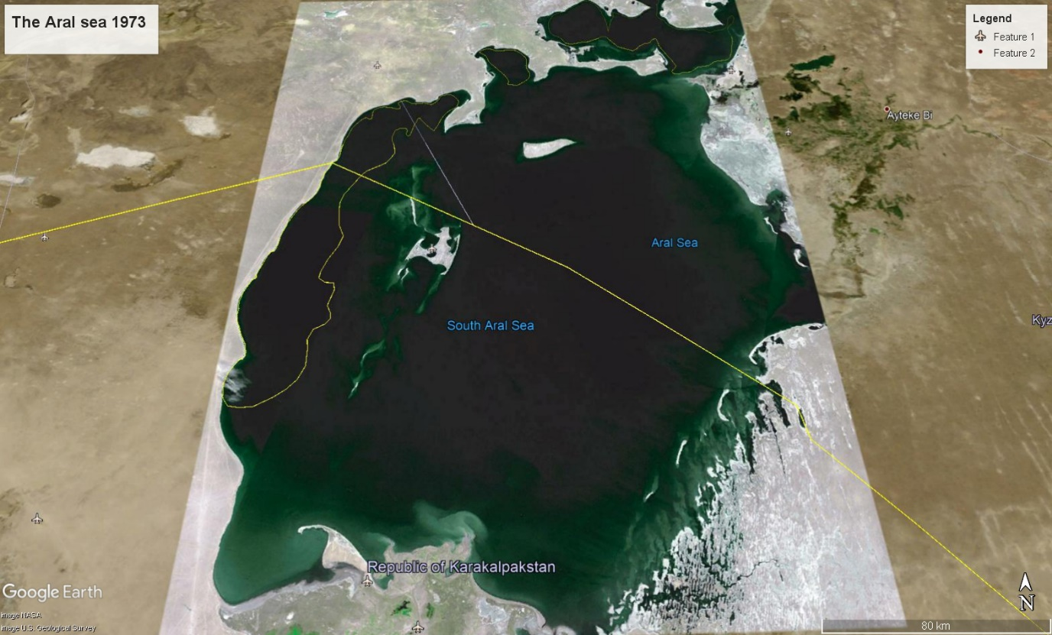

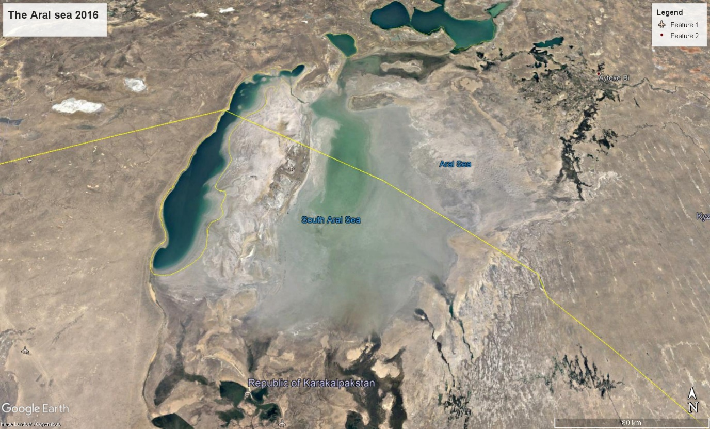
3.
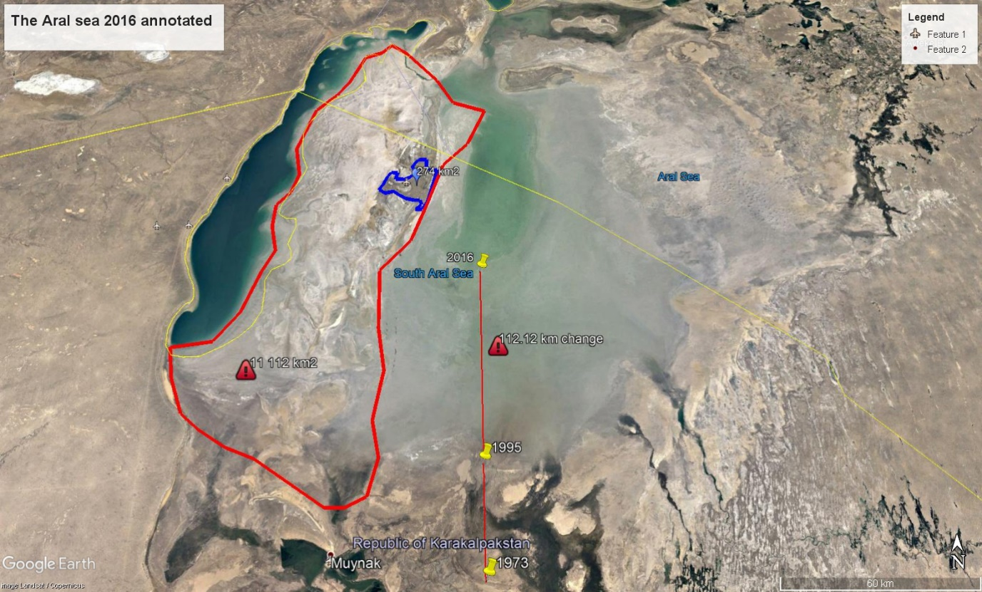
The Aral Sea was once the fourth largest in the world, however nowadays, this sea is only a tenth of its original size. Dry conditions and intensive irrigation are considered as the main destructive factors of this lake (Howard, 2014). I’ve compared this sea in years 1973 and 2016, where the dried area reached the length of 112.12 km as a straight line. From our picture we can see the speed of water disappearance- 1973-1995 (22 years range) it was the line with the 37.08 km. This rate almost doubled between years 1995-2016 (21 years range), as the dried area growth in 75.4 km. I found interesting to compare the size of the small island located on the left side of the sea. In the year 1973 this island comprised of 274km² and reached the enormous are of 11 112 km² in 2016. This increased in size had split the sea into eastern and western lobes that remained tenuously connected at both ends. Dried-up seabed of the Aral Sea’s has left the dust, salt and chemicals that are causing health problems for locals. Moreover, many people lost their income from fishing, as number of fish strongly decreased and rusting ships only sit in the desert in the former ports (NASA).
References
Howard, B.C., 2014. Aral Sea's Eastern Basin Is Dry for First Time in 600 Years. National geographic. Available at: https://www.nationalgeographic.com/science/article/141001-aral-sea-shrinking-drought-water-environment [Accessed by 25 February 2021]
NASA. World of Change: Shrinking Aral Sea. Available at: https://earthobservatory.nasa.gov/world-of-change/AralSea [Accessed by 25 February 2021]

