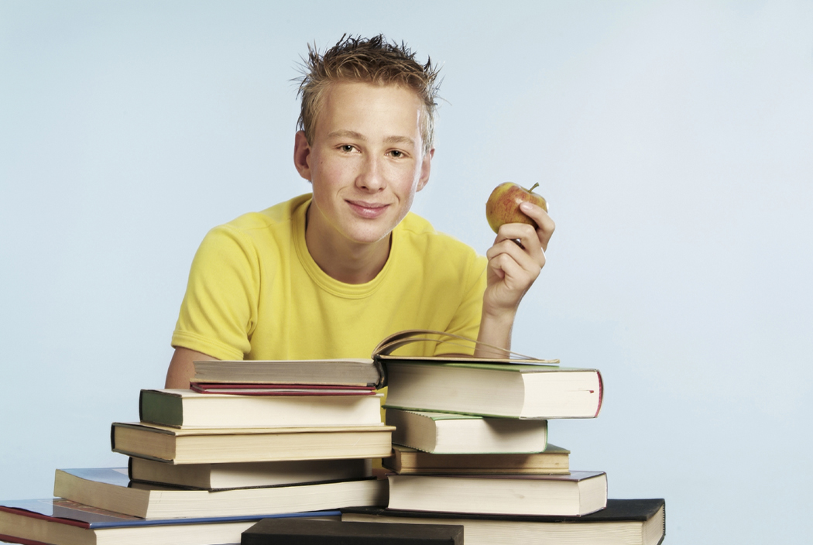
BOOK

- What kinds of books do you like to read and why?
- What do you prefer- a book or a film version?
- Why do people read less than they did before?

If you ask people about their favourite leisure time activity, the answer is sometimes reading books. People have always liked books. Before the printing press was invented, people loved looking at manuscripts. At that time being able to read was considered a unique achievement. After Guttenberg made printed books available to almost everyone, people fell in love with books. Each year, millions of books are written, sold, read and presented as gifts on occasions such as birthdays and Christmas.
Books accompany people everywhere: we read them while traveling to school/work, waiting for a consultation with our GP, during breaks at school, on holiday. We don´t imagine our lives without books. Reading gives people a lot of pleasure. There are books that give a chance to learn about the world around you. Other books give a lot of information and advice. And, of course, there are those entertaining books which are amusing to read because they´re about other people´s experiences. Those are keen on reading can choose from a wide variety of books.
There are many different genres of literature. Basically we can divide literature into poetry, prose and drama. Poetry is usually written in verses and it expresses the author= s feelings, their interpretation often depends on the reader. Poetry is the way of outlet for sensitive emotional people who want to express their feelings, people often write or read poetry when they are in love, people read poems to dream, to imagine and to think about their feelings.
Non- fiction is literature of fact, these books are for information, e.g. biography or autobiography, travel books, history books, diaries, textbooks, memoirs, dictionaries, encyclopaedias, self hel books, cookery books history and art books, etc.
Fiction – is an invented story made up by the author´s imagination, e.g. novels, tales, romances, novellas, short stories, whodoneits, adventude stories, thrillers, police novels, suspence stories, etc. A story in a book can be set in a real or imaginary place and time in which characters live. The plot –the series of events- can be narrated by the author or by one of the characters. Talented writers are excellent story tellers, able to attract readers and keep their attention from the very first page until the plot culminates at teh end of teh book. The best books are usually read in one sitting.

Every year, the Nobel Prize for literature is awarded to the writer whose woek of fiction is considered to be a unique literary achievement. There are many writerwho are Nobel Prize winners. W.Faulkner, Steinbeck and Hemingway just to mention some of them.

Our first books are usually read to us by our parents or grandparents.
Children in general like fairy tales and stories, fables, children´s rhymes and later juvenile liteature. These books have usually more pictures than text. The children´s books by Hans Christian Andersen or Brothers Grimm are popular worldwide. English classic children´s books like Alice in Wonderland and Winnie the Pooh have been read and loved by many generations of English children.

Nowadays, people in Slovakia can read both original Slovak books and books translated from different languages, mainly English. They read fiction and non-fiction genres. Boys usually read adventure stories or science fiction, girls prefer romances or novels. Many young Slovaks have started to read in English. Adults like to read detective stories, historical novels or books of travels. Some also read non fiction genres, such as biographies or scientific papers. Some people read poetry, but this genre is not easy to read. Fantasy series for children have become very popular genres in recent years. People also enjoy watching film versions of famous books which they have read. Books make us think, amuse us and give answers to some questions. A good book is also a pleasant way to escape from the real world.

Books can be bought in a wide range of bookshps. Some are small and quite specialised, others are situated in big shopping centres. It is becoming more and more popular to buy a book via the Internet. It is also possible to read a book in electronic form, such a book is called an e-book.

The book is better in my opinion than films, because you can take them with you on holiday, read when travelling or on the beach and they last much longer. If it is a good book then you really enjoy it and you can re-read the parts that you like. Films are usually much shorter, and it is up to the director to decide how to approach the original story. Directors may have their own personal style or just have a different view of the book, and this may make the film unattractive for us as the hero we have always imagined when reading the book suddenly comes out a totally different person. Internet is also not bad- you can find everything there, you don´t have to go and search for the book in the library or bookshop, but on the other hand you can read a book e.g. in bed and take it with you anywhere.

People whose hobby is reading can buy books in a bookshop or borrow books from a library. Libraries store books, magazines and newspapers and you may be sure you´ll be able to find almost any book you need here. Some libraries are free of charge, but most of them charge a small fee for yearly membership or for each book borrowed. If you want to borrow books from a library, you should get a library card. There are several ways to choose a book to read. You can ask a librarian or a friend who is keen on reading to recommend a good book or you could check the book reviews in your local newspaper. Booksops acan be small or specialized, others are situated in big spopping centres. It is becoming more and more popular to buy a book via the Internet. It is also possible to read a book in electronic form, such a book is called an e-book.

People read less than they did in the past. They do not look for information on books (such as encyclopedias or textbooks) as much as tehy used to. They need to save as much time as possible. Therefore, they prefer to look up the information on teh Internet. Instead of reading good fiction, they watch films.Reading a book takes days or weeks, watching a film just one or two hours. People do not need to concentrate so much, they do not need to imagine things. Everything is ready for them on the screen. Adults read more and more magazines because it takes less time and concentration than reading a book.
Some people think that books will die out one day. They say that everything will be read in electronic form and people will have less time to read books. Others argue taht reading is a hobby for many people and booka are a part of the cultural heritage of every nation. That is why they think that books will always be here and irreplaceable.

English writers: Chaucer, Shakespeare, Fletcher, Milton, Byron, Shelley, Scott, Austen, Dickens, Wilde, Christie, Shaw
American: Emerson, Twain, Poe, Whitman, Fitzerald, Hemingway, Steinbeck, Faulkner, Frost

- What is reading?
- Why is reading important?
- What kind of reading material do you know?
- What were your first books?
- Name some famous writers of fairy tales.
- What do children read?
- What do teenagers like reading?
- What about adults and older people?
- What reading material is favourite for you?
- Do you like to read fiction or non- fiction?
- Who are your favourite writers from your country or from overseas?
- What is your historical period in literature?
- What is your favourite magazine and why?
- Do you regularly read a newspaper and which one?
- What can you normally find in newspapers and magazines?
- Which articles do you normally choose?
- What is your opinion of tabloid magazines?
- What do you think of comics?
- What type of reading do you find the most relaxing?
- Do you have a book that helps you when you feel under stress?
- Do you enjoy humorous reading?
- Do you like reading sad or tragic stories? Why?
- What do you think of war stories?
- Do you like horror stories?
- Do you like poetry? Why?
- What hero from a book have you admired and wanted to imitate?
- What do you think of tabloid magazines and newspapers?
- Do you buy such magazines?
- Wher can you get books?
- Do you go to the libraries, bookshop?
- Where is the nearest library?
- What do i have to do to borrow some books from the library?
- Do you know any literary magazines?
- What are you reading right now?
- Can you tell us the content of the book?
- Who is your popular writer?
- Which books has she/he written?
- What do your family members like to read?
- What are the benefits of reading?
- Can you compare reading and watching TV?
- Name some Slovak , British and American newspapers and magazines.
- Name some Slovak, American and British authors.
- Have you read anything in English or German?
- Do you know anyone who was awarded by the Nobel Prize for Literature?
- What do you think about reading via Internet?
- Do Slovaks buy enough books?
- Have you read a bestseller recently?
- Why is there a crisis of reading among young people?
- Do you think that books will disappear one day?

A, Which literary genres from the box below would you recommend to somebody who likes reading about?

- 1.folklore heroes, fairies, princesses and talking animals
- science and technology and the futue of life on Earth
- detectives who investigate a crime, usually a murder
- somebody´ s life
- experiences and adventures from journeys
- cartoon characters in a dynamic story

Example: deep feelings and dreams of poets which are written in verse : poems

fairy tales detective stories science fiction comic books biographies books of travel

B, What genres are the following books? Who were they written by?

1. Romeo and Juliet
2. A Farewell to Arms
3. Harry Potter
4. The Catcher in the Rye
5. Hamlet

C, Which books in the previous exercise are the following characters from?

- a wounded soldier fighting on the Italian front during World War I is sent to a hospital in Milan where he falls in love
- a Prince of Denmark who wants to revenge the death of his father
- a 16-year old boy who is describing his experiences in New York
- an orphan wizard boy who attends a school to learn magic
- a teenage couple who love each other despite the hatred of their families and die together in the end

D, Read the short paragraphs below. Which books from the exercise B do they describe? Which paragraph describes:

  - author
  - main characters
  - plot
  - main conflict
  - setting

- The books describe several years of life of an orphan. They concentrate mostly on this young adolescent. Two of his classmates and best friends are also quite well-described. Throughout the story, the orphan learns more and more about his dead parents. The story is mostly set in a school, where the main character and his classmates meet a lot of teachers. They get on well with many of them. However, some of the teachers are not very popular.
- The beginning of the story is set in a family ouse, while most of teh events take place in an old school. Most of it is set in a fantasy world.
- The main character, the orphan, discovers that he is a wizard. He is sent to a wizard school to learn the magical skills. He meets a lot of friends and has to overcome many problems there.
- The main character struggles against the evil wizard who killed his parents
- She has become a multi-millionaire and a popular celebrity. She has participated in creating film versions of her books.

E, Talk about the book you have read recently. Talk about its:

  - Author –full name, country, other books
  - The time when it was written –century, period
  - Main characters/ protagonists , characteristics, names of other characters and their relationships
  - Main conflict (between whom?, why?
  - Setting (Where is the story happenin? What country? Real world? Fantasy world?
  - Plot /describe the story

F, Talk about your reading habits

- Which book have you read recently?
- How many books per year do you read?
- How many books per year do you buy?
- Who do you usually buy books for?
- Do you ever go to the library? What for?
- What kind of books do you buy as a gift?
- Do your friends read books or do they prefer going to the cinema to watch films?
- If they like reading books, which genres do they prefer? Why?
- Have you ever read any e-books?
- Do you think that books will die out in the future?

