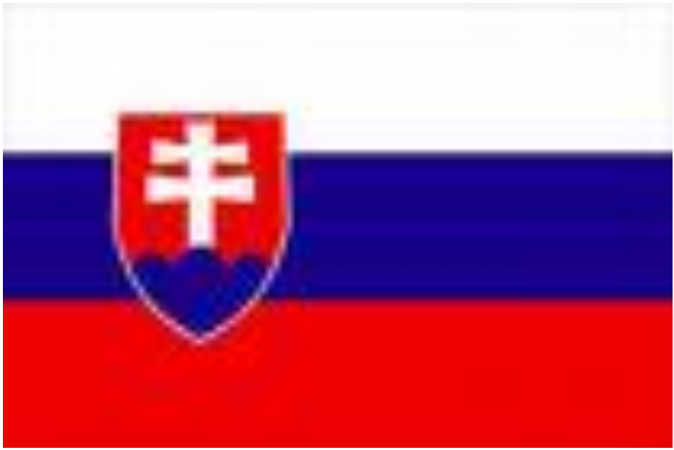

SLOVAK NATIONAL FOOD – HALUŠKY

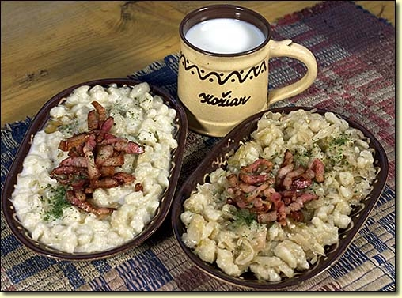

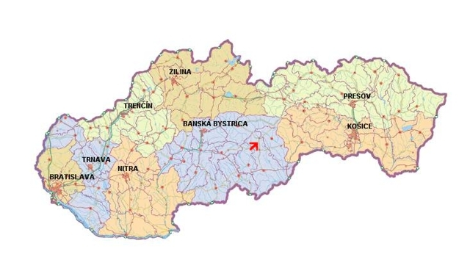

SLOVAK NATIONAL COSTUME

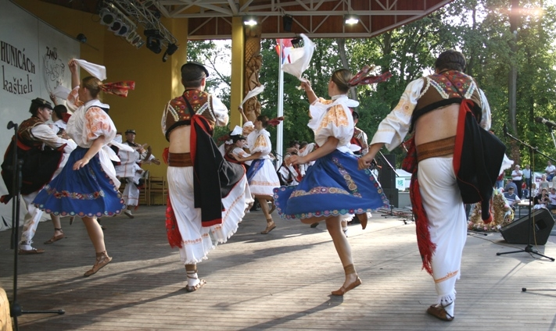

Why to visit Slovakia ?

You will see:

- High mountains
- Beautiful nature
- Many caves and spas
- The prettiest girls in the world
- Friendly and hospitable people
- Cheap services
- Delicious food and drinks
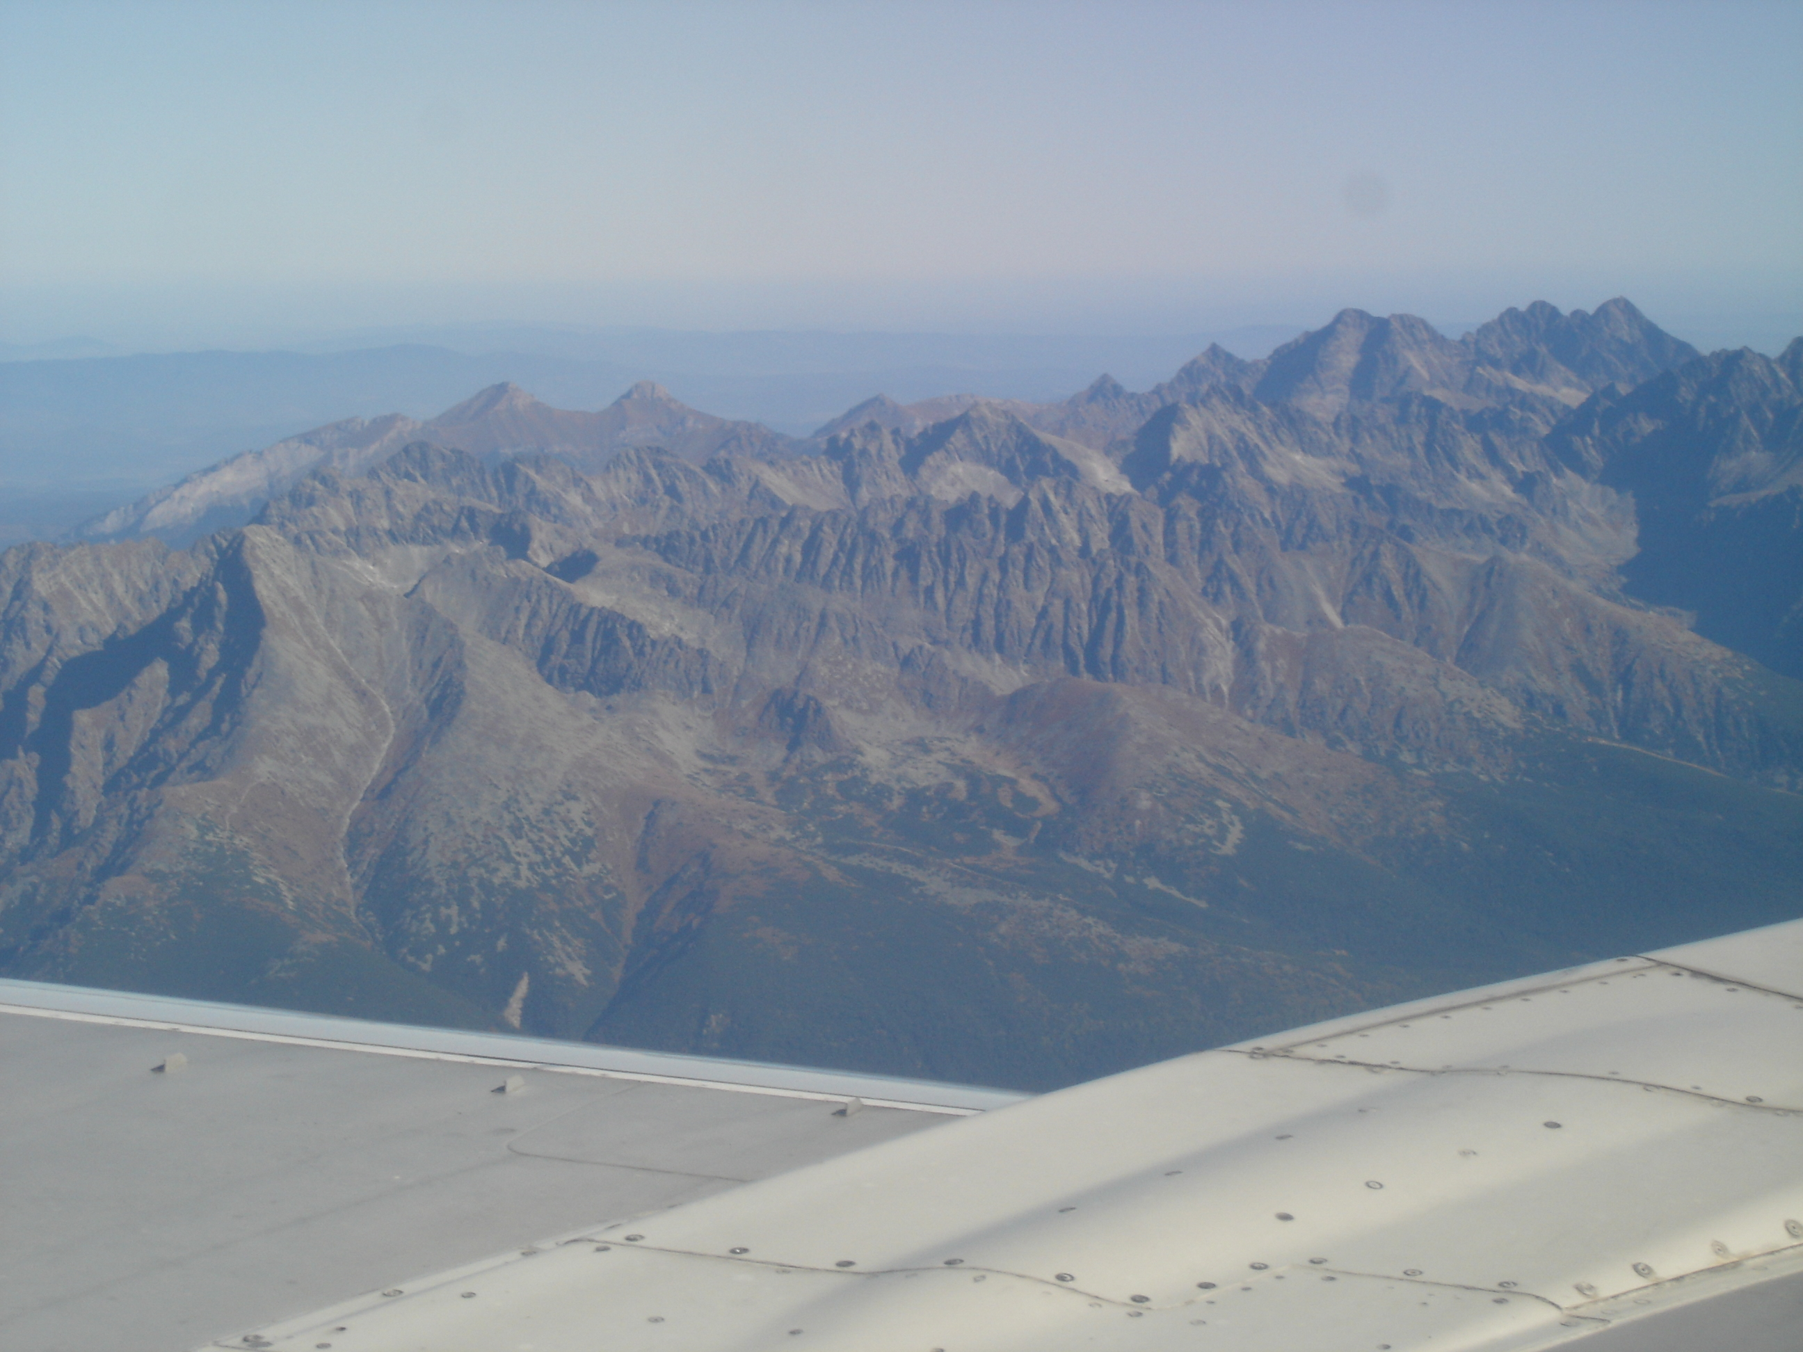

LOCATION: Middle Europe /the exact middle of Europe is in Kremnica
NICKNAME: the heart of Europe 
AREA: 49,039 sq km
POPULATION: 5,500, 000 people
NATIONALITIES: Slovaks 80%, Hungarians {10%}, Gypsies {9%}
RELIGION: Catholics {83%}
LONGEST RIVER: the Vah {403 km}
HIGHEST POINT: GERLACH
{2,655 m}
TOWNS: 136
NATIONAL PARKS: 9
CAVES: 660
CASTLES: 300
CLIMATE: continental
Winter: -30 ˚C
Summer: +39˚C
CURRENCY:
from 1 st January 2009 EURO !
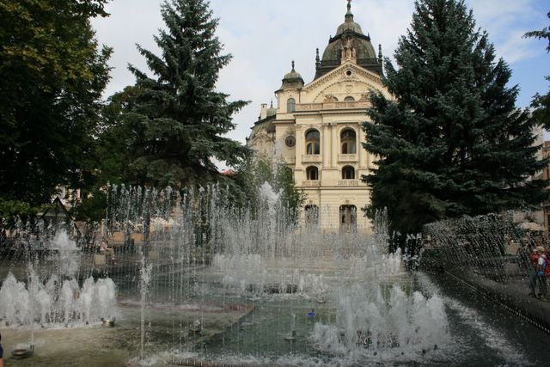

KOŠICE – the second largest city

