READING
The Great Famine
The year of 1845 changed the history of Ireland forever. The weather was good so people were expecting a good potato crop that year. What they didn’t know was that a new form of potato disease had been brought into Europe.
The disease first appeared in America two years earlier, then it arrived via cargo ships into France and finally reached the Isle of Wight and Ireland. It turned potatoes into a black, rotten mess, which nobody could eat. More than half of the year’s crop was destroyed.
Irish people depended on potatoes for their survival. Most people owned very small areas of land, and they grew potatoes instead of grain because a farmer could produce three times as much food on the same plot of land. A single acre of potatoes produced enough food for a family for a year. Each family grew only what they needed as they didn’t have anywhere to store potatoes over the winter.
There was famine all over the country. People went hungry without any food to eat for days. Then in 1846, the potato crop was devastated once again. The harvest in 1847 was also very poor. Three years without potatoes led to enormous problems for Ireland.
The British government, which ruled Ireland at the time, first did very little to help the people in need. In fact, during the crisis, British landlords continued exporting food from the country simply because they could get a better price abroad. Finally, in 1847 the government decided to do something about Ireland. They set up soup kitchens to give free food to people who needed it the most. They also started work programmes to help people make money so they could buy food for their families. But it was too little, too late.
Between 1845 and 1855, more than 700,000 Irish people died. After the famine, an estimated 2 million people left the country. Some people started new lives in Britain’s industrial cities, for example Glasgow, London and Liverpool. Others went to the USA. The population of Ireland dropped by more than a quarter.
The Great Famine, as they called the hunger crisis, transformed Irish culture and had a big effect on the Gaelic language. The crisis was worst in the west of Ireland, where most Gaelic speakers lived. Families who decided to emigrate no longer had any use for Gaelic in their new countries, and future generations of Irish immigrants didn’t learn the language at all. Today only a small minority of Irish people speak Gaelic as their first language.
But many historians believe it was also the Great Famine that led to the nationalist movements which finally brought about Ireland’s independence from Britain in 1921.
1 Read the article. Write true (T) or false (F).
1 The potato crop in 1845 was better than people expected. F
2 The disease appeared in America and Europe in 1845. ___
3 Farmers who grew potatoes could produce more food than farmers who grew grain. ___
4 There were problems with the potato crop in 1846 and 1847 as well. ___
5 British landlords bought food from abroad to help deal with the crisis. ___
6 The British government controlled Ireland from London in the 1840s. ___
7 The government gave people in the worst situation money to buy food. ___
8 There were about 25% fewer people left in Ireland after the Famine. ___
9 After the Famine, Irish immigrants usually spoke Gaelic in Britain and the USA. ___
10 Most Irish people today speak Gaelic. ___
11 Some people say the independence movement started with the Great Famine. ___
2 points for each correct answer |  | 20
2 Match the underlined words in the text to the definitions.
1 continuing to live survival
2 the smaller part of a group ________
3 changed completely ________
4 leave one’s country ________
5 destroyed ________
6 illness ________
1 point for each correct answer |  | 5

 | Reading total |  | 25

WRITING
1 Choose the best phrase for a letter to a company. Circle the correct letter.
1 a Hello
b Dear Sir or Madam
c Dear Brian
2 a I am writing in response to your advertisement.
b I saw your advertisement and decided to write.
c Great advert – I’d like to know more about it.
3 a I would be grateful if you could send me some
information about the summer course.
b I’d love to know more about the summer course.
c Please give me some information about the summer course.
4 a I’d like to study business English for my job.
b Can you teach me some business English, please?
c I would be interested in developing my business English skills for my career.
5 a I’m expecting to hear from you.
b Please write soon.
c I look forward to hearing from you.
6 a Bye,
b Yours faithfully,
c All the best,
1 point for each correct answer |  | 5
2 Read this advertisement. Write a letter requesting more information about the course. Write your letter in 120–150 words.
INTERNATIONAL SUMMER ACADEMY
Intensive short courses and extended training courses offered in Business English.
Training available at different levels of English.
Based in London, Brighton and Bournemouth.
For a course prospectus and further information, write to:
c/o Training Department
188 Maygrove Street
London NW6 1QJ
UK

Writing task |  | 20

 | Writing total |  | 25
LISTENING
1 Listen to five people talking about their work. Circle the correct letter.
1 Fiona works in
a a bank.
b a baker’s shop.
2 Where Fiona works, she and her husband are
a shop assistants.
b the owners.
3 Jason says he enjoys working
a on his own.
b in a car factory.
4 Peter
a is a lawyer abroad.
b teaches English.
5 Donna’s teenage dream was to
a be a champion cyclist.
b help other sportspeople deal with problems.
6 Chris has two jobs,
a he’s a food critic and a waiter.
b one in Ibiza, and another in Cambridge.
1 point for each correct answer |  | 5
2 Listen again. Match two statements from a–k to each speaker. There is one extra statement.
1 Fiona __ __
2 Jason __ __
3 Peter __ __
4 Donna __ __
5 Chris __ __
a couldn’t speak the language when he/she first arrived.
b didn’t have his/her dream come true.
c had a stressful job after university.
d wants to have children soon.
e is not successful yet, but is hoping to be.
f applied to an online advertisement.
g is always excited about the start of the summer.
h doesn’t like visiting restaurants very often.
i moved to Britain from another country.
j suffered from depression.
k lives in a small flat.
2 points for each correct answer |  | 20

 | Listening total |  | 25
SPEAKING
1 Ask and answer the questions with a partner.
1 What do you think your life will be like in ten years’ time?
2 In what ways do you think Britain is similar to your country? In what ways is it different?
3 What is the worst job you have ever had to do? What was it like?
4 What advice would you give to a friend who wanted to be fitter and healthier?
5 Where are you going to go and what are you going to do this weekend?
max. 1 point for each topic |  | 5
2 Look at the photos. Compare the different families. Talk about what the advantages and the disadvantages are. In your opinion, what is the ideal family like?


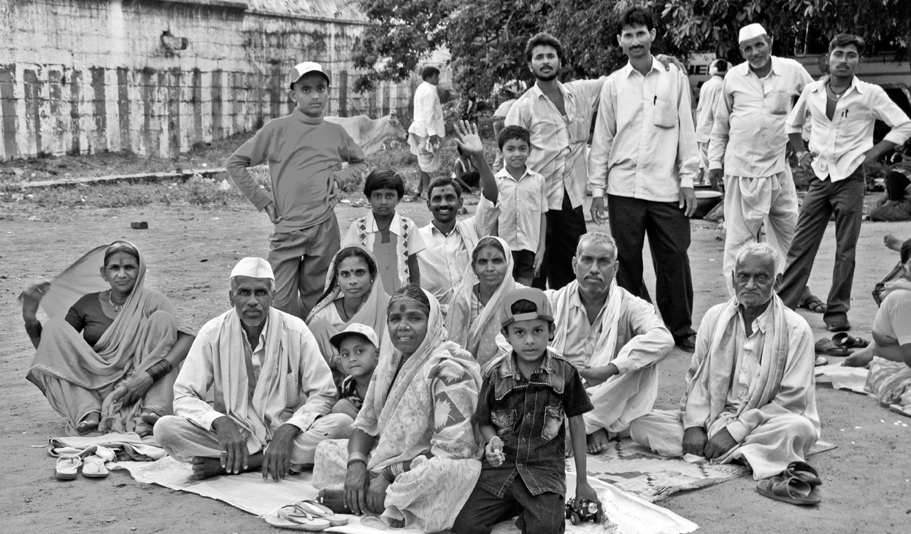

max. 10 points |  | 10
3 A Look at the information. Use the words to make five questions.
New York City factfile
History: The largest city in the USA since 1790.
Population: 8 million (city), 18 million (metropolitan area).
Nationalities: 36% of its population were born abroad. They come from Africa, Puerto Rico, Italy, China, Ireland, Russia and Germany, to name a few.
Public transport: New York City Subway runs 24 hours a day, 7 days a week. Only 22% of people in the city own cars.
Free time: over 500 art galleries, 39 large theatres, all the major designer stores, 110 square kilometres of parks and 23 kilometres of public beaches.
1 how long / New York City / in the USA?
2 how many ?
3 where from ?
4 how / travel around ?
5 what / do ?
1 point for each correct question |  | 5
B Answer the questions.
1 point for each correct answer |  | 5

 | Speaking total |  | 25

 | Skills test 3 total |  | 100

