READING
Men on the moon
What is your biggest ambition? For some young men in the 1960s, it was to become an astronaut and walk on the moon. But what do you wish for if you have already walked on the moon? Very few people have ever been able to ask themselves that question.
Reaching the moon was perhaps humankind’s greatest achievement. On 20 July 1969, Neil Armstrong became the first person in recorded history to set foot on another planet. Many believed at the time that many similar triumphs were just around the corner. They turned out to be wrong.
Altogether, 24 astronauts have travelled to the moon, and only half of them have had a chance to step outside. All of them were American. All of them were men. And they all visited the moon in a brief interval from 1969 to 1972. Since then, not a single soul has travelled there. Some engineers claim today it would take us another ten to fifteen years to ever do that again. Now ask yourself this: how many moonwalkers could you name? People remember the names of pop stars, presidents, even racing car drivers long after they disappeared from the public eye. But very few of us could name a handful of people that walked on the moon.
What kind of people were they? One of them, Jack Swigert, whose only trip to the moon was the near-disaster of Apollo 13, once said it was not surprising astronauts never said anything interesting about the most momentous experience in their lives. For example, when Pete Conrad, commander of Apollo 12, stepped on the moon, he didn’t make a speech. He only said, ‘Whoopee!’
Astronauts were strong people: psychologically as well as physically. They were selected by NASA for their ability to survive in extreme conditions. They were usually patient, focused and very calm. They were not poets or artists, they were Air Force pilots. But they could never have achieved what they did if they had been less resolute. They all knew that if they made just one mistake, they could die at any moment. They all came home safely. And now, when the era of the space shuttle concludes with the return of the Atlantis on the 42nd anniversary of the first moon landing, we can all remember their achievement, which was just one small step for them, but one giant step for humankind.

1 Read the article. Match sentence beginnings 1–11 with endings a–l. There is one extra ending.
1 The first astronaut who walked on the moon g.
2 There were twelve American astronauts ___
3 Between 1969 and 1972 ___
4 According to experts, these days ___
5 Very few people today ___
6 Astronaut Jack Swigert ___
7 Astronaut Pete Conrad ___
8 NASA selected astronauts ___
9 Astronauts all know they could die ___
10 All the moon astronauts ___
11 The space shuttle Atlantis returned from its final journey ___
a who had a chance to walk on another planet.
b twenty-four astronauts travelled to the moon and back.
c could name all the moon astronauts.
d travelled to the moon on Apollo 12.
e said astronauts were not very good at talking about their journey to the moon.
f who were psychologically as well as physically strong.
g was Neil Armstrong.
h got back safely from their trips to the moon.
i in July 2011.
j it would take us several years to be able to repeat the moon expedition.
k who have ever made a journey to the moon.
l if they made just one mistake in space.
2 points for each correct question |  | 20
2 Match the underlined words or phrases in the text with the definitions.
1 all the people in the world humankind
2 very few __________
3 nobody __________
4 ends __________
5 determined __________
6 successes __________
1 point for each correct answer |  | 5

 | Reading total |  | 25
WRITING
1 Fill in the form for you.
FRIENDSHIP.NET
First name: _______
Surname (write in capital letters): _______
Gender (circle as applicable): M / F
Date of birth (dd/mm/yyyy): _______
Marital status: _______
Occupation: _______
Country: _______
City: _______
Languages spoken (indicate level):
1. _______ (elementary / intermediate / fluent / native speaker)
2. _______ (elementary / intermediate / fluent / native speaker)
3. _______ (elementary / intermediate / fluent / native speaker)
Hobbies, interests: _______
Looking for (delete where not applicable): friends / online gaming partners / serious relationship / husband / wife

Shorter writing task |  | 5
2 Write a review of book you have read and didn’t like. Write about:
• the author.
• the type of book.
• the story.
• the style of writing, the language.
• anything that was good about it.
• what you didn’t like about it, and why you wouldn’t recommend it.
Write your review in 150–180 words.
Longer writing task |  | 20

 | Writing total |  | 25

LISTENING
1 Listen to five short extracts. Write the number of the correct extract (1–5) for the summaries. There is one extra summary.
someone phoning a friend’s parents ___
someone meeting an old school friend ___
a caller talking to a friend’s work colleague ___
someone telling a friend his/her personal news ___
someone calling to find out about a phone number ___
a conversation with a rock star ___
1 point for each correct answer |  | 5
2 Listen again. Read two statements about each extract. Write true (T) or false (F).
1 Mr Wilson is away on a work trip. ___
2 The caller doesn’t know Mr Wilson’s mobile
number. ___

3 Nick has been waiting for his friend for a long
time. ___
4 Nick didn’t know Sean and his wife were expecting a baby. ___

5 The first operator at the call centre helps the caller. ___
6 The operator gives the caller two phone numbers. ___

7 Kelly didn’t have blonde hair when they were
younger. ___
8 Patrick is living abroad. ___

9 The tour doesn’t include the UK. ___
10 You cannot buy festival tickets yet. ___
2 points for each correct answer |  | 20

 | Listening total |  | 25

SPEAKING
1 Ask and answer the questions with a partner.
1 Who’s your favourite writer? Which of his/her books has impressed you the most? Why?
2 What scares you? What makes you angry? What makes you happy?
3 What gadget would you find the most difficult to live without? Why?
4 What’s your biggest ambition in life? Do you think you’ll achieve it? Why?/Why not?
5 If you could live as anyone else, whose life would you live? Why?
max. 1 point for each topic |  | 5
2 Look at the photos. Compare the different discoveries or inventions. Talk about how they have changed our lives for the better or for the worse. In your opinion, which invention has changed our world the most?


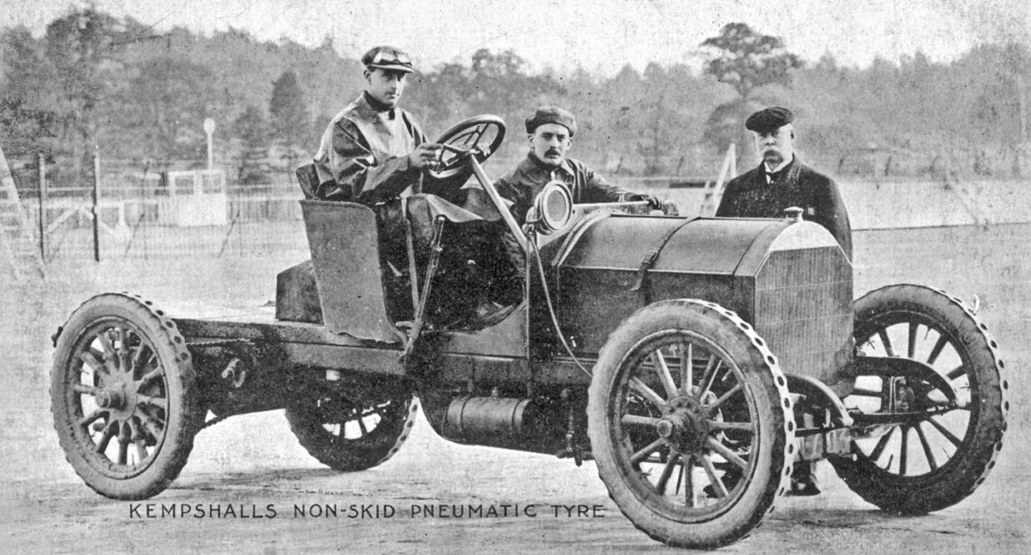

max. 10 points |  | 10
3 A Look at the information. Use the words to make five questions.
Jane Austen
1775 Steventon (Hampshire, England) – 1817 Winchester (Hampshire, England)
English novelist, one of the most popular writers in English literature
Educated at home by her father and brothers
Most famous works: Sense and Sensibility, Pride and Prejudice, Emma, and Persuasion – many successful film adaptations of her novels
Stories about the place of women in 19th century society
Seriously ill from 1816, died of unknown causes in 1817
1 when and where / be born / die ?
2 why / famous ?
3 who / taught by ?
4 what / write ?
5 why / die ?
1 point for each correct question |  | 5
B Answer the questions.
1 point for each correct answer |  | 5

 | Speaking total |  | 25

 | Skills test 4 total |  | 100

