About you
A
1 Talk about numbers.
 What year were you born? In what year did you first go to school?
 How much time did you spend doing homework last week?
 Have you got a lucky number? What is it? Why is it lucky for you?
 What do you think the world will be like in 2020?

Role play
2 Complete the dialogue with the words in the box. Then practise the dialogue.
definitely not disagree me think
think probably

A Can I ask you a question? I’m doing a survey.
B Yes, OK.
A Do you (1) ________________ that people will be happier in the future?
B Let (2) ________________. No,
(3) ________________.
I don’t think people will be happier, because I think they will have more problems. What about you?
A Well, I (4) ________________ with you.
I think that people will (5) ________________ be happier, because they’ll be richer and they’ll have bigger houses and better food.
EXTENSION You are doing a survey and want to ask your partner the question: Will people live longer in the future?
A ask your partner if you can ask them a
survey question
B agree
A ask the question
B respond and give a reason for your opinion
A explain your answer to the survey question and give a reason for your opinion

Photo description
3 Describe the photos.
Photo A
 Describe the photo. How many people can
you see?
 What are the people doing?
 What personalities do you think these people have got?
 What do you think the children will do in the future? Why?
Photo B
 Describe the photo. How many people can
you see?
 What are the people doing?
 What personality has this girl got?
 What do you think this girl will do in the future? Why?
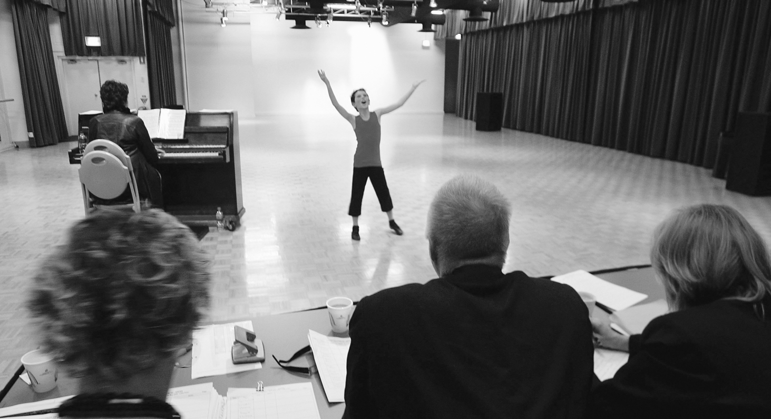
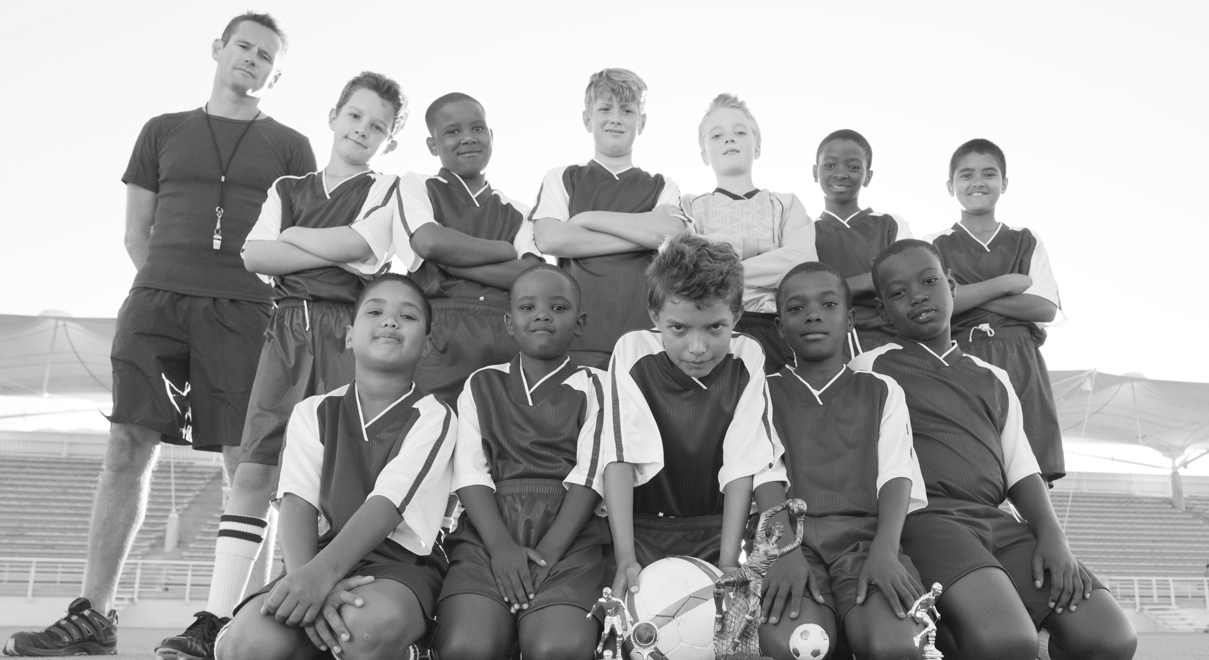
EXTENSION Answer the questions.
B
 Describe your personality.
 Are you ambitious? What do you want to do in the future?
 What things do you think you will definitely do in the future? What things won’t you do?

