Najskôr vypočítaj a potom vyfarbi:

zelená |  | žltá |  | červená |  | oranžová |  | fialová
(-2).(-1) |  | -8-(-9) |  | (10 -16):(-2) |  | -1.(-1-1-1-1-1) |  | -2-3-5+17
-(-2-2) |  | -6-(-15) |  | -1.[22:(-2)] |  | -3.4 +25 |  | -3.(-3)-(-3).2
2-(-4) |  | -17.(-1) |  | -12-6-4+41 |  | 3.[3-(-4)] |  | -5.(-4)-(-3)
-40:(-5) |  | -5.(-1).5 |  | 3.(-3).(-3) |  | 10-(-10)-3.(-3) |  | -20.3+91
-100: (-10) |  | -99:9.(-3) |  | -5+8.5 |  | -1.(-19-7-11) |  | -10+9-10+50
-(-3-5-4) |  | (-20 -20-1).(-1) |  | -2-3-2+50 |  | -5.(-3).(-1).(-3) |  | -47+94
+24:(+2) |  | -7.(-7) |  | -9+20+20+20 |  | -5.2.(-5)+3 |  | -5+(-5).(-12)
-3+2-5+29-7 |  | +114: (+2) |  | -1+60 |  | -9-(-70) |  | -3.(-3).7
(-2).(-9) |  | -13.(-5) |  | 7-3.(-20) |  | -3.3.3.(-3)-3.4 |  | -1+8.9
-10+40-10 |  | -27+100 |  | -3.5.(-5) |  | 7.(-1).(-11) |  | -1-[(-5).4].4)

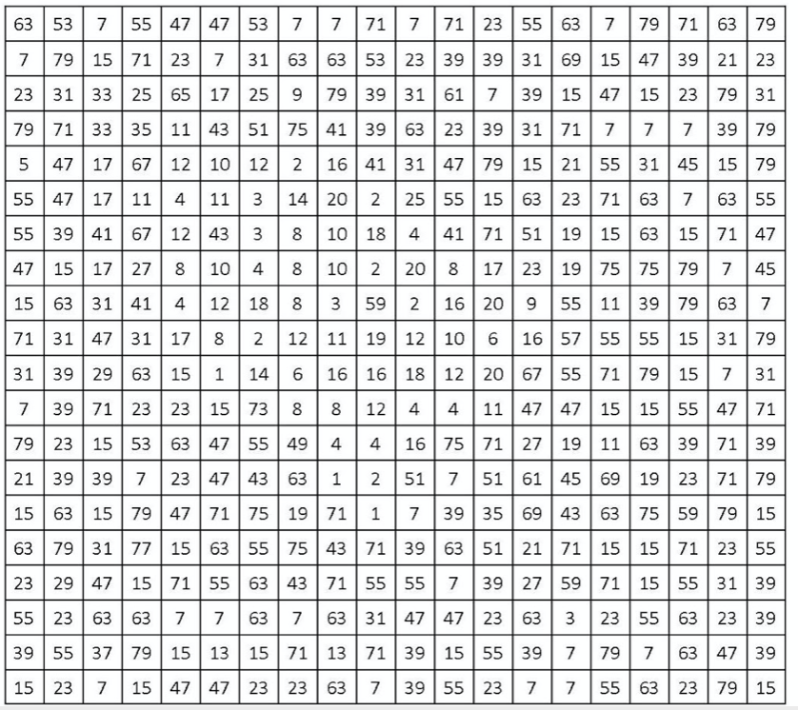

Riešenie:
zelená |  | žltá |  | červená |  | oranžová |  | fialová
(-2).(-1) | 2 | -8-(-9) | 1 | (10 -16):(-2) | 3 | -1.(-1-1-1-1-1) | 5 | -2-3-5+17 | 7
-(-2-2) | 4 | -6-(-15) | 9 | -1.[22:(-2)] | 11 | -3.4 +25 | 13 | -3.(-3)-(-3).2 | 15
2-(-4) | 6 | -17.(-1) | 17 | -12-6-4+41 | 19 | 3.[3-(-4)] | 21 | -5.(-4)-(-3) | 23
-40:(-5) | 8 | -5.(-1).5 | 25 | 3.(-3).(-3) | 27 | 10-(-10)-3.(-3) | 29 | -20.3+91 | 31
-100: (-10) | 10 | -99:9.(-3) | 33 | -5+8.5 | 35 | -1.(-19-7-11) | 37 | -10+9-10+50 | 39
-(-3-5-4) | 12 | (-20 -20-1).(-1) | 41 | -2-3-2+50 | 43 | -5.(-3).(-1).(-3) | 45 | -47+94 | 47
+24:(+2) | 14 | -7.(-7) | 49 | -9+20+20+20 | 51 | -5.2.(-5)+3 | 53 | -5+(-5).(-12) | 55
-3+2-5+29-7 | 16 | +114: (+2) | 57 | -1+60 | 59 | -9-(-70) | 61 | -3.(-3).7 | 63
(-2).(-9) | 18 | -13.(-5) | 65 | 7-3.(-20) | 67 | -3.3.3.(-3)-3.4 | 69 | -1+8.9 | 71
-10+40-10 | 20 | -27+100 | 73 | -3.5.(-5) | 75 | 7.(-1).(-11) | 77 | -1-[(-5).4].4) | 79



