About you
1 Talk about your possessions.
 What things have you usually got in your bag?
 What is your favourite possession? Why?
 What do you like doing after school?
 What do you like doing at the weekend?
 Are there any sports or hobbies you don’t like? Why?

Role play
Don’t you like it I can’t stand
Not much it’s OK do you reckon

2 Complete the dialogue with the expressions. Then practise the dialogue.

A Hey, look at this T-shirt.
What (1) ______________________________?
B Not much, really. It’s not very fashionable.
A Oh. (2) ________________________________ ? I think it’s really nice.
B Well, (3) _______________________________, I suppose, but I don’t really like the colour. What about this jumper? Do you like it?
A (4) _______________________________. I don’t think it’s fashionable. And it’s red, and
(5) ________________________________ red!
B Oh, well. It’s good that we don’t all like the same clothes!
EXTENSION Imagine you are in a clothes shop.
A ask your partner to look at some clothes
B give your opinion of the clothes
A respond
B show some different clothes
A give your opinion
B respond

Photo description
3 Describe the photos.
Photo A
 What are the people doing?
 What free-time activities do you think these people like doing?
 Do you like doing this activity?
 When do you usually do this activity?
Photo B
 What is the woman doing?
 What other things do we use a computer for?
 Do you like using the computer? What do you like doing?
 When do you usually use a computer?

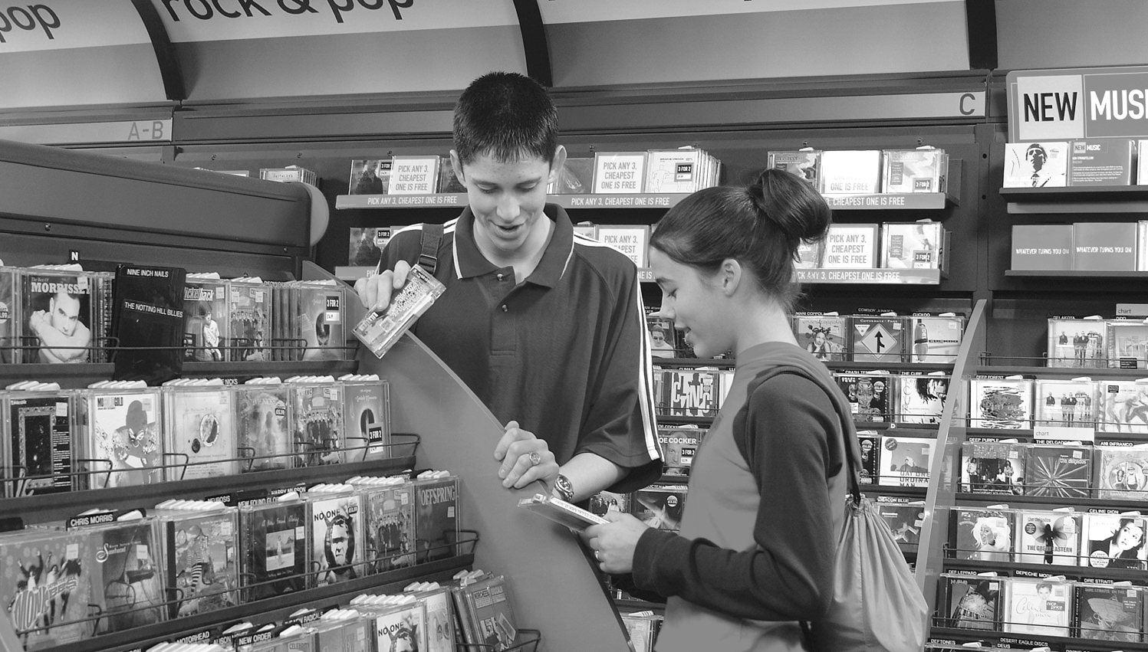
EXTENSION Answer the questions.
 Do you like going shopping with friends or shopping on the internet?
A
B
 What are your favourite shops? Why?
 What are your favourite websites? Why?

