Idols

Small children from all over the world have idol. Their idols are mainly princess, strong king in the love story. These idols aren’t really, because they are only the story not in the really life. These idols are good. They can save the life and make good things. 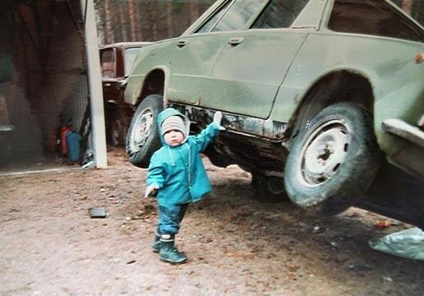☺☺
I think that people, who are famous mustn’t be good idols. Someone of these famous people, who have a lot of money are fair, because they spend it sensibly. For example they give money to alone children and ill people to the hospital in over the world. But someone of these”STARS” take a drugs, drink alcohol and make scandals. We can read about these bad idols in the magazines.
Work, which is dangerous make often people better. I think, that a policeman, a fireman have very dangerous and hard work. They spend all day so, that they save lives of the people. Sometimes they can die by rescue people.
The one of the most famous people in 20th century was Pope John Paul second. This man was very charismatic. He helps a lot of people and was very favourite. On his kind and love we can never forget. He had a huge heart.
Green peace is an organization, which help to protect our nature and all Earth. We should to agree with their ideas and make world better. We should protect our environment together with this organization too.
My idol is Yngwie Malmsteen. He is a guitar virtuous. He is Swedish. His music made crazy a lot of people (a lot of rockers) in 80th years. I like him, because I’m a rocker too and his music bewitches me. These songs are very mixed and incredibly composite.

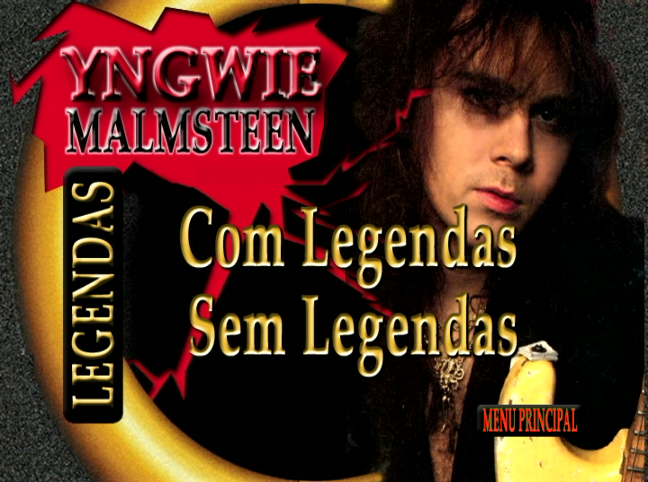

I think that this music isn’t very favourite by my father. He has his own sort of the music, which he likes. It is an old group THE BEATLES

