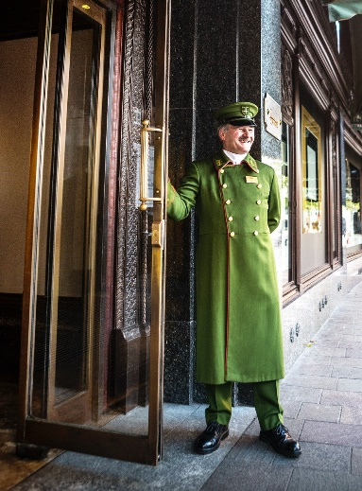
LOWER GROUND FLOOR
Beauty Events & Services
Fine Wines & Spirits
Gifts & Bookshop
GROUND FLOOR
The Beauty Halls
Fine Jewellery & Watches
The Food Halls
Luxury Accessories
FIRST FLOOR
Womenswear

HARRODS

SECOND FLOOR
Menswear
THIRD FLOOR
Home & Furniture
FOURTH FLOOR
Childrenswear, Toys & Wizarding World
Women's Contemporary & Denim
The Wellness Clinic
FIFTH FLOOR
Hair & Beauty Salon
Shoe Heaven
Technology
SIXTH FLOOR
Salon de Parfums

