About you
B
A
1 Talk about you.
 How do you like to spend your time?
 Where do you usually meet friends? How often do you meet them?
 Describe your typical daily routine.
 What do you want to do when you leave school?

Role play
a really big fan Well, it’s OK
was your weekend What do you think of it
you like it

2 Complete the dialogue with the expressions. Then practise the dialogue.

A Hi. How (1) _______________________________?
B It was really good. I went shopping and bought this new shirt.
(2) _______________________________?
A Hmm, I’m not sure.
B Don’t (3) _______________________________?
A (4) _______________________________. But
it’s red, and I don’t really like red.
B Well, I like it. Anyway, how was your weekend?
A It was good. I bought a new Kylie Minogue CD.
B Oh, can I listen to it?
I’m (5) ______________________________ of hers.
A Is it OK if we listen to it later? I want to finish my homework first.
B Yes, of course. See you later.
EXTENSION Imagine you are talking to a friend about shopping.
A ask about your partner’s weekend
B say that you went shopping and ask your partner if he / she likes what you bought
A give your opinion of what your partner bought
B ask what your partner did last weekend
A say that you bought a new DVD
B explain that you really like the film and ask if you can watch it
A agree but explain why you want to watch it later

Photo description
3 Describe the photos.
Photo A
 What kind of room can you see in the photo?
 What furniture is there in the room?
 What other things can you see?
 Find a bed and a lamp, and say where they are.
 What is the person doing?
 Do you think she tidies her room very often?
Photo B
 What kind of room can you see in the photo?
 What furniture is there in the room?
 What other things can you see?
 Find a chair and a lamp, and say where they are.
 What are the people doing?
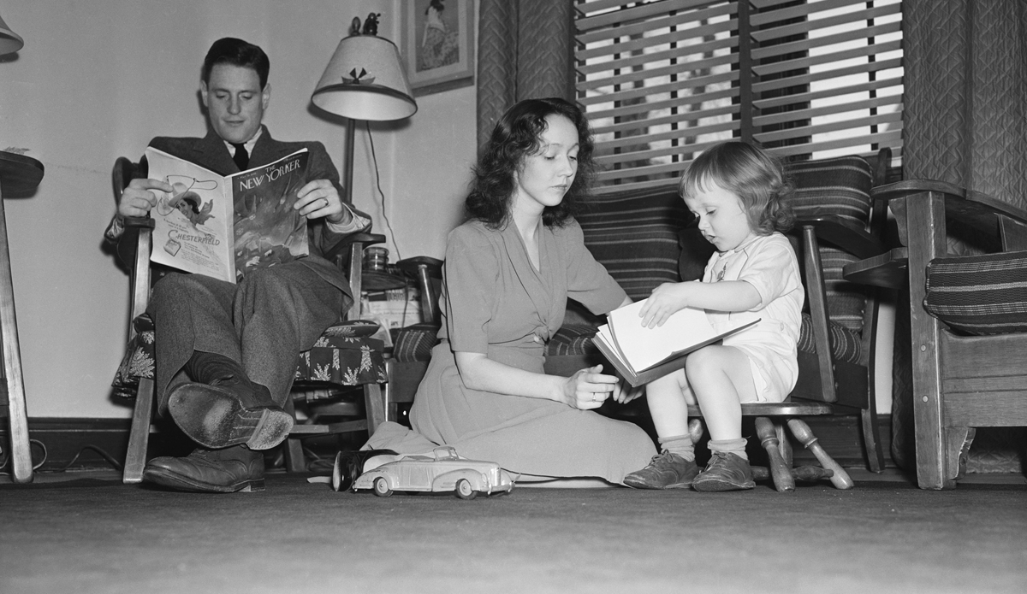
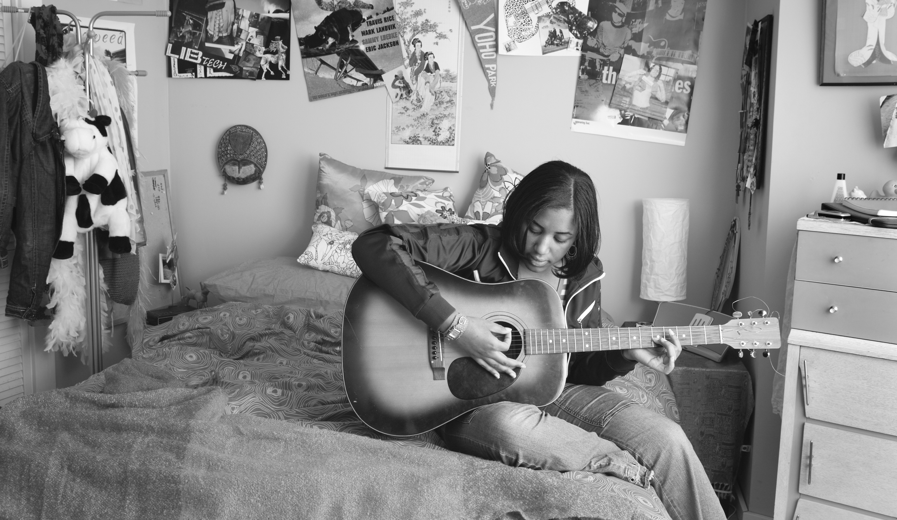
EXTENSION Answer the questions.
 How were houses different in the past?
 What things didn’t people have in the past?
 What did people do in the evenings when there was no TV?
 Do you think life was better or worse in the past? Why?

