About you
1 Talk about you.
 Describe your personality.
 What are your likes and dislikes?
 Talk about something interesting that happened to you. When was it? What happened? How did you feel?
 What things do you want to do in the future?

Role play
2 Complete the dialogue with the expressions. Then practise the dialogue.
definitely how was your
it’s OK, I suppose what about you
what do you reckon

A Hi. (1) _________________________ holiday?
B It was great! We went to the USA.
A That’s amazing! I want to go there one day.
Do you think you’ll go there again next year?
B Yes, (2) _________________________.
It was really good fun. Look, this is the flat where we stayed in New York.
(3) _________________________?
A (4) _________________________, but I prefer holidays by the sea.
B Yes, I love going to the beach, too. Anyway,
(5) _________________________? How was your holiday?
A It was brilliant! I spent two weeks on the beach.
EXTENSION Imagine you are talking to a friend about the summer holidays.
A ask your partner if he / she enjoyed their holiday
B respond and say where you went
A respond with interest and ask if he / she will go there again next year
B respond and show a photo
A express your opinion about the photo and talk about your holiday
B show interest

Photo description
3 Describe the photos.
Photo A
 What animal can you see in the photo?
 What is it doing?
 Where does this animal live?
 Do you think this animal is intelligent? Why?
 What other clever things can animals do?
Photo B
 What is happening in the photo?
 What are all the people doing?
 Do you think this is dangerous? Why?
 What personalities do you think these people have got? Why?
 How will these people feel later?
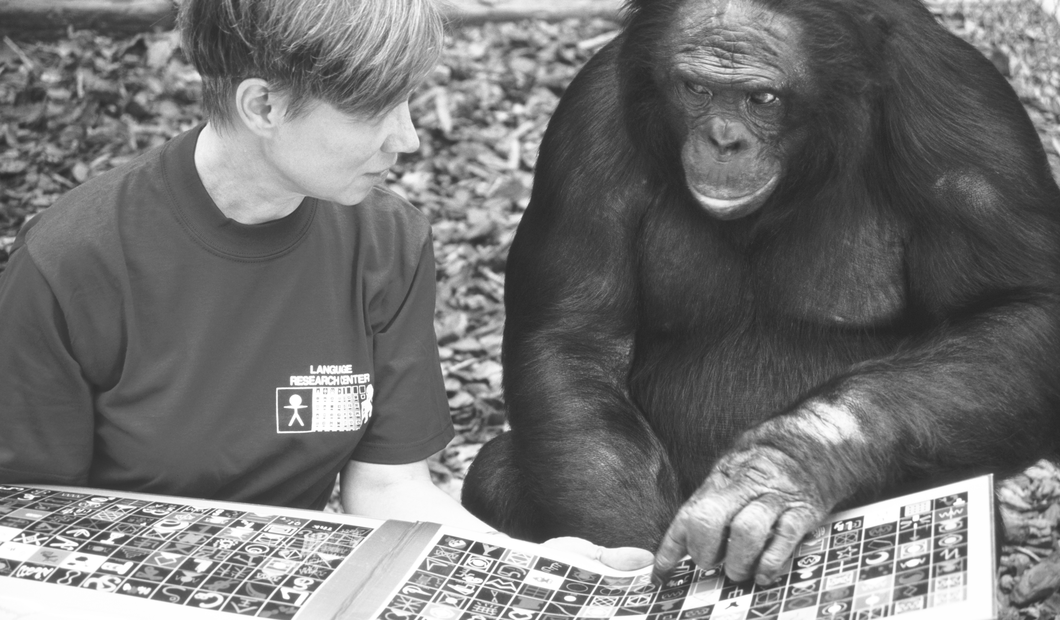

EXTENSION Answer the questions.
A
B
 What do you think is the most intelligent
animal? Why?
 Do you think that sometimes animals are more intelligent than people? Why?
 Why do some people enjoy doing dangerous activities?
 What new sport or hobby do you want to try? Why?

