READING
Half a century in the UK
1 F What was life like in Britain in the 1960s? Many would say it was simpler, quieter, and safer. It seems to me that in every generation, people look back and say things were better when they were young. But that’s because they felt better because they were younger! Being a 20-something, with all our dreams still possible, is different from being grown up with responsibilities: children, elderly parents, a home to pay for, money to make … in other words, your life changes, as well as the world around you. But what has actually changed in the last 50 years?
2 ___ The 1960s was the time when the technological wonders we nowadays take for granted started to become more common. By the end of the decade, nearly all homes had a television set. Programmes were still made in black and white, not colour. They started at five in the afternoon on weekdays, and they finished at midnight. People didn’t have mp3 players or CDs – they listened to music on the radio. Small, portable transistor radios were starting to replace the huge radio sets of the 1950s – which were bigger than most televisions are today. Nobody had personal computers. In the 1960s, the early computers were enormous, and only scientists with special training could use them.
3 ___ Shopping was different, too. Many people bought all their groceries in local shops. Supermarkets were a new idea in the 1960s, and although they were becoming popular, less than half of the population used them. A lot of people made their own clothes. There were fashion shops in big cities, of course, but people didn’t spend the weekend shopping like they do now: perhaps they went to a football game or did some gardening.
4 ___ Travelling abroad on holiday was becoming more popular, but most British families spent their holidays in the UK – in places like Blackpool or the West Country.
5 ___ Fewer people owned cars, but there were still enormous traffic jams on roads, especially during the summer holidays. The government had just started building motorways, so people usually had to use older, narrower roads to travel long distances. But trains were more frequent and a lot cheaper than they are today. British Rail was famous around the world for its service.
So, what do you think – was life better in the 1960s or was it simply different?
1 Read the article quickly and circle the correct answer. According to the author, why are people nostalgic about their twenties?
a They were able to enjoy technology more then.
b They like to look back to a time when they had fewer responsibilities.
c Because life is getting more and more complicated for every generation.
1 point for each correct answer |  | 1
2 Read the article again. Match the headings (A–F) with the paragraphs. There is one extra heading.
A Home or away?
B Buy what you need
C New inventions in the 1950s
D New entertainment in the 1960s
E Train or car?
F What every generation thinks
2 points for each correct answer |  | 8
3 Read the article again. Complete each statement with no more than two words.
1 The author thinks people saw the 1960s differently because they were younger .
2 In the 1960s, television programmes were not made in ______ .
3 You could not watch TV ______ midnight on working days.
4 In the 1960s you could have radios which you could ______ .
5 Only people with special ______ used computers in the 1960s.
6 Less than 50% of people bought their food in ______ .
7 Many British families spent their holidays in ______ .
8 ______ people own cars today than in the 1960s.
9 There were still only very few ______ where you could drive in the 1960s.
2 points for each correct answer |  | 16

 | Reading total |  | 25
WRITING
1 Think about the worst holiday in your life. Imagine you are writing a postcard to your English friend from this holiday. Write about:
• where you are.
• what the place and the weather is like.
• how you’re feeling.
• why you’re not enjoying the holiday.
Write in the present tense. Write your postcard in 60–100 words.
Shorter writing task |  | 10
2 Write the (real or invented) story of how your met your partner. Write about:
• when and where it happened.
• how old you were.
• where you worked or what you studied.
• what activities you did together.
• an interesting episode in your life together.
• what brought you together.
Write in the past tense. Write your story in 120–180 words.
Longer writing task |  | 15

 | Writing total |  | 25
LISTENING
1 Listen to an interview with Jason talking about his lifestyle. Tick () five points he mentions.
He doesn’t eat any meat these days. 
He is a fitness fanatic.
He enjoys watching tennis and golf.
He met his wife at the gym.
Anita ran the London Marathon.
He used to eat dairy products.
He is a very good cook.
Jason lost weight when he started a vegan diet.
He made a television show about his diet.
1 point for each correct answer |  | 5
2 Listen again. Circle the correct letter.
1 Jason can eat …
a meat.
b cheese.
c vegetables.
2 When he was a teenager, Jason …
a was a vegan.
b still ate meat.
c didn’t wear leather shoes.
3 When he was at university, Jason went to the gym …
a every second day.
b every evening.
c at the weekends.
4 He decided to change his diet because he …
a wanted to be attractive to girls.
b felt unhealthy.
c read about the effects of eating meat.
5 When he followed a vegetarian diet, Jason …
a lost a lot of weight.
b felt he had more energy.
c felt sorry he couldn’t have chicken pizza.
6 When he met Anita, she was …
a following a vegan diet.
b a trainer at the gym.
c preparing for the London Marathon.
7 Jason became a vegan …
a because of animal rights.
b to protect the environment.
c so he could impress Anita.
8 Vegan food products are easy to find …
a online.
b in healthfood stores.
c in most supermarkets.
9 Jason thinks that tofu …
a is not easy enough to find.
b tastes just as good as cheese.
c has an awful taste.
10 When Jason ran the Marathon, he …
a enjoyed running more than he had before.
b felt the distance was too long for him.
c lost a lot of calories.
11 When he eats out with friends who aren’t vegetarians, he …
a tries to change their mind about eating meat.
b thinks it’s up to them to decide what they eat.
c tells them to feel comfortable.
2 points for each correct answer |  | 20

 | Listening total |  | 25
SPEAKING
1 Ask and answer the questions with a partner.
1 Who’s the happiest person you know? What do you think makes them happy?
2 Do you think it is important to follow the news? Why?/Why not?
3 What dishes are popular in your country? Do you like them? Why?/Why not?
4 What do you think your parents were like when they were your age? In what ways were they like you and in what ways were they different?
5 What would you show a first-time visitor to your country’s capital city? Why?
max. 1 point for each topic |  | 5
2 Look at the photos. Compare different places where people live. Talk about what the advantages and disadvantages are. In your opinion, what would be
the ideal place to live and why?

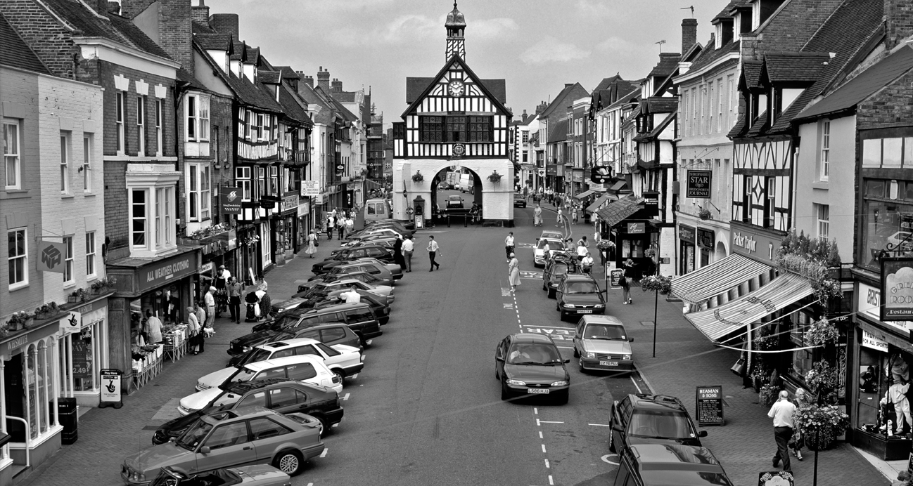
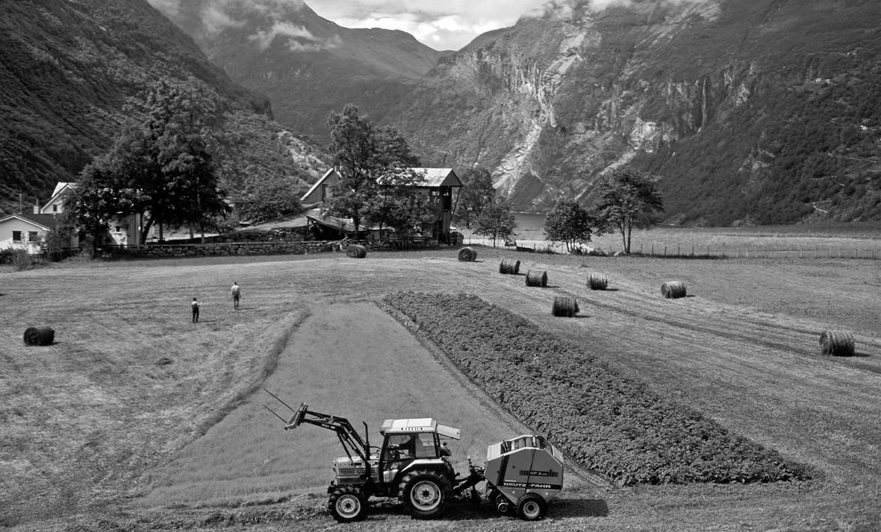
max. 10 points |  | 10
3 A Look at the information. Use the words to make five questions.
Summer part-time work: Tourist Information Officers wanted!
From mid-July to end-August.
Help tourists at outdoor information stands at major tourist sights.
You must speak one foreign language, be good at working with people and willing to work outdoors.
Flexible working hours: 4 hours/day (from 8 to 16 hours/week)
Pay: £10/hour. 50% higher pay for weekend work (Saturdays and Sundays)
1 when / need part-time workers ?
2 what / will do ?
3 what skills / need ?
4 how many hours / a day or a week / can work ?
5 what / pay / for weekends ?
1 point for each correct question |  | 5
B Answer the questions.
1 point for each correct answer |  | 5

 | Speaking total |  | 25

 | Skills test 2 total |  | 100

