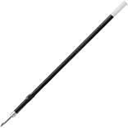

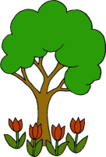





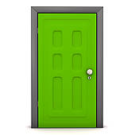
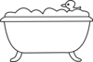

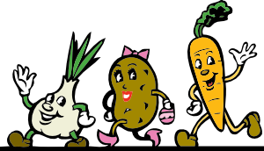
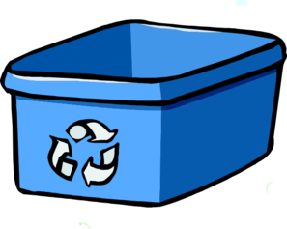
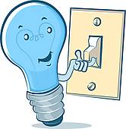
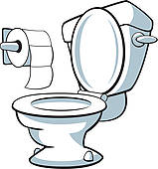
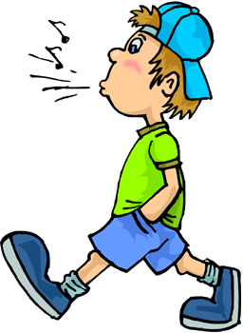
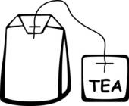
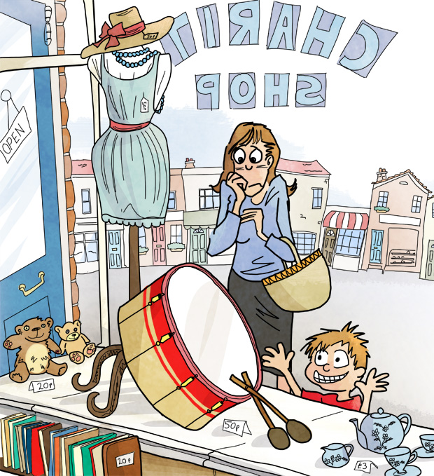
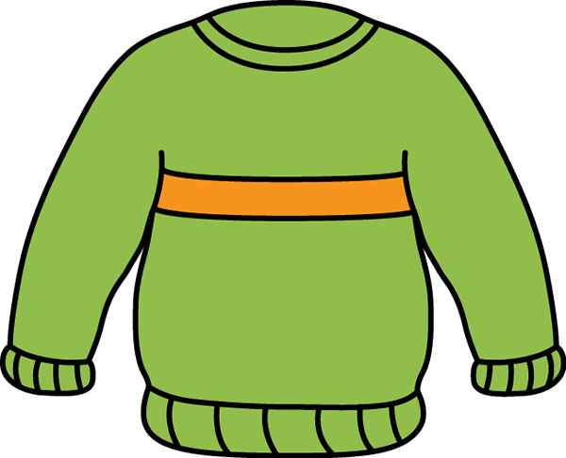
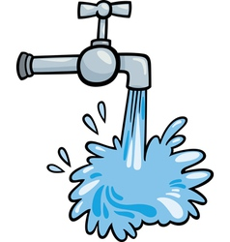

Match up the picture with the instruction. Then, put them in a pyramid of importance. Which measures are the most important to help our world?
1
9
13
17
6
10
14
18
3
7
11
15
19
4
8
12
16
200
Turn the lights out. Save electricity.
Don’t eat beef burgers.
5
Close doors to keep the heat in.
Re-use comestibles, for example, tea bags.
Buy re-fills for pens.
Have a short shower. No baths!
2
Eat more vegetarian food; less meat.
Turn the tap off when cleaning your teeth
Buy clothes from charity shops. ‘Chachic’
Don’t use bubble bath – it poisons the planet.
Walk! Don’t rely on public transport.
Buy and use recycled paper. Save trees.
Wear warm clothes to save on heating
Re-use plastic bags.
Persuade your parents to leave the car home.
Recycle as much as you possibly can.
Turn your screen off when not in use.
Plant trees and plants.
Don’t buy items with a lot of packaging.
Don’t flush the toilet every time!
bubbles
off!

