About you
B
A
1 Talk about your home.
 What sort of house do you live in? Where is it?
 What rooms has it got?
 What’s in the living room?
 What’s in your bedroom?
 Do you like your home? Why?
 Do you help at home? What housework do you do?

Role play
2 Complete the dialogue with the words in the box. Then practise the dialogue.
I suppose so I’m busy can you
I’ll do it are you doing

A (1) _______________________ tidy your room, please?
B (2) _______________________ at the moment.
A What (3) _______________________ ?
B I’m doing my homework.
(4) _______________________ in fifteen minutes, OK?
A (5) _______________________, but please don’t forget to do it.
B OK.
EXTENSION Work in pairs. Imagine one of you is a parent and the other is a teenager.
A ask the teenager to clean the kitchen floor
B say that you are busy at the moment
A tell the teenager that you want them to clean the kitchen floor now
B say what you are doing and say that you will clean the floor in half an hour
A agree, but tell them not to forget to do it

Photo description
3 Describe the photos.
Photo A
 Describe the room in the photo. What kind of room is it? What things can you see in the room?
 Describe where the basketball, mirror and bed are in the room.
 What is the person doing at the moment?
 Describe how this room is different from the same type of room in your house.
Photo B
 Describe the room in the photo. What kind of room is it?
 What things can you see in the room?
 Describe where the sofa and the TV are in the room.
 What are the people doing at the moment?
 Describe how this room is different from the same type of room in your house.
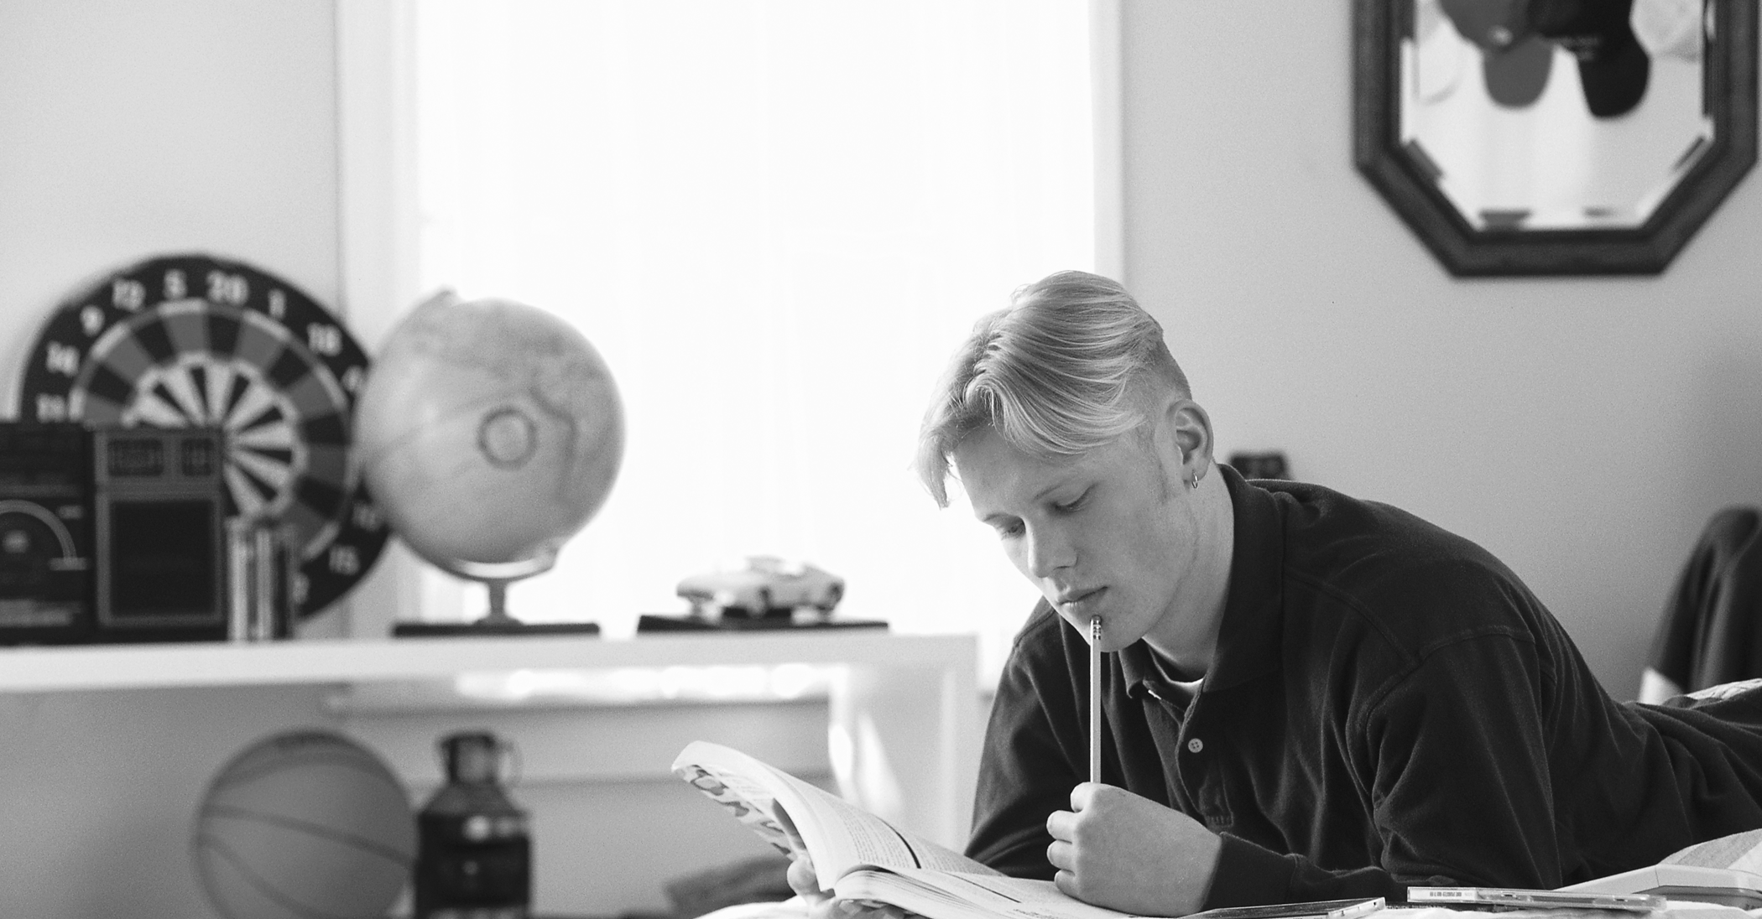
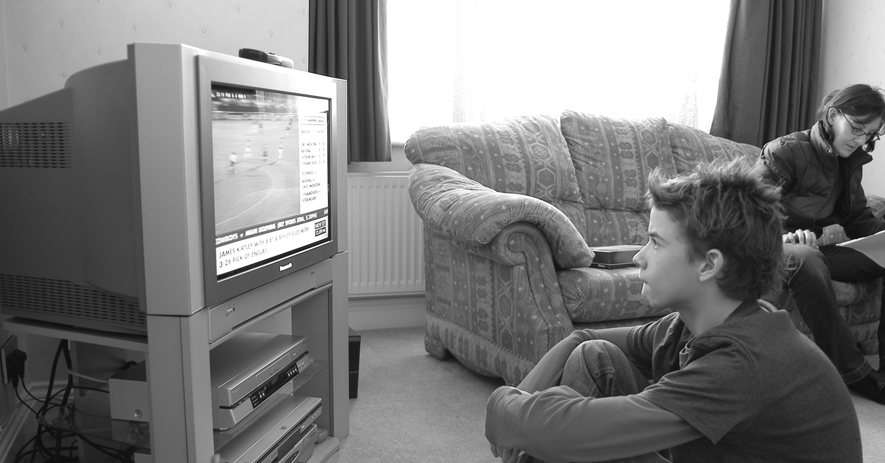
EXTENSION Answer the questions.
 Where do you usually do your homework?
 Where do you usually watch TV?
 How often do you tidy your room?
 How often do you clean other rooms at home?

