READING
The Great Famine
The year of 1845 changed the history of Ireland forever. The weather was good so people were expecting a good potato crop that year. What they didn’t know was that a new form of potato disease had been brought into Europe.
The disease first appeared in America two years earlier, then it arrived via cargo ships into France and finally reached the Isle of Wight and Ireland. It turned potatoes into a black, rotten mess, which nobody could eat. More than half of the year’s crop was destroyed.
Irish people depended on potatoes for their survival. Most people owned very small areas of land, and they grew potatoes instead of grain because a farmer could produce three times as much food on the same plot of land. A single acre of potatoes yielded enough food for a family for a year. Each family grew only what they needed as they didn’t have anywhere to store potatoes over the winter.
There was famine all over the country. People went hungry without any food to eat for days. Then in 1846, the potato crop was devastated once again. The harvest in 1847 was also very poor. Three years without potatoes led to enormous problems for Ireland.
The British government, which ruled Ireland at the time, first did very little to help the people in need. In fact, during the crisis, British landlords continued exporting food from the country simply because they could get a better price abroad. Eventually, in 1847 the government decided to do something about Ireland. They set up soup kitchens to give free food to people who needed it the most. They also initiated work programmes to help people make money so they could buy food for their families. But it was too little, too late.
Between 1845 and 1855, more than 700,000 Irish people died from starvation. After the famine, an estimated 2 million people left the country. Some people started new lives in Britain’s industrial cities, for example Glasgow, London and Liverpool. Others went to the USA. The population of Ireland dropped by more than a quarter.
The Great Famine, as they called the hunger crisis, transformed Irish culture and had a big effect on the Gaelic language. The crisis was worst in the west of Ireland, where most Gaelic speakers lived. Families who decided to emigrate no longer had any use for Gaelic in their new countries, and future generations of Irish immigrants didn’t learn the language at all. Today only a small minority of Irish people speak Gaelic as their first language.
But many historians believe it was also the Great Famine that led to the nationalist movements which finally brought about Ireland’s independence from Britain in 1921.
1 Read the article. Write true (T) or false (F).
1 The potato crop in 1845 was better than people expected. F
2 The disease appeared in America in 1843. ___
3 Farmers produced enough potatoes for their families, but not enough for difficult times. ___
4 1847 was the third year when Ireland had problems with the potato crop. ___
5 In the 1840s the landlords in Ireland were British.
___
6 The British government bought food for Ireland from other countries during the crisis. ___
7 Work programmes started in 1847 to help people make money for food. ___
8 A lot of Irish people moved to England, Scotland and the USA after the Famine. ___
9 Before the Famine, people only spoke English in the west of Ireland. ___
10 Later generations of Irish immigrants learned Gaelic as their first language. ___
11 Some historians claim the country’s independence in 1921 was a consequence of the Great Famine. ___
2 points for each correct answer |  | 20
2 Match the underlined words in the text to the definitions.
1 continuing living survival
2 finally, in the end ________
3 started ________
4 suffering or dying from lack of food ________
5 produced, provided ________
6 illness ________
1 point for each correct answer |  | 5

 | Reading total |  | 25

WRITING
1 Choose the best phrase for a letter to a company. Circle the correct letter.
1 a Hello
b Dear Mr Williams
c Dear Brian
2 a I saw your advertisement and thought I should
write.
b I am writing in response to your advertisement.
c Great advert – please tell me more about it.
3 a I was wondering if you could send me some
information about the work at the camp.
b I would like to know more things about working at the camp.
c Please give me some information about camp and the work.
4 a I’d like to be a supervisor at the camp.
b Could I be a supervisor at your camp, please?
c I would be interested in the role of supervisor at the camp.
5 a I look forward to hearing from you.
b Write soon, please.
c I can’t wait to hear from you.
6 a Take care,
b All the best,
c Yours sincerely,
1 point for each correct answer |  | 5
2 Read this advertisement. Write a letter requesting more information about the summer job. Write your letter in 120–150 words.
INTERNATIONAL CHILDREN’S CAMP
Summer supervisors, sports trainers and language tutors wanted!
Sports courses and language courses for children.
Different age groups.
Based in Bristol, Exeter and Bournemouth.
For camp brochure and further information, write to:
Brian Williams
223 Leeward Street
Bristol BS6 1QJ
UK

Writing task |  | 20

 | Writing total |  | 25
LISTENING
1 Listen to five people talking about their work. Circle the correct letter.
1 Fiona works in
a a bank.
b a baker’s shop.
2 The owners of the place where Fiona works are
a bakers.
b Fiona and her husband.
3 Jason says he likes working as a
a trainee electrician.
b car factory engineer.
4 Peter
a couldn’t speak Hungarian at first.
b wanted to be a lawyer.
5 Donna gave up cycling because
a she had an accident.
b a sports consultant told her to set new goals.
6 Chris doesn’t like eating in restaurants because
a he’s paid to eat there as a food critic.
b he works in two restaurants as a waiter.
1 point for each correct answer |  | 5
2 Listen again. Match two statements from a–k to each speaker. There is one extra statement.
1 Fiona __ __
2 Jason __ __
3 Peter __ __
4 Donna __ __
5 Chris __ __
a doesn’t earn much money but doesn’t mind.
b sometimes feels envious about other people’s work.
c has a summer job and another job.
d wanted to be a sports champion.
e borrowed money from the bank.
f teaches English at his/her own school.
g helps other people get over their difficulties.
h enjoys working on his/her own.
i hired two people to work for him/her.
j met his/her wife at university.
k moved to Britain from another country.
2 points for each correct answer |  | 20

 | Listening total |  | 25
SPEAKING
1 Ask and answer the questions with a partner.
1 What do you think your life will be like in ten years’ time?
2 In what ways do you think Britain is similar to your country? In what ways is it different?
3 What is the worst job you have ever had to do? What was it like?
4 What advice would you give to a friend who wanted to get fit and healthy?
5 Where are you going to go and what are you going to do this weekend?
max. 1 point for each topic |  | 5
2 Look at the photos. Compare the different families. Talk about what the advantages and the disadvantages are. In your opinion, what is the ideal family like?


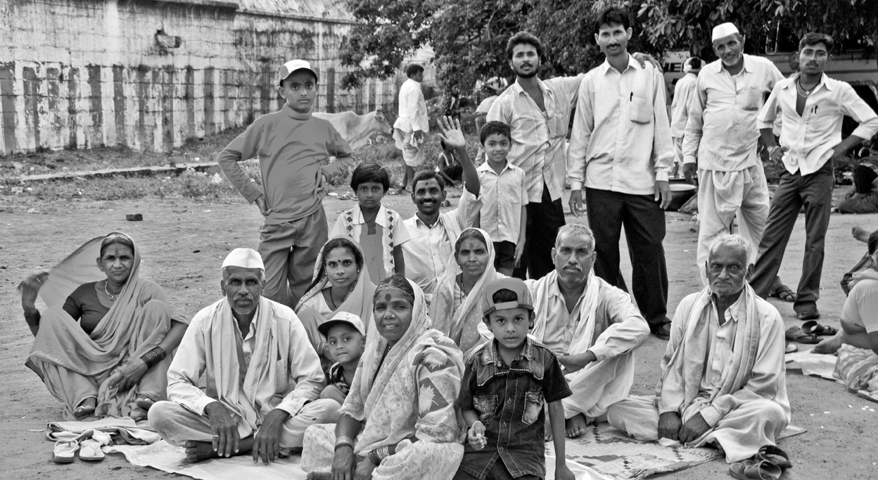

max. 10 points |  | 10
3 A Look at the information. Use the words to make five questions.
New York City factfile
History: The largest city in the USA since 1790.
Population: 8 million (city), 18 million (metropolitan area).
Nationalities: 36% of its population were born abroad. They come from Africa, Puerto Rico, Italy, China, Ireland, Russia and Germany to name a few.
Public transport: New York City Subway runs 24 hours a day, 7 days a week. Only 22% of people in the city own cars.
Free time: over 500 art galleries, 39 large theatres, all the major designer stores, 110 square kilometres of parks and 23 kilometres of public beaches.
1 how long / New York City / in the USA?
2 how many ?
3 where from ?
4 how / travel around ?
5 what / do ?
1 point for each correct question |  | 5
B Answer the questions.
1 point for each correct answer |  | 5

 | Speaking total |  | 25

 | Skills test 3 total |  | 100

