About you
1 Talk about an adventure.
A
B
 Describe something dangerous or frightening that happened to you in the past.
 Where was it? What was the place like?
 What did you do? How did you feel?
 What happened in the end?
 Do you like doing dangerous or scary things?

Role play
2 Complete the dialogue with the words in the box. Then practise the dialogue.
amazing done happened kidding Really

A Is that your photo? That’s (1) ________________!
B Do you like it?
A Yes. Where is it?
B In London. It (2) ________________ while I was on holiday there.
A (3) ________________?
B Yes. These people were doing tricks on BMX bikes.
A Wow! Did you try it?
B You’re (4) ________________! I can’t ride a BMX bike like that!
A Well, it’s a great photo. Well (5) ________________.
EXTENSION Imagine you are showing someone some exciting photos.
A show a photo to your partner
B show you are interested and ask questions about the photo
A explain what you were doing when it happened
B show you are interested

Photo description
3 Describe the photos.
Photo A
 Describe the place that you can see. What is the weather like?
 What happened to this person?
 What was she doing when the accident happened?
 How do you think she felt?
 What do you think happened in the end?
Photo B
 Describe what you can see.
 What happened to the boy?
 What was he doing when the accident happened?
 How do you think he felt?
 What do you think happened in the end?
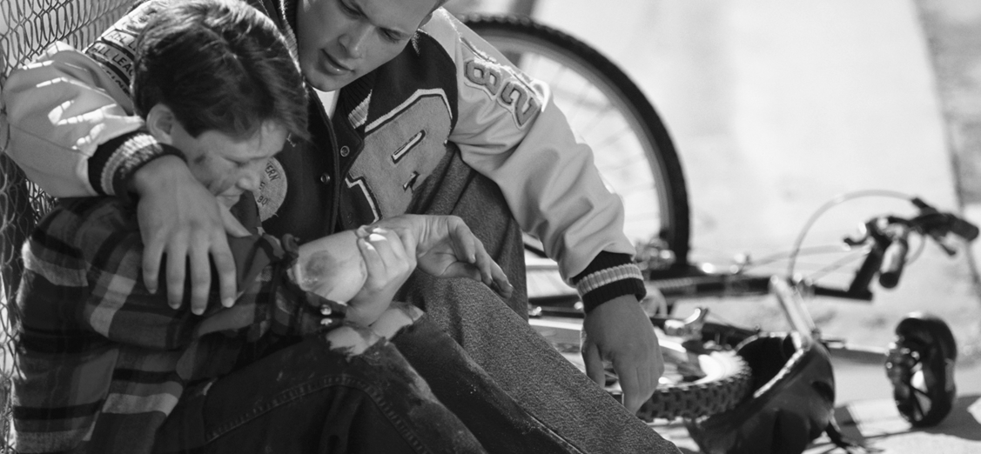
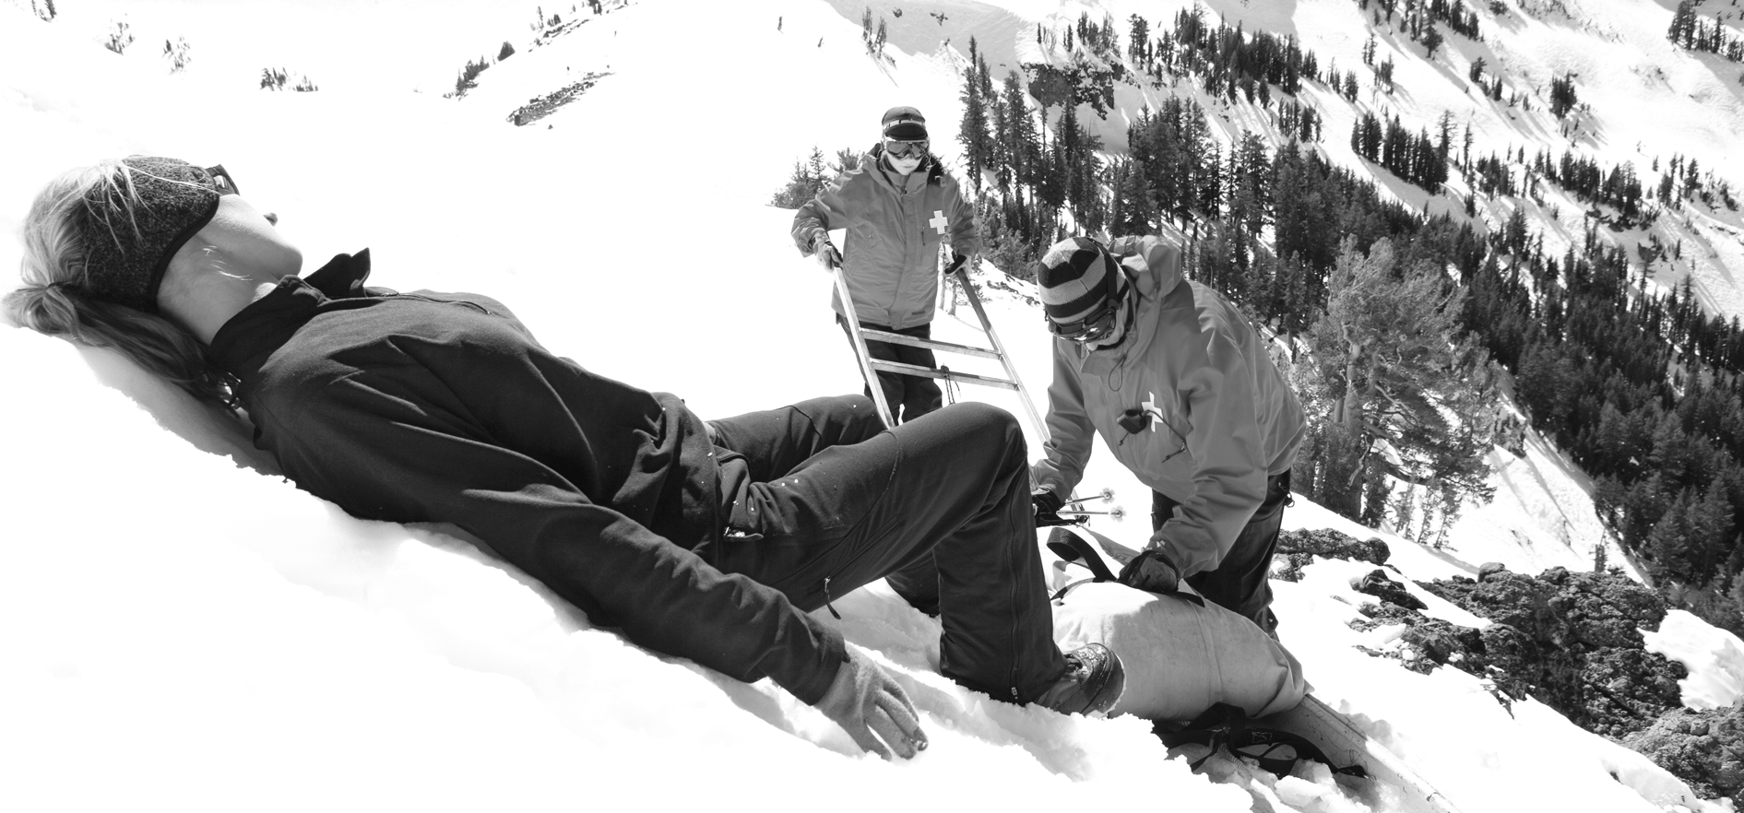
EXTENSION Answer the questions.
 Do you like doing dangerous things?
 Why do you think some people like doing dangerous things?
 Who is your favourite daredevil? Why? What did he / she do?
 Do you want to do daredevil things in the future? Why?

