Match the sentences to the pictures.

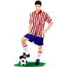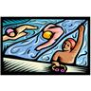

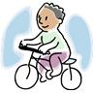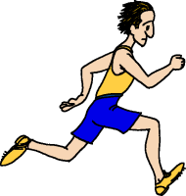



- He can play the guitar.
- They can ski.
- He can ride a bike.
- She can sing.
- They can swim.
- He can run.
- They can dance.
- He can play golf.
- She can play tennis.
- He can play football.
- He can drive a car.
- She can play the piano.

Answer the following questions. Then ask your friend.

Can you sing?Friend:
Can you dance?Friend:
Can you swim?Friend:
Can you play football?Friend:
Can you play the guitar?Friend:
Now write sentences about what you can or can’t do.
E g. We can ski. / We can’t ski. / I can ski but she can’t.

1.
2.
3.
4.
5.

Key:

Matching exercise

10; 2; 5; 9
8; 3; 6; 12
1; 7; 4; 11

Ask and answer

Yes, I can. / No, I can’t.
Friend: Yes, he can. / No, he can’t.
Yes, she can. / No, she can’t.

Writing

Students’ own answers

