READING
Half a century in the UK
1 C What was life like in Britain in the 1960s? Many would say it was simpler, quieter, and safer. It seems to me that in every generation, people look back and say things were better when they were young. But that’s because they felt better because they were younger! Being a 20-something, with all our dreams still possible, is different from being grown up with responsibilities: children, elderly parents, a home to pay for, money to make … in other words, your life changes, as well as the world around you. But what has actually changed in the last 50 years?
2 ___ The 1960s was the time when the technological wonders we nowadays take for granted started to become more common. By the end of the decade, nearly all homes had a television set. Programmes were still made in black and white, not colour. They started at five in the afternoon on weekdays, and they finished at midnight. People didn’t have mp3 players or CDs – they listened to music on the radio. Small, portable transistor radios were starting to replace the huge radio sets of the 1950s – which were bigger than most televisions are today. Nobody had personal computers. In the 1960s, the early computers were enormous, and only scientists with special training could use them.
3 ___ Shopping was different, too. Many people bought all their groceries in local shops. Supermarkets were a new idea in the 1960s, and although they were becoming popular, less than half of the population used them. A lot of people made their own clothes. There were fashion shops in big cities, of course, but people didn’t spend the weekend shopping like they do now: perhaps they went to a football game or did some gardening.
4 ___ Travelling abroad on holiday was becoming more popular, but most British families spent their holidays in the UK – in places like Blackpool or the West Country.
5 ___ Fewer people owned cars, but there were still enormous traffic jams on roads, especially during the summer holidays. The government had just started building motorways, so people usually had to use older, narrower roads to travel long distances. But trains were more frequent and a lot cheaper than they are today. British Rail was famous around the world for its service.
So, what do you think – was life better in the 1960s or was it simply different?
1 Read the article quickly and circle the correct answer.
According to the author, why do people see their youth differently?
a There was more technology to enjoy.
b They didn’t have the same responsibilities they have today.
c They feel life is getting faster and more complicated all the time.
1 point for each correct answer |  | 1
2 Read the article again. Match the headings (A–F) with the paragraphs. There is one extra heading.
A People’s shopping habits
B New discoveries today
C Every generation is nostalgic
D Transport in the 1960s
E Technology and leisure
F Taking a break
2 points for each correct answer |  | 8
3 Read the article again. Complete each statement with no more than two words.
1 The author thinks people saw the 1960s differently because they were younger.
2 Most families at the end of the 1960s owned a ______ .
3 You could only watch TV programmes from ______ o’clock on working days.
4 Radios in the 1950s were ______ than in the 1960s.
5 Scientists were the only people who used ______ .
6 Some people went shopping for ______ , but others made their own.
7 Most British families didn’t spend their holidays in ______ .
8 There were fewer car owners in the 1960s, but ______ were still a problem on the roads.
9 In the 1960s, trains ran ______ often than today.
2 points for each correct answer |  | 16

 | Reading total |  | 25

WRITING
1 Imagine your ideal holiday. Imagine you are writing a postcard to your English friend from this holiday. Write about:
• where you are.
• what the place and the weather are like.
• how you’re feeling.
• what activities you do.
Write in the present tense. Write your postcard in 60–100 words.
Shorter writing task |  | 10
2 Write the story of how your parents met each other. Write about:
• when and where it happened.
• how old they were.
• where they worked or what they studied.
• what activities they did together.
• an interesting episode in their life together.
• what (you think) brought them together.
Write your story in 120–180 words.
Longer writing task |  | 15

 | Writing total |  | 25
LISTENING
1 Listen to an interview with Jason talking about his lifestyle. Tick () five points he mentions.
He doesn’t eat any food that comes from an animal. 
He likes exercising at the gym.
He read about becoming a vegetarian.
His wife was working at the gym.
Anita ran the London Marathon.
She is a very good cook.
He used to eat cheese omelettes.
Jason ran the London Marathon.
Most of his friends are vegetarians or vegans.
1 point for each correct answer |  | 5
2 Listen again. Circle the correct letter.
1 Jason eats a lot of …
a eggs.
b vegetables.
c meat.
2 When he was a teenager, Jason …
a loved burgers.
b wasn’t interested in girls.
c decided to be a vegan.
3 When he was at university, Jason went cycling …
a every other day.
b in the evenings.
c at the weekends.
4 When he tried a vegetarian diet for a month, he …
a didn’t think it suited him.
b felt he was more attractive to girls.
c found it easier than he’d expected.
5 When the month was over, Jason …
a started eating meat again.
b lost a lot of weight.
c felt vegetarian food gave him more energy.
6 He met his wife Anita …
a at the London Marathon.
b when he was out running.
c at the gym where he trained.
7 When Jason started a vegan diet, he …
a did it to protect the environment.
b found it hard to give up his favourite food.
c gave up after a few weeks.
8 Jason thinks most vegan substitutes …
a are too difficult to find.
b taste awful.
c taste just as good as dairy products.
9 According to Jason, tofu is …
a a dairy product.
b made of rubber.
c not very tasty.
10 He found that a vegan diet was different from a vegetarian diet …
a because he lost more weight.
b his meals had fewer calories than before.
c he didn’t have to eat as often as before.
11 When he eats out with friends who eat meat, he …
a notices that they feel uncomfortable about this.
b finds it hard to accept their decision to eat meat.
c tells them his choice of diet wasn’t personal.
2 points for each correct answer |  | 20

 | Listening total |  | 25
SPEAKING
1 Ask and answer the questions with a partner.
1 Who’s the happiest person you know? What do you think makes them happy?
2 Do you think it is important to follow the news? Why?/Why not?
3 What dishes are popular in your country? Do you like them? Why?/Why not?
4 What do you think your parents were like when they were your age? In what ways were they like you and in what ways were they different?
5 What would you show a first-time visitor to your country’s capital city? Why?
max. 1 point for each topic |  | 5
2 Look at the photos. Compare different places where people live. Talk about what the advantages and disadvantages are. In your opinion, what would be
the ideal place to live and why?

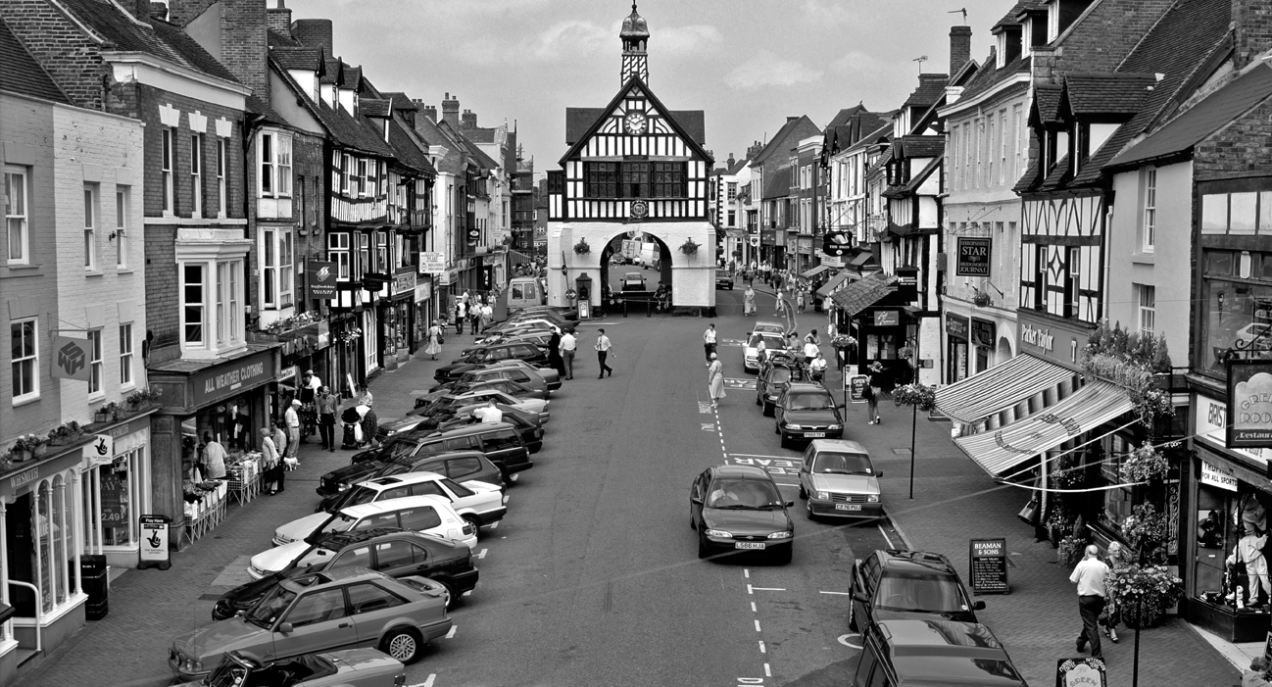
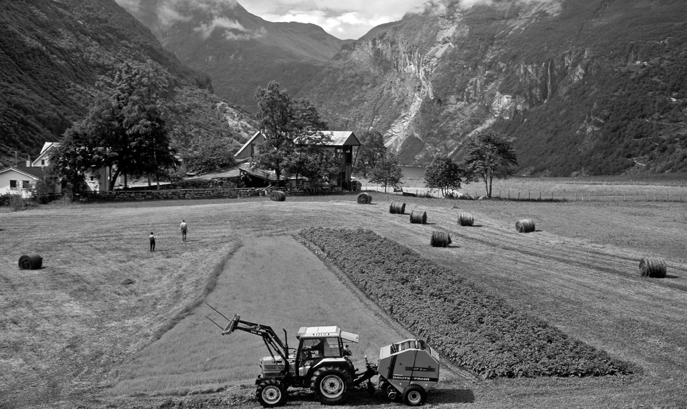
max. 10 points |  | 10
3 A Look at the information. Use the words to make five questions.
Summer part-time work: Tourist Information Officers wanted!
From mid-July to end-August.
Help tourists at outdoor information stands at major tourist sights.
You must speak one foreign language, be good at working with people and willing to work outdoors.
Flexible working hours: 4 hours/day (from 8 to 16 hours/week)
Pay: £10/hour. 50% higher pay for weekend work (Saturdays and Sundays)
1 when / need part-time workers ?
2 what / will do ?
3 what skills / need ?
4 how many hours / a day or a week / can work ?
5 what / pay / for weekends ?
1 point for each correct question |  | 5
B Answer the questions.
1 point for each correct answer |  | 5

 | Speaking total |  | 25

 | Skills test 2 total |  | 100

