READING
Blade Runner
1 F Oscar Pistorius is a South African athlete. He was born in Johannesburg in 1986, as the middle child of a family with Italian roots. His grandmother had emigrated to Kenya from Italy. Pistorius lost both his legs below the knee when he was only 11 months old.
2 Despite his disability, he has been very active in sports all his life. He took up running after a rugby accident in 2004. In the same year he finished third in the 100 metres, and won the 200 metres with a new world record at the Paralympic Games in Athens. The following year he won both the 100 and 200 metre events at the World Cup, and broke his own world record. In 2006, he won the 100 and 200 metres and also came first in the 400-metre event at the World Championships. In 2007, he became the first sportsperson in history to set the world record for all three distances. During his career, Pistorius has broken his own world records more than 30 times!
3 Pistorius usually competes with athletes who still have one functioning leg, while he has to wear artificial limbs, whose special shape earned him the nickname, ‘Blade Runner’.
4 His lifelong ambition, however, has been to compete with able-bodied athletes. He took part in his first international event in 2007, but the International Association of Athletics Federations (IAAF) banned him from competing a year later. Scientific tests in Germany showed that his artificial legs gave him ‘an unfair advantage’.
5 He successfully challenged that decision when further tests in Houston, Texas proved that he also had disadvantages which the first tests ignored. The IAAF allowed him to try for the Beijing Olympic Games in 2008, but his times were not good enough then. He did, however, enter the Beijing Paralympic Games, and became the first runner ever to win gold in all three short-distance races.
6 2011 was a turning point for Pistorius: he successfully qualified for the 2011 World Championships and the 2012 London Olympic Games in the 400 metres. He said in an interview after the qualifying race, ‘I have dreamed for such a long time of competing in a major championship and this is a very proud moment in my life.’
7 In 2006, the President of South Africa awarded him a medal for his outstanding achievements in sport. Pistorius continues to be an inspiration for people around the world.
1 Read the article quickly and circle the correct letter.
Which full Olympic Games did Pistorius qualify for?
a 2004
b 2008
c 2012
d He has never qualified for Olympic Games, but he has competed in the Paralympic Games.
1 point for each correct answer |  | 1
2 Read the article again. Match the headings (A–H) with the paragraphs. There is one extra heading.
A What makes his achievements special
B Results in disabled competitions
C Fighting to change a bad decision
D A broken dream?
E Inspiration for everyone
F A disadvantage from childhood
G Winning the first able-bodied competition
H A dream come true
2 points for each correct answer |  | 12
3 Read the article again and circle the correct letter.
1 Oscar Pistorius is …
a an Italian living in Africa.
b originally from Kenya.
c a sportsman from South Africa.
2 Pistorius lost his legs …
a as a teenager.
b when he was just a baby.
c because had an accident playing rugby.
3 He broke his first world record …
a at the Paralympics in Athens.
b at the World Cup in 2005.
c in history in 2007.
4 Pistorius became the first athlete ever to …
a compete with athletes whose disability is less serious than his own.
b break world records more than 30 times.
c hold the world record in all three short-distance running events.
5 He entered his first competition for able-bodied athletes …
a while he was banned by the IAAF.
b a year before the IAAF decided to ban him from entering.
c only after the IAAF allowed him to compete.
6 The scientific tests in Texas proved that …
a Pistorius really had an unfair advantage in running.
b the IAAF had not considered his disadvantages when it banned him.
c the previous tests in Germany were correct.
7 He said it was a proud moment in his life when he …
a was given a medal by the President of his country.
b won the Beijing Olympic Games in the 400-metre event.
c finally qualified for two world events for able-bodied athletes.
2 points for each correct answer |  | 12

 | Reading total |  | 25
WRITING
1 Circle the best word or phrase.
1 We don’t read magazines online, but / so / and we read newspapers on the internet.
2 Many people dislike e-books so / because / although they find looking at a screen for too long very tiring.
3 Portable DVD players, that / which / what have been around for many years now, are great for entertaining children on long car journeys.
4 Most people do not watch films on their mobile phones. Although, / However, / What is more, they often listen to mp3 music files.
5 Because / The fact is / Despite the small size of smartphone screens, a lot of people visit social networking sites using their phones.
6 Clearly, / Firstly, / Finally, mobile phones have developed a lot in recent years.
1 point for each correct answer |  | 5

2 Write an essay about the pros and cons of using mobile phones. Write about:
• how people are using their mobile phones (e.g. for socializing and entertainment).
• the advantages of mobile phones compared to other devices.
• the disadvantages of mobile phones.
• how you see the future of mobile phones in these areas.
Write your essay in 150–200 words.
Writing task |  | 20

 | Writing total |  | 25
LISTENING
1 Listen and tick () five things that the lion does.
runs around eats lunch
visits the chemist’s builds walls
sits in the grass puts up the roof
goes shopping sleeps
has some cereal
1 point for each correct answer |  | 5
2 Listen again. Write true (T) or false (F). If there is no information in the story about the statement, write no information (N).
1 The lion was walking by the river one morning. F .
2 The rabbit asks the lion if he can help him build the house. ___
3 The lion likes eating meat for breakfast. ___
4 The lion gets very tired after building the foundations with the rabbit. ___
5 The lion sleeps for four hours. ___
6 When the walls are finished, they both say they like the house. ___
7 The rabbit would like a biscuit for lunch. ___
8 The lion doesn’t feel well after his meal. ___
9 The rabbit takes a short break in the afternoon. ___
10 The sun is shining when the house is completed. ___
11 The lion goes to bed and sends the rabbit away. ___
2 points for each correct answer |  | 20

 | Listening total |  | 25
SPEAKING
1 Ask and answer the questions with a partner.
1 If you could decide, would you rather have a sister or a brother? Why?
2 When did you last see a doctor? What was your problem? How long did it take you to get better?
3 How much do you know about your family history? Who do you admire the most? Why?
4 How much time do you spend on the internet? What do you use it / not use it for? Why?
5 What’s your dream job? Why? Do you think you are likely to get that job?
max. 1 point for each topic |  | 5
2 Look at the photos. Compare the different sports. Talk about what you think is good and bad about them. In your opinion, which sport is the best sport to do, and which is the best to watch? Why?
max. 10 points |  | 10
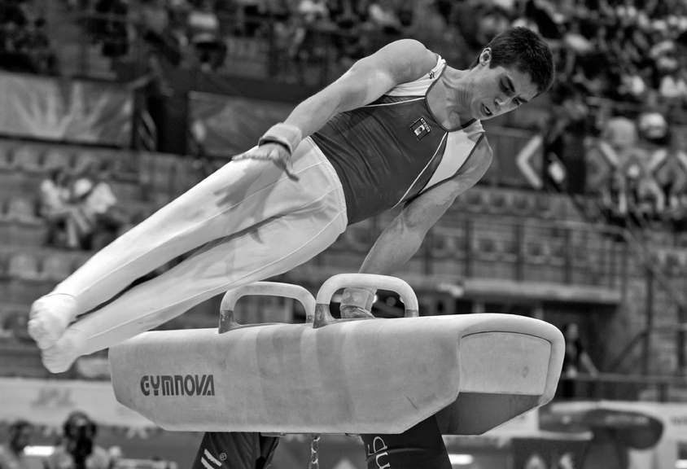
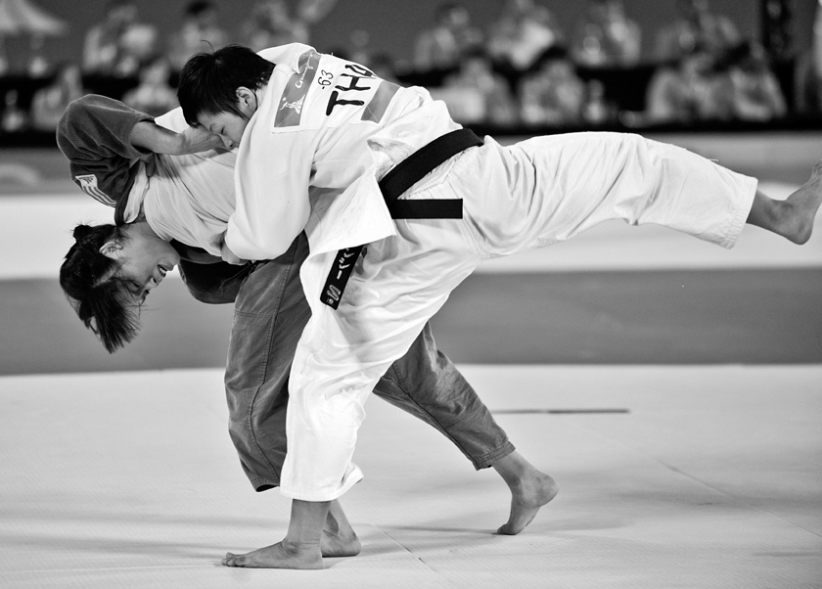
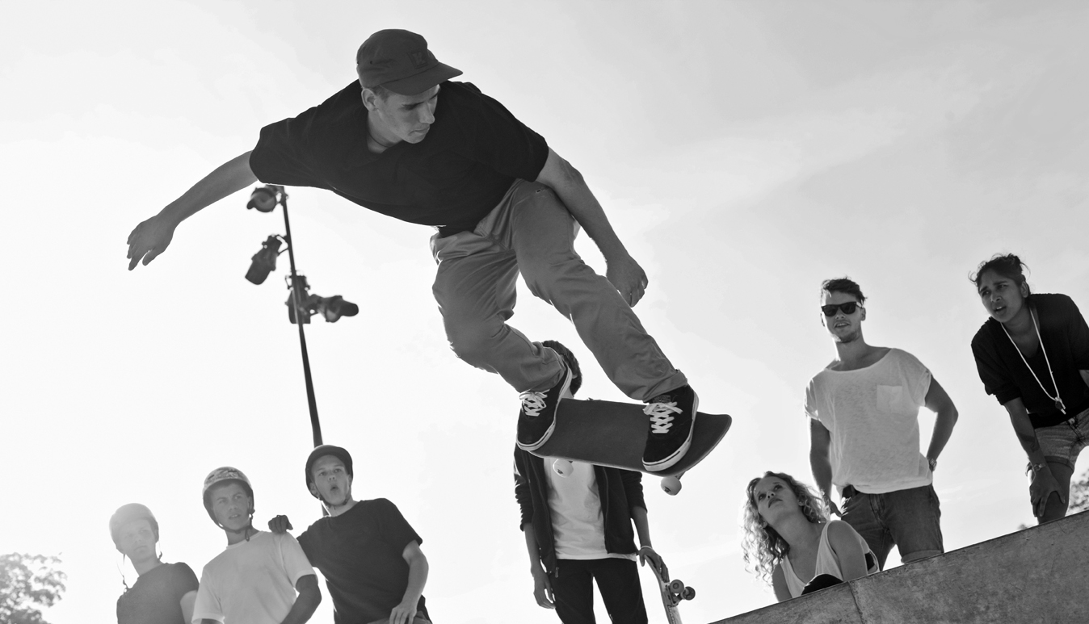
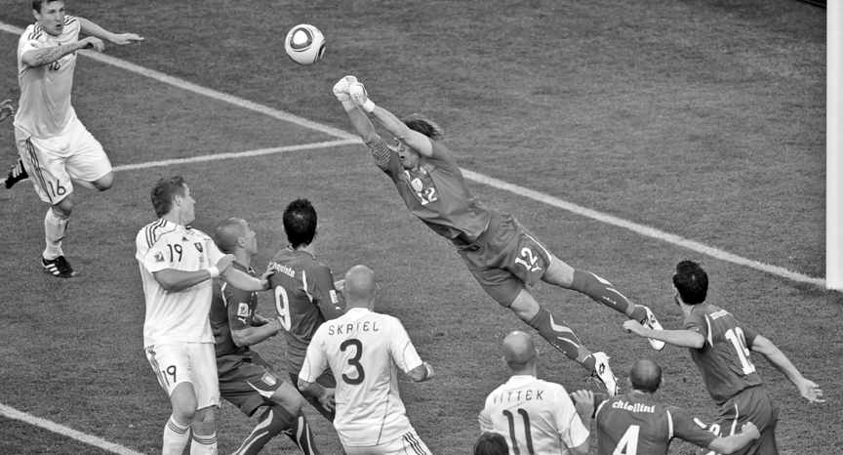
3 A Look at the information. Use the words to make five questions.
MegaPhone 1.0! Special offer!
90mm touchscreen. Weighs only 100 grams.
Plays mp3 and mp4 in hi-fi sound quality!
Built-in digital TV and radio.
64 GB disc space for all your personal files.
Up to 50 hours battery life (450 hours on standby).
Was £299, now only £89!
1 how big ?
2 what / can / do ?
3 how much / space / store files ?
4 how long / battery ?
5 how much ?
1 point for each correct question |  | 5
B Answer the questions.
1 point for each correct answer |  | 5

 | Speaking total |  | 25

 | Skills test 5 total |  | 100

