1.Hnev (Greta Thunberg) 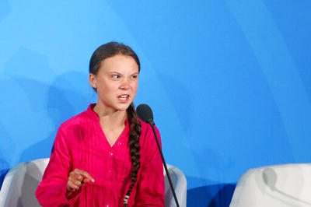

2.radost (Trump) 

3.prekvapenie (*Miley Cyrus)* 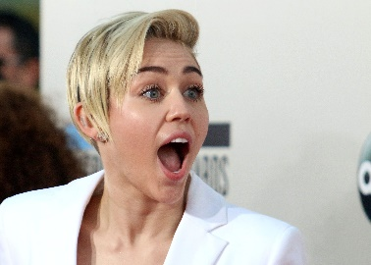

4.strach(Emma Stone)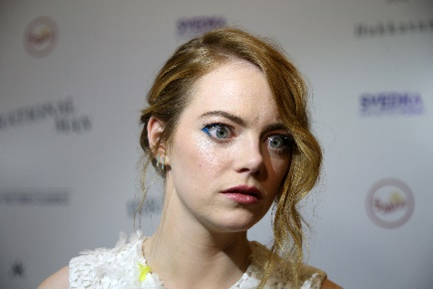

5.znechutenost(Gordon ramsay)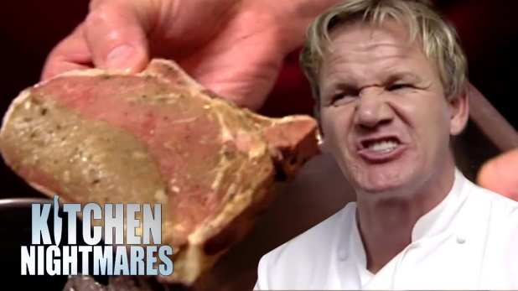

6.smutok(Tobey Maguire) 